Paper X

COVER SHEET FOR PAPERS TO BE CONSIDERED BY EXECUTIVE TEAM

Q1 Complaints Handling Report 2023/24

Date of Meeting: | 20 December 2023
Purpose of Paper: | To report key performance information on complaints handling to the Executive Team (ET), including the volume and types of complaints recorded by the University during the first quarter of the academic year 2023/24.
Intended Outcome: | ET is invited to note the information provided, as required by the University’s Complaints Handling Policy.
Paper Submitted by: | Strategy and Policy
Prior Committee Approvals: | N/A
Financial Implications: | None
Reserved Business: | No
Key Contact(s): | Chris Mochan, Complaints & Corporate Governance Officer  Chris.Mochan@strath.ac.uk
Date of Production: | 8 December 2023

Complaints Handling: 2023/24 Quarter 1 Report

It is a regulatory requirement that the University reports key performance information on complaints quarterly to senior officers (Executive Team) and annually to Court.

- The SPSO published a revised Complaints Handling Procedure (CHP) in 2020 which the University formally implemented on 1 April 2021. A MyPlace site is available containing the training materials for the compulsory frontline training required, under the CHP, for all staff at induction. These materials, along with additional guidance and templates, are also available to all staff on MyPlace for refresher training and ongoing reference. (https://classes.myplace.strath.ac.uk/course/view.php?id=26168)

- Annex A provides key performance information on the volume and types of complaints received during the first quarter of 2023/24 and on the resolution times achieved. Annex B looks at comparable data from the fourth quarter dating back to 2020/21. Annex C provides qualitative information on some of the actions taken and/or recommendations made to deliver service improvement in response to complaints received by the University during the quarter.

- In March 2022, SPSO published a set of Key Performance Indicators (KPIs) which institutions will be required to report on from 2022/23. For Further Education and Higher Education, the KPIs are applicable for data collected from 1 September 2022 and this report reflects those amendments.

- The quarterly reporting at Strathclyde already met most of the requirements except for the need to specify when a complaint was handled directly at investigation (stage 2) and when it was moved to investigation due to the complainant’s dissatisfaction with the frontline response. Further development work is due to begin shortly on the SharePoint recording site, which is used to generate the required data for these reports, to better support future reporting. For the present, complaints recorded as having been moved to stage 2 by the University are considered as handled directly at stage 2 and those moved at the request of the complainant to have been moved following an attempt at closing the complaint at frontline.

- The University recorded 34 frontline complaints during the first quarter of 2023/24, an increase of 42% from the first quarter of 2022/23. Of the complaints received, 29 were from students, three from member of the public and two from applicants for study. Complaints were received across all the faculties and Professional Services (Information Services and Student Experience). The most frequent types of complaints recorded were those relating to:

- Staff Attitude and/or Conduct (34%)
- Service Provision (23%)
- University Policies and Procedures (12%)
- Academic Support (12%)

- Staff Attitude and Conduct complaints were spread across University faculties and related to different issues including inappropriate language and behaviour, discrimination and unconscious bias. The total number of Staff Attitude and Conduct complaints (11) for the first quarter was half of last year’s total (22) and we expect this trend to continue upwards as students become more aware of what is acceptable behaviour and the University continues to prioritise the safety, health and wellbeing of students on campus through initiatives such as Safe 360 and the Strathclyde Community Commitment.

- With the above in mind, we organised for our solicitors Andersen and Strathearn to conduct training for our investigators with a specific focus on complaints against staff and particularly those that may require further HR involvement at the complaint’s conclusion. The first session took place on 5 December 2023 with another five scheduled for 2024 and we hope this will provide investigators with the support and knowledge that they require to carry out potentially complex and sensitive investigations.

- The average time taken to resolve frontline complaints decreased from 10 days in the previous quarter to 7.3 days with 50% of complaints closing within the 5 working day timescale target. The revised CHP requires frontline complaints to be closed on day 10 or moved to stage 2. Three frontline complaints took over 10 days and an email will be sent to all complaints champions to remind their teams to ensure complaints are being escalated to Stage 2 as soon as they reach day 10.

- The average time taken to investigate complaints handled directly at stage 2 decreased substantially from 40.3 days to 29.8 days. There was a total of 10 complaints investigated directly at Stage 2, six of which were partially upheld and four not upheld. Six complaints were escalated to investigation by the complainant. Three were not upheld and the remaining three partially upheld.

- The below table breaks down the total number of complaints received in this quarter and the equivalent quarter in 2021/22.

Faculty | Q1 2023/24 | Q1 2022/23 | Change | % Change
HAAS | 11 | 3 | +8 | +266%
Engineering | 7 | 7 | 0 | 0
Business | 6 | 1 | +5 | +500
Science | 2 | 4 | -2 | -50%
Total | 26 | 15 | +11 | +73%

- Both HAAS and the Business School have seen increased complaints in comparison to the same stage last year although as an overall figure in comparison to the number of students they remain very small. HAAS accounted for six of the quarters Staff Conduct complaints and the Business School saw an increase in complaints around Service Provision.

- Frontline complaints may be classified as ‘upheld’, ‘not upheld’ or ‘resolved’. The University continues to focus on frontline resolution and 40% of frontline complaints were resolved and that will continue to be a focus for this year. Only 8 % of complaints were upheld and another 8% were not upheld.

- At the end of the quarter six investigations were ongoing.
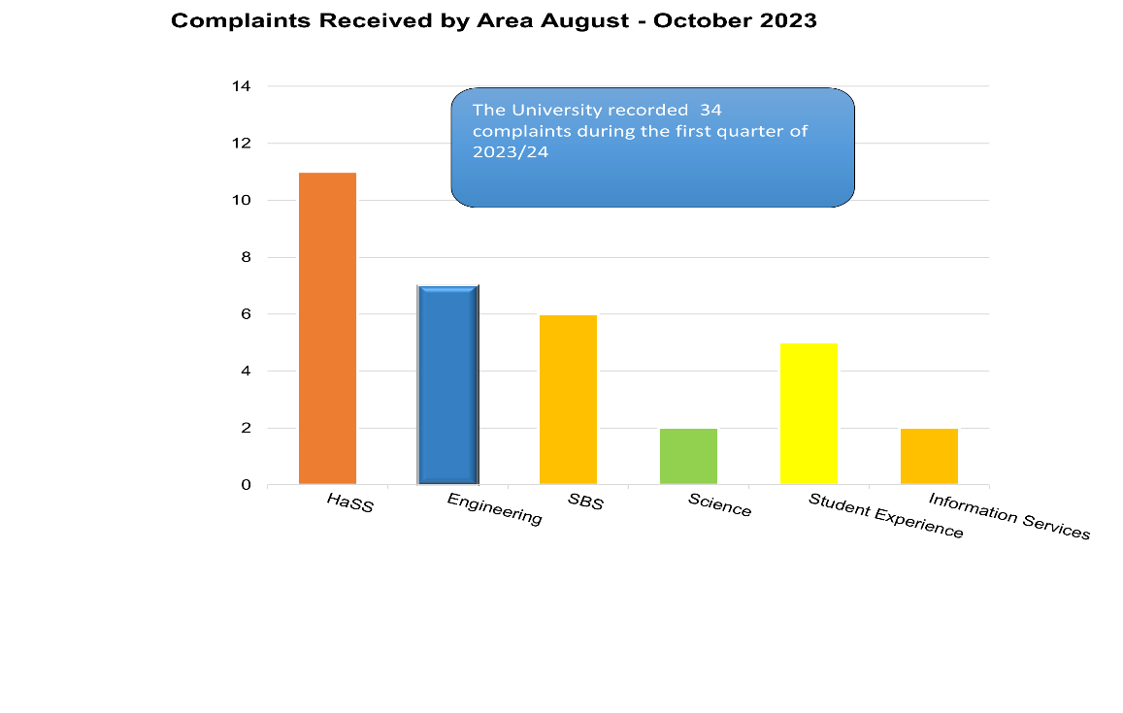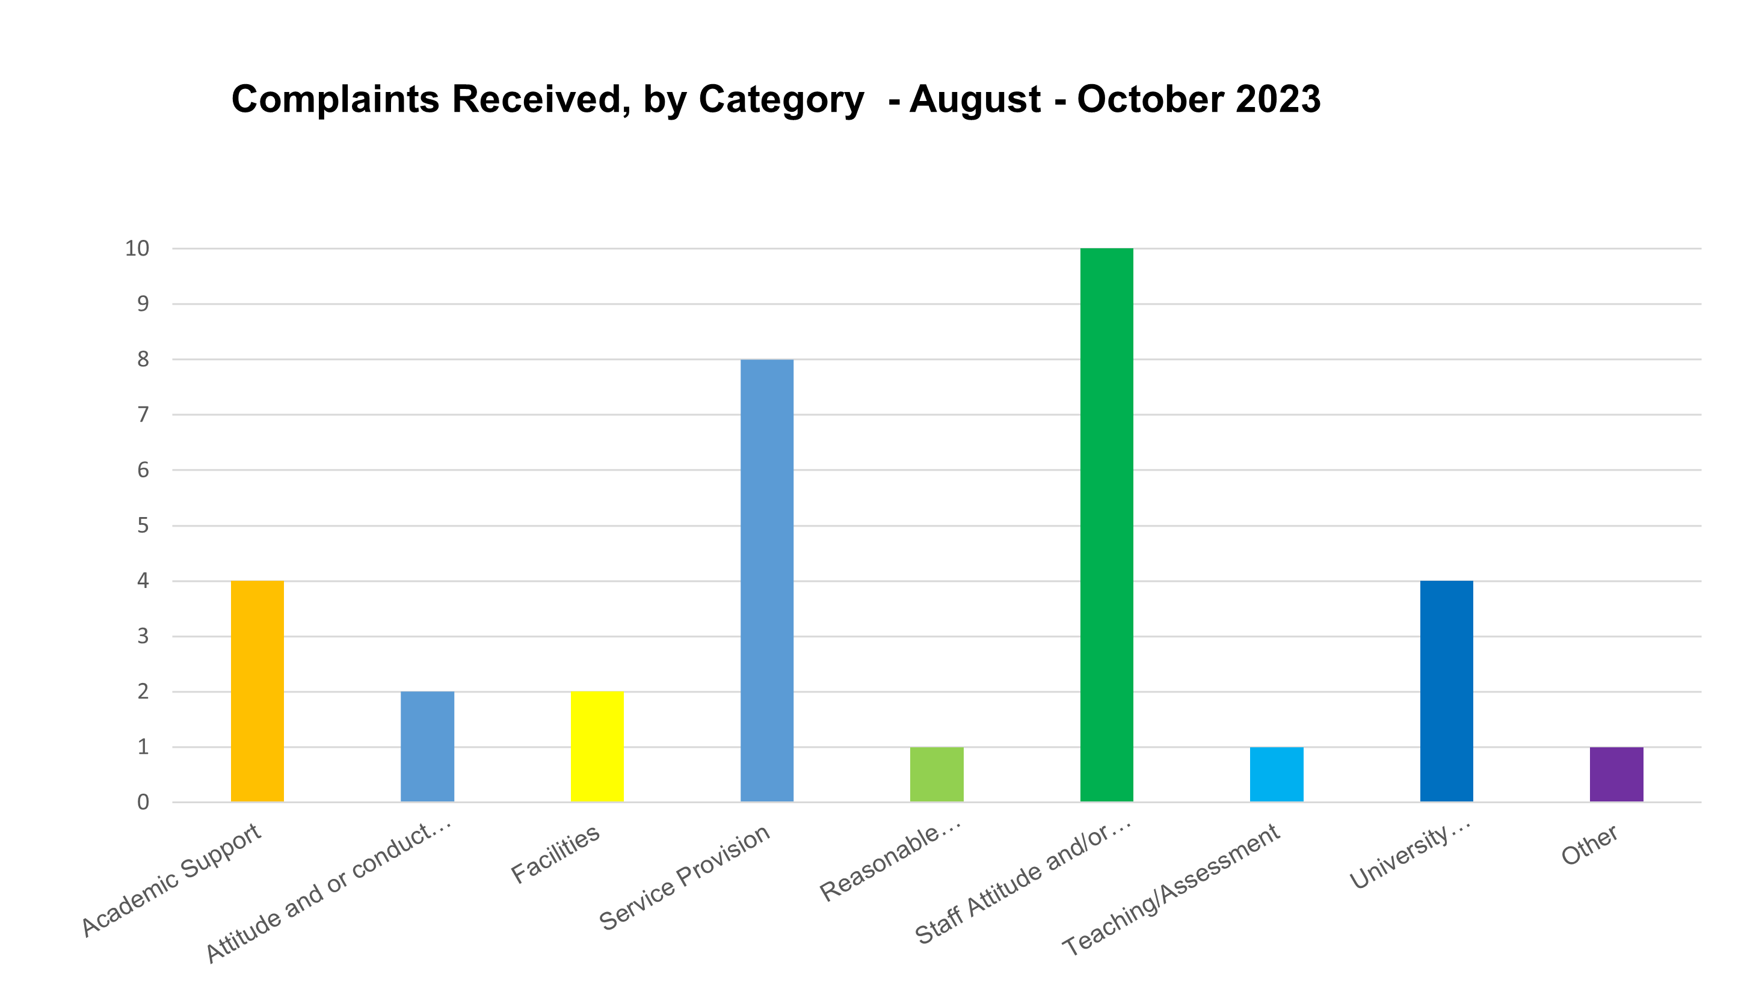
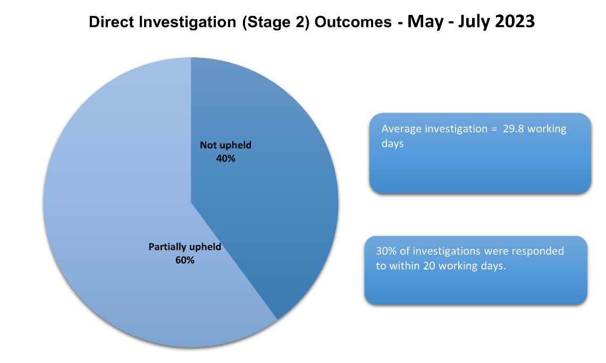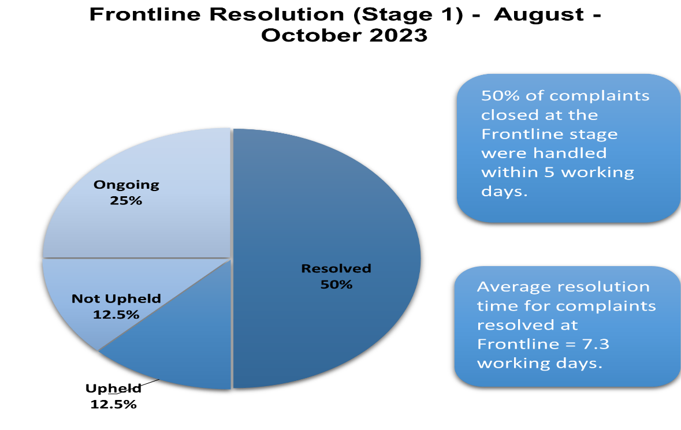

ANNEX B
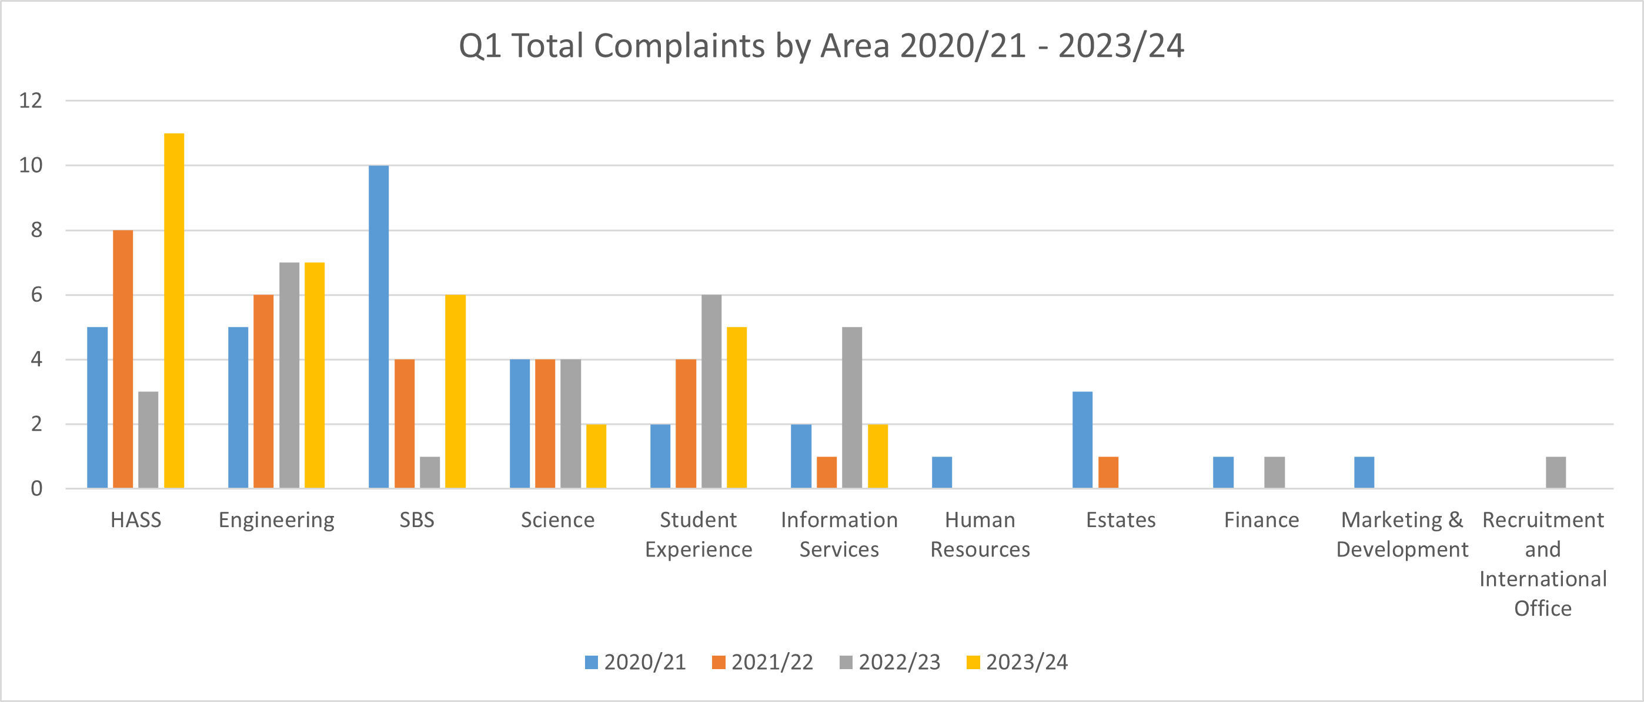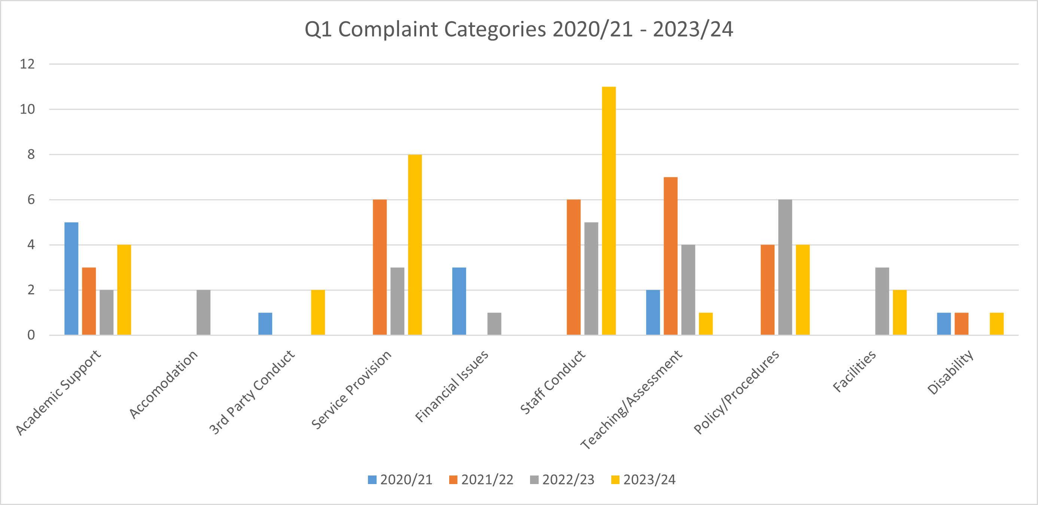

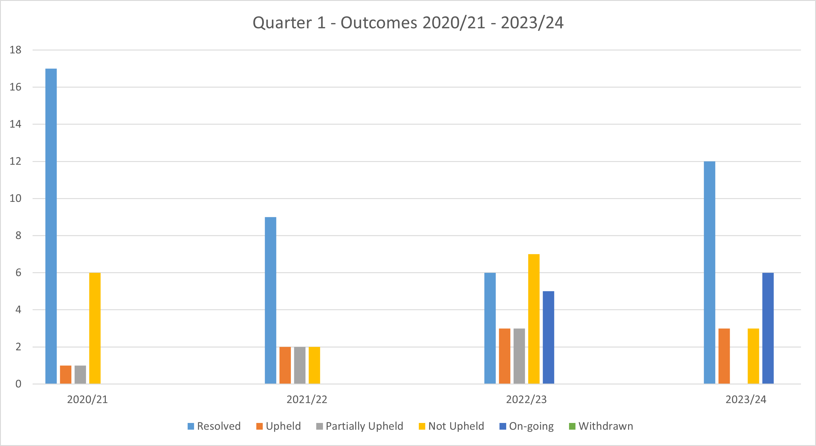

Learning from Complaints – Examples from 1 February 2023 – 30 April 2023
ANNEX C
Complaint Category | Complainant | Complaint Summary | Outcome | Learning
Attitude and/or Conduct of a Third Party Contract or University Partner | Student | The student let the department know that she was unhappy with the supervision that she received whilst on industrial placement. She submitted an account. We have offered her support and to complete a complaints form. She is meeting colleagues 5 September. | Resolved | Currently we recommend that placement providers conduct a mid-placement skills matrix mark to guide progress. This will become a mandatory aspect of the supervision to ensure that students are clear about performance expectations before a final mark is issued.
University Policy, Procedures or Administration | Student | The complainant voluntarily withdrew from his course of study after two consecutive periods of voluntary suspension. His withdrawal request was processed, but he has subsequently emailed to say that he wanted a further period of voluntary suspension. He was advised that students cannot have more than two consecutive periods of voluntary suspension and that withdrawal and reapplication to his course was his only option. The complainant complained that he was not properly informed of the limitations of voluntary suspension. However, the voluntary suspension guidance had been sent to him at the time he enquired about applying for his second round of VS. I have responded to reiterate University policy on this matter. | Partially Upheld | Whilst the University followed the correct policy in this case, they could have followed up on the voluntary withdrawal request to check directly with the student that this was, in fact, the intended course of action. This may not have changed the overall action/decision on his study, but it may have allowed the student to get further information on his status earlier.
Academic Support | Student | The complaint was submitted as an appeal around lack of support during preparation for resit including a lack of response to the student queries by email. | Upheld | The Head of Department must instigate a module review to put in place appropriate methods of feedback, support and marking scheme.

