IUCN World Commission on Environmental Law

CLIMATE CHANGE LAW SPECIALIST GROUP

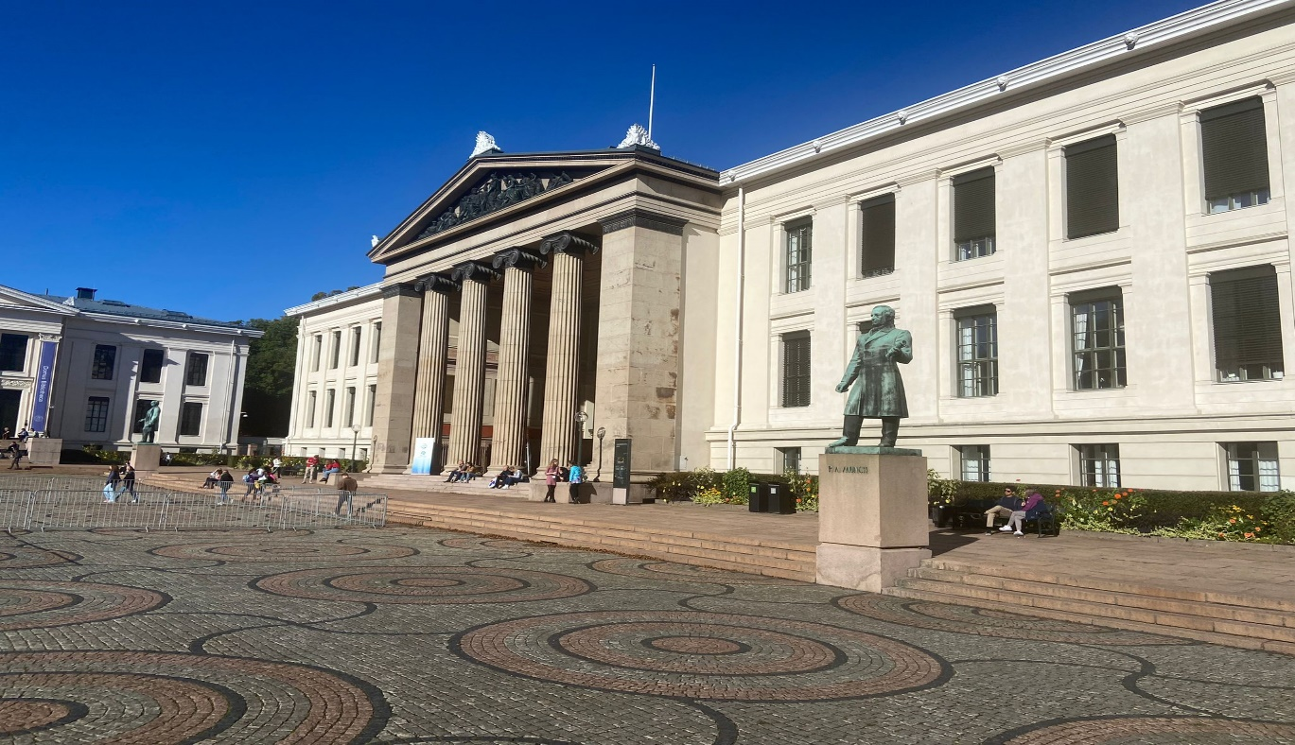

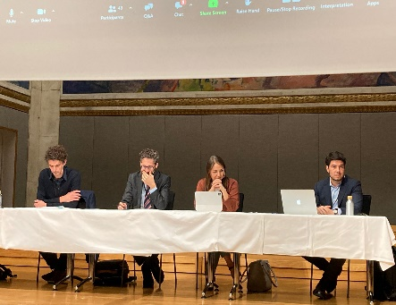
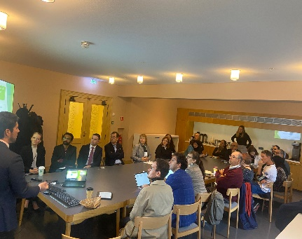
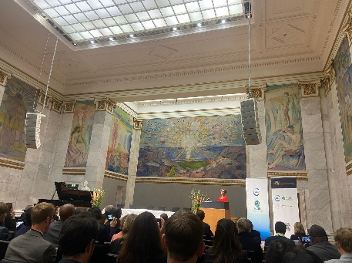

About:

- The IUCN WCEL Climate Change Law Specialist Group (CCLSG) has 420 members as of 14 October 2022.
- CCLSG´s Climate Law Network has 184 members as of 14 October 2022.

Co-chairs: Fabiano de Andrade Correa and Francesco Sindico
Executive Assistants: Aditi Shetye and Manon Rouby

Recent activities

CCLSG co-chairs and Executive Assistants participation at the IUCN WCEL Oslo International Environmental Law Conference.

On 04 October 2022, the CCLSG met at the crack of dawn at 7:45 at the University of Oslo. An amazing 35 people attended the meeting showing a growing interest in the work of the Specialist Group and in the possibility to collaborate.

At the meeting Fabiano, Francesco, Aditi, and Manon presented the five Specialist group projects:
- Fighting climate change: A best practice guide for judges and courts​  - Islands and Climate Change  - Legal pathways to net-zero GHG emissions and nature-based solutions​  - Enabling legal environment for emerging technologies to support climate action  - The Climate Law Network  Actions agreed at the meeting:  - Members to share comments/feedback on specific projects.  - Additional projects to the ones presented can be considered only if there is a clear pathway to impact. In some cases, rather than a new project, the Specialist Group can be affiliated with other projects.  - Members to share moments during the year in which they are willing to write a blog for the specialist group about ongoing national/international climate change law developments/events.  - Members to share whether they will be attending COP27. | 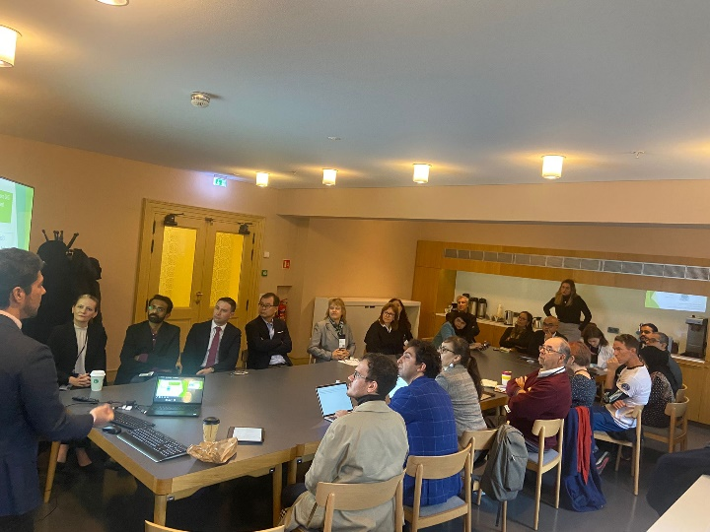

The slides presented at the meeting can be accessed HERE.

In addition to the CCLSG meeting, it was a very event for Fabiano, Francesco, Aditi and Manon! Please find below the sessions in which we contributed:  - Francesco chaired the parallel session “Transformative legal tool to address climate change (part I)” on Monday 3 October 2022.  - Aditi and Manon delivered a presentation titled “The transformative potential of an Advisory Opinion from the International Court of Justice on the matter of integrating Human Rights Law and Climate Change Law” at the parallel session “Youth panel: Children, Youth and the Interests of Future Generations” on Tuesday 4 October 2022.  - Francesco and Fabiano contributed to the plenary session “How to Address Climate Change, Pollution and Biodiversity Loss?” on Wednesday 5 October 2022.  - Fabiano chaired the parallel session “Nature-based solutions” on Thursday 6 October 2022. | 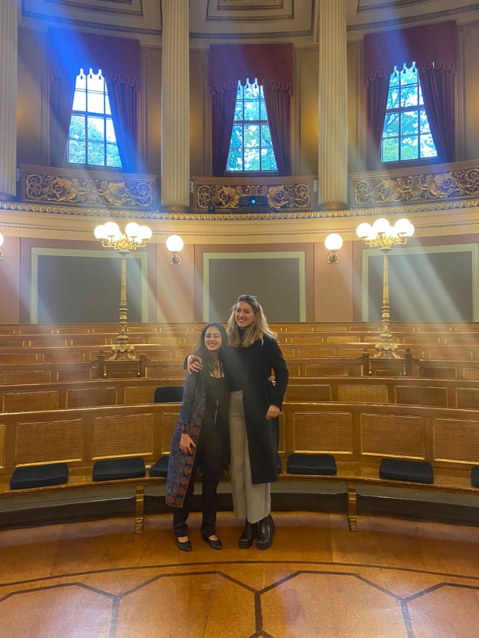  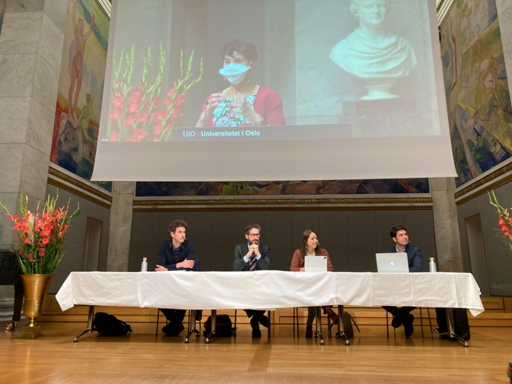

Next steps:

- UNFCCC COP27
  - The CCLSG will be represented at COP27, which takes place from 7-18 November 2022 in Sharm El-Sheikh, Egypt. A series of side-events and meetings is being planned, including on topics such as nature-based solutions and the connection between climate change and pollution. CCLSG will also be present at the Climate Law and Governance Day on 11 November (online). More information about events and dates will be shared soon.
  - We would love to organize a CCLSG meeting at COP27, please let us know whether you will be there and events you will participate in.

- Moving forward with the projects as mentioned above. We will soon be sharing the workplans for each of the projects and encourage you to reach out to us expressing your interest to join and contribute, mentioning also activities you already do in these areas.
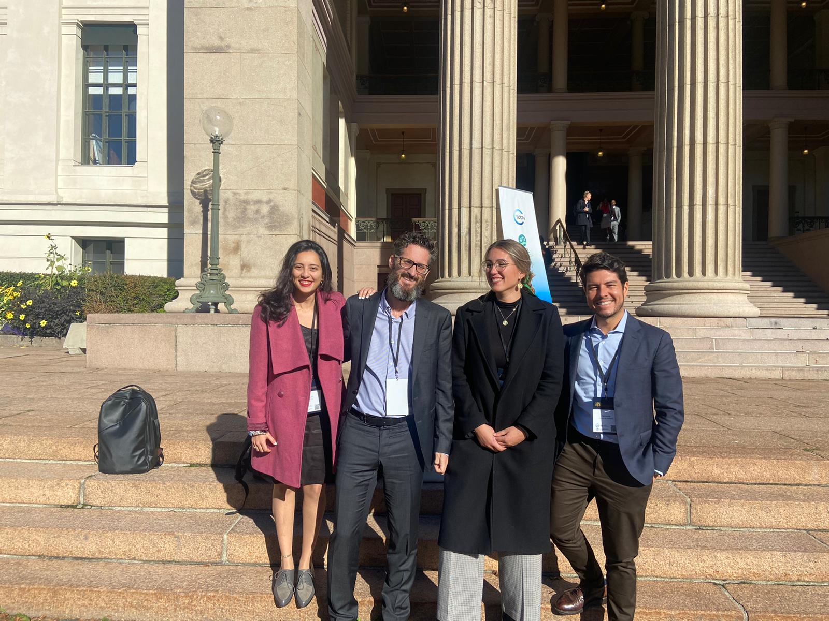

We look forward to connecting with you and we encourage you to share this newsletter to your own climate change law colleagues.

