How to review you PO commitments at Year End

Step-1 - Identify PO’s to check

- Go to: Reports > Your Reports > Purchase Enquiries > Purchase Order Enquiry
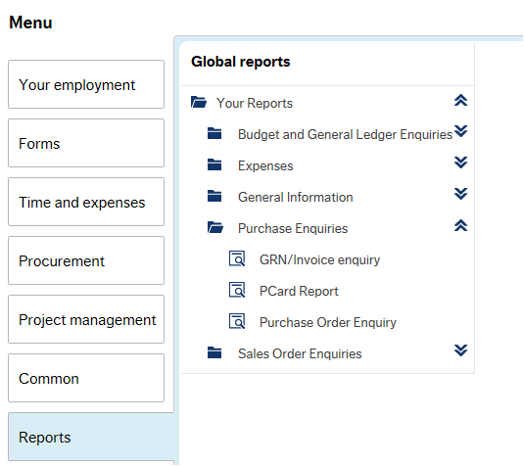

- Enter the Sub Project in the Search Criteria
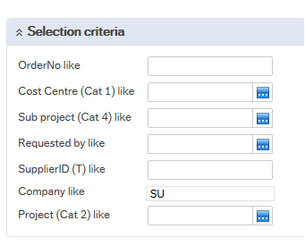

- In the Status column, enter the Status you wish to search on
F = Finished
C = Closed
T = Terminated
O = Ordered
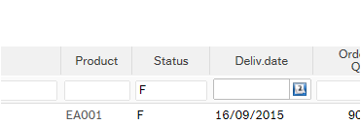

Step-2 Identify the GRN’s for each PO

- For each of the PO’s identified in step-1
- Go to: Reports > Your Reports > Purchase Enquiries > GRN/Invoice enquiry

Enter the PO and click search
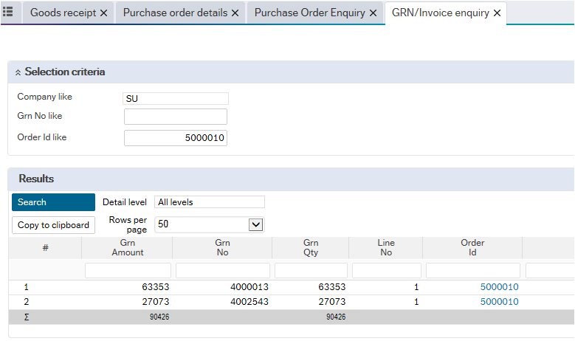
All related GRN’s for this PO are now displayed

Step-3 Check the Remaining Amount (commitment) on the PO/GRN

- For the PO/GRN identified in Steps-1 & 2, check the Remaining Amount
(Budget Statement: Drill down – Approved Amount)
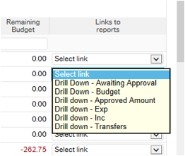

- Check that the Remaining Amount is as expected for the PO
(Budget Statement: Drill down – Approved Amount)

  - If the PO was at Status:
F = Finished
C = Closed
T = Terminated

- Then the Remaining Amount should be zero for the PO

  - If the PO was at Status:
O = Ordered

- Then the PO Remaining Amount should be:
(Gross PO Line Amount – (All GRN’s summed))

Example:
PO line is for £100 plus £20 VAT = £120
GRN1 is for £50
GRN2 is for £40
PO Remaining Amount should be = (£120 – (£50+£40)) = £30

- Check that the Remaining Amount is as expected for the GRN
(Budget Statement: Drill down – Approved Amount)

  - If the PO was at Status:
F = Finished
C = Closed
T = Terminated

- Then the Remaining Amount should be zero for each GRN on this PO

  - If the PO was at Status:
O = Ordered

- Then the GRN Remaining Amount should be:
(GRN Amount – (Invoiced Amount – from GRN/Invoice Enquiry))

Example:
GRN is for £100
Invoice matched is for £75
GRN Remaining Amount should be = (£100 – (£75)) = £25

- Check that any Invoices at Status of ‘Registered’ are shown in Approved Amount
(Budget Statement: Drill down – Approved Amount)

Invoices at a Status of Registered should appear in A

  - First you can find the Invoices for the PO using the Linked Report on the Purchase Order Enquiry
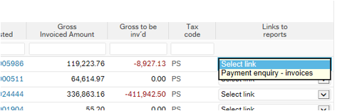

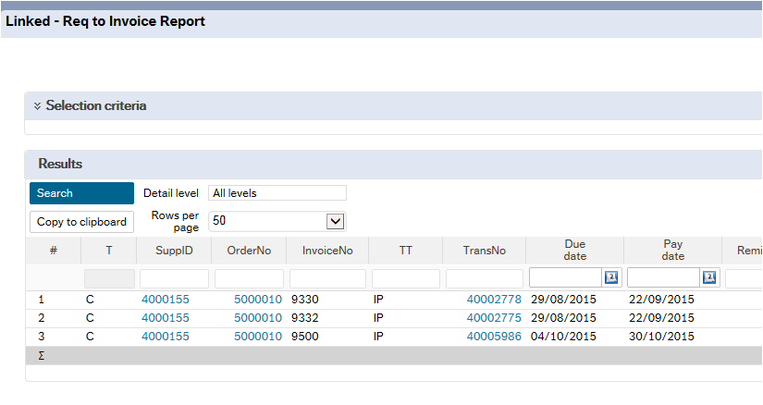

- Check that any Invoices at Status of ‘Posted’ are shown in Expenditure
(Budget Statement – Expenditure)

  - First you can find the Invoices for the PO using the Linked Report on the Purchase Order Enquiry

  - Now check in Budget Statement – Expenditure to see that these Invoices are shown

