Commitments Overview

The Budget Statement has 2 levels:
- a summary report level
- drill-down level where you can see the detailed transactions that make up the summary

In the summary report level the commitment for PO’s is shown in the Approved Amount column

Using the Linked Reports drop-down you can drill into the Approved Amount column to see the detail behind it. Here, the Remaining Amount column shows that actual commitment for the transaction.

Commitment Lifecycle - ‘Requisition to Invoice’

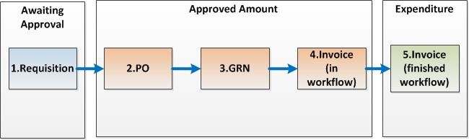

Awaiting Approval
1. Requisition
Approved Amount
2. PO > 3. GRN > 4. PIN (Purchase Invoice)
Expenditure
5. PIN (Purchase Invoice)

Worked Example:

- We have a one line Requisition with Qty 4 at Unit Price of £25 & Tax Code = PS (Standard Rate)
Net £100
Gross £120
In the Budget Statement this appears in Awaiting Approval
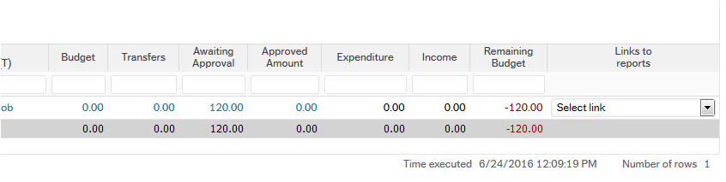
Drill down on Awaiting Approval
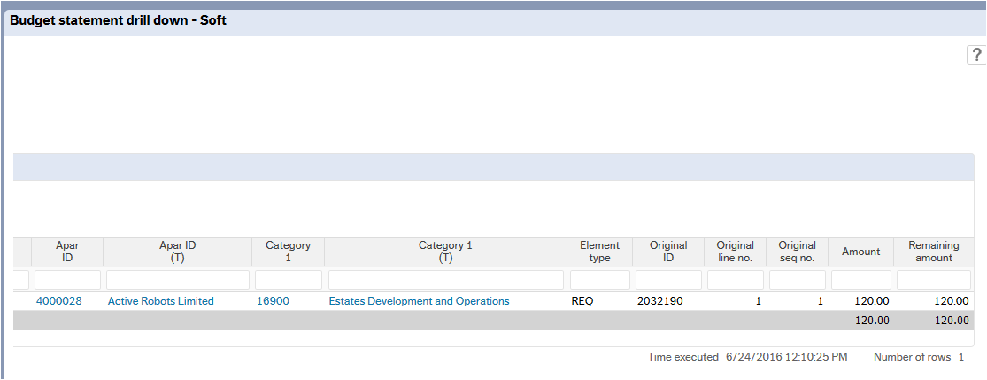

- The Requisition completes in workflow and a PO is now created
In the Budget Statement – the £120 commitment now moves from the Requisition (in Awaiting Approval) to the PO (in Approved Amount)

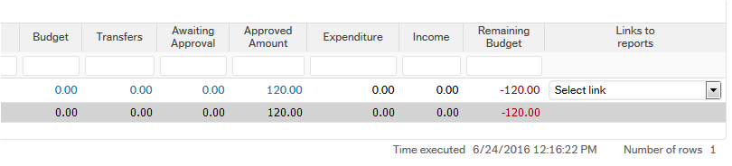

Drill down on Approved Amount
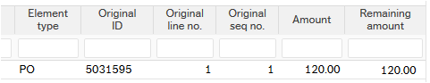

- If we then do a GRN for £25 (Qty 1)

We can see that the in Remaining Amount, the Gross Amount of the GRN has moved from the PO to the GRN
- The Remaining Amount on the PO is now £90
- The Remaining Amount on the PO is £30
- Total Remaining Amount is still £120

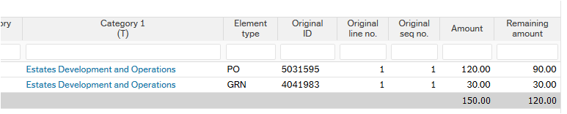

Since the overall Approved Amount is still 120, the total Approved Amount is still £120

- This GRN is now Registered to an invoice for £30
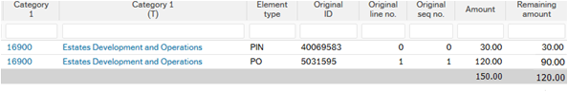

- When this PIN is approved in workflow it will moved to Expenditure
