Change FMS Settings to UK date format

The date format on the Web version of is driven via the browsers settings. If you need to change it, try the following steps.
- Google Chrome
- Internet Explorer
- Mozilla Firefox

Google Chrome (Version 32.0.1700.107 m)
1. Select the Menu button
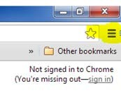
- Go to settings
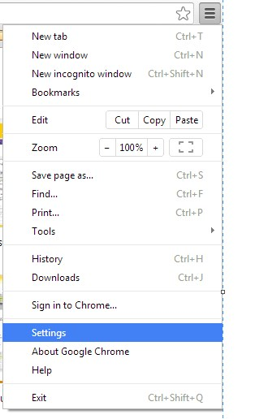
- Show advanced settings

- Language and input settings
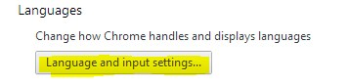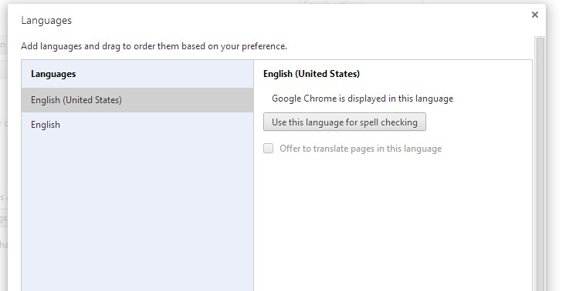

- NB: If English (United Kingdom) does not appear in the list
  - Select <Add>
  - Select “English (United Kingdom)”
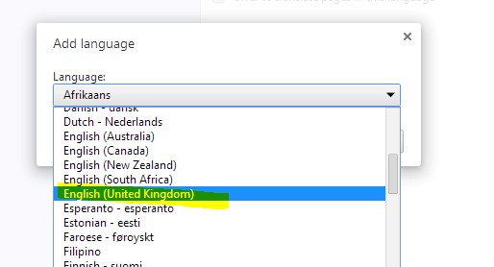

- Drag the “English (United Kingdom)” language to the top of the list
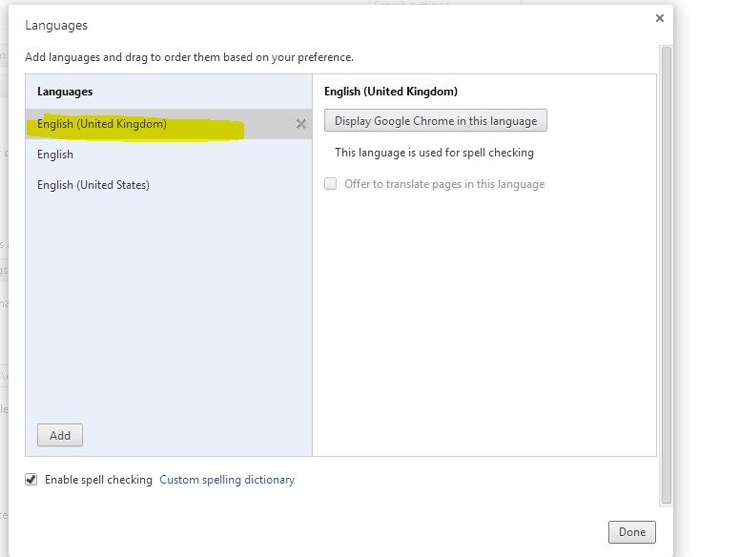
- Press ‘Display Google Chrome in this language’
- Press ‘Done’ and close all Google Chrome Windows
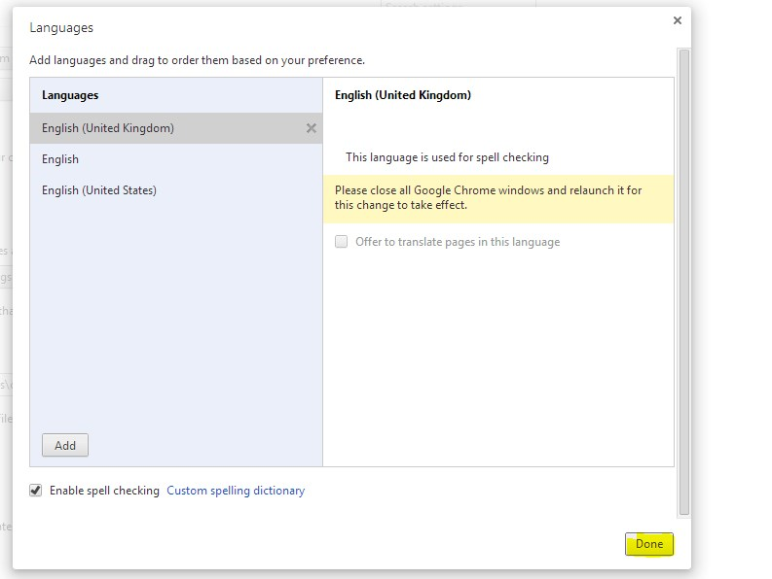
- The next time Google Chrome opens, the language preference should be English (United Kingdom) and the date format will be UK.

Internet Explorer (Version 9.0.8112.16421)

- Select ‘Tools’ > ‘Internet Options’
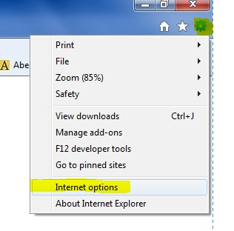
- Via the ‘General’ tab, select ‘Languages’
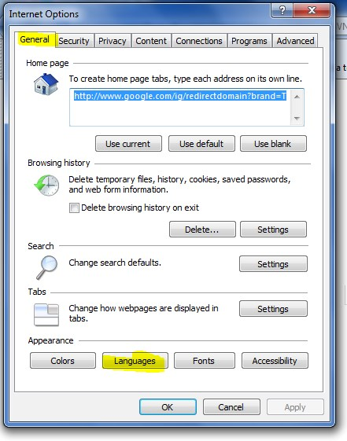
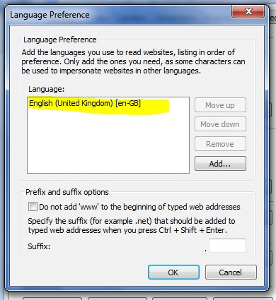
- NB: if English (United Kingdom) [en-gb] is not visible
  - Press <Add>
  - Select ‘English (United Kingdom)’
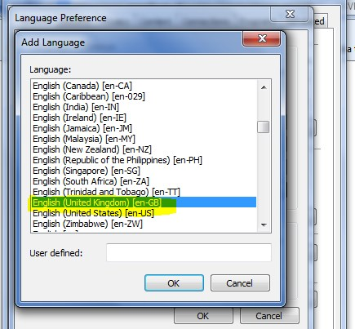
  - Press <ok>

- Press <OK> to apply changes
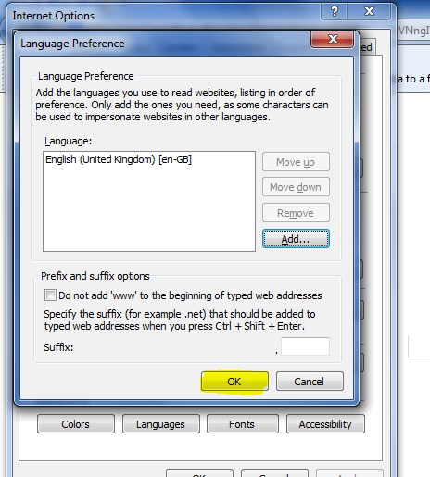
- Press <OK> to close Internet Options and apply the language change
- The next time Internet Explorer opens, the language preference should be English (United Kingdom) and the date format will be UK.

Mozilla Firefox (Version 32.0.3)
- Select ‘Open Menu’
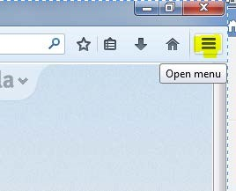

- Select ‘Open options’
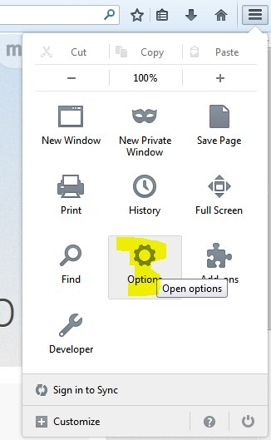

- Select the ‘Content’ tab then under the languages section press ‘choose’
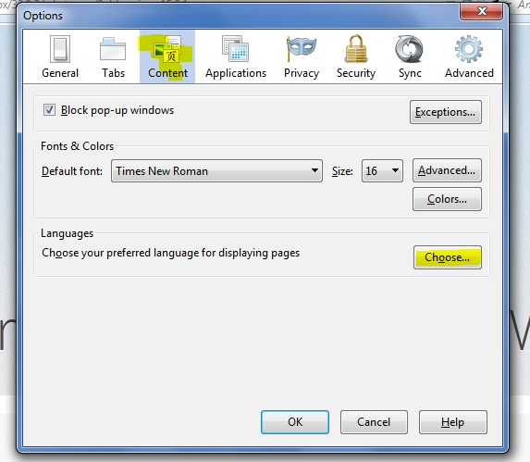

- Via the menu, press the ‘select a language to add’ and choose ‘English (United Kingdom)
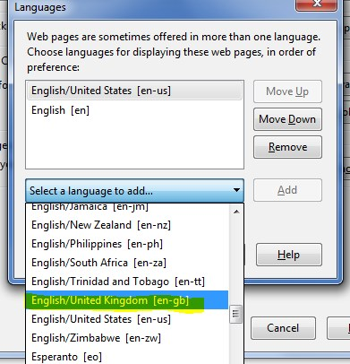
- Press ‘OK’
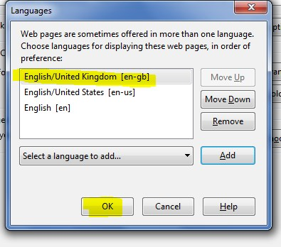

- Press ‘OK’
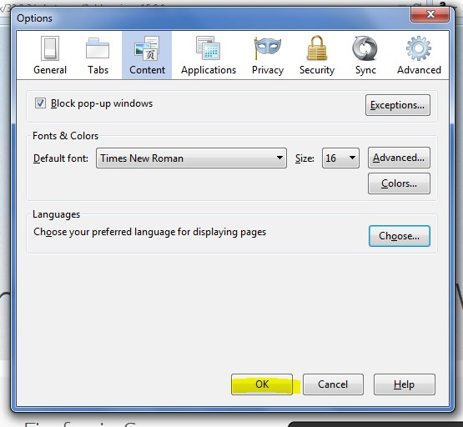
- Close all Firefox sessions.
- The next time Mozilla Firefox opens, the language preference should be English (United Kingdom) and the date format will be UK.

