Changes to the Undertaken Duties System

There are two changes to the Undertaken Duties system:

1. Where a Ledger Code has to be enter you should enter the relevant Cost Centre, Sub Project and Activity codes together with Account Code 5100.
2. The ‘Budget Approvers’ which were previously used for authorisation have been replaced by a list of Sub-Project Managers and Substitutes

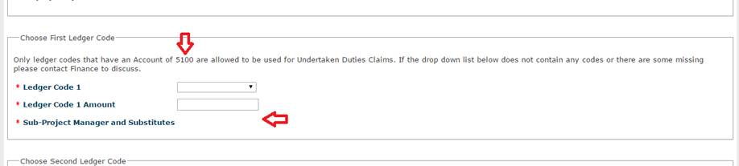

If the code you want to charge the payment to does not appear in the ‘Ledger Code’ drop-down list it may have to be enabled on the system.

If this is the case then

* please email  the Helpdesk (Professional Services) at  [cas-help@strath.ac.uk](mailto:cas-help@strath.ac.uk)
* ask for the Account Code to be added to the General Ledger Posting String (quoting the first three parts of the old or new Posting String)
* indicate whether it is a Student Payment or an Undertaken Duties payment  .
* The request should be marked for the attention of the **Systems Team in Finance.**