Issues Accessing FMS with Safari

If you experience ‘Web page cannot be found’ / ‘Bad Request’ error messages when accessing FMS then follow the guidance below :

Click on the tool icon on the right-hand side.

Click on preferences.

On the general tab, set remove history items to after one day.

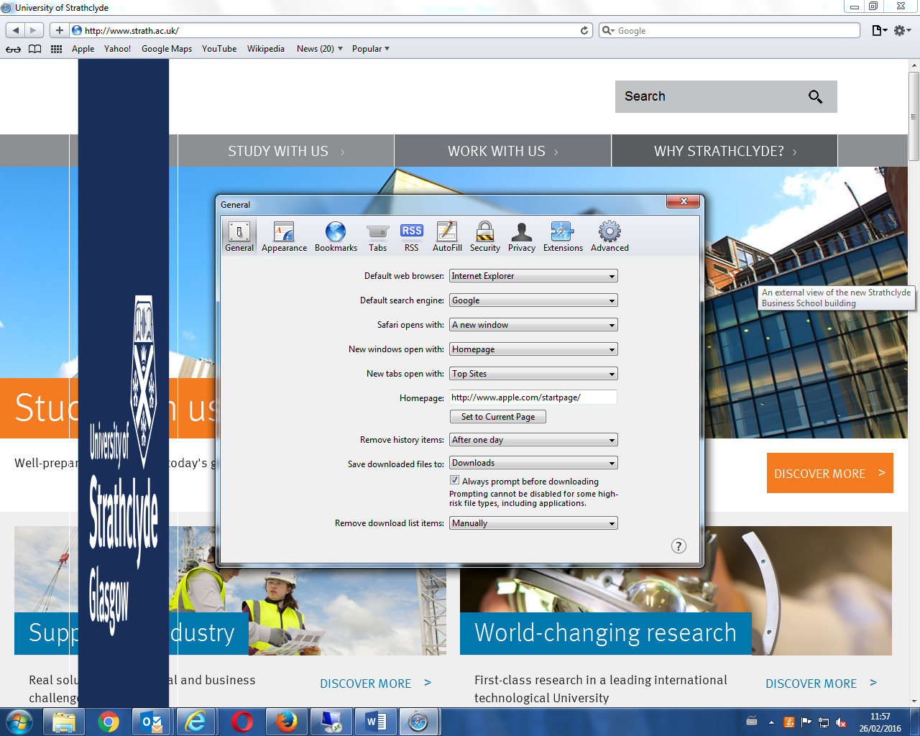

Click on the privacy tab. Click on the remove all website data button, click on the remove now button. Click the cross on the right hand side of the pop up box to close. Shut down Safari and start a new session.

