FMS Milestone 7 Upgrade

- Introduction
This brief guide provides an overview of some minor changes seen on the “Milestone 7” version of the University Financial Management System, FMS (Unit 4 ERP)
This upgrade was primarily to improve the underlying infrastructure and introduce Multi Factor Authentication (MFA) to ensure our Corporate Finance Systems remain secure against cyber-attacks.

- Logging into and out of Milestone 7
MFA will now be switched on for FMS login. If you have already authenticated your device then clicking on the link to FMS will take you directly into the system. Otherwise you will be asked to authenticate using your chosen authentication method, app or text etc. This is the same MFA set up as you will have used to set up your university email account. For more information on MFA within Strathclyde please see https://www.strath.ac.uk/professionalservices/is/cybersecurity/mfa/

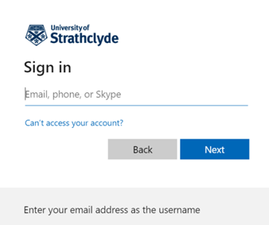

The logout process on Milestone 7 has slightly changed. When you logout you will see additional screen as follows:
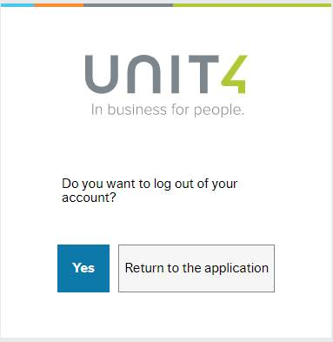

- Different look to some screens

You will notice within M7 that some screens have been renamed or look slightly different.

- Once you have logged into FMS the logo at the top of the screen will look different and will now show as Unit 4 ERP

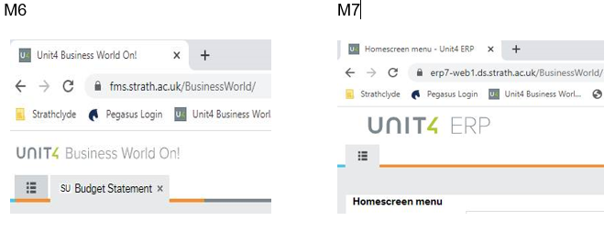

- You will also notice the Menu screen has been renamed to Homescreen menu.
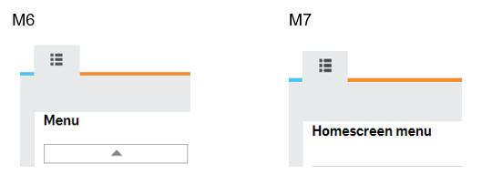

- Workflow maps – slightly different look i.e. step box outlines; symbols

M6 M7
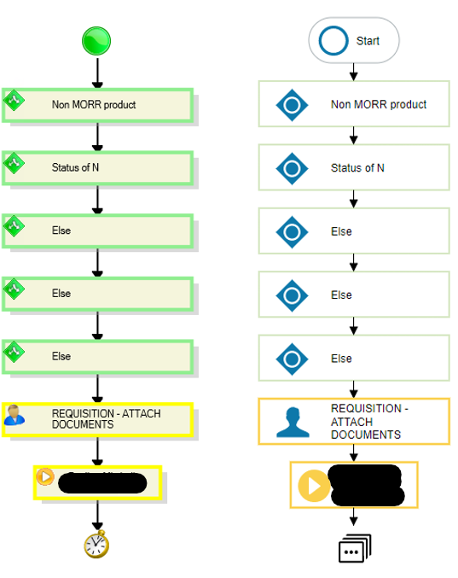

- Within tasks you will also notice that the workflow log now shows most recent date/time at the top and displays as AM & PM where previously 24hr clock.
M6
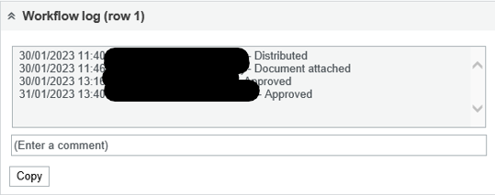
M7
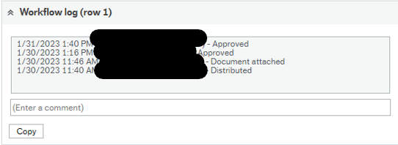

- Enquiries

Enquiry screens – are now located within Enquiries folder under each section. Purchase orders example shown below

M6 M7
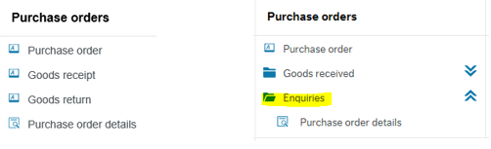

- Document archive

You will now notice there are 2 ways to attach documents. You can select the type of document and select “Add a document” at left hand side of pop up or as previously on M6 select the Add a document icon and select which type of document to be added.

M6

M7

- Procurement

- Requisitions – advanced

Punchout option is now available on ‘Requisition entry’ tab as well as the individual tab. The minor difference between both Punchout options is at the stage of being re-directed back to FMS to generate a requisition. If using the standard Punchout tab the process does not change. If using Punchout from Requisition entry you will be re-directed back to this tab where you can select ‘Generate to requisition’ without first having to click ‘Retrieve shopping’ then checking the box beside the marketplace line. Please see below

Please note users should ensure all relevant fields are completed on Requisition entry tab prior to selecting either Punchout option.

M6

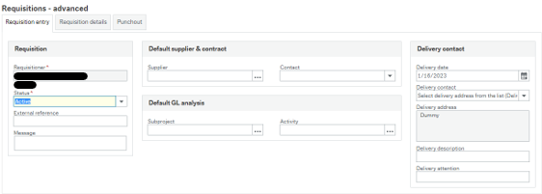

M7
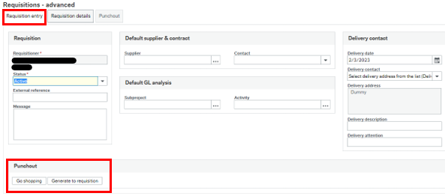

- Select ‘Go shopping’ on Requisition entry tab (after completing the relevant fields)

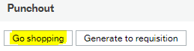
- Proceed with shopping
- After all items have been added, select Checkout.
- Opens with Requisition entry tab when re-directed back to FMS
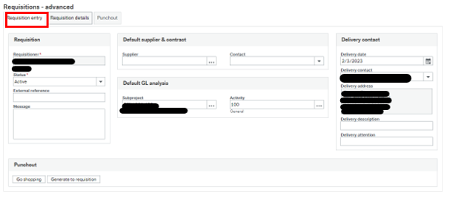
- Select ‘Generate to requisition’

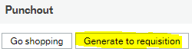

- Items are populated onto Requisition details tab

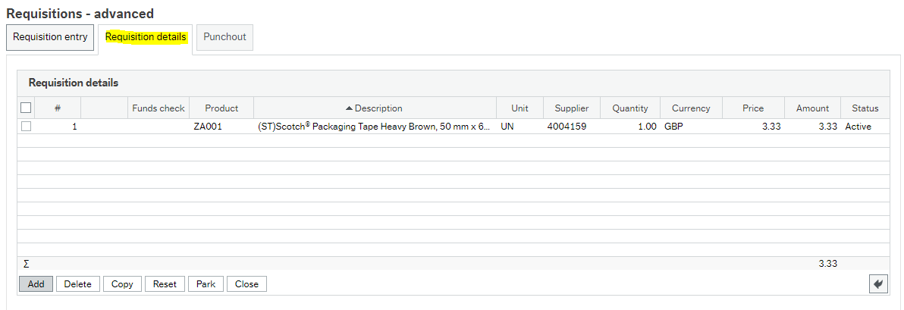

- Goods receipt & Goods return

Goods receipt & Goods return menu options (if applicable) – are now located within a new folder titled Goods received under Purchase orders header

M6 M7
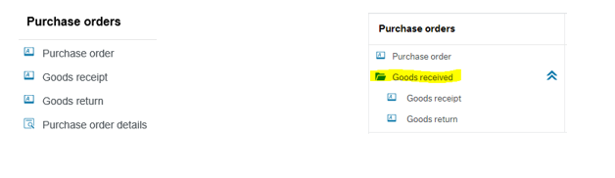

- Customers and sales

Simple sales orders

Default GL analysis – field names are in a different order on M7 compared to M6 (i.e. Sponsor; Subproject; Stsession)

M6 M7
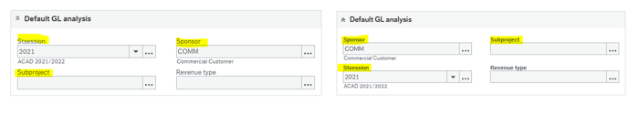

- Costing and Pricing Module (CPM)

To create a new Project costing in CPM you now have to click NEW along the bottom bar of the Project Setup window (previously opening the Project Setup window took you to the page to start entering the details of a new project).

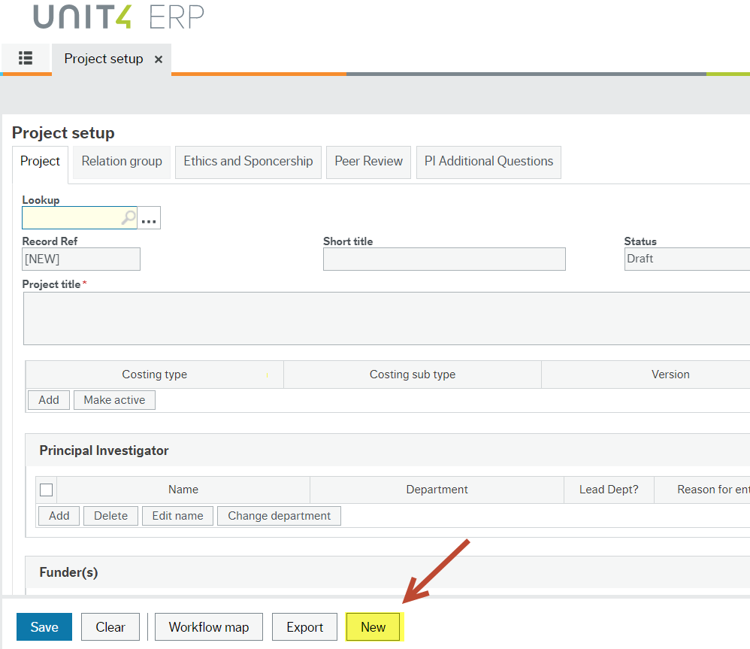

The Project Set up window now allows you to search/query for a previously saved ID number. Type in the 5 digit ID number and hit the tab key.

