Updating the URL on the Excelerator function:
Due to the latest upgrade of the Finance Management System (FMS) there is a requirement to update the excelerator function credentials on your Excel software so this can be pointed to the correct system.
To do this please follow the below instructions:
- Open Excel
- On the Menu Ribbon, Select the UNIT4 Excelerator tab

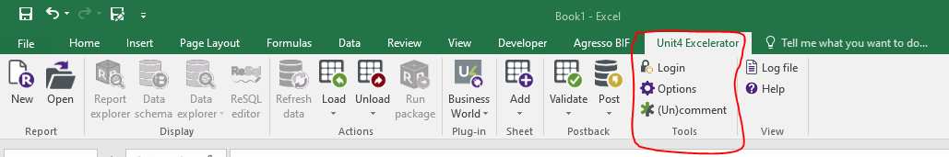

- Select the ‘Login’ icon
- You will see your screen below (with your own user ID credentials)

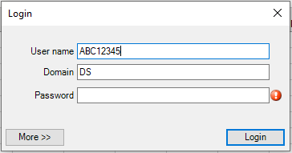

- Select the ‘More>>’ icon

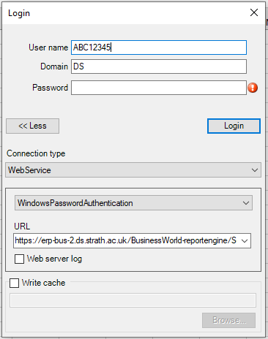

- You will be required to amend the URL on the Connection Type. Please use the latest URL below:

https://erp7-bus1.ds.strath.ac.uk/BusinessWorld-reportengine/Service.asmx

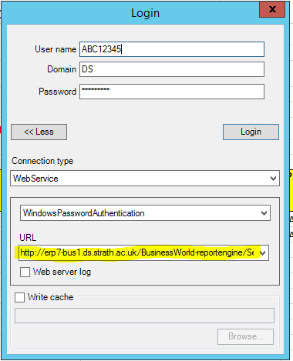

- Enter your password and select ‘Login’
- This should now connect you to the latest Milestone 7 version of FMS to run your excelerator reports.
- If there are any issues then please contact financial-systems@strath.ac.uk for assistance.

