Issues Accessing FMS with Edge

If you experience ‘Web page cannot be found’ / ‘Bad Request’ error messages when accessing FMS then follow the guidance below :

At the top right hand side of screen select the three dots and select Settings:

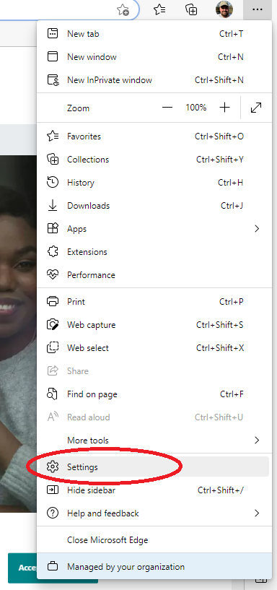

Select Privacy, search and services:

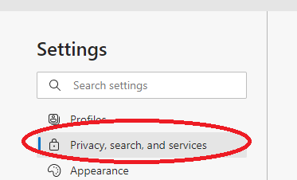

Scroll down to Clear browsing history:

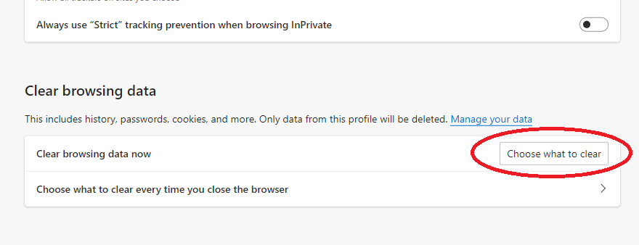

Amend the time range drop down to “All time”. Then hit “Clear now”:
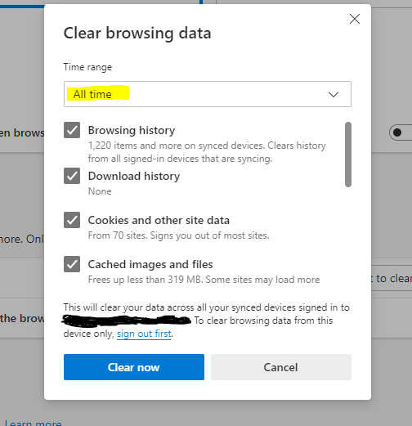

Shut down Edge and restart a new Edge session.

