PROCUREMENT QUICK REFERENCE GUIDE
Procurement website: www.strath.ac.uk/procurement
Our email address: procurement.enquiries@strath.ac.uk
Status | Final
Owner | University Procurement
Source location | Procurement website
Endorsed | Head of Procurement
Version | 4
Publication | March 2023
Next Review Date | Feb 2024
Mission Statement
"To work collaboratively with faculties, departments, suppliers and other public bodies to implement efficient and cost-effective sustainable procurement practices that deliver best value for money on supplies, services and works whilst supporting the University's Strategic Plan﻿".

Who We Are
University Procurement (UP) sits under the Finance Directorate and provides support and guidance to staff for all purchasing and procurement requirements. As well as advising on available procurement routes, UP support and drive tendering for high value requirements, assist with contract and supplier management, advocate for compliance in all purchasing activity and help mitigate risk to the University.

Key Principles in Conducting Procurements
All procurement activities should be carried out in accordance with the relevant procurement legislation or internal governance procedures.
Guidelines which have been established to Protect the University's interests with regards to:
- Encouraging an innovative market response.
- Value for money which considers whole life costs; evaluation should not be based on price alone.
- Compliance with procurement legislation:
    - The Public Contracts (Scotland) Regulations 2015
    - The Public Contracts (Scotland) Amendment Regulations 2016
    - The Procurement Reform (Scotland) Act 2014,

- Application of the appropriate Terms and Conditions of Contract,
- Adherence to the University Financial Regulations and purchase to pay procedures.
- Open and transparent competition facilitated by electronic tendering.
- Internal and external auditing.
- Consideration of corporate and social responsibility measures.
- Environmental and Sustainability consideration
- Fair work first consideration.
Procurement Process
There are Procurement thresholds which apply to the aggregate (total) value of all requirements for the purchase, lease, rental or hire of goods and services of a similar type. In judging whether supplies/services are “of a similar type”, account should be taken of whether they would normally be ordered together and/or from the same suppliers.
Aggregate value may be calculated by one of the following methods:
- the estimated value of separate contracts for meeting a single requirement;
- the total value of goods and services purchased during the last financial year from the same supplier;
- the estimated total value of all contracts/orders expected to be placed in the next financial year, or during the term of the contract (if the term of contract is longer than one financial year);
- where contracts have no definite duration but are ongoing supply, aggregate value should be calculated as 4 x the annual value.
Please consider the aggregate spend when assessing your procurement route as this relates to which procedure you are required to follow. As outlined below:
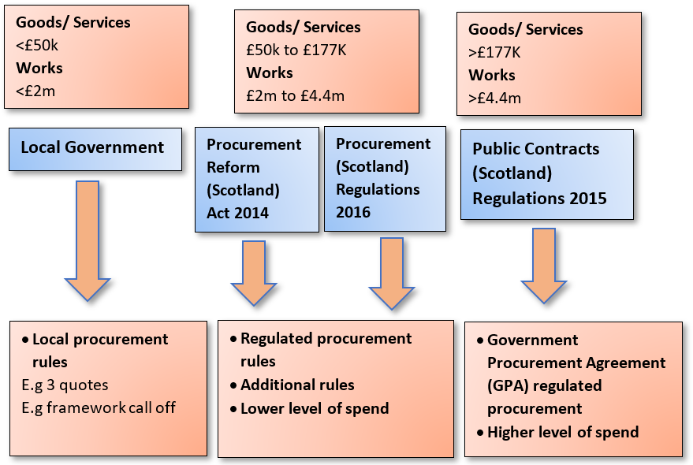
Framework Agreements
There are currently various National, Regional and Local Framework Agreements in place that have been tendered by, or on behalf of, the University, and these routes are normally considered in the first instance as a pre tendered and compliant route to market.
Please contact UP to discuss your requirement and a strategy will be developed to determine the best route. If that route is via a framework UP will support the process to ensure the contract is formed under the framework which guarantees framework pricing and the protection of the framework terms and conditions.

Procurement Thresholds
Please refer to the below procedures when you have a procurement requirement:

Goods & Services Procurement Value (Ex VAT) | Process
Less than £3,000 | No quotes required.
£3,001 to £24,999 | Minimum of 3 recorded quotations (subject to a framework agreement not being available)
£25,000 to £50,000 | Quotation in consultation with UP via Public Contracts Scotland
Over £50,000 | Contact UP who will carry out tender
Above £177,897 | Tender following Public Contracts (Scotland) Regulations 2015
Works - (Estates) Procurement Value (Ex VAT) | Process
Not exceeding £99,999 | Minimum of 3 written quotations
Above £100,000 | Tender in consultation with UP
Above £2,000.000 | Regulated procurement process which must be advertised on Public Contracts Scotland (PCS) tendering portal.
Above £4,447,447 | Tender following Public Contracts (Scotland) Regulations 2015

For any requirements over £24,999 please complete the Request for Procurement Action form and send it to procurement.enquiries@strath.ac.uk

Awarding without Competition

In exceptional circumstances, a negotiated contract may be required where competition is deemed impractical. To proceed with this route a Single Source Justification Form (SSJ) should be completed and reviewed by the Head of Procurement (or delegate where appropriate).

Example exceptions to the legislation include:
- No tenders or no suitable tenders (but can’t substantially alter the conditions);
- Only one supplier due to:
  - Artistic reasons;
  - Competition being absent for technical reasons;
  - Protection of exclusive rights such as IP rights.
(N.B. a. and b. above only apply where there is no reasonable alternative or substitute and the procurement has not been artificially narrowed.)
- Extreme urgency (not caused by the Public Authority);
- Repetition of similar works or services where this possibility was flagged in the original procurement; the estimate value included these additional works or services; and not more than 3 years have elapsed since original contract.
- Research and development contract.
- Partial replacement or extension of existing supplies or installations where a change of supplier would result in incompatibility or disproportionate technical difficulties in operation or maintenance.
- Supplies quoted and purchased on a commodity market.
- Liquidation sale.

In these circumstances, an SSJ should be completed in respect of all orders exceeding £3000 (excluding VAT), where the proposed purchase is not being made under a recommended contract and where competitive offers are not or cannot be obtained
- Where the total value exceeds £3,000 (ex VAT) a Single Source Justification Form should be completed, signed by Head of Department and retained for Audit purposes.
- If the proposed purchase exceeds £25,000 (ex VAT), this form will be routed to the Head of Procurement for final review.
- Regulated values, above £50k (ex VAT), which are not considered to be exempt from the regulation or in the negotiated category will be sent to the CFO to be considered for approval.

Guidance on SSJ process can be found at: www.strath.ac.uk/procurement/procurementguidance/procurementtoolkitdocumentation/singlesourcejustification

Suppliers on FMS

The Unviersity does not hold a preferred suppliers list, therefore supplier selection is subject to the following rules:

- New suppliers will not be added to FMS unless there is a contract in place for the requirement or the approriate procurement route has been followed.
- Where UP has implemented the contract, we will add the supplier onto FMS.
- Suppliers will be parked (closed down) when a contract ends.

Creating a Purchase Requisition

The University operates a No PO No Payment Policy, and suppliers are informed that invoices received without a Purchase Order number will be returned unpaid.

When completing a Requisition to be converted into a Purchase Order on FMS, staff must ensure the following information is included as a minimum:
- Description of the goods/service requirements;
- Any quotes or contract reference numbers relevant to the purchase
- Deliverables and timescales;
- Details of the delivery address and point;
- The Charges including any discounts;
- Reference to adherence to the UoS Terms and Conditions is automatically added to electronic PO’s.
Your Requisition will require the appropriate financial approvals (depending on the value concerned) before it is converted into a Purchase Order and issued to the supplier.

Request for Payment

Purchase Orders should be used for all requirements where possible. It is recognised that there will be a few instances where exceptional circumstances exist. Exceptions will be considered and monitored on a case by case basis.

Non-Compliance Procurement Risks
Non-Compliance with the Procurement Regulations can result in one or more of the following detrimental repercussions for the University:

- Litigation, Damages and Fines
    - Challenge of an awarded contract
    - Fines for non-compliance with Procurement Regulations can be substantial.
- Claw back of funding
    - This is relevant when dealing with funding from a grant award. Grants normally will stipulate that funds must be spent in accordance with the appropriate procurement regulations.
- Costly Delays
    - For example, programme slippages caused by challenges being raised by the market or Scottish Government regarding correct routes to market not being followed.
- Reputational Damage
    - The University falls under the definition within the public procurement legislation as a “contracting authority” and therefore is subject to the Public Procurement rules. It is import that the organisation is considered to be operating responsibly with the public funding received.
- Loss of Value, Lost Opportunities, and Resource Impacts
    - Improperly conducted Procurement processes can negatively impact timescales and staff time, as time will need to be taken to make corrections or deal with legal challenges.
- Potential Criminal Charges

Q&A’s

Q. What is acceptable evidence of 3 quotes?
A. A quotation should be a written submission from a supplier, this may be by email which can be (converted to word or PDF) uploaded onto FMS and filed by the originator. Evidence of gathering three quotations is required for your own department as an auditing requirement.

Q. What is Public Contracts Scotland?
A. Public Contracts Scotland (PCS) is the national advertising website for Scottish public sector organisations. The website is as follows: https://www.publiccontractsscotland.gov.uk/

Q. What is a framework agreement?
A. A framework is a general term for a competitively tendered agreement with suppliers that sets out terms and conditions which specific (call offs) can be made through. The mechanisms to call off a contract from a framework may be different and specific to each framework.

Q. What is a contract?
A. A contract is when parties enter into a formal and legally binding agreement.
These are established by the University through a tender process published to the market or can be a call off under a framework in line with legislation or guidance.

Q. What are the timescales for a procurement project?

A. The timescales relating to a procurement project are subjective and will be determined by factors such as the nature of the requirement (supply, services or works), the type of market concerned and the required timescales for project delivery/completion.

The below timescales are indicative only, please contact UP for more accurate timescales regarding your requirement:

Type of Project | Timescales for carrying out procurement action
Complex Procurement Project following GPA Regulations | 6- 9 months
Standard Procurement Project  Following GPA Regulations | 3 - 4 months
Complex Procurement Project Reform Act Regulations | 3 - 4 months
Standard Procurement Project  Reform Act Regulations | 2 - 3 months
Quick Quote | 2 – 4 weeks

Q. What is the process of adding a new supplier on FMS?
A. Please refer to the Suppliers on FMS section above and the below webpage for details on the process of adding a new supplier onto FMS:

https://www.strath.ac.uk/procurement/suppliersandfms

Q. Where should I turn to for procurement advice?
Please contact Procurement Team.
Alternatively, email: procurement.enquiries@strath.ac.uk

