TGMD-3 GNERAL INFORMATION

The TGMD-3 assesses 13 fundamental motor skills, subdivided into two subscales:
- Locomotor
- Ball Skills· ‬
‬‬‬
This is a direct observation, process-oriented skill assessment looking at 3-5 performance criteria per skill that reflects the most mature movement pattern.‬
‬‬‬
Primary uses:‬
- Identification & Screening‬‬‬‬
- Instructional Programming‬‬‬‬
- Assessment of an individual’s progress‬‬‬‬
- Program evaluation‬‬‬‬
- Research tool‬‬‬‬
‬‬‬
Brief Administration Guidelines:‬
- A researcher demonstrates the proper execution of the skill.‬‬‬‬
- Children complete one practice and then two formal trials.‬‬‬‬
- Coding is completed for only the two formal trials.‬‬‬‬
‬‬‬
Scoring: ‬
Each skill is evaluated on three to five performance criteria‬‬‬‬
- 0 = if a criterion was not performed.‬‬‬‬
- 1 = if a criterion was performed.‬‬‬‬
- There are no half credits allocated for this administration.‬‬‬‬

Information to consider prior to testing and coding:‬
‬‬‬
1. Standardization!‬
One of the most important components about using the TGMD-3, particularly for research purposes, is that the test be standardized in every way. This would include:‬‬‬
  - Proper demonstrations‬‬‬‬
  - Standardized feedback‬‬‬‬
  - Consistent coding‬‬‬‬
Without the consistency of administration and later coding, the results that may be used later would be unreliable. ‬
‬‬‬
2. Code what you see‬
Specifically for research purposes, although a child may exhibit certain performance criteria during the practice trial or in between trials, you can only code the behaviors that you see during the two formal trials.‬‬‬‬

This plays into the standardization part of this project and is important that you don’t assume a child can or cannot perform certain criteria. If a child is not performing the skill during the formal trials, it is possible that they cannot consistently exhibit the appropriate behaviors. ‬‬‬

Equipment

Name | Description | Picture
Sportime Heavy Duty Playground Ball - 8 1/2 inch | Designed to take on kicking, batting, bouncing and all tougher playground activities. Nylon wound for durability and shape retention. Contains latex. | 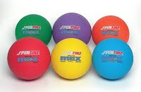
Sportime Pickle Ball Plastic Pickle Ball Paddles with Wrist Straps - Set of Three - Assorted Colors | These Plastic Pickle-Ball Paddles are ideal for your Pickle-Ball program or any paddle activity using plastic, rubber and foam balls. Each is 14" (35.6cm) long with durable 1/2" (1.3cm) simulated solid plastic grid, with a rope wrist safety thong. Weighs just 7.6 ounces (216g), so it's ideal for elementary all the way up through high school. Set of 3. | 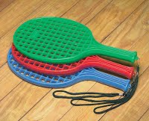
Gopher  ResisDent Balls | Lightweight yet super-tough, rigid polyethylene offers extreme durability. Choose from Rainbow® colors and in easy-to-track Screamin' Yellow® and traditional White. | 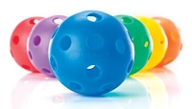
Sportime BallsEye Rubber Batting Tee | This high-quality Rubber Batting Tee is made for use with BallsEye. Latex free. You can also use a cone. | 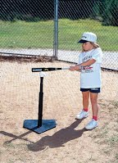
Sportime  School Smart Gradeballs Rubber Basketball - Men's 29.5 inch | SchoolSmart Gradeball Rubber Basketballs are a best buy for any school or recreation program. Durable rubber construction, built to exacting institutional specifications and backed with our unconditional, 1-year guarantee. GradeBalls can virtually eliminate conflicts over ball ownership. Balls are assigned and tracked by each class, according to color. | 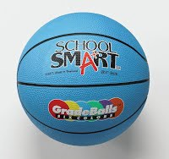
Penn Championship Tennis Balls - Can of 3 - Yellow | These Penn Tennis Balls are extra heavy-duty yellow for hard court surfaces. Can of 3. | 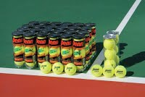
SportimeMax ProRubber Soccer Ball - Size 4 | SportimeMax ProRubber Soccer Ball has a look and feel so close to an official game ball that most people who pick them up are convinced they’re rubber. These cellular rubber balls are even thicker, softer and more tactile. Includes our unconditional guarantee of satisfaction... period. Size 4 in yellow with red-and-blue linear design. Latex free. | 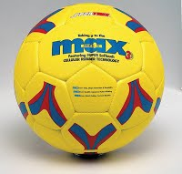
Gopher Rainbow Mini markers | Durable injection-molded polyethylene. 3¾" dia base x 6½"H. | 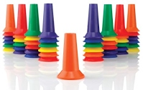
Gopher  Rainbow Phenom Bats | Twice as strong as other plastic bats for long-lasting durability. Taped handles offer an excellent grip. | 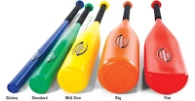
Optional Equipment
Sportime Heavy Duty Nylon Bean Bags - 4 x 4 - Set of 12 - Assorted Colors | Ruggedly sewn heavy nylon covers with hand-conforming pellet fill. 4" bean bags come in a set of 12. Assorted colors. | 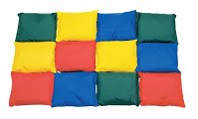
Poly Spot Markers - 9 inches - Set of 6 - Assorted Colors | 9" diameter vinyl spots will not slide. Set of 6 in rainbow colors. | 