Feedback from Learning by Doing: The First UK Mediation Clinic Conference
February 25th 2021, 5:42 am MST
Q1 - In what capacity were you attending the Conference?
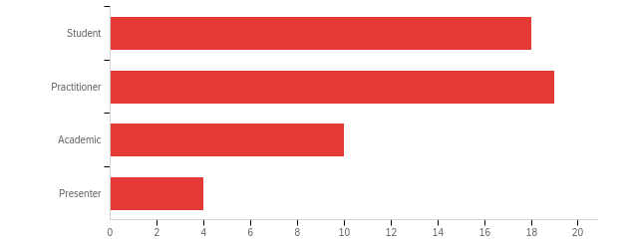

Other, please state
Member of the Scottish Mediation Board
I qualified as a mediator in South Africa and am now living in Scotland, looking to gain accreditation here
newly qualified mediator, not yet practised, no HR background otherwise

Q2 - Where in the world are you located?
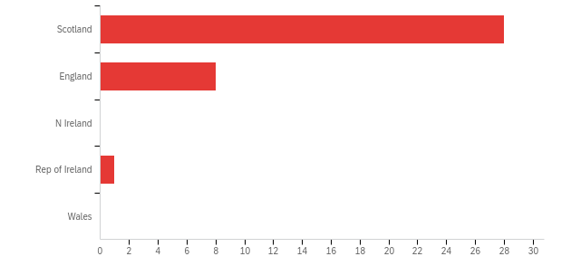
If not in UK, please specify
INDIA
Scotland and England....
India
Kenya
INDIA
India
India
India
Lebanon

Q3 - Which of these did you enjoy most at the Conference?
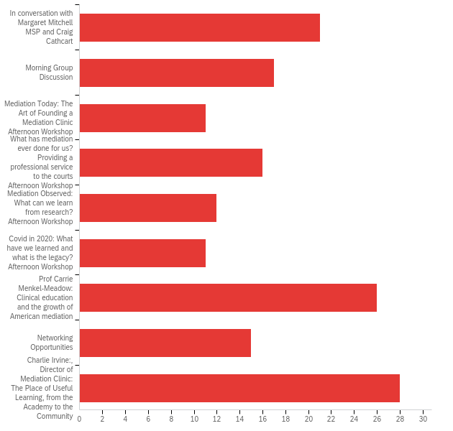

Q4 - What did you take away from the Conference?
it was particularly good to have discussions and perspectives from an international point of view. this added to the discussions. this was a real benefit from online format as people confirmed they would not have travelled for the conference.
Besides an even better understanding of what has been done in relation to mediation clinics by University of Strathclyde, I took away a better understanding of that need to keep the politicians and judiciary in the loop, and the need for continuing research.
enjoyed listening to experienced leaders in mediation
Untapped potential for future networking and sharing learning globally
I learnt about the current and future potential of mediation as a method of alternative dispute resolution for justice delivery in the Uk and across the world.
The global influence of mediation and its advancement internationally. I gained an appreciation on how countries outside of England, Wales & NI have made more progress in the integration of mediation with the civil justice systems. The opportunity to network with those new to mediation as well as those well versed-with the mediation process.
CLINICAL LEGAL EDUCATION AND MEDIATION INTERLINKING BY THE RESOURCE PERSONS
It was wonderful to have the opportunity to connect with a diverse group of people who all have an interest in and passion for mediation. Also, to hear Carrie Menkel-Meadow speak was a privilege, and her story both inspirational and full of learning.
I definitely have a much better understanding of mediation and how it works. Particularly how it can be a great tool for the courts to use. It was also great to hear from Margaret Mitchell about her attempts at making mediation become part of the legislation.
How mediation is still finding it difficult to be recognised, and how much money is saved through mediation.
Very informative. A good variety of topics of relevance to the current pandemic. The talk by Carrie Menkel Meadow was outstanding.
The diversity of the speakers, and the range of topics, surprised me. I was very impressed.
Encouragement to work to develop a mediation clinic. encouragement meeting other non-lawyers who do court work. Lots of valuable information. Desire to know if the Mediation Bill will become law and if there is anything we can do to support its progress
I am new to mediation and I enjoyed learning the context of the mediation clinic at Strathclyde Uni and the legal framework mediation sits in.
I think that it worked very well. Zoom was an excellent format, allowing the presentations to flow easily. It was good to focus on mediation clinics and their importance as the link between theory and practice.
Huge opportunity for clinic input and learning.
opportunity for a world wide community links with India different approaches to mediating in lockdown
A thoroughly rewarding feeling and sense of 'mediation community'.
How to start a mediation clinic in the UK specifically.
A real sense of the accomplishment and further potential of the Strathclyde Clinic, and some challenging points to reflect on from CMM's presentation, not least re mediation training, and use of caucusing, .
A number of different things. One was the interest of LLB students in practicing and learning mediation.
Mediation can be taken as a profession
A sense of optimism and the direction of growth that the mediation field is taking.I really enjoyed the discussion with Carrie Menkel-Meadow.
A renewed sense of the importance of working and teaching in this area and the benefits for students of participating in training and live mediation experiences. Charlie's idea of identity - which I am interested in in a wider context of clincial legal education.
More enthusiasm that there are enough of us out there to begin making a real difference.. The Time Is Now
Really all the session where enlighten and taking us around the effectiveness of mediation process in resolving disputes
That the community of mediators is world wide and mostly individuals. We need to become more inter -connected such as a Community of Mediators Group on Whats app, for instance. That we are a dedicated, committed and creative set of people whose hearts are in the right place, and we need to continue to promote mediation to civil society in accessing justice for all our citizens.
Mediation can be a great option for disposal of cases in far better way than the normal litigation. People should be made aware about this form of dispute resolution.
Great networking with people from around the world. Reassuring that others have the same challenges. Carrie Menkel-Meadow was excellent
That legal aid, however limited, is available for mediation. That mediation is not voluntary in some countries, for example, Belgium. An opportunity to research the works of Ben Friedman.
The best practices developed by a law school clinic may influence law and policy in Scotland.
a sense of international family of mediators all deeply involved in the ADR concept and who were all determined to forward its principles and ideas in the future and in its ever changing form and in the context of having to move with the times and not seeking to reestablish the "golden age " of mediation but to adapt and adjust to modern technology and practice.
The conference provided me with a good perspective of where mediation is and how it works in Scotland.
As a student it gave me a practical understanding of the art of mediation from practitioners and learned individuals.
It was good to listen to Margaret Mitchel MSP otherwise I would not have an opportunity to hear her thoughts directly. Two workshops I attended were informative.
How challenging and slow it still is to convince the judiciary, and parliament that mediation is such a beneficial alternative to litigation.
It was a good experience.
Importance of qualitative evidence in order to get buy in from those who can fund and shape . Understanding of process from case management discussion through to resolution( or not) Reasons why wheels of govt on such issues , grind so slowly !
I am less concerned about potential loss of access to judicial process in those engaging in mediation.
The importance of having Mediation not voluntary, but an obligation before any litigation. In addition to a lot of information. New friends and connections.
I learned a lot from all the speakers I heard. Thanks to everyone for all the work that went into this!
sadly that legal aspects are important - i have no legal background or training

Q5 - What could have worked better?
more time for networking that was not in the groups format
I think, in our morning group, we were a little unclear on what specifically we needed to do with Padlet.
I like the inactive listening parts the best - so more of them
Nothing.
1.The timings were well managed but it was a shame because of time differences Carrie M M could not have presented earlier in the day. By the time of her presentation I was becoming Zoomed-out. 2. I attended the research workshop which was interesting and well presented. Both presenters were referring to their research papers which were 12/13 years ago so it would have been helpful to have more recent research experiences shared. I had hope to gain an insight to possible mediation research topics and how to approach a new piece of research.
IT WAS GOOD
Whilst recognising that the Zoom platform allowed the event to take place, I do hope that we might be able to meet in person at the next Conference.
There were a couple of times in the breakout room we ended up with the same people so that reduced the networking opportunities.
Nothing
Reduce the number of workshops to allow a better selection.
Perhaps having it during the week?
The day was brilliant. Ideally, I would have liked a wrap up session at the end with an opportunity to say goodbye to delegates I met throughout the day.
in the different breaks we could have been allocated to different groups to meet more people.
Shame we couldn't all be there in person. Despite that, the virtual conference format worked well.
More interactive content and more visuals
It all worked pretty smoothly I thought, there was maybe scope to be a bit more directive from a single chair about what was happening next.
I thought that the idea of using break outs to facilitate discussion at the breaks was good but that it was difficult to have the break and go to the break out room. Maybe needs more time.
More awareness/trust about mediation in public mind
It was quite a long day to be doing it 'digitally' and maybe splitting it into two half days might have been better.
The format worked very effectively with a good balance between input and interaction.
It might have been nice to have more time for Q+A with Carrie
If Professor Carrie had made more of her mediation work practice, perhaps......
writing captions would be better for clear understanding.
All good
Nothing that I can think of.
The possibility of meeting different groups of ppl in different groups during tea and lunch breaks.
the usual self criticism question ! Not sure given the circumstances if it could have been better worked. We had a large attendance. The technology worked. It would have been more sociable if we could have had video contact with certain parties from abroad but that is no ones fault. Interesting topics and excellent and topical speakers . Perhaps one more speaker and slightly less caucuses
I think the breakout rooms may have worked better or provided more information / networking opportunities if one was sent to a different breakout room each time, (perhaps might have worked better with fewer breakout rooms)
The only improvement would be that the playback of the morning session comments could have flowed a little better.
I was a bit confused about suddenly allocating me to breakout rooms. Some people were a bit shy to start speaking up in the group so it might have been better just using breakout rooms for group discussion.
Nothing - all worked very well
Nothing
Personal preference I know but just found the last session very talk heavy for the end of a day .
I saw no significant problems. I found value in all the presentations and was fascinated by the insight into the difficulties of bringing legislation to fruition in parliament.
Everything was perfect
Using the breakout rooms for networking and chat was a good idea. However, I ended up in a room with only 1 or 2 other people (the same people each time) so it didn’t quite have the best outcome for us I think. Perhaps thinking about the size of groups and switching people around each time would help in future.
too many breakout rooms, especially over lunch - a break is good and we shouldn't feel guilty we wanted one

Q6 - Where did you find out about the Conference?
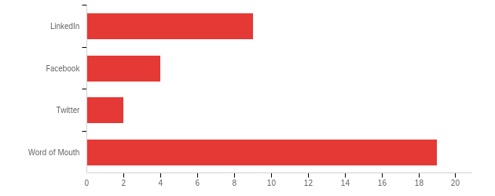

Other, please state
Student at University of Strathclyde
Through my university.
Through the University of Strathclyde
Email from the Mediation Clinic
email
Strathclyde Mediation Clinic, Charlie.
Involvement with the Clinic
I got the information from my senior professor in Faculty of Law, University of Delhi, India.
Through my university, the OU.
Received an email in my inbox
Scottish Mediation
Open University
Previous event too
Scottish Mediation website

Q7 - Do you have any suggestions or feedback for the next Conference?
I thoroughly enjoyed the whole day - which for a day on Zoom is saying something. And particularly for a Saturday on Zoom! I would love to hear from students in some shape or form as to the experience for them. Particularly that reflective element of moving from learning to mediate, thinking about mediating, actually mediating and the impacts of mediation on the clients.
I think the conference was well organised and covered relevant topics on mediation. What I would suggest for the next conference would be to to invite more mediation practitioners and academics from around the world to offer a more nuanced understanding and practice of mediation in different jurisdictions across the world.
Perhaps workshops aimed at specific groups e.g: Those with Mediation Clinics up and running; Those considering establishing a clinic; An overview of the process & environments where mediation is used for those new to mediation (students?); Reflections of a mediation practitioner.
PLEASE INCLUDE NEGOTIATION IN THE CONFERENCE
An absolutely fabulous Conference which I do hope will become an established and regular event in the years to come.
Really interesting and enjoyable, hope to return next year! So well organised too!
More speakers of Carrie Menkel Meadow’s calibre
Perhaps shift the focus from court based mediation to community or universities?
Nothing to add
If the next conference is physical, I think that it should be online as well.
Well done! Hope this becomes a regular event hosted by different clinics.
please continue to include some online content
Let's get together for a real (rather than) virtual conference when the restrictions imposed by the pandemic are lifted. It would be great to set up/establish a global network of mediation clinics to further clinical aims and aspirations of such ventures and initiatives across the academic community.
More interactive content and more practical aspects. More students and associations could be included.
Link it to the wider agenda of mediation being received in the mainstream of civil justice, with a deliberate focus on showing the added value, and challenges to government over adequate resourcing.
In future conferences you may take other countries mediation process and recognition. Help then how they can start Mediation Clinic in their Universities effectively.
Having two days for the conference instead.
I was particularly interested in learning more about how different models of mediation were used in mediation clinics in different settings
The conference was really great - thanks all.
It must also emphasize on techniques and skills of mediators.
More of the same would be great. Thanks for a great day! 😊
None at all.
India has long history of mediation and some experts may be invited to speak about Indian experience in the field in future.
as above perhaps one more speaker and slightly less peer group discussion. Discussion can be had readily but to hear quality speakers is special and something that people will come many miles real or virtual for
For me personally, I would be looking to gain CPD points at the next conference I attend.
Not that I can currently think of.
I enjoyed the conference very much. All the speakers gave interesting presentations and I have learned new ideas and perspectives. Participants also asked many questions and discussions went very well in each workshop. I just thought speakers in the workshop looked a bit tired in the second workshop. It might have been better to split four workshops into two for the first hour and the other two for the next hour. However, the participants enjoyed moving around the workshops and listening to different aspects of mediation from distinguished speakers. Thank you again for organising this big interesting online conference. I look forward to the second conference if you organise!
Please share the schedule in advance.
Ethical dilemmas in Mediation
More of same. Perhaps insights into different styles of mediation and how practical the more advanced styles might be in normal practice eg transformative and narrative. Further discussion of ethics and informed consent.
Maybe next time we can divide the schedule on two days instead of one, and maybe have the opportunity to attend all sessions, not to choose between them. And it would be nice to send certificates of attendance or participation.
The hardest thing to replicate online are the social interactions that people would normally have the opportunity for in person. Perhaps thinking about how this aspect might be developed would help in the future.
Id like a mix of face to face and online, especially if I was face to face

