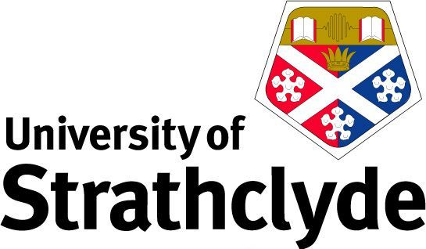

The Person in Scotland and the World: 40 Years of Private Law Reform
A seminar to honour the contribution to scholarship of Professor Kenneth McK. Norrie

Friday 15 November 2024
University of Strathclyde Technology & Innovation Centre, 99 George St. Glasgow. G1 1RD

9:00 – 9:30am | Registration and coffee
9:30 – 9:45am | Welcome  The Right Hon Lady Wise (Chair)  Professor Adelyn Wilson, Head of the Law School, University of Strathclyde
9:45 – 11:00am | Shaping the Law: Professor Norrie’s contribution to law reform in Scotland  Professor Gillian Black, Scottish Law Commission & University of Edinburgh  What would a progressive abortion law look like in Scotland?  Dr Lynsey Mitchell, University of Strathclyde  Disputed information in a children’s hearing: Is there still a defence of O v Rae?  Dr Alyson Evans, University of Strathclyde
11:00 – 11:15am | BREAK
11:15 – 12:30pm | An Age of Inconsistency: The legal capacity and responsibility of children and young people in Scotland  Elaine E. Sutherland, Professor Emerita University of Stirling & Distinguished Professor Emerita Lewis and Clark Law School, Portland, Oregon  Crossing Borders: Changing approaches to children’s views  Janys M. Scott KC, Westwater Advocates  The Incorporation of the UN Convention on the Rights of the Child in Scotland  Bruce Adamson, previous Children and Young People’s Commissioner Scotland

12:30 – 13:30pm | LUNCH
13:30 – 14:45pm | Trans Parenthood: “Factual Purposes” and “Legal Statuses”  Dr Alan Brown, University of Glasgow  Case-watching and trend-spotting: shifting habits of domestic abuse in Scots family law  Professor Jane Mair, University of Glasgow  Succession  Dr Dot Reid, University of Glasgow
14:45 – 15:00pm | BREAK
15:00 – 16:15pm | From ‘rough and ready’ to regulated? The case for adopting a children’s rights-based approach in childhood negligence proceedings  Dr Lesley-Anne Barnes Macfarlane, University of Glasgow  Reflecting on Romantic Romanisms: Divine Janus and the delict of ‘assault’  Dr Jonathan Brown, University of Strathclyde  Dignity and Delict  Dr Stephen Bogle, University of Glasgow
16:15 - 16:30pm | Chair’s Reflections & Close  The Right Hon Lady Wise

