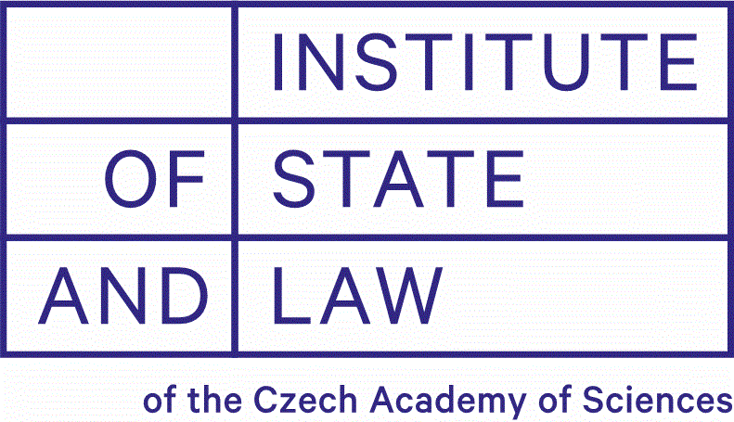
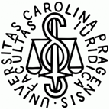
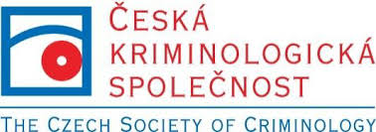
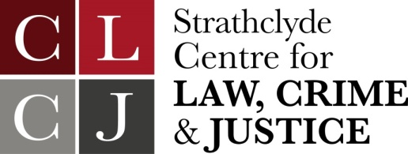

The European Group on Sentencing & Penal Decision-Making
Cultures of Sentencing and Penal Decision-Making:
A European Conference

Thursday 30th – Friday 31st May 2019
Faculty of Law, Charles University
Prague, Czech Republic

Preliminary Delegate List at 12th April 2019

Name/Affiliation | Presenting Paper?
Harry Annison ,Southampton, England & Wales | X
Nicole Bögelein ,Cologne, Germany | x
Kristel Beyens , Vrije Universiteit Brussel, Belgium | X
Maciej Bocheński, Jagiellonian, Poland | x
Gavin Dingwall ,De Montfort, England & Wales

Jozef Fabik ,Directorate of Prison & Court Guards, Slovak Republic
Jakub Drapal ,Charles, Cezech Republic | x
Jay Gormley ,Strathclyde, Scotland | x
Ana Guerrio, Maia, Portugal

Miha Hafner, Ljubljana, Slovenia | x
Barbora Jekielek Henzl, Intl Criminal Dept, Min of Justice, Czech Rep
Tim Hillier ,De Montfort, England & Wales
Anthea Hucklesby, Leeds, England & Wales

Vladyslava Irinieiva, EU Advisory Mission, Ukraine

Jessica Jacobson, Birkbeck, England & Wales | x
Louise V Johansen, Copenhagen, Denmark | x
Fiona Jamieson, Edinburgh, Scotland | x
Amy Kirby, Birkbeck, England & Wales

Kirill Titaev, Europ St. Petersburg, Russia | x
Jakub Ľorko, Directorate of Prison & Court Guards, Slovak Republic
Grazia Mannozzi, Insubria, Italy

Petra Masopust Šachová, Palacky University, Czech Republic | x
Gabriel Oancea, Bucharest, Romania

Andrea Matoušková, director of the Czech Probation and Mediation Service
Mojca Plesničar, Ljubljana, Slovenia | X
Sylva Řezníková, Glasgow, Scotland | X
Milan Svoboda, Dept of Supervision of Places of Detention, Czech Republic
Katja Šugman Stubbs, Ljubljana, Slovenia | X
Cyrus Tata, Strathclyde, Scotland | X
Kristýna Tomšů, Charles, Czech Republic | x
Lucie Valoušková, International Criminal Law Dept, Min of Justice, Czech Rep
Javier Velasquez, Glasgow/ Chile

Sigrid van Wingerden, Leiden, Netherlands

Mihaela Vidaicu, Moldova State, Moldova | X
Hilde T. Wermink, Leiden, Netherlands | X
Jakub Drapal’s Charles students x3 ?

