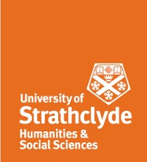
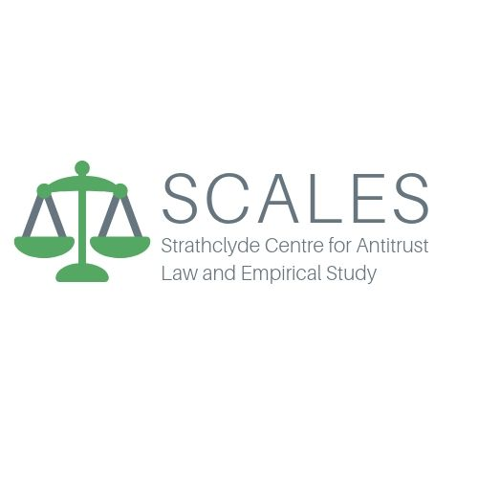
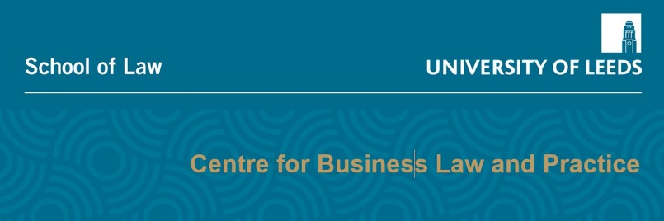

Strathclyde Centre for Antitrust Law and Empirical Study (SCALES), together with the Centre for Business law and Practice (CBLP), University of Leeds and the Lancaster University Law School Research Seminar Series

The UK Competition Regime: A Twenty Year Retrospective (OUP, 2021) Rodger, Whelan and MacCulloch eds

Book Launch Event

21 May 2021, 12 noon- 2pm
Programme
12.00 Welcome/Book Introduction

12.10 UK Competition Law Institutions
Peter Freeman, Bruce Lyons, Niamh Dunne and Liza Lovdahl-Gormsen

12.45 UK Competition Law Substantive Rules
Richard Whish, Alison Jones, Robert O’Donoghue, David Reader and Christian Ahlborn/Will Leslie

13.25 UK Competition Law and Enforcement
Arianna Andreangeli, Barry Rodger, Angus MacCulloch and Peter Whelan

13.55-14.00 Concluding Remarks

Format will be short 5 minute presentations by each contributor, followed by 15 minutes Q and A in each session.
The book launch event will be a zoom event.
Registration and zoom details provided on request to barry.j.rodger@strath.ac.uk

