POLICE SCOTLAND

Disclosure Scheme for Domestic Abuse Scotland

You can access the Domestic Abuse Disclosure Form here
The Disclosure Scheme for Domestic Abuse Scotland aims to prevent domestic abuse by empowering both men and women with the right to ask about the background of their new partner. It also allows concerned members of the public, such as relatives and friends, to make enquiries about someone’s partner if they are concerned that person has been abusive in the past. The concerned relative or friend will not, under normal circumstances, receive any information on the person causing concern. If a disclosure is deemed necessary, lawful and proportionate, the person potentially at risk, or person best placed to safeguard that individual, will receive the information.
The scheme also creates a formal mechanism for Police Scotland to tell both men and women, who are potentially at risk of abuse from their partner, about that partner’s past.
The scheme aims to enable potential victims to make an informed choice on whether to continue the relationship, and provides further help and support to assist the potential victim when making that choice.
Right to Ask is the powerful message behind the new scheme. Police Scotland is empowering potential victims of domestic abuse and/or their concerned friends and family, with the right to ask about the new partner. In the past, it could have been difficult for someone entering a new relationship to find out or be aware if their new partner had prior convictions for violence or domestic abuse.
If police checks show that the individual has a record of abusive behaviour; or there is other information to indicate the person you know is at risk, the police will consider sharing this information with the person(s) best placed to protect the potential victim.
The police will make contact with you to discuss your concerns and ask for more information from you, as well as confirming your identity during a face to face meeting.

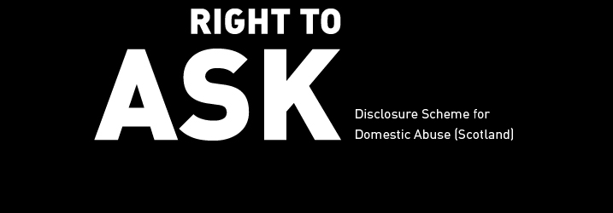

What is the Disclosure Scheme for Domestic Abuse Scotland?
The aim of this scheme is to give you a formal mechanism to make inquiries about your new partner if you are worried they have been abusive in the past.
If police checks show your partner has a record of violent or abusive behaviour; or there is other information to indicate that you may be at risk from your new partner, the police will consider sharing this information with you.
The scheme aims to help you to make a more informed decision on whether to continue a relationship, and provides further help and support to assist you when making that choice.

Who is this form for?
This form is for everyone who wants to apply to the Scheme either for themselves or another person. It is for both members of the public and for professionals.
This application form is for the Disclosure Scheme for Domestic Abuse Scotland only.
Click here if you want to navigate away from this page quickly.

What will happen once I submit the form?
Once you submit the form you will have formally applied to the Disclosure Scheme for Domestic Abuse Scotland. Police Scotland will process the application – including conducting checks and meeting with you, the applicant.
At the end of the process a decision will be made as to whether or not a disclosure will be made.

What if I live outwith Scotland?
If you live outwith Scotland and are worried about your new partner, you should contact your local police force for information.
If you live in England and Wales there is a very similar scheme to DSDAS called the Domestic Violence Disclosure Scheme (also known as Clare’s Law), which is operated by the police forces there.
If you are a concerned relative or friend of someone who resides in Scotland, you can make an application into the scheme.
Click here if you want to navigate away from this page quickly.

Related Documents
- Asking on behalf of someone else (PDF)
- Making an application about your partner (PDF)
- Domestic Abuse Disclosure Form Poster (PDF)
PDF files on this page require a PDF reader, such as the free Adobe Acrobat Reader (download).
If you would like this information in an alternative format or language - please phone us on 101 to discuss your needs.

