Default Report
GBV Level 3 Training Course - Pilot
March 26th 2018, 3:22 am MDT
Q1 - What is your role / area of work?

What is your role / area of work?
Security Warden
Library
IS Assistant, Library
Student Support
Campus Warden
Assistant Area Manager - Residence Services

Q2 - How relevant was the course content to your role?
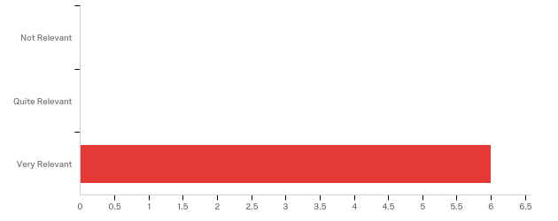

# | Answer | % | Count
1 | Not Relevant | 0.00% | 0
2 | Quite Relevant | 0.00% | 0
3 | Very Relevant | 100.00% | 6
 | Total | 100% | 6

Q3 - Can you tell us the elements of the course which you found useful - Day 1
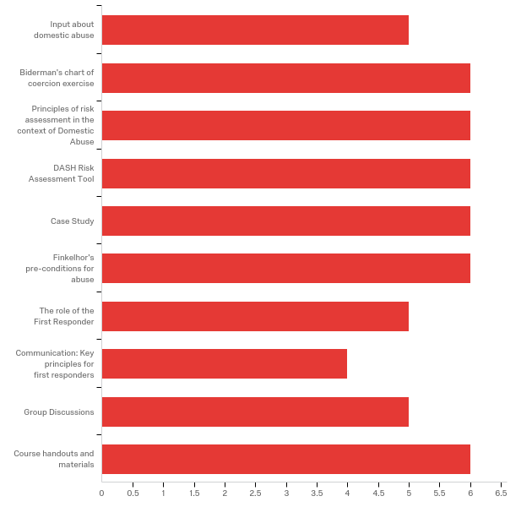

# | Answer | % | Count
1 | Input about domestic abuse | 9.09% | 5
2 | Biderman's chart of coercion exercise | 10.91% | 6
3 | Principles of risk assessment in the context of Domestic Abuse | 10.91% | 6
4 | DASH Risk Assessment Tool | 10.91% | 6
5 | Case Study | 10.91% | 6
6 | Finkelhor's pre-conditions for abuse | 10.91% | 6
7 | The role of the First Responder | 9.09% | 5
8 | Communication: Key principles for first responders | 7.27% | 4
9 | Group Discussions | 9.09% | 5
10 | Course handouts and materials | 10.91% | 6
 | Total | 100% | 55

Q4 - Can you tell us the elements of the course which you found useful - Day 2
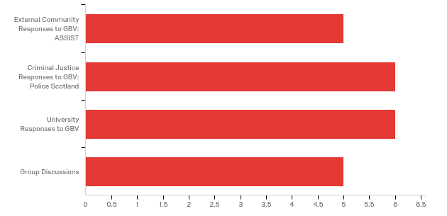

# | Answer | % | Count
1 | External Community Responses to GBV: ASSIST | 22.73% | 5
2 | Criminal Justice Responses to GBV: Police Scotland | 27.27% | 6
3 | University Responses to GBV | 27.27% | 6
4 | Group Discussions | 22.73% | 5
 | Total | 100% | 22

Q5 - Can you tell us the elements of the course which you found useful - Comments

Can you tell us the elements of the course which you found useful - Comments
Big ground covered! Very interesting.
It was all useful and really interesting - any knowledge is good.
Really good to get an understanding about the IDAA, MARAC and Police processes, so you can have a better idea a survivor would be facing if you referred them on. Risk assessment tool was really helpful.
Missed the ASSIST presentation
Very good course, well presented and interesting. Vital tool in keeping students / staff safe.

Q6 - Can you identify the key learning points from the course that you will be able to put into practice immediately?

Can you identify the key learning points from the course that you will be able to put into practice immediately?
Identify a GBV and how to respond according to the risk assessment, identify Biderman procedure by questioning around which is my role and not.
Awareness of the subject, options for victims, ways to support and communicate with victims. Hopefully will be able to pass this on to colleagues.
Yes, more aware of warning signs.
Risk Assessment
Identifying GBV and passing on knowledge to my colleagues.
Risk Assessment - DASH. Very good to have input from other departments. Good to see a more linked up thinking between departments.

Q9 - Please let us know if there are any changes you would make to the course as it currently stands?

Please let us know if there are any changes you would make to the course as it currently stands?
The course is fantastic, a lot of different services and resources.
I'd have liked the ASSIST and Police bit to have been longer, there was lots of new information in there and it went really fast.
Fill out or sharpen up second afternoon - case studies?
Thought course was excellent and very beneficial to attend.

Q10 - Do you have any recommendations for future courses on this topic?

Do you have any recommendations for future courses on this topic?
No
Who supports us? Will there be a sort of debrief option for us if we end up dealing with a really bad incident? Can we talk about it without breaking confidentiality?
No

Q11 - Would you recommend this course to colleagues?

Would you recommend this course to colleagues?
Absolutely
Yes
Yes, I wish it was compulsory.
Yes
Yes
Definitely feel that colleagues should attend.

Q12 - Further Comments

Further Comments
I really enjoyed the course, better than I expected. I can say that now I’m more aware about GBV and the background of an incident.
Good to see that the work is continuing on giving support to all departments. Hopefully this work will continue and I'm happy to be involved at any level. Still feel that a lot of work is required on support out of hours.

