A selection of campaign materials can be obtained from Rape Crisis Scotland
Email: Eileen.Maitland@rapecrisisscotland.org.uk

You Tube links for the #IJustFroze Campaign are at the bottom

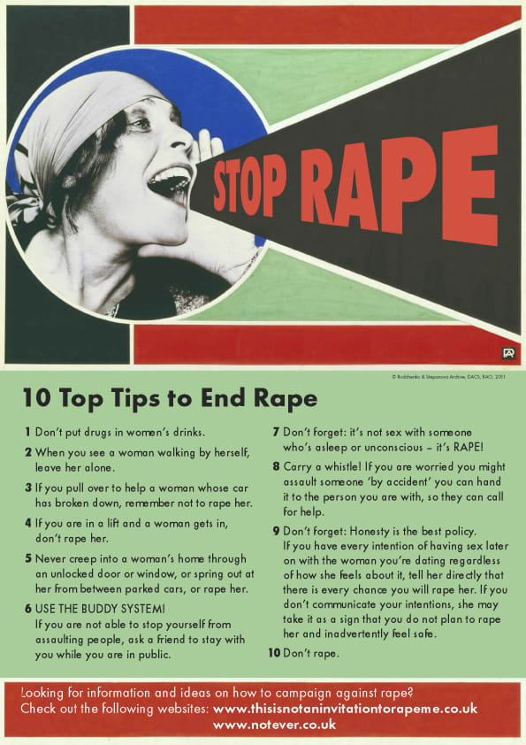

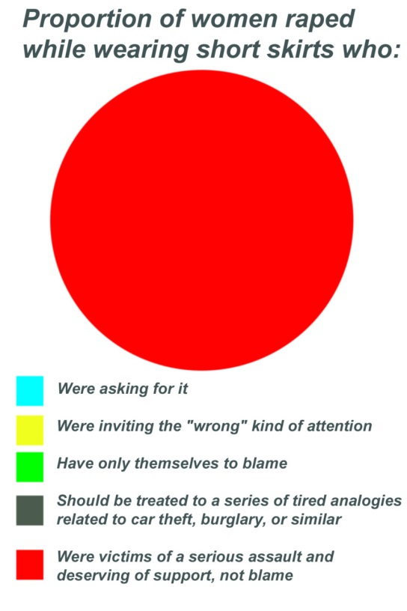

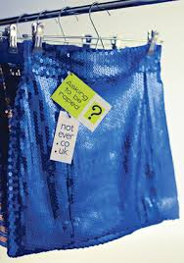

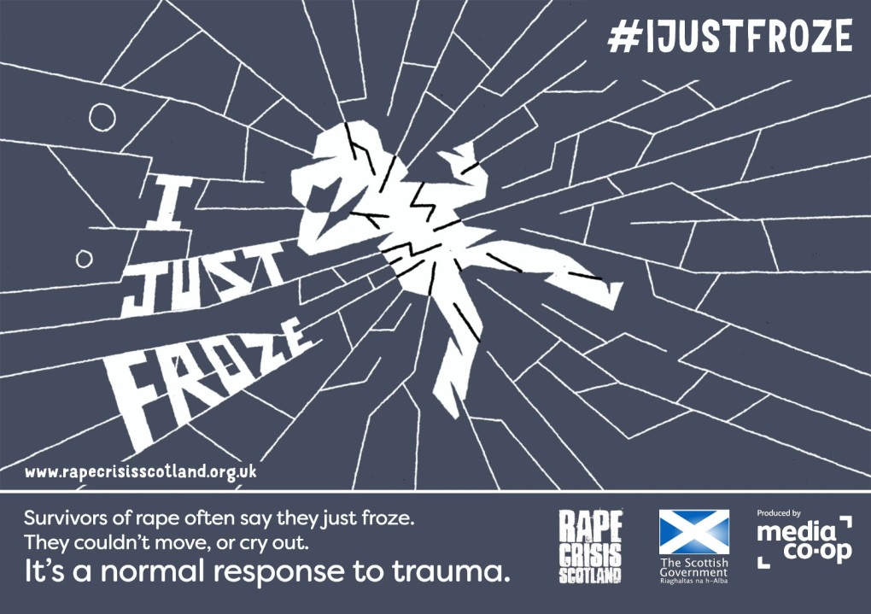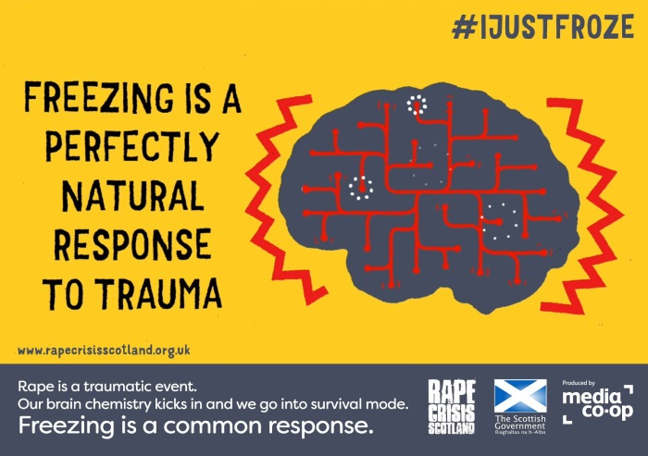

https://www.youtube.com/watch?v=O5h-N0N8DaY

https://www.youtube.com/watch?v=WcZUWsvNyyU

