
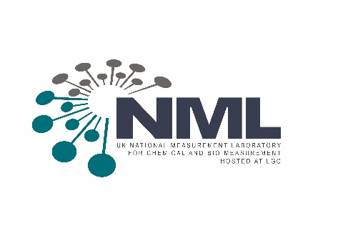
Centre for Advanced Measurement Research and Health Translation

The University of Strathclyde and the UK National Measurement Laboratory
Would like to invite you to attend the ‘ReConnect’ Event on

Thursday 10 February 2022
10:00 – 11.30

Executive Suite, Level 9
Technology and Innovation Centre
99 George St, Glasgow, G1 1RD

The Centre - launched in 2019 - is part of an ambitious, long-term collaboration between the University of Strathclyde and the National Measurement Laboratory (NML) at LGC, which aims
to embed the critical role of measurements and support the growth of Scotland’s health and life sciences innovation ecosystem.

The collaboration builds upon LGC’s National Measurement Laboratory vision to be a leading centre for chemical and bio-measurement, supporting the delivery of the UK Government’s Innovation Strategy, and the University of Strathclyde’s areas of strength in Measurement Science and Enabling Technologies and Health and Well-Being.

Since its launch, The Centre is working to create an interdisciplinary environment for joint research projects and innovation in measurement. Despite the challenges posed by the COVID pandemic, the Centre has provided examples of support to Scottish industry in research for technology solutions in a wide range of areas from clinical diagnostics to innovative new food products. More recently, the appointment of a new LGC Chair in Measurement Science for Health has been possible through contributions from the University of Strathclyde, CAMS UK and LGC. More details can be found at:
https://www.strath.ac.uk/research/centreforadvancedmeasurementresearchandhealthtranslation/

We think it is time to ‘ReConnect’ and look forward to your attendance and future engagement with the Centre. If your commitments do not allow you to accept this invitation, please feel free to nominate an individual from your organisation that can participate.

Please register here by Tuesday 31st January 2022

Enquiries to corporate-events@strath.ac.uk or 0141 548 2245

Data Protection We promise to store your personal data securely, and to use it respectfully. Find out more about how we process your information in our Privacy Policy. We may contact you from time to time about new products or services that we think may be of interest. If you do not wish to receive such information, you can email us at corporate-events@strath.ac.uk

