
Procedure on the Approval of Programmes in Bahrain – Higher Education Council and Bahrain Quality Authority

Version No. | Description | Author | Approval body | Effective Date
1.0 | Procedure for obtaining approval for new programmes and substantive changes to existing programmes in Bahrain, including amendments to Programme Regulations and Module Descriptors. | Quality Enhancement and Assurance (Partnerships and Internationalisation), Education Enhancement | ESC

Review Date | One year from approval date
Section Responsible | Quality Enhancement and Assurance, Education Enhancement

Purpose of Policy/Procedure
This procedure outlines the institutional process for submitting academic programmes for approval by the Higher Education Council (HEC) and Bahrain Quality Authority (BQA). It ensures a consistent and compliant approach to programme development, licensing, and alignment.
Scope of Policy/Procedure
This procedure applies to:
- Academic staff involved in programme development
- Faculty and Administrative teams
- Compliance and quality assurance, Professional Services
- External stakeholders involved in programme delivery
It complements existing policies on programme approval, quality assurance, and academic governance.
Internal Review Framework
Policy & Procedure on Programme & Module Approval
Policy & Procedure for the Quinquennial Review of Academic Provision
Guidance on the Annual Review of Programme Regulations
General Regulations for UG & Integrated Masters programmes
General Regulations for PGT programmes

Lead Author
Quality Enhancement and Assurance Officer (Partnerships and Internationalisation), Education Enhancement

Contributing Authors
Bahrain Programme Approval Group

Quality Enhancement and Assurance, Education Enhancement

Partnerships and Internationalisation, Education Enhancement

Strathclyde Business School

Faculty of Engineering

Faculty of Science

Committee Route
Bahrain Programme Approval Group
Education Strategy Committee
Senate (for information)

Contact Team | Partnerships and Internationalisation, Quality Enhancement and Assurance, Education Enhancement
Contact Email | educationenhancement-quality@strath.ac.uk

Introduction
This procedure has been designed to guide academic, faculty, and professional services staff through the preparation and submission of academic programmes for licensing approval by the Higher Education Council (HEC), as well as programme alignment with the Bahrain Quality Authority (BQA) in the Kingdom of Bahrain. It aims to promote a consistent, transparent, and institutionally coordinated approach to programme approval across all faculties and departments.

Programme Identification and Initial Consultation
- All proposed programmes intended for international delivery must first be discussed and agreed upon by the Associate Principal & Executive Dean and Head of Department, to ensure strategic alignment and operational feasibility. This includes CPD and short courses.

Please note: Only programmes that are currently delivered in Glasgow may be proposed for delivery in Bahrain.

- The Associate Principal & Executive Dean and Head of Department should initiate discussions concerning the staffing of the programme, including the identification and assessment of any additional staff requirements and associated costs.

- The faculty and programme team will carry out a mapping process to determine to what extent the programme aligns with an existing programme or where it requires modifications.
- The faculty and programme team will decide operationally how the programme will be delivered in the Kingdom of Bahrain, consulting HEC Regulations on Teaching Delivery

- The programme mapping and delivery plan must be presented and signed off as approved by the Associate Principal & Executive Dean and Head of Department.

- The appropriate Faculty committee/group will decide upon an appropriate fee for the programme. The faculty should follow the UoS Resource Allocation Model for costing proposed (credit-bearing) programmes. Recognising that Strathclyde’s share of UoSB fees will be 20% (unless otherwise agreed). Non-credit bearing programmes will be reviewed on a case-by-case basis. The agreed fee must be signed off as approved by the Faculty Associate Principal & Executive Dean, President and Dean, UoSB and submitted to Fee Strategy Group for review and approval.

UoSB fees do not automatically increase in line with the remainder of the University of Strathclyde's fee structure. Once fees have been agreed with HEC, they are fixed for a minimum period of three years and may only be amended following consultation and agreement with HEC.

- The Associate Principal & Executive Dean, Head of Department, and Programme Lead will prepare a Bahrain Business Case for submission to the Bahrain Programme Approval Group for review and approval. This requirement applies to all proposed provision, including CPD and short courses.

- The President and Dean UoSB will notify S Eleven of the intention to seek programme approval from the HEC.
- The HEC stipulates that when seeking approval for new programmes we must submit a feasibility study. To support consistency in submissions, Faculties should use the guidance in appendix 1 when compiling a feasibility study.

Internal Approval

- The faculty and programme team should proceed with the internal approval process and submit relevant documentation, including the programme regulations and business case, to the Faculty Academic Committee (FAC). Guidance is available  Programme and Module approval routes.pdf
Following Faculty Academic Committee approval, the relevant documentation should be sent to the Bahrain Programme Approval Group and Bahrain Quality Assurance Working Group.
- Approval for new or revised programme guidance applies to all Bahrain programmes. Guidance is available Programme and Module approval routes.pdf
Minor/Accuracy: Approved by FAC, recorded in minutes.
Significant: Reviewed by FAC/QEAT/Peer Reviewers/Quality Assurance Committee (QAC). Guidance is available Guidance on the Annual Review of Programme Regulations.
Substantive: Requires Senate approval, ideally 6 months prior to implementation. Guidance is available Programme and Module approval routes.pdf
If further guidance is required, the Quality Enhancement and Assurance Team can be contacted educationenhancement-quality@strath.ac.uk.
National Requirements
- All undergraduate programmes must include the following mandatory, non-credit-bearing modules, which should be included in the programme regulations. Cost implications and capacity to deliver these modules should be discussed with the Associate Principal & Executive Dean and Head of Department.
  - History of Bahrain
  - Human Rights
  - Arabic Language

Programme and Module Codes

- New programme codes and module codes are required for all programmes to be delivered in Bahrain. Following approval of the programme by Faculty, QAC and Senate, a ‘Programme Code Request Form’ should be completed by the relevant person. The form can be found on Student Lifecycle’s SharePoint page.

- The completed form should be emailed to studentlifecycle-systemsdata@strath.ac.uk and Bahrain Programme Approval Group educationenhancement-quality@strath.ac.uk together with a copy of the approved programme regulations.
- As soon as the form is received, Student Lifecycle will prioritise it for programme creation and notify all relevant parties of the new code as soon as possible.
Higher Education Council (HEC) Submission Requirements
- Once all internal approval Is complete including Senate approval, the faculty and programme team should notify the Partnerships and Internationalisation Team (QEAT) educationenhancement-quality@strath.ac.uk. of the intended submission. Supporting documentation is available to download Higher Education Council (HEC) Supporting Documentation.
- While alignment with the Bahrain Quality Authority (BQA) cannot be initiated until licensing approval is granted by the Higher Education Council (HEC), the documentation for both processes may be compiled at this stage refer to paragraph 38 – 54.
- The faculty and programme team should prepare a separate application form and evidence pack for each programme. This includes:
HEC Requirements | Responsibility
Completed HEC application form | Programme Team | Academic program licensing application form.docx  SAMPLE completed HEC application form.pdf
Translated programme title | Partnerships and Internationalisation Team (QEAT)
Signed HEC application form with institutional stamp | Partnerships and Internationalisation Team (QEAT) | Request the president’s signature and University of Bahrain stamp before submission
President’s signed letter with institutional stamp | Partnerships and Internationalisation Team (QEAT) | Prepare letter and request the president’s signature and University of Bahrain stamp before submission
Evidence folders (annex 1 – 5) | Programme Team | HEC Licensing - document evidence to be collated.docx
All prepared evidence is added to University of Bahrain branded paper | Programme Team | Branded Bahrain headed paper.docx

Evidence for Submission

- The programme team is responsible for compiling the supporting material for each annex and developing a corresponding evidence list that aligns precisely with the structure and content outlined in the HEC application form (Annexes 1–5). A master form is available to download Academic program licensing application form

- The faculty and programme team should organise and store the supporting documentation for each programme in designated Teams folder.

Programme Approval - Business | EDEN_International Programmes
Programme Approval - Engineering | EDEN_International Programmes
Programme Approval - HaSS | EDEN_International Programmes
Programme Approval - Science | EDEN_International Programmes

  - Create a Folder with Programme Name
  - Set up folders on Teams (Annex 1 – 5) as below.

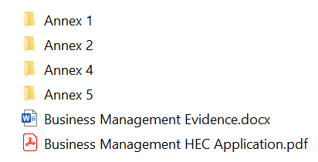

  - Add relevant documentation in accordance with the evidence and document lists available to download Document Evidence to be collated.

  - Ensure the completed application form and evidence list are added. A sample application form and evidence list is available to download SAMPLE completed HEC application form, SAMPLE - Evidence List.
  - Notify Quality Enhancement and Assurance Officer (Partnerships and Internationalisation) educationenhancement-quality@strath.ac.uk.
Internal Document Review

- The Partnerships and Internationalisation Team (QEAT) will undertake a thorough preliminary review and quality assurance check of all documentation.

- The Partnerships and Internationalisation Team (QEAT) may request supplementary information or clarification from the faculty and programme team to ensure the submission is accurate and aligns with HEC requirements.

Final Submission
- Once internal review and quality assurance checks are complete the Partnerships and Internationalisation Team (QEAT) will compile the folders containing the supporting evidence, the corresponding evidence list, and the signed and stamped HEC application form for each programme into individual compressed (ZIP) files for submission.
- The Partnerships and Internationalisation Team (QEAT) will forward each programme’ s compressed file, along with the signed and stamped letter from the University President to the UoSB Project Manager.

- The UoSB Project Manager will submit the complete final application to the HEC via the University President’s official email address. The submission email will be copied to the President and Vice President UoSB, the General Manager of S Eleven, the designated programme team contact, and the Partnerships and Internationalisation Team (QEAT).

- In the event that the UoSB Project Manager is unavailable, the Partnerships and Internationalisation Team (QEAT) will assume responsibility for submitting the application to HEC, following the same procedure and distribution outlined above.

- The Quality Enhancement and Assurance Officer (Partnerships and Internationalisation) is primarily responsible for managing the HEC approval process. In their absence, this responsibility will be supported by other designated team members via educationenhancement-quality@strath.ac.uk.

Submission Timeline
27. The faculty and programme teams should note that the standard working week in Bahrain
runs from Sunday to Thursday.

- The faculty and programme teams should allow a minimum of five working days for the Partnerships and Internationalisation Team (QEAT), to conduct a preliminary review and quality assurance check of all documentation.

- The faculty and programme teams should allow a minimum of five working days for the Partnerships and Internationalisation Team (QEAT), to collate, review, and submit the final documentation.

Review and Approval

- The HEC will conduct a review of the submitted application form and accompanying documentation. During this process, they may request additional information or clarification.

- Following the initial review, the application will be submitted to the HEC Board of Trustees for formal consideration and approval. The HEC Board of Trustees convenes on a quarterly basis to evaluate and review new applications.

- At this stage, the HEC may issue further requests for clarification or additional documentation to support the decision-making process of the Board of Trustees.

- The request for additional information will be routed through the Bahrain Programme Approval Group; the Partnerships and Internationalisation Team (QEAT) will arrange translation of the request and send a Microsoft Team's link to the relevant programme team to action. The programme team should prepare a response and supporting documentation for the HEC and add these to the Teams site. Although the specific questions are not yet known, the response should follow the same format as previous submissions. A sample response is available for reference SAMPLE PhD Additional Information response.

- The HEC will conduct an on-site visit and inspection of the campus to verify that all institutional and programme-specific requirements are fully in place.

- An application fee of 500 BHD will be submitted to the Higher Education Council (HEC) as part of the programme approval process. The fee will be charged through the Bahrain Campus. Contact the Project Manager, UoSB, to arrange this.

- The HEC will issue a formal letter of approval to the President, and the UoSB Project Manager will distribute a copy to all relevant stakeholders for their information. Upon receiving formal approval, the University must submit a request to the HEC for authorisation to commence advertising and student registration.

- Following programme approval, the University shall initiate the alignment process with the Bahrain Quality Authority (BQA) refer to paragraph 38 – 54.
Please note: Marketing and recruitment activities for the programme must not commence until licensing approval has been granted by HEC; alignment is approved by the BQA and formal permission from HEC to proceed has been obtained. Authorisation will be submitted through the Bahrain Programme Approval Group educationenhancement-quality@strath.ac.uk.

Bahrain Quality Authority (BQA) Submission Requirements
- Once formal licensing approval is granted by the Higher Education Council (HEC) the faculty and programme teams can progress to Bahrain Quality Authority (BQA) alignment.

- The faculty and programme team should prepare a separate alignment form and supporting material for each programme. This includes:

BQA Requirements | Responsibility
Completed Alignment request form | Programme Team | BQA Alignment Request Form - MASTER.docx  SAMPLE Alignment Request form.docx
Signed BQA Alignment form | Partnerships and Internationalisation Team (QEAT) | Request the president’s signature before submission
Mapping Scorecard for each module | Programme Team | SAMPLE Mapping Scorecard
Supporting Material | Programme Team | BQA Alignment document evidence to be collated
All prepared evidence is added to University of Bahrain branded paper | Programme Team | Copy of the branded paper

Evidence for Submission

- The programme team is responsible for compiling the supporting material for each programme and developing a corresponding evidence list that aligns precisely with the structure and content outlined in the BQA Alignment form (SM 1.4 – SM 4.4.4). A master form is available to download Alignment Request Form .
- The programme team is responsible for completing a mapping scorecard for each module of the programme. A master is available to download Mapping Scorecard
- The faculty and programme team should organise and store the supporting documentation for each programme in designated Teams folders.

Programme Approval - Business | EDEN_International Programmes
Programme Approval - Engineering | EDEN_International Programmes
Programme Approval - HaSS | EDEN_International Programmes
Programme Approval - Science | EDEN_International Programmes

      - Create a Folder with Programme Name
      - Set up folders in Teams
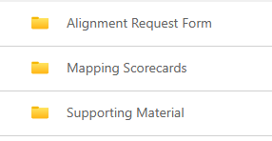

      - Add relevant documentation in accordance with the evidence and document lists available to download Document Evidence to be collated.

      - Ensure that the completed application form and evidence list are added.
      - Notify Quality Enhancement and Assurance Officer (Partnerships and Internationalisation) educationenhancement-quality@strath.ac.uk .

Internal Document Review

- The Partnerships and Internationalisation Team (QEAT) will undertake a thorough preliminary review and quality assurance check of all documentation.
- The Partnerships and Internationalisation Team (QEAT) may request supplementary information or clarification from the faculty and programme team to ensure the submission is accurate and aligns with BQA requirements.

Final Submission

- Once internal review and quality assurance checks are complete, the Partnerships and Internationalisation Team (QEAT) will prepare the material for submission to the BQA.
- The Partnerships and Internationalisation Team (QEAT) will request the submission payment is made to the BQA via the Project Manager, University of Strathclyde, Bahrain.
- The Partnerships and Internationalisation Team (QEAT) will submit the complete final alignment application via the BQA portal. Once the submission is complete the Partnerships and Internationalisation Team (QEAT) will notify by email the President and Dean of UoSB, the General Manager of S Eleven, the designated programme team contact, and the UoSB Project Manager.
- The Quality Enhancement and Assurance Officer (Partnerships and Internationalisation) is primarily responsible for managing the BQA submission process. In their absence, this responsibility will be supported by other designated team members via educationenhancement-quality@strath.ac.uk.

Submission Timeline

- The faculty and programme teams should note that the standard working week in Bahrain runs from Sunday to Thursday.

- The faculty and programme teams should allow a minimum of five working days for the Partnerships and Internationalisation Team (QEAT) Team to conduct a preliminary review and quality assurance check of all documentation

- The faculty and programme teams should allow a minimum of five working days for the Partnerships and Internationalisation Team (QEAT) to collate, review, and submit the final documentation.

Review and Approval

- The BQA will conduct a review of the submitted application and accompanying documentation. During this process, they may request additional information or clarification.

- The BQA will issue a formal letter and an alignment report to the President UoSB. The university have one week to review the report for factual accuracy and return any comments to the BQA.

- The UoSB Project Manager will distribute a copy of the letter and report to all relevant stakeholders for their information. Upon receiving formal approval, the University must submit a request to the HEC for authorisation to commence advertising and student registration.

Please note: Marketing and recruitment activities for the programme must not commence until licensing approval has been granted by HEC; alignment is approved by the BQA and formal permission from HEC to proceed has been obtained. Authorisation will be submitted through the Bahrain Programme Approval Group educationenhancement-quality@strath.ac.uk.

Higher Education Council (HEC) Approval Process for changes to Regulations and Module Descriptors

- We are required to share any changes to programme regulations with the HEC. This process aligns with the annual review of regulations carried out by the Quality Enhancement and Assurance Team and the internal approval process. Guidance on Approval Routes for New, or Changes to Existing, Programme Regulations

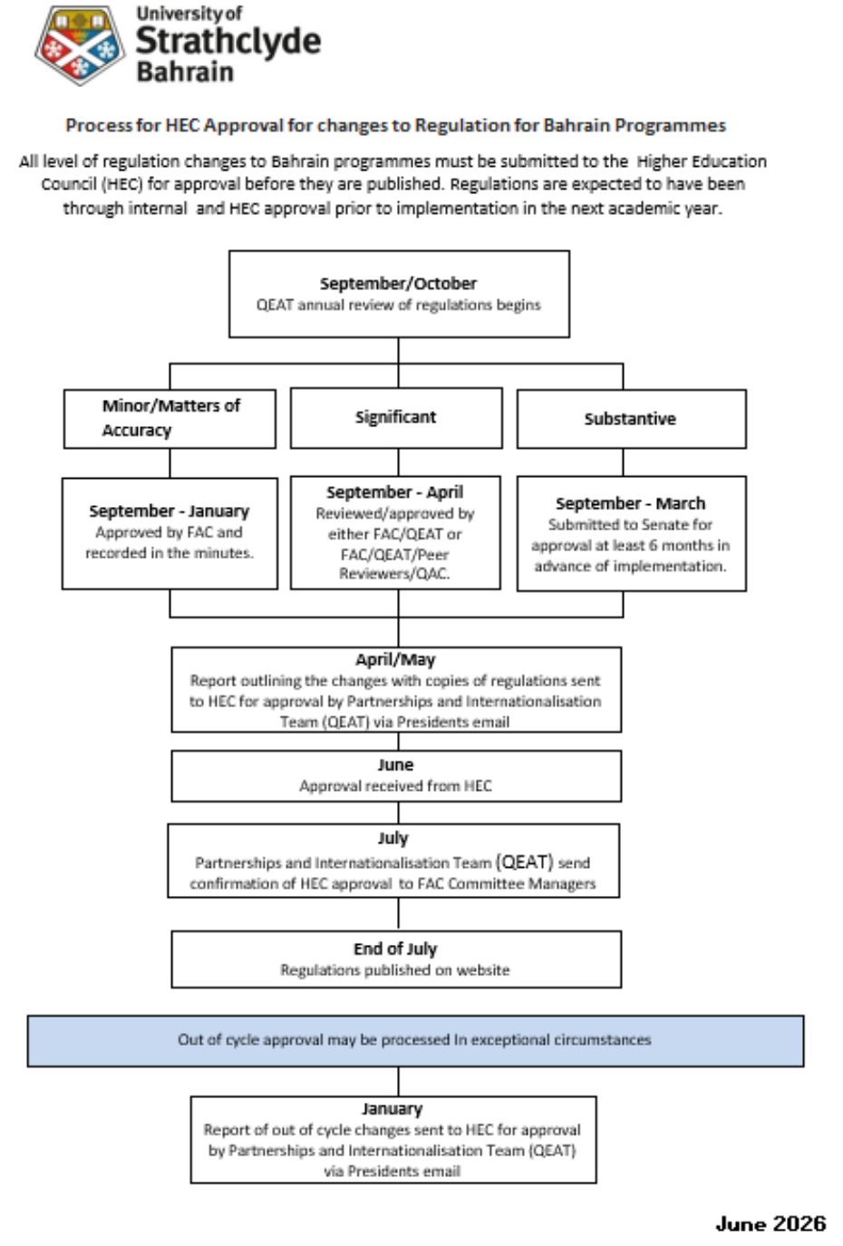

- Any changes to module descriptors must be shared with the HEC. This process aligns with the University’s internal approval process, and the Module Descriptor Form for Bahrain programmes should be used.

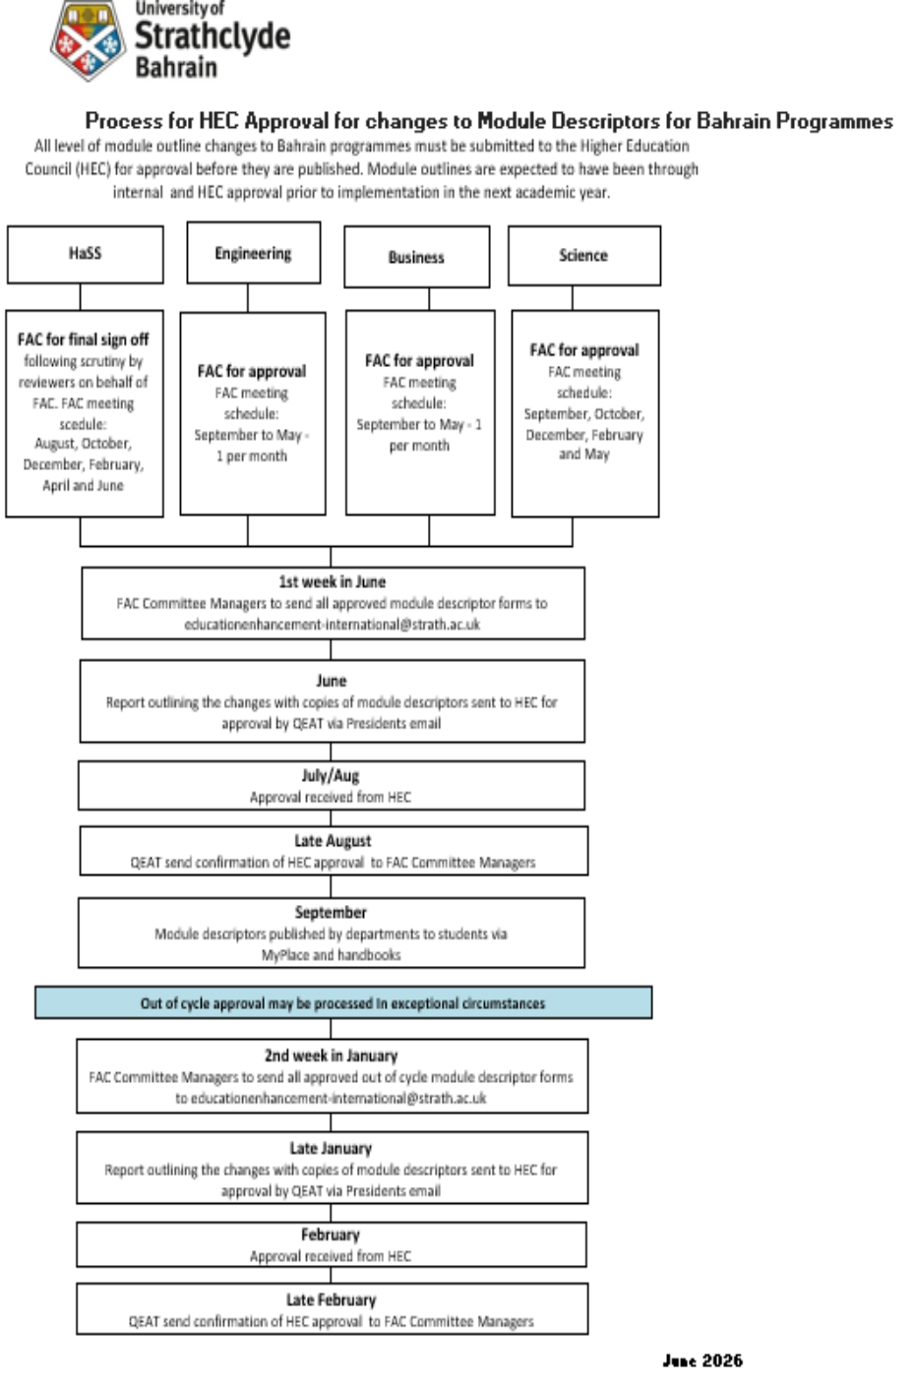
Key Contacts

President, University of Strathclyde, Bahrain
Dean, University of Strathclyde, Bahrain
Project Manager, University of Strathclyde, Bahrain
Quality Enhancement and Assurance Team | educationenhancement-quality@strath.ac.uk.
Student Lifecycle Systems and Data Team | Studentlifecycle-systemsdata@strath.ac.uk
Fee Strategy Group | strategyandplanning@strath.ac.uk
Bahrain Programme Approval Group | educationenhancement-quality@strath.ac.uk
Quality Enhancement and Assurance Officer (Partnerships and Internationalisation) | educationenhancement-quality@strath.ac.uk

Appendix 1

UOSB NEW PROGRAMME FEASIBIILITY STUDY
PROPOSED STRUCTURE

For the Bahrain Higher Education Council (HEC), a feasibility study is expected to do more than show that a programme is academically sound. It should demonstrate that the proposed degree is aligned with Bahrain's national priorities, responds to labour market needs, is financially and operationally viable, and can be delivered to an appropriate quality standard. Current HEC policy also expects institutions to submit a feasibility study alongside an academic review and a detailed study plan when seeking approval for new programmes.
Faculties should consider the following structure when preparing a feasibility study to be submitted alongside the business case in support of a new UoSB programme approval:

1. Executive Summary
This should briefly explain:
- title of the proposed programme
- award level (Bachelor, Master, etc.)
- department responsible
- expected launch date
- expected enrolment
- key justification
- recommendation to approve.

2. Strategic Justification
Explain why the programme fits:
- institutional mission
- university strategic plan
- Bahrain Vision 2030
- Bahrain's economic diversification priorities
- national human capital development
- HEC priorities for programmes that respond to labour market needs.

3. Labour Market Needs Analysis
Include evidence from:
- Labour Market Regulatory Authority (LMRA)
- Bahrain Economic Development Board
- Ministry reports and indicators
- industry associations
- employer surveys
- interviews with employers
- recruitment data
- international reports (World Economic Forum, OECD, etc.)

Demonstrate:
- current shortages
- future demand
- graduate employment opportunities
- expected salary ranges
- sector growth.

(Where possible include letters of support from employers.)

4. Student Demand Analysis
Include:
- consultation with RIO, UoSB recruitment staff, agents and other relevant in-country stakeholders
- surveys of current students
- enquiries received
- feeder school data
- market size & demographic analysis
- international recruitment potential
Compare:
- current programmes in Bahrain
- regional competitors
- tuition fees
- market gaps

5. Benchmarking
HEC commonly expects benchmarking when proposing new programmes or programme modifications. Benchmarking against reputable universities should include regional and internationally recognised institutions and should typically seek to compare:
- programme aims
- admission requirements
- curriculum
- credits
- learning outcomes
- graduate attributes
- assessment methods

7. Graduate Employability
Describe:
- expected occupations
- employer demand
- internship opportunities
- work-based learning
- entrepreneurship opportunities
- further study routes
- professional accreditation (if relevant)

8. Unique Selling Points (USPs) and Programme Differentiation
This section should compare the proposed programme with similar programmes offered by other Bahraini universities and explain how it provides additional value.

A suggested structure is:
Area | Existing Programmes | Proposed Programme | Added Value
Curriculum | Traditional discipline-focused curriculum | Interdisciplinary curriculum integrating emerging technologies | Produces graduates with broader skill sets aligned to current industry needs
Industry Engagement | Limited internships | Mandatory industry placement and live projects | Greater graduate employability
Digital Skills | Basic digital competencies | Advanced AI, data analytics and digital transformation modules | Meets evolving workforce requirements
Professional Certification | No embedded certifications | Industry-recognised certifications embedded within the curriculum | Graduates gain additional professional credentials
Research | Limited undergraduate research | Applied research and capstone projects with industry | Stronger innovation and problem-solving skills
Flexible Delivery | Face-to-face only | Blended, hybrid and experiential learning | Greater accessibility and flexibility

