Report & Support Overview: 2024/25

Introduction
At Strathclyde, as a socially progressive institution, our first priority is the safety, health and wellbeing of our community. Unacceptable behaviour has no place, and we will not tolerate any form of racism, discrimination, harassment, victimisation or bullying.

Our dedicated Gender-based violence (GBV) webpages provide an accessible introduction to GBV. It notes the impact of GBV making clear that, whilst women and girls comprise most survivors, anyone can be affected. It details reporting processes and the support available to staff and students.

The University’s Equally Safe at Strathclyde Group was set up as an outcome of the Scottish Government-funded Equally Safe in Higher Education research project (2017-2019). This group reports to the Equality, Diversity and Inclusion Committee (EDIC) and Safeguarding Committee, both of which report to Executive Team. Membership is drawn from across the institution involving staff from a cross-section of grades, faculties, and professional services to ensure diversity, representation, and a student-centered approach.

Our work to tackle gender-based violence is situated within our broader safeguarding approach, Safe360°. This underpins the University’s duty of care and enhances support mechanisms for students and staff, integrating national guidance and University policies and procedures.

The University actively challenges racism and inequality across the institution; our Race Equality Steering Group advocates for, and works to ensure an inclusive, welcoming and equitable learning and working environment for Black, Asian and minority ethnic students and staff. Whilst we promote the use of Report and Support for racist behaviours, there is still a good deal of work to be done in this area as this report will highlight.

About Report & Support
The purpose of Report & Support is to make everyone feel safer and to challenge behaviours that are seen to be detrimental to society.
Some of the behaviours that we encourage people to report include:
- Harassment,
- Stalking,
- Discrimination,
- GBV,
- Racism,
- To raise concerns about someone’s safety or wellbeing,
- Other issues that are seen to undermine an inclusive University.

How Report & Support operates
When a Report is received, the information is viewed by a small group of senior University staff from Student Experience, Security & Safeguarding.
The Report was initially managed by the Student Conduct & Support Team who will assess the report and decide on how best to respond. Once they have discussed the report with the reporter (where contact information is provided) they may then escalate to other appropriate teams within Strathclyde or to the Police (where appropriate).
Every report is given the focus and time it deserves. In most circumstances no action is taken without the consent of the person reporting or on whose behalf the report is made. Full consideration is given to confidentiality and privacy. In matters where there is a perceived immediate risk to the safety of the reporter or other staff or students, or that could affect the safeguarding of other staff or students, or where a child might be at risk, an urgent Report & Support Management Group meeting is convened, and appropriate action is agreed.
Should a report be received out of hours, and be deemed as requiring immediate action, the On-Call Student Experience Head of Department will implement support (or police involvement) depending on the issue raised. Each issue is risk-assessed, and decisions are made on what is best for the reporter/person being reported.
The tool is free text-based, enabling reporters to submit the level of detail with which they feel comfortable; all non-anonymised reports are followed up on irrespective of level of information.
submitted and every endeavour is made to follow up on anonymised reports.

Report & Support data

All Reports
The table and graph below detail the number of total reports received via the Report & Support platform over the past four years.
Academic Year | Total number of reports
20/21 | 71
21/22 | 80
22/23 | 174
23/24 | 234
24/25 | 369

369 reports were submitted in total this academic year, representing a 58% increase in reports received since 2023/24 academic year.

Of those 369 reports received, 66 were submitted by current students, 241 were submitted by staff members, 9 were submitted by individuals externally to the University community (members of the public), and 53 were anonymous. This has been the trend for the years since the inception of Report & Support; staff members appear to be significantly more likely than students to submit reports.

The total student cohort for 2024/25 was 24,013, meaning that only 0.27% of the total student cohort submitted reports.

Reports were received relatively evenly throughout the academic year, with several key peaks; namely in November, February, and May as outlined below:

All Reports by Category
Reports have been categorised by the Student Conduct & Support Team based on the information provided by the reporter as well as follow-up conversations and actions. For each report, the team note the main issue or concern identified by the reporter. For some reports, there may also be a secondary category. For example, a report may have the main issue categorised as gender-based violence, sexual violence and sexual misconduct, with an additional category of physical harm.
The figures reflect incidents that were perceived by the reporter as a particular issue or subsequently categorised as such by the Student Conduct & Support Team. They do not indicate whether this was found to be the case by the University following an investigation.
Low reporting of particular issues may indicate that there have been few or no incidents, however it may also represent under-reporting. A higher number of reports of a particular issue may represent an increase in incidents, however it may also indicate that reporters feel more comfortable reporting to the University and have an awareness of the channels by which to do so.

 | 2021/22 | 2022/23 | 2023/24 | 2024/25
Academic | 5 | <5 | 10 | <5
Accommodation | 8 | 11 | 15 | 14
Complaints | 15 | 26 | 61 | 64
Estates/Security/H&S | <5 | 8 | 17 | 16
Financial | <5 | 12 | 5 | 6
GBV, sexual violence, sexual misconduct | 12 | 31 | 31 | 79
Harassment | <5 | 25 | 18 | 31
LGBTQ+ | 5 | 5 | 7 | 10
Race, culture, belief | <5 | 8 | 25 | 10
Safeguarding | 0 | 0 | <5 | 10
Unclear reasons for reporting | 0 | 0 | 0 | 4
Violence | 0 | 6 | 16 | 14
Welfare concern | 22 | 39 | 75 | 110
As noted above and in the graph showing total reports earlier in this report, the team have experienced a 155% increase in the number of reports received relating to Gender-based violence, sexual violence, and sexual misconduct. Another noticeable increase was found in the number of reports relating to welfare concerns for students (an increase of 47% since 2023/24).
The year-on-year increase of concerns categorised as ‘complaints’ being submitted via the Report & Support tool is perhaps indicative of a requirement across the institution to raise better awareness of the University’s Complaints Handling Procedure, and how this should be used.

All Reports by Subcategory
It should be noted that several subcategories may be attached to each report; therefore, the number of issues or concerns raised here will differ to the total reports submitted.
Academic issues | <5
Accessibility concerns | <5
Accommodation issues | <5
Antisemitism | <5
Bullying | 8
Car parking | <5
Care experienced student concerns | <5
Child welfare | <5
Civil matter (monies owed) | <5
Coercive control | <5
Concerning behaviours | 24
Concerns re staff conduct | 35
Concerns re Strath Union | <5
Concerns re student conduct | 23
Criminal charges and convictions | <5
Disability and wellbeing concerns (including reasonable adjustments) | <5
Discrimination | <5
Disturbance (generally) | <5
Domestic violence | 10
Drugs/alcohol concerns | 6
Estates concerns | 6
Facilities concerns | <5
Financial difficulties | 8
Fraud/scam | 7
Graffiti | <5
Harassment (in person and online) | 66
Hate crime concerns | <5
Health & Safety | <5
Homelessness | 6
HR concerns | <5
Inappropriate comments | 17
IT concerns | <5
Mental health concerns | 59
Misc | 7
Mugging | <5
Physical harm | 8
Physical health concerns | 7
Racism | 14
Religious discrimination | <5
Sextortion | <5
Sexual violence/misconduct (historic) | 5
Sexual violence/misconduct/GBV | 38
Social media concerns | <5
Spiking | <5
Stalking | <5
Student immigration visa concerns | <5
Suicide/risk to life concerns | 13
Theft | <5
Threatening/abusive behaviour | 5
Trans support concerns | 10
Verbal harm | <5
Welfare concerns | 72
World conflict concerns (Palestine/Israel) | <5
TOTAL | 505

Outcomes
The outcomes noted below do not necessarily reflect the final outcome of a submission; there may be an internal investigation or disciplinary process, for example, that the Student Conduct & Support team are not made aware of. This report therefore provides details on next steps from the perspective of the Report and Support process. It should be noted that each report can have several outcomes, and consequently, the number of outcomes will invariably differ to the number of reports submitted.
As demonstrated above, the largest proportion of reports were referred to other University teams, with the majority being referred to colleagues in Disability & Wellbeing services. It is worthy of mention that this team, together with colleagues in Safeguarding, Security, and Accommodation Services are consulted with on a daily basis when considering the vast majority of reports. The figures below are therefore not necessarily representative of those colleagues’ significant contributions to our work:

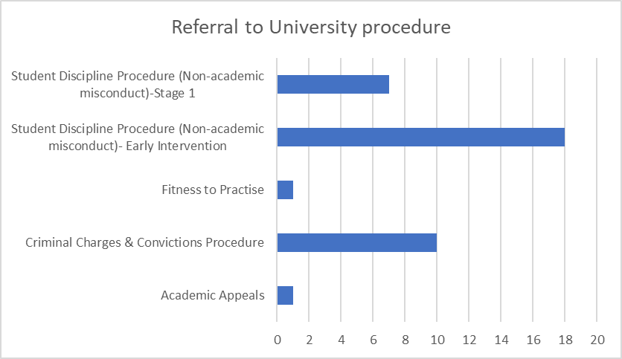

Focus for 2025-25

Enhanced approach to addressing racism and discrimination

In April 2025, the University conducted the Race Equality Charter survey. The subsequent report from this survey highlighted significant gaps in awareness around reporting racism; only 33% of Black, Asian and Minority Ethnic (BAME) students, and 43.8% of BAME staff, indicated that they knew how to report incidents of racism. The report also found that individuals from Mixed ethnic backgrounds in particular reported even lower levels of knowledge about reporting mechanisms compared to their white counterparts.

Since the publication of this report, the Student Conduct & Support team, Safeguarding team, and Access, Equality & Inclusion (specifically members of the Race Equality Steering Group) have met to consider how to improve awareness of reporting mechanisms within the staff and student bodies, specifically BAME staff and students. One key element of our approach will be in building trust and confidence with staff and students that action will be taken when incidents are reported, and we will continue to work with our colleagues within the Race Equality Steering Group to progress this work in 2025/26.
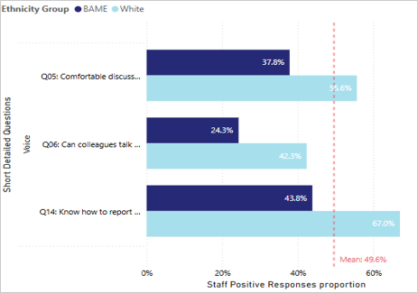

Staff survey responses

Knowing how to report racism (Q14): 59.7% staff reported that they know how to report racism, in which white (67.0%), Asian (48.9%), Black (50%) and Mixed (33.3%).

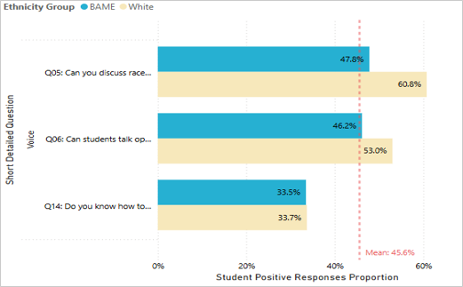

Student survey responses

Knowing how to report racism (Q14): 33.8% student reported that they know how to report racism, in which white (33.7%), Asian (38.6%), Black (20%) and Mixed (5.9%).

(Final question on this graph)

Improved data recording and reporting
Whilst improvements have been made over 2024/25 to the data the Student Conduct & Support team record (for example, more detailed information on outcomes and referral pathways), there is still much to be strengthened to provide a robust data set. For 2025/26, we will record:

- Reporter and reported student Faculty and department (if applicable)
- Reporter and reported student mode of study (i.e. UG/PGT/PGR)
- Reporter and reported student fee status.
- Enhanced information on outcomes, including outcomes of student discipline investigations conducted within departments and faculties. This will provide us with an essential comprehensive overview of what happens when a concern is raised with the University; from initial report being submitted to resolution.

A consistent approach will also be taken by both the Student Conduct & Support team and the Safeguarding team to the categorisation of our data sets to ensure that data request responses are consistent, and that the University has a comprehensive overview of concerns of this nature which are raised across the institution.

It is anticipated that in 2025/26 our gathering of management information and data sets should be improved as we move to procure an updated case management system to eventually replace Alcumus Report & Support. We are currently in the process of bidding for and procuring such a system.

Promotion
In addition to the standard methods of awareness raising and promotion which have been carried out in the previous academic year (such as attending open and applicant days, featuring in the Inside Strathclyde staff comms, posting on the Student news items in the Strath app and Myplace, participating in the live ‘We Are Strathclyde’ sessions for students), we have also created freshly branded images and assets for use in our promotion and awareness raising.

These regular promotional activities will be enhanced in 2025/26 with increased collaboration with Strath Union. One example is that we plan to host a specific joint event with Strath Union at the end of November 2025 to commence the University’s 16 days of activism against Gender-based violence. This will include a Strathclyde community safety fair at which Student Conduct & Support, Safeguarding, Security, and Res Life will all attend to promote Report and Support. External organisations such as Rape Crisis, Amina, and Women’s Aid are also scheduled to attend. This event will also include a programme of training opportunities for both staff and students, and a University social media takeover which will focus on Safe360°.

Student Experience Directorate
September 2025

