Department of Accounting and Finance
AG432 Financial Quantitative Methods
2025/26 Semester 2
20 Module Credits

Module Details

Module Description

This module aims to build on the knowledge, understanding, and skills acquired in the Quantitative Methods in Finance module and extend it further, especially in the context of matrix operations and computer programming skills such as MATLAB. It focuses on applications in finance of econometric techniques and is extended to incorporate Limited Dependent Variable (LDV) methods with their applications in finance.

Teaching Hours

Lectures: Fridays 10am-12pm .
Lab: Fridays 12-1pm.

Prerequisites
Honours entry requirements

Contact Details

Lecturer: Dr Leilei Tang
Room number: Stenhouse 3.29
Telephone: 0141 548 4961

E-mail: Leilei.tang@strath.ac.uk
Office Hours: Thursdays 13:00 – 15:00

Module Learning

Module Aims

The main aim of the module is to enable students to understand regression analysis, theories of hypothesis testing, and both linear and nonlinear regression estimations. The main feature of this module is to introduce matrix operations and computing programming skills to conduct data analysis with MATLAB.

Learning Objectives and Outcomes

Subject-specific knowledge and skills

On completing this module, you will be able to:

- Understand the concept and use of multivariate analysis and matrix operation
- Understand issues involved in modelling time series data and computer programming
- Understand and question the problems of some of the theoretical models in practice and consider the practical solutions to these problems.
- Have a better understanding of the relevant theoretical aspects of finance.
- The module will lead to a greater appreciation of the problems and limitations of the theory of finance in working with real information. Through this, students will be asked to
- question theories and models which they previously have used.

Cognitive abilities and non-subject specific skills

During the module you will:

- develop academic skills in reading and understanding basic computer programming.
- carry out practical assignments using analytical skills that can be applied to other
- situations requiring case study interpretation.
- The module will enable students to analyse real world finance problems and cases.
- The module will encourage students to participate actively in discussions.

Module Structure

Timetable

Week 1: Basic matrix operation (1)
Week 2 Basic matrix operation (2) and Hypothesis testing
Week 3: Introduction multivariate regression analysis
Week 4: Class test (30%)
Week 5: Introduction to final project and Logistic regression
Week 6: Logistic regression estimation using MATLAB
Week 7: Project discussion
Week 8-9: Advance Econometric Topics
Week 10: Project submission (70%)

Assessment and Feedback Details

- Class test worth 30% Friday 13th February 2026 during the lab slot, 12pm. Marks/Feedback will be released on or before Friday 6th March 2026, 12pm.

- Final assignment worth 70%.

An overall weighted average mark of 40% is required to pass the module.

It is a requirement for course completion to submit all assessed coursework. Non-submission of any part will result in an overall mark of zero being awarded for the module.

The following forms of feedback will assist you in this module: Verbal general feedback and formal written project feedback.
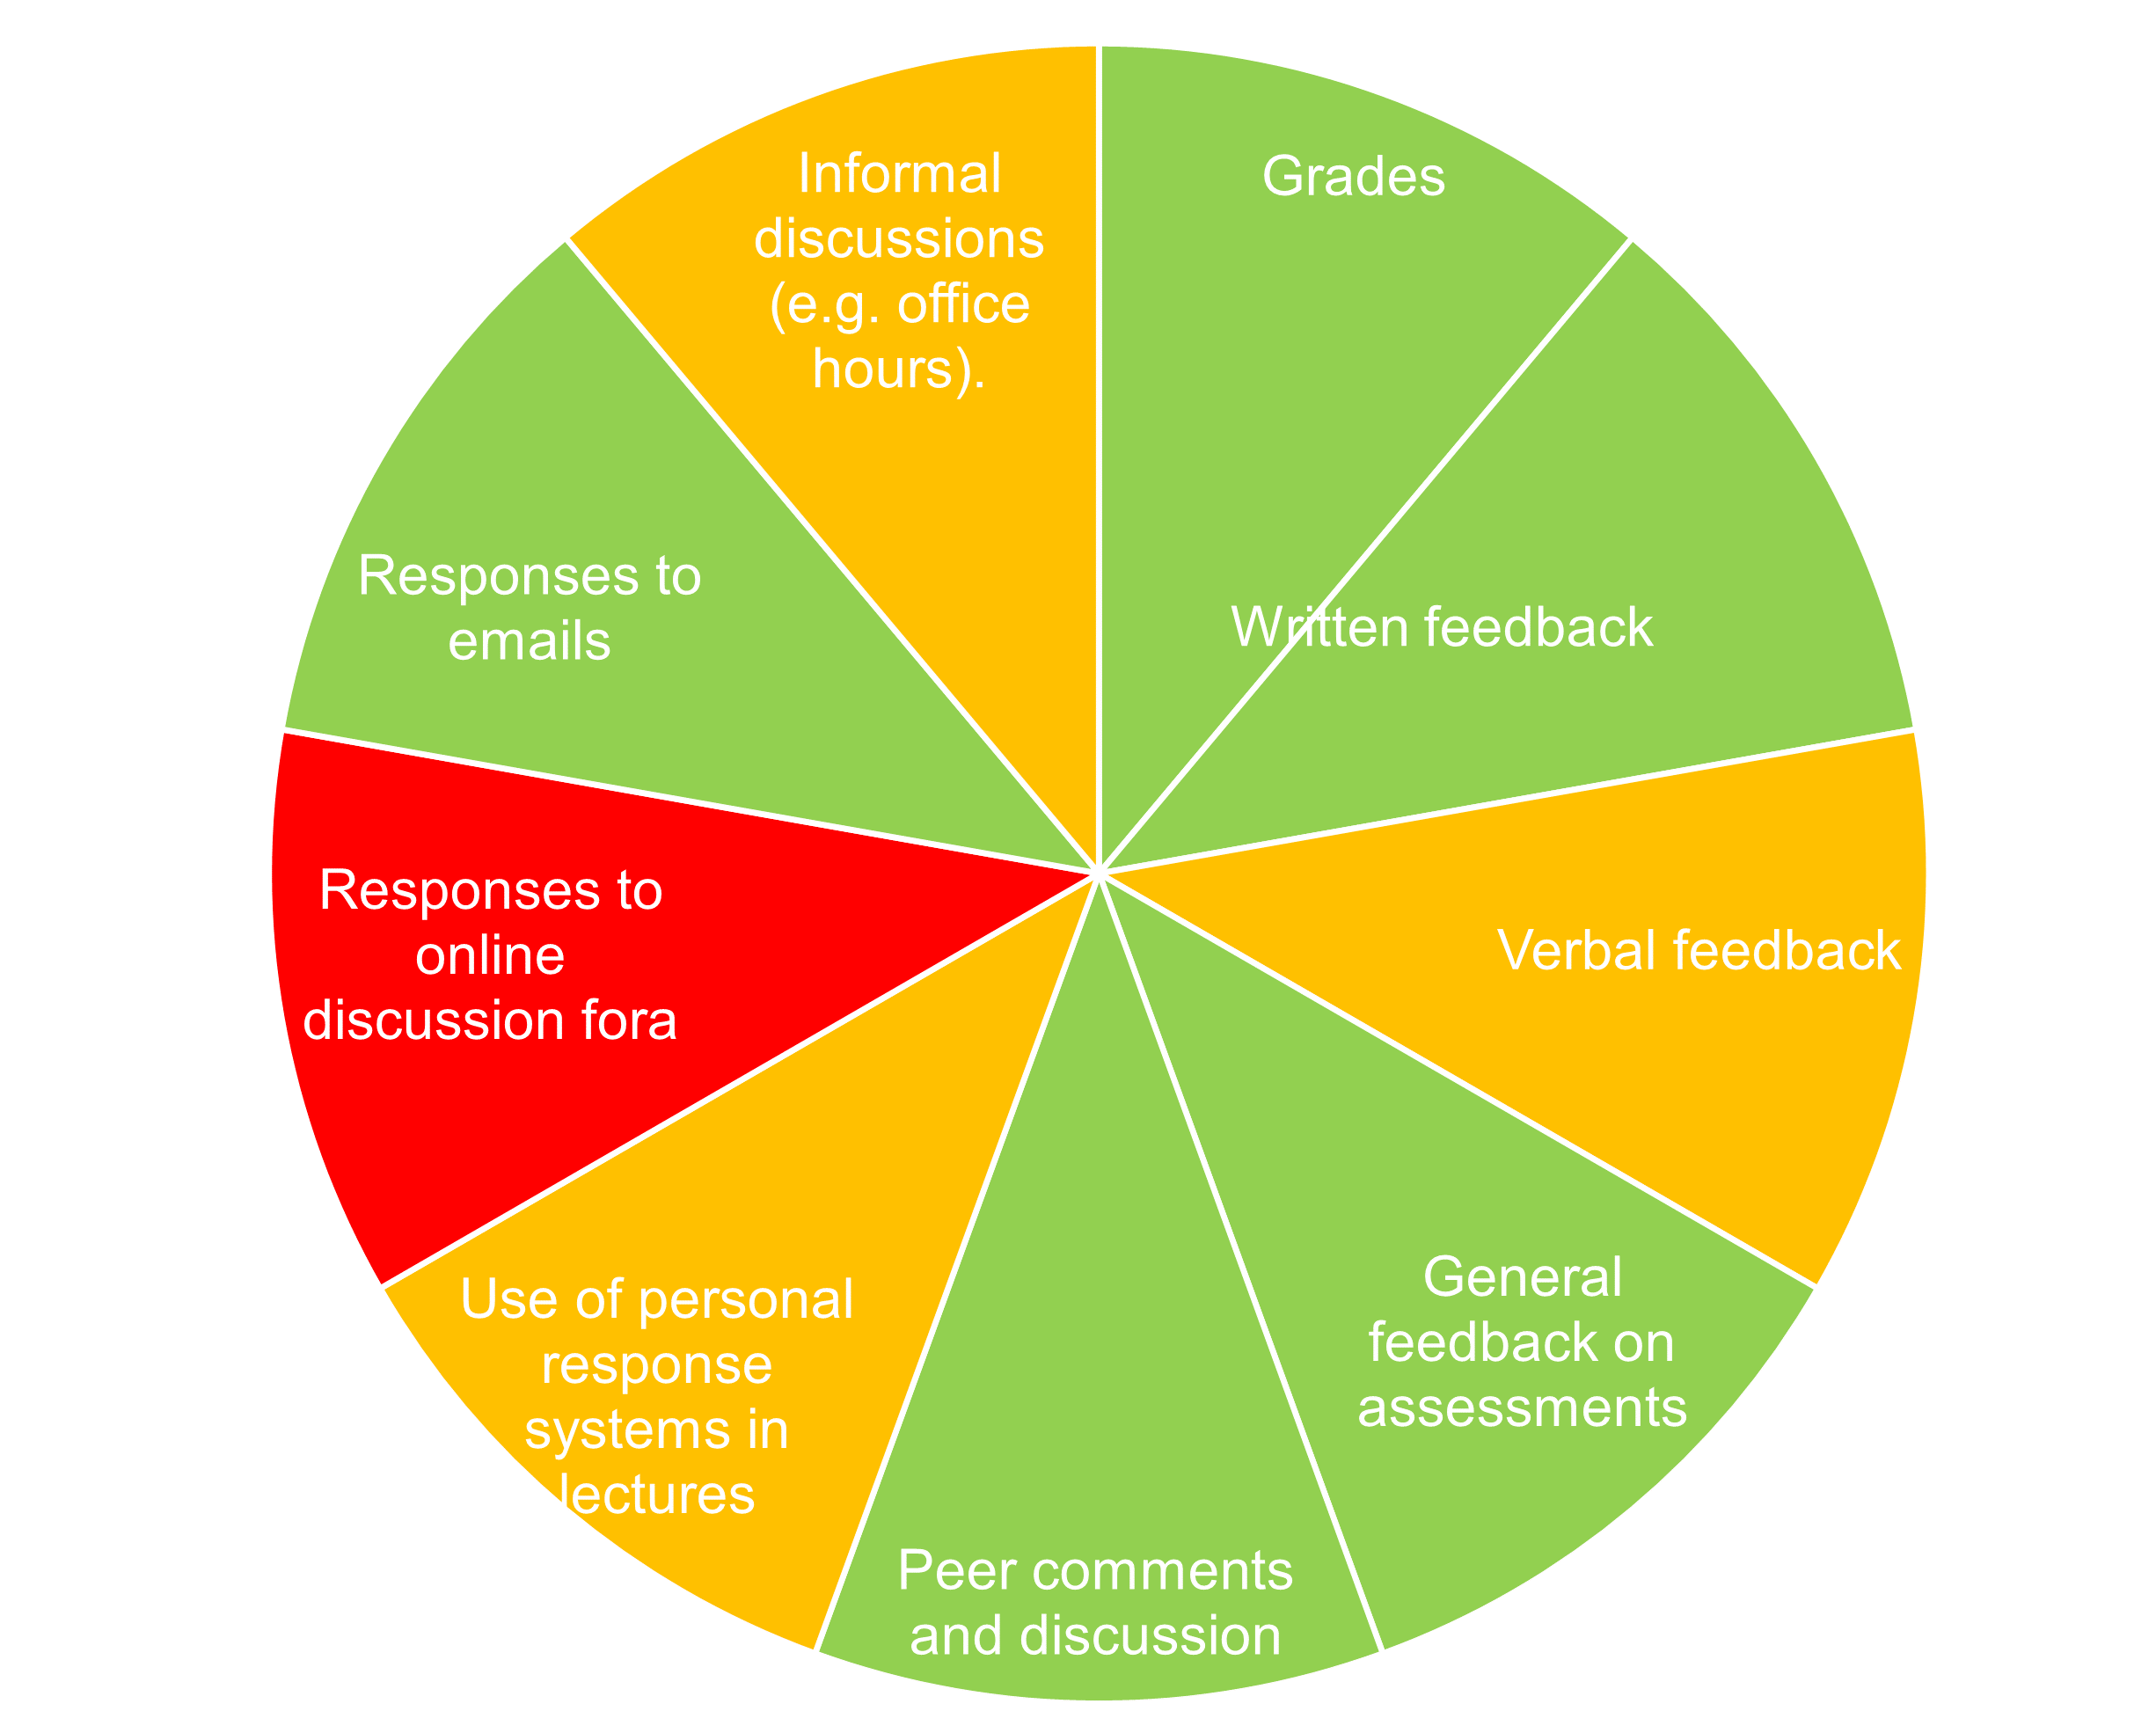

Artificial Intelligence
You are not permitted to use Gen-AI tools for this module unless you are a student with an adjustment report on Pegasus where this is explicitly specified as a ‘reasonable adjustment’. Any student suspected of using such tools will be subject to investigation outlined in the Student_Discipline_Procedure_-_Academic_Misconduct.pdf (strath.ac.uk) process.

Reading List

Please refer to the AG432 Myplace page to access the Reading List.
UG Module Manual (Honours)
Please refer to the accounting and finance UG manual module for the following (Honours Module Manual.docx).
- Tutorial Attendance
- Useful Contacts
- Penalties for Late Submission
- Feedback
- Compensation Scheme
- Resit Policy – no resits in honours year
- Universal Marking Guide
- Useful Links

