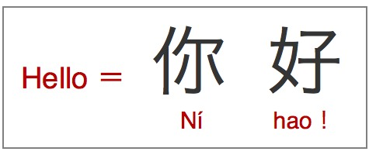**Learning Mandarin**

**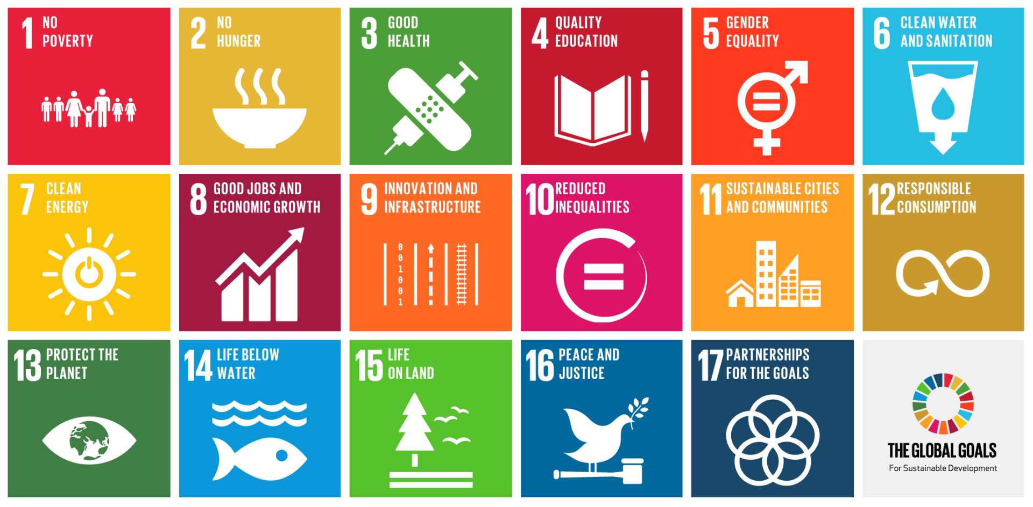My Passport for the Goals**



**Name:\_\_\_\_\_\_\_\_\_\_\_\_\_\_**

**School:\_\_\_\_\_\_\_\_\_\_\_\_\_\_**

****

|  |  |
| --- | --- |
| C:\Users\Vickers\AppData\Local\Microsoft\Windows\Temporary Internet Files\Content.IE5\PNZ2N3W1\facts-about-mandarin-chinese2-002[1].jpg**Selected Goals** | |
| **In class we learnt about:** | |
| **1. No Poverty** | C:\Users\Vickers\AppData\Local\Microsoft\Windows\Temporary Internet Files\Content.IE5\Z01ZFJVV\end_poverty-200x150[1].gif |
| **2. No Hunger** | C:\Users\Vickers\AppData\Local\Microsoft\Windows\Temporary Internet Files\Content.IE5\PNZ2N3W1\Stop_Hunger_Now_Logo[1].png |
| **3. Good Health** | **C:\Users\Vickers\AppData\Local\Microsoft\Windows\Temporary Internet Files\Content.IE5\F4KWLNWF\chinese-zodiac[1].jpg**C:\Users\Vickers\AppData\Local\Microsoft\Windows\Temporary Internet Files\Content.IE5\Z10UC2FR\Día-Europeo-para-la-Prevención-del-Riesgo-Cardiovascular[1].jpg |
| **4. Quality Education** | C:\Users\Vickers\AppData\Local\Microsoft\Windows\Temporary Internet Files\Content.IE5\PNZ2N3W1\1407593052[1].png |
| **5. Gender Equality** | C:\Users\Vickers\AppData\Local\Microsoft\Windows\Temporary Internet Files\Content.IE5\Z10UC2FR\Gender-Equality[1].jpg |
| **6. Clean Water and Sanitation** | C:\Users\Vickers\AppData\Local\Microsoft\Windows\Temporary Internet Files\Content.IE5\F4KWLNWF\water_drop_cartoon[1].jpg |
| **7. Clean Energy** | C:\Users\Vickers\AppData\Local\Microsoft\Windows\Temporary Internet Files\Content.IE5\Z01ZFJVV\technology[1].jpg |
| **8. Good Jobs and Economic Growth** | C:\Users\Vickers\AppData\Local\Microsoft\Windows\Temporary Internet Files\Content.IE5\Z10UC2FR\orient._profesional.1[1].jpg |
| **9. Innovation and Infrastructure** | C:\Program Files (x86)\Microsoft Office\MEDIA\CAGCAT10\j0297707.wmf |
| **10. Reduced Inequalities** | C:\Users\Vickers\AppData\Local\Microsoft\Windows\Temporary Internet Files\Content.IE5\Z01ZFJVV\jokes_5[1].jpg |
| **11. Sustainable Cities and Communities** | C:\Users\Vickers\AppData\Local\Microsoft\Windows\Temporary Internet Files\Content.IE5\F4KWLNWF\justice[1].jpg |
| **12. Responsible Consumption** | **C:\Users\Vickers\AppData\Local\Microsoft\Windows\Temporary Internet Files\Content.IE5\PNZ2N3W1\153219[1].jpg** |
| **13. Protect the Planet** | C:\Users\Vickers\AppData\Local\Microsoft\Windows\Temporary Internet Files\Content.IE5\Z10UC2FR\tumblr_ljn1oemxDf1qbcmvco1_500[1].png |
| **14. Life Below Water** | C:\Users\Vickers\AppData\Local\Microsoft\Windows\Temporary Internet Files\Content.IE5\F4KWLNWF\Life%20Below%20the%20Red%20Sea,%20Egypt[1].jpg |
| **15. Life on Land** | C:\Users\Vickers\AppData\Local\Microsoft\Windows\Temporary Internet Files\Content.IE5\Z10UC2FR\earth-and-nature[1].png |
| **17. Partnerships for the Goals** | C:\Users\Vickers\AppData\Local\Microsoft\Windows\Temporary Internet Files\Content.IE5\PNZ2N3W1\Community-500x408[1].jpg |





|  |  |
| --- | --- |
| **Showing My Understanding** | |
| **I can enjoy a song and a story in Mandarin related to the topics I am studying** | C:\Users\Vickers\AppData\Local\Microsoft\Windows\Temporary Internet Files\Content.IE5\Z01ZFJVV\nsmb2art20[1].jpgC:\Users\Vickers\AppData\Local\Microsoft\Windows\Temporary Internet Files\Content.IE5\Z01ZFJVV\nsmb2art20[1].jpgC:\Users\Vickers\AppData\Local\Microsoft\Windows\Temporary Internet Files\Content.IE5\Z01ZFJVV\nsmb2art20[1].jpg |
| **I can repeat new vocabulary and short sentences in Mandarin** | C:\Users\Vickers\AppData\Local\Microsoft\Windows\Temporary Internet Files\Content.IE5\Z01ZFJVV\large-Smiling-Star-166.6-17091[1].gifC:\Users\Vickers\AppData\Local\Microsoft\Windows\Temporary Internet Files\Content.IE5\Z01ZFJVV\large-Smiling-Star-166.6-17091[1].gifC:\Users\Vickers\AppData\Local\Microsoft\Windows\Temporary Internet Files\Content.IE5\Z01ZFJVV\large-Smiling-Star-166.6-17091[1].gif |
| **I can take part in a song or story related to the topics I am studying** | C:\Users\Vickers\AppData\Local\Microsoft\Windows\Temporary Internet Files\Content.IE5\PNZ2N3W1\large-Smiling-Star-33.3-17091[1].gifC:\Users\Vickers\AppData\Local\Microsoft\Windows\Temporary Internet Files\Content.IE5\PNZ2N3W1\large-Smiling-Star-33.3-17091[1].gifC:\Users\Vickers\AppData\Local\Microsoft\Windows\Temporary Internet Files\Content.IE5\PNZ2N3W1\large-Smiling-Star-33.3-17091[1].gif |
| **I can tell you the words I understand when I listen** | **C:\Users\Vickers\AppData\Local\Microsoft\Windows\Temporary Internet Files\Content.IE5\F4KWLNWF\600px-URSS_aviation_black_bordered_red_star.svg[1].pngC:\Users\Vickers\AppData\Local\Microsoft\Windows\Temporary Internet Files\Content.IE5\F4KWLNWF\600px-URSS_aviation_black_bordered_red_star.svg[1].pngC:\Users\Vickers\AppData\Local\Microsoft\Windows\Temporary Internet Files\Content.IE5\F4KWLNWF\600px-URSS_aviation_black_bordered_red_star.svg[1].png** |
| **I can identify the different tones in Mandarin** | **C:\Users\Vickers\AppData\Local\Microsoft\Windows\Temporary Internet Files\Content.IE5\Z10UC2FR\3D-Spiral-Star[1].pngC:\Users\Vickers\AppData\Local\Microsoft\Windows\Temporary Internet Files\Content.IE5\Z10UC2FR\3D-Spiral-Star[1].pngC:\Users\Vickers\AppData\Local\Microsoft\Windows\Temporary Internet Files\Content.IE5\Z10UC2FR\3D-Spiral-Star[1].png** |
| **I can understand information about other people in Mandarin** | **C:\Users\Vickers\AppData\Local\Microsoft\Windows\Temporary Internet Files\Content.IE5\Z01ZFJVV\1377511851[1].pngC:\Users\Vickers\AppData\Local\Microsoft\Windows\Temporary Internet Files\Content.IE5\Z01ZFJVV\1377511851[1].pngC:\Users\Vickers\AppData\Local\Microsoft\Windows\Temporary Internet Files\Content.IE5\Z01ZFJVV\1377511851[1].png** |

****

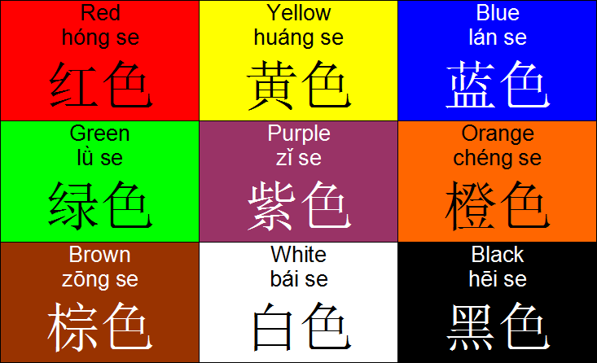

|  |  |
| --- | --- |
| **Using My Language** | |
| **I can introduce myself in a new context** | C:\Users\Vickers\AppData\Local\Microsoft\Windows\Temporary Internet Files\Content.IE5\Z10UC2FR\10001362-smiling-star-showing-thumbs-up[1].jpgC:\Users\Vickers\AppData\Local\Microsoft\Windows\Temporary Internet Files\Content.IE5\Z10UC2FR\10001362-smiling-star-showing-thumbs-up[1].jpgC:\Users\Vickers\AppData\Local\Microsoft\Windows\Temporary Internet Files\Content.IE5\Z10UC2FR\10001362-smiling-star-showing-thumbs-up[1].jpg |
| **I can greet other people** | C:\Users\Vickers\AppData\Local\Microsoft\Windows\Temporary Internet Files\Content.IE5\Z01ZFJVV\1377511851[1].pngC:\Users\Vickers\AppData\Local\Microsoft\Windows\Temporary Internet Files\Content.IE5\Z01ZFJVV\1377511851[1].pngC:\Users\Vickers\AppData\Local\Microsoft\Windows\Temporary Internet Files\Content.IE5\Z01ZFJVV\1377511851[1].png |
| **I can say how I feel** | C:\Users\Vickers\AppData\Local\Microsoft\Windows\Temporary Internet Files\Content.IE5\Z10UC2FR\Blue_star_on_white[1].gifC:\Users\Vickers\AppData\Local\Microsoft\Windows\Temporary Internet Files\Content.IE5\Z10UC2FR\Blue_star_on_white[1].gifC:\Users\Vickers\AppData\Local\Microsoft\Windows\Temporary Internet Files\Content.IE5\Z10UC2FR\Blue_star_on_white[1].gif |
| **I can find out how other people feel** | C:\Users\Vickers\AppData\Local\Microsoft\Windows\Temporary Internet Files\Content.IE5\Z01ZFJVV\Award_star_(gold)[1].pngC:\Users\Vickers\AppData\Local\Microsoft\Windows\Temporary Internet Files\Content.IE5\Z01ZFJVV\Award_star_(gold)[1].pngC:\Users\Vickers\AppData\Local\Microsoft\Windows\Temporary Internet Files\Content.IE5\Z01ZFJVV\Award_star_(gold)[1].png |
| **I can tell you information about myself in a new context** | C:\Users\Vickers\AppData\Local\Microsoft\Windows\Temporary Internet Files\Content.IE5\F4KWLNWF\Silver_star_with_red_border[1].pngC:\Users\Vickers\AppData\Local\Microsoft\Windows\Temporary Internet Files\Content.IE5\F4KWLNWF\Silver_star_with_red_border[1].pngC:\Users\Vickers\AppData\Local\Microsoft\Windows\Temporary Internet Files\Content.IE5\F4KWLNWF\Silver_star_with_red_border[1].png |
| **I can ask others about themselves** | **C:\Users\Vickers\AppData\Local\Microsoft\Windows\Temporary Internet Files\Content.IE5\PNZ2N3W1\large-Smiling-Star-33.3-17091[1].gifC:\Users\Vickers\AppData\Local\Microsoft\Windows\Temporary Internet Files\Content.IE5\PNZ2N3W1\large-Smiling-Star-33.3-17091[1].gifC:\Users\Vickers\AppData\Local\Microsoft\Windows\Temporary Internet Files\Content.IE5\PNZ2N3W1\large-Smiling-Star-33.3-17091[1].gif** |
| **I can count to twenty in Mandarin and I can recognise patterns to help me to recognise higher numbers** | **C:\Users\Vickers\AppData\Local\Microsoft\Windows\Temporary Internet Files\Content.IE5\PNZ2N3W1\512px-Rainbow_star.svg[1].pngC:\Users\Vickers\AppData\Local\Microsoft\Windows\Temporary Internet Files\Content.IE5\PNZ2N3W1\512px-Rainbow_star.svg[1].pngC:\Users\Vickers\AppData\Local\Microsoft\Windows\Temporary Internet Files\Content.IE5\PNZ2N3W1\512px-Rainbow_star.svg[1].png** |
| **I can take part in a conversation or a role play** | **C:\Users\Vickers\AppData\Local\Microsoft\Windows\Temporary Internet Files\Content.IE5\Z01ZFJVV\large-Smiling-Star-166.6-17091[1].gifC:\Users\Vickers\AppData\Local\Microsoft\Windows\Temporary Internet Files\Content.IE5\Z01ZFJVV\large-Smiling-Star-166.6-17091[1].gifC:\Users\Vickers\AppData\Local\Microsoft\Windows\Temporary Internet Files\Content.IE5\Z01ZFJVV\large-Smiling-Star-166.6-17091[1].gif** |
| **I can say what the weather is like** | **C:\Users\Vickers\AppData\Local\Microsoft\Windows\Temporary Internet Files\Content.IE5\Z01ZFJVV\shooting-star[1].pngC:\Users\Vickers\AppData\Local\Microsoft\Windows\Temporary Internet Files\Content.IE5\Z01ZFJVV\shooting-star[1].pngC:\Users\Vickers\AppData\Local\Microsoft\Windows\Temporary Internet Files\Content.IE5\Z01ZFJVV\shooting-star[1].png** |
| **I can tell you what the weather is like in different countries** | **C:\Users\Vickers\AppData\Local\Microsoft\Windows\Temporary Internet Files\Content.IE5\F4KWLNWF\smiling-star-face-16371-large[1].pngC:\Users\Vickers\AppData\Local\Microsoft\Windows\Temporary Internet Files\Content.IE5\F4KWLNWF\smiling-star-face-16371-large[1].pngC:\Users\Vickers\AppData\Local\Microsoft\Windows\Temporary Internet Files\Content.IE5\F4KWLNWF\smiling-star-face-16371-large[1].png** |
| **I can say words to do with nature (colour, object, texture, what I like or do not like)** | **C:\Users\Vickers\AppData\Local\Microsoft\Windows\Temporary Internet Files\Content.IE5\Z10UC2FR\10001362-smiling-star-showing-thumbs-up[1].jpg**C:\Users\Vickers\AppData\Local\Microsoft\Windows\Temporary Internet Files\Content.IE5\Z10UC2FR\10001362-smiling-star-showing-thumbs-up[1].jpgC:\Users\Vickers\AppData\Local\Microsoft\Windows\Temporary Internet Files\Content.IE5\Z10UC2FR\10001362-smiling-star-showing-thumbs-up[1].jpg |

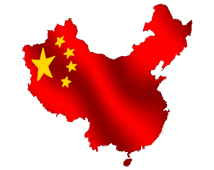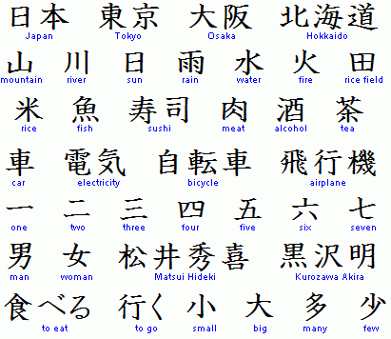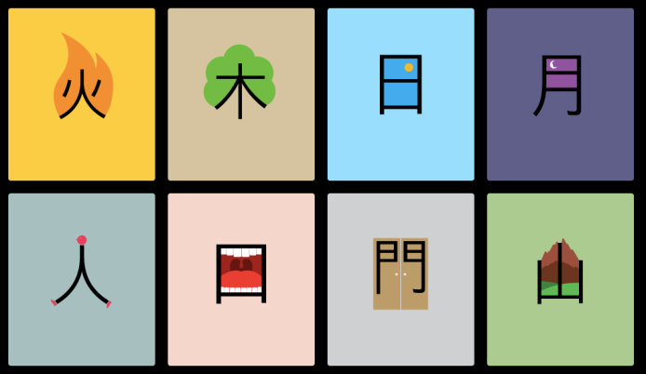

|  |  |
| --- | --- |
| **I can match some simple characters  to pictures** | C:\Users\Vickers\AppData\Local\Microsoft\Windows\Temporary Internet Files\Content.IE5\PNZ2N3W1\808px-Sun_Star.svg[1].pngC:\Users\Vickers\AppData\Local\Microsoft\Windows\Temporary Internet Files\Content.IE5\PNZ2N3W1\808px-Sun_Star.svg[1].pngC:\Users\Vickers\AppData\Local\Microsoft\Windows\Temporary Internet Files\Content.IE5\PNZ2N3W1\808px-Sun_Star.svg[1].png |
| **I can write some Chinese characters** | C:\Users\Vickers\AppData\Local\Microsoft\Windows\Temporary Internet Files\Content.IE5\F4KWLNWF\600px-URSS_aviation_black_bordered_red_star.svg[1].pngC:\Users\Vickers\AppData\Local\Microsoft\Windows\Temporary Internet Files\Content.IE5\F4KWLNWF\600px-URSS_aviation_black_bordered_red_star.svg[1].pngC:\Users\Vickers\AppData\Local\Microsoft\Windows\Temporary Internet Files\Content.IE5\F4KWLNWF\600px-URSS_aviation_black_bordered_red_star.svg[1].png |
| **I can tell you some short sentences in Mandarin from topics we have covered in class** | C:\Users\Vickers\AppData\Local\Microsoft\Windows\Temporary Internet Files\Content.IE5\Z01ZFJVV\sy-bethlehem-star[1].png**C:\Users\Vickers\AppData\Local\Microsoft\Windows\Temporary Internet Files\Content.IE5\Z01ZFJVV\sy-bethlehem-star[1].png**C:\Users\Vickers\AppData\Local\Microsoft\Windows\Temporary Internet Files\Content.IE5\Z01ZFJVV\sy-bethlehem-star[1].png |
| **I can explain some facts about China** | C:\Users\Vickers\AppData\Local\Microsoft\Windows\Temporary Internet Files\Content.IE5\Z01ZFJVV\nsmb2art20[1].jpgC:\Users\Vickers\AppData\Local\Microsoft\Windows\Temporary Internet Files\Content.IE5\Z01ZFJVV\nsmb2art20[1].jpgC:\Users\Vickers\AppData\Local\Microsoft\Windows\Temporary Internet Files\Content.IE5\Z01ZFJVV\nsmb2art20[1].jpg |
| **I can explain some cultural facts about the topics I have covered** | C:\Users\Vickers\AppData\Local\Microsoft\Windows\Temporary Internet Files\Content.IE5\Z10UC2FR\20090120035706!Free_Blue_Star[1].jpgC:\Users\Vickers\AppData\Local\Microsoft\Windows\Temporary Internet Files\Content.IE5\Z10UC2FR\20090120035706!Free_Blue_Star[1].jpgC:\Users\Vickers\AppData\Local\Microsoft\Windows\Temporary Internet Files\Content.IE5\Z10UC2FR\20090120035706!Free_Blue_Star[1].jpg |
| **I am becoming aware of different cultures and languages around the world** | C:\Users\Vickers\AppData\Local\Microsoft\Windows\Temporary Internet Files\Content.IE5\PNZ2N3W1\large-Smiling-Star-33.3-17091[1].gifC:\Users\Vickers\AppData\Local\Microsoft\Windows\Temporary Internet Files\Content.IE5\PNZ2N3W1\large-Smiling-Star-33.3-17091[1].gifC:\Users\Vickers\AppData\Local\Microsoft\Windows\Temporary Internet Files\Content.IE5\PNZ2N3W1\large-Smiling-Star-33.3-17091[1].gif |

**The Goal I learned about was:**

|  |
| --- |
| **C:\Users\Vickers\AppData\Local\Microsoft\Windows\Temporary Internet Files\Content.IE5\Z01ZFJVV\global-goals-logo-2[1].png**  **I found out:**  **C:\Users\Vickers\AppData\Local\Microsoft\Windows\Temporary Internet Files\Content.IE5\PNZ2N3W1\The-Global-Goals[1].jpg** |

****

**My main activities were:**

|  |
| --- |
| **C:\Users\Vickers\AppData\Local\Microsoft\Windows\Temporary Internet Files\Content.IE5\Z01ZFJVV\global-goals-logo-2[1].png** |

|  |
| --- |
| Image result for images for one to twenty in mandarin**Count how many stars you collected. Write the number in CHINESE**  Image result for images for one to twenty in mandarin**How many stars will you aim to collect next? Write the number in CHINESE** |

**How many stars did I collect on my passport?   
How can I get more?**