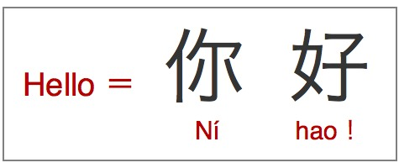**Learning Mandarin**

**My Passport to Nature**

**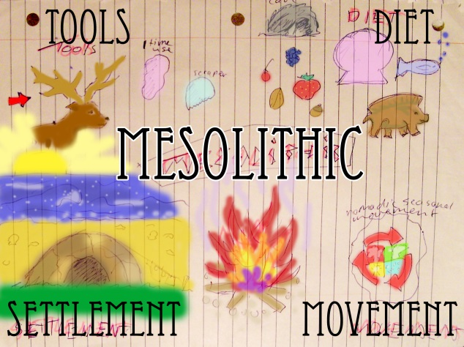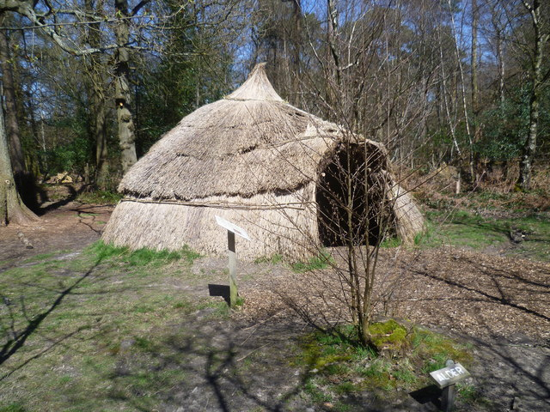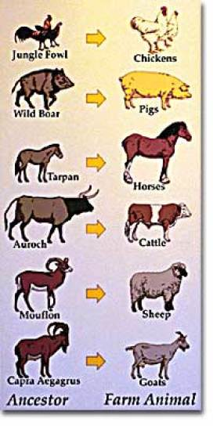**

**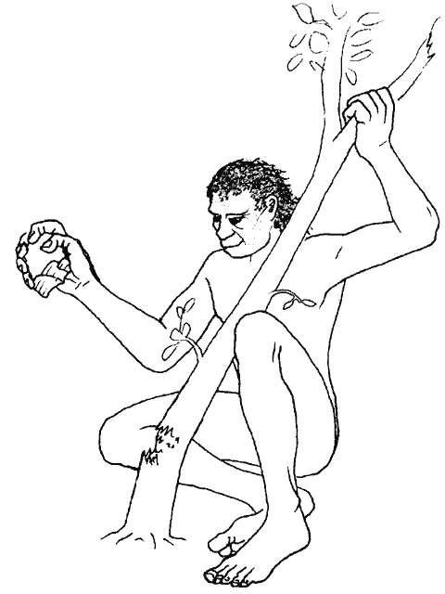**

**Name:\_\_\_\_\_\_\_\_\_\_\_\_\_\_**

**School:\_\_\_\_\_\_\_\_\_\_\_\_\_\_**

****

|  |  |
| --- | --- |
| C:\Users\Vickers\AppData\Local\Microsoft\Windows\Temporary Internet Files\Content.IE5\PNZ2N3W1\facts-about-mandarin-chinese2-002[1].jpg**If You Go Down to the Woods Today** | |
| **In class we chose the following topics in Mandarin:** | |
| **1. Nature** | **C:\Users\gpb14233\AppData\Local\Microsoft\Windows\Temporary Internet Files\Content.IE5\7WUXOGGD\Steps_in_Windy_Nook_Nature_Reserve[1].jpg** |
| **2. Colours and textures** | **C:\Users\gpb14233\AppData\Local\Microsoft\Windows\Temporary Internet Files\Content.IE5\VK9RZAI2\Abstract_Rainbow_Colours_Wallpapers_2[1].jpg** |
| **3. Dwellings / Where we live/Rooms** | **C:\Users\gpb14233\AppData\Local\Microsoft\Windows\Temporary Internet Files\Content.IE5\VXIR3EQE\yurt[1].jpgC:\Users\Vickers\AppData\Local\Microsoft\Windows\Temporary Internet Files\Content.IE5\F4KWLNWF\chinese-zodiac[1].jpg** |
| **4. Journeys/ Adventures** | **C:\Users\gpb14233\AppData\Local\Microsoft\Windows\Temporary Internet Files\Content.IE5\EYUNEFHL\your-journey[1].jpg** |
| **5. Family / Ethnic Groups** | **C:\Users\gpb14233\AppData\Local\Microsoft\Windows\Temporary Internet Files\Content.IE5\YL02FC8E\Čuvajte_Jugoslaviju[1].jpg** |
| **6. Animals** | C:\Users\gpb14233\AppData\Local\Microsoft\Windows\Temporary Internet Files\Content.IE5\VK9RZAI2\Bedburg_14er_front[1].png |
| **7. Food and Water** | C:\Users\gpb14233\AppData\Local\Microsoft\Windows\Temporary Internet Files\Content.IE5\YL02FC8E\berries[1].jpg |
| **8. Buying things /Trading** | C:\Users\gpb14233\AppData\Local\Microsoft\Windows\Temporary Internet Files\Content.IE5\YL02FC8E\6498611045_94f6c7459f_z[1].jpg |
| **We completed the following activities:** |  |
| **1.Building a Yurt or Mini Camp inside or outside** | C:\Users\gpb14233\AppData\Local\Microsoft\Windows\Temporary Internet Files\Content.IE5\VXIR3EQE\3422606_49e3eb3a[1].jpg |
| **2. Making a journey stick** | C:\Users\gpb14233\AppData\Local\Microsoft\Windows\Temporary Internet Files\Content.IE5\YL02FC8E\200px-Rainstick_01[1].png |
| **3. Outdoor postcard activities** | C:\Users\gpb14233\AppData\Local\Microsoft\Windows\Temporary Internet Files\Content.IE5\VK9RZAI2\6526315613_83dce4d96d[1].jpg |
| **4. Trust games to develop a Clan** | C:\Users\gpb14233\AppData\Local\Microsoft\Windows\Temporary Internet Files\Content.IE5\YL02FC8E\trust_building[1] |
| **5. Nature Character Safari** | C:\Users\gpb14233\AppData\Local\Microsoft\Windows\Temporary Internet Files\Content.IE5\7WUXOGGD\map-159714_640[1].png |
| **6. Woodland Supermarket/Nature Supermarket** | C:\Users\gpb14233\AppData\Local\Microsoft\Windows\Temporary Internet Files\Content.IE5\VK9RZAI2\flints%2015%20flakes[1].jpg |
| **7. Making Tree Spirits** | C:\Users\gpb14233\AppData\Local\Microsoft\Windows\Temporary Internet Files\Content.IE5\B8NFIUNS\6560998555_b826b1f979_z[1].jpg |
| **15. Making a Chinese Wishing Tree** | C:\Users\gpb14233\AppData\Local\Microsoft\Windows\Temporary Internet Files\Content.IE5\EYUNEFHL\clipart_-_tree.228122843_std[1].jpg |
| **17. Looking at Poems about Nature and the names of trees in Gaelic** | C:\Users\gpb14233\AppData\Local\Microsoft\Windows\Temporary Internet Files\Content.IE5\9PADYDM6\armsreaching2[1].jpg |
| **18. Creating our own trans-language poem about what we have learned (Using some Chinese characters and our own/other languages)** | C:\Users\gpb14233\AppData\Local\Microsoft\Windows\Temporary Internet Files\Content.IE5\7WUXOGGD\cinquain_monkey[1].png |

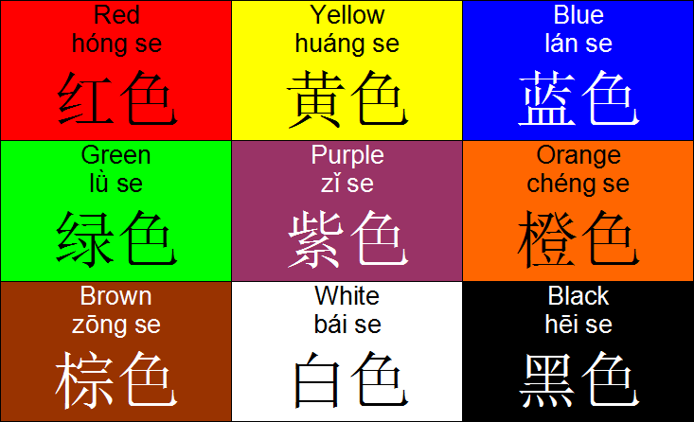****



|  |  |
| --- | --- |
| **Showing My Understanding** | |
| **I can enjoy a song and a story in Mandarin related to the topics I am studying** | **C:\Users\gpb14233\AppData\Local\Microsoft\Windows\Temporary Internet Files\Content.IE5\YL02FC8E\sturdy_tree[1].png**C:\Users\gpb14233\AppData\Local\Microsoft\Windows\Temporary Internet Files\Content.IE5\YL02FC8E\sturdy_tree[1].pngC:\Users\gpb14233\AppData\Local\Microsoft\Windows\Temporary Internet Files\Content.IE5\YL02FC8E\sturdy_tree[1].png |
| **I can repeat new vocabulary and short sentences in Mandarin** | **C:\Users\gpb14233\AppData\Local\Microsoft\Windows\Temporary Internet Files\Content.IE5\B8NFIUNS\5718214892_dedd9704bb[1].jpgC:\Users\gpb14233\AppData\Local\Microsoft\Windows\Temporary Internet Files\Content.IE5\B8NFIUNS\5718214892_dedd9704bb[1].jpg**C:\Users\gpb14233\AppData\Local\Microsoft\Windows\Temporary Internet Files\Content.IE5\B8NFIUNS\5718214892_dedd9704bb[1].jpg |
| **I can take part in a song or story related to the topics I am studying** | **C:\Users\gpb14233\AppData\Local\Microsoft\Windows\Temporary Internet Files\Content.IE5\VK9RZAI2\think-green[1].jpgC:\Users\gpb14233\AppData\Local\Microsoft\Windows\Temporary Internet Files\Content.IE5\VK9RZAI2\think-green[1].jpgC:\Users\gpb14233\AppData\Local\Microsoft\Windows\Temporary Internet Files\Content.IE5\VK9RZAI2\think-green[1].jpg** |
| **I can tell you the words I understand when I listen** | **C:\Users\gpb14233\AppData\Local\Microsoft\Windows\Temporary Internet Files\Content.IE5\YL02FC8E\sturdy_tree[1].pngC:\Users\gpb14233\AppData\Local\Microsoft\Windows\Temporary Internet Files\Content.IE5\YL02FC8E\sturdy_tree[1].pngC:\Users\gpb14233\AppData\Local\Microsoft\Windows\Temporary Internet Files\Content.IE5\YL02FC8E\sturdy_tree[1].png** |
| **I can identify the different tones in Mandarin** | **C:\Users\gpb14233\AppData\Local\Microsoft\Windows\Temporary Internet Files\Content.IE5\6J0AERG3\5718206198_78e21e2695_z[1].jpgC:\Users\gpb14233\AppData\Local\Microsoft\Windows\Temporary Internet Files\Content.IE5\6J0AERG3\5718206198_78e21e2695_z[1].jpgC:\Users\gpb14233\AppData\Local\Microsoft\Windows\Temporary Internet Files\Content.IE5\6J0AERG3\5718206198_78e21e2695_z[1].jpg** |
| **I can understand information about other people in Mandarin** | **C:\Users\gpb14233\AppData\Local\Microsoft\Windows\Temporary Internet Files\Content.IE5\6J0AERG3\tree%202[1].jpgC:\Users\gpb14233\AppData\Local\Microsoft\Windows\Temporary Internet Files\Content.IE5\6J0AERG3\tree%202[1].jpgC:\Users\gpb14233\AppData\Local\Microsoft\Windows\Temporary Internet Files\Content.IE5\6J0AERG3\tree%202[1].jpg** |
| **I can understand and explain a poem about ancient trees in English** | **C:\Users\gpb14233\AppData\Local\Microsoft\Windows\Temporary Internet Files\Content.IE5\VXIR3EQE\bamboo-23890_960_720[1].pngC:\Users\gpb14233\AppData\Local\Microsoft\Windows\Temporary Internet Files\Content.IE5\VXIR3EQE\bamboo-23890_960_720[1].pngC:\Users\gpb14233\AppData\Local\Microsoft\Windows\Temporary Internet Files\Content.IE5\VXIR3EQE\bamboo-23890_960_720[1].png** |
|  |  |

C:\Program Files\Microsoft Office\MEDIA\CAGCAT10\j0285444.wmf

|  |  |
| --- | --- |
| **Using My Language** | |
| **I can introduce myself in a new context** | **C:\Users\gpb14233\AppData\Local\Microsoft\Windows\Temporary Internet Files\Content.IE5\VK9RZAI2\tree-19[1].pngC:\Users\gpb14233\AppData\Local\Microsoft\Windows\Temporary Internet Files\Content.IE5\VK9RZAI2\tree-19[1].pngC:\Users\gpb14233\AppData\Local\Microsoft\Windows\Temporary Internet Files\Content.IE5\VK9RZAI2\tree-19[1].png** |
| **I can greet other people** | **C:\Users\gpb14233\AppData\Local\Microsoft\Windows\Temporary Internet Files\Content.IE5\7WUXOGGD\bonsai-154570_960_720[1].pngC:\Users\gpb14233\AppData\Local\Microsoft\Windows\Temporary Internet Files\Content.IE5\7WUXOGGD\bonsai-154570_960_720[1].pngC:\Users\gpb14233\AppData\Local\Microsoft\Windows\Temporary Internet Files\Content.IE5\7WUXOGGD\bonsai-154570_960_720[1].png** |
| **I can say how I feel** | **C:\Users\gpb14233\AppData\Local\Microsoft\Windows\Temporary Internet Files\Content.IE5\6J0AERG3\Chinese-Bonsai-Tree[1].pngC:\Users\gpb14233\AppData\Local\Microsoft\Windows\Temporary Internet Files\Content.IE5\6J0AERG3\Chinese-Bonsai-Tree[1].png** |
| **I can find out how other people feel** | C:\Users\gpb14233\AppData\Local\Microsoft\Windows\Temporary Internet Files\Content.IE5\VXIR3EQE\cherry_blossom_tree_branch_texture_by_gkwill-d4xxsto[1].jpgC:\Users\gpb14233\AppData\Local\Microsoft\Windows\Temporary Internet Files\Content.IE5\VXIR3EQE\cherry_blossom_tree_branch_texture_by_gkwill-d4xxsto[1].jpgC:\Users\gpb14233\AppData\Local\Microsoft\Windows\Temporary Internet Files\Content.IE5\VXIR3EQE\cherry_blossom_tree_branch_texture_by_gkwill-d4xxsto[1].jpg |
| **I can tell you information about myself in a new context** | **C:\Users\gpb14233\AppData\Local\Microsoft\Windows\Temporary Internet Files\Content.IE5\VK9RZAI2\lgi01a201408270200[1].jpgC:\Users\gpb14233\AppData\Local\Microsoft\Windows\Temporary Internet Files\Content.IE5\VK9RZAI2\lgi01a201408270200[1].jpgC:\Users\gpb14233\AppData\Local\Microsoft\Windows\Temporary Internet Files\Content.IE5\VK9RZAI2\lgi01a201408270200[1].jpg** |
| **I can ask others about themselves** | **C:\Users\gpb14233\AppData\Local\Microsoft\Windows\Temporary Internet Files\Content.IE5\B8NFIUNS\rg1024-soft-trees-2[1].pngC:\Users\gpb14233\AppData\Local\Microsoft\Windows\Temporary Internet Files\Content.IE5\B8NFIUNS\rg1024-soft-trees-2[1].pngC:\Users\gpb14233\AppData\Local\Microsoft\Windows\Temporary Internet Files\Content.IE5\B8NFIUNS\rg1024-soft-trees-2[1].png** |
| **I can count to twenty in Mandarin and I can**  **recognise patterns to help me to recognise higher numbers** | **C:\Users\gpb14233\AppData\Local\Microsoft\Windows\Temporary Internet Files\Content.IE5\VK9RZAI2\tree-19[1].pngC:\Users\gpb14233\AppData\Local\Microsoft\Windows\Temporary Internet Files\Content.IE5\VK9RZAI2\tree-19[1].pngC:\Users\gpb14233\AppData\Local\Microsoft\Windows\Temporary Internet Files\Content.IE5\VK9RZAI2\tree-19[1].png** |
| **I can take part in a conversation or a role play** | **C:\Users\gpb14233\AppData\Local\Microsoft\Windows\Temporary Internet Files\Content.IE5\6J0AERG3\tree%202[1].jpgC:\Users\gpb14233\AppData\Local\Microsoft\Windows\Temporary Internet Files\Content.IE5\6J0AERG3\tree%202[1].jpgC:\Users\gpb14233\AppData\Local\Microsoft\Windows\Temporary Internet Files\Content.IE5\6J0AERG3\tree%202[1].jpg** |
| **I can find out how much something costs** | **C:\Users\gpb14233\AppData\Local\Microsoft\Windows\Temporary Internet Files\Content.IE5\B8NFIUNS\green-tree-3670-large[1].pngC:\Users\gpb14233\AppData\Local\Microsoft\Windows\Temporary Internet Files\Content.IE5\B8NFIUNS\green-tree-3670-large[1].pngC:\Users\gpb14233\AppData\Local\Microsoft\Windows\Temporary Internet Files\Content.IE5\B8NFIUNS\green-tree-3670-large[1].png** |
| **I can tell you what I would like to buy/trade** | **C:\Users\gpb14233\AppData\Local\Microsoft\Windows\Temporary Internet Files\Content.IE5\VK9RZAI2\poinciana_tree_by_lilipilyspirit-d4zkifl[1].pngC:\Users\gpb14233\AppData\Local\Microsoft\Windows\Temporary Internet Files\Content.IE5\VK9RZAI2\poinciana_tree_by_lilipilyspirit-d4zkifl[1].png** |
| **I can say words to do with nature (colour, object, texture, what I like or do not like)** |  |
| **I can appreciate the importance of trees for learning the Gaelic Alphabet** | C:\Users\gpb14233\AppData\Local\Microsoft\Windows\Temporary Internet Files\Content.IE5\EYUNEFHL\364747-3-4-99fad[1].jpgC:\Users\gpb14233\AppData\Local\Microsoft\Windows\Temporary Internet Files\Content.IE5\EYUNEFHL\364747-3-4-99fad[1].jpgC:\Users\gpb14233\AppData\Local\Microsoft\Windows\Temporary Internet Files\Content.IE5\EYUNEFHL\364747-3-4-99fad[1].jpg |

**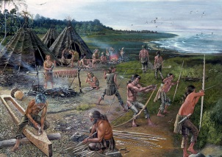**

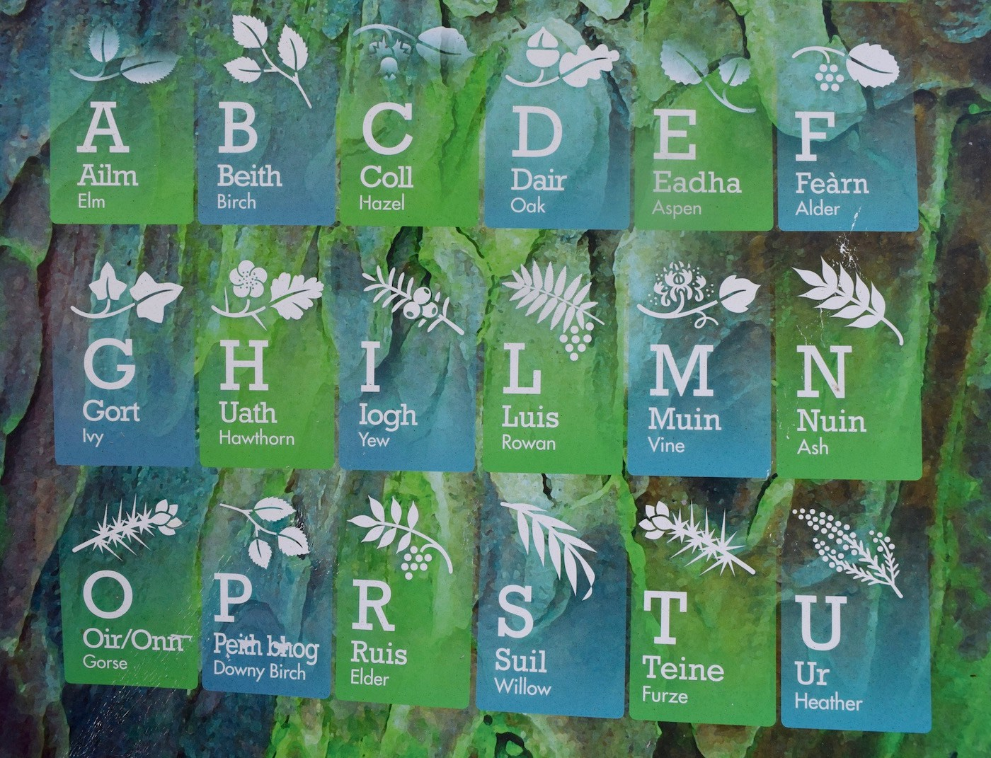

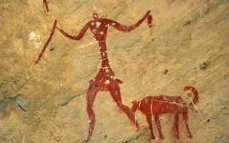

|  |  |
| --- | --- |
| **I can match some simple characters  to pictures** | C:\Users\gpb14233\AppData\Local\Microsoft\Windows\Temporary Internet Files\Content.IE5\YL02FC8E\TN_mango_tree_27[1].jpgC:\Users\gpb14233\AppData\Local\Microsoft\Windows\Temporary Internet Files\Content.IE5\YL02FC8E\TN_mango_tree_27[1].jpgC:\Users\gpb14233\AppData\Local\Microsoft\Windows\Temporary Internet Files\Content.IE5\YL02FC8E\TN_mango_tree_27[1].jpg |
| **I can write some Chinese characters** | C:\Users\gpb14233\AppData\Local\Microsoft\Windows\Temporary Internet Files\Content.IE5\VXIR3EQE\ace_gla_DOUGLASM[1].gifC:\Users\gpb14233\AppData\Local\Microsoft\Windows\Temporary Internet Files\Content.IE5\VXIR3EQE\ace_gla_DOUGLASM[1].gifC:\Users\gpb14233\AppData\Local\Microsoft\Windows\Temporary Internet Files\Content.IE5\VXIR3EQE\ace_gla_DOUGLASM[1].gif |
| **I can tell you some short sentences in Mandarin from topics we have covered in class** | C:\Users\gpb14233\AppData\Local\Microsoft\Windows\Temporary Internet Files\Content.IE5\YL02FC8E\sturdy_tree[1].pngC:\Users\gpb14233\AppData\Local\Microsoft\Windows\Temporary Internet Files\Content.IE5\YL02FC8E\sturdy_tree[1].pngC:\Users\gpb14233\AppData\Local\Microsoft\Windows\Temporary Internet Files\Content.IE5\YL02FC8E\sturdy_tree[1].png |
| **I can explain some facts about China** | C:\Users\gpb14233\AppData\Local\Microsoft\Windows\Temporary Internet Files\Content.IE5\B8NFIUNS\rg1024-soft-trees-2[1].pngC:\Users\gpb14233\AppData\Local\Microsoft\Windows\Temporary Internet Files\Content.IE5\B8NFIUNS\rg1024-soft-trees-2[1].pngC:\Users\gpb14233\AppData\Local\Microsoft\Windows\Temporary Internet Files\Content.IE5\B8NFIUNS\rg1024-soft-trees-2[1].png |
| **I can explain some cultural facts about the topics I have covered** | C:\Users\gpb14233\AppData\Local\Microsoft\Windows\Temporary Internet Files\Content.IE5\VK9RZAI2\15_19_1_web[1].jpg |
| **I am becoming aware of different cultures and languages around the world** | C:\Users\gpb14233\AppData\Local\Microsoft\Windows\Temporary Internet Files\Content.IE5\6J0AERG3\tree%202[1].jpg |

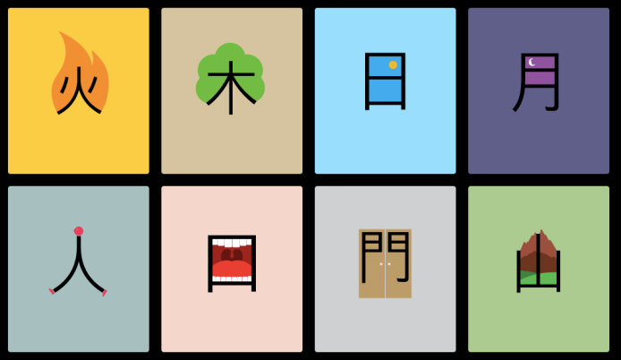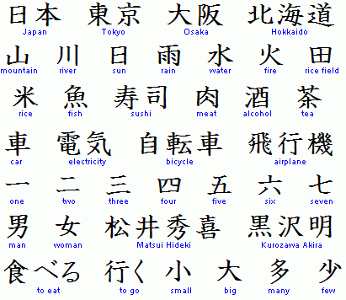

**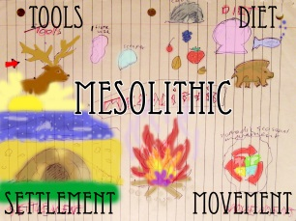**

**My own learning record:**

|  |
| --- |
| **I found out:** |



**My main activities were:**

|  |
| --- |
|  |

|  |
| --- |
| Image result for images for one to twenty in mandarin**Count how many trees you collected. Write the number in CHINESE**  Image result for images for one to twenty in mandarin**How many trees will you aim to collect next? Write the number in CHINESE** |

**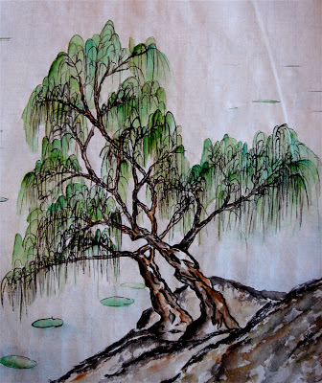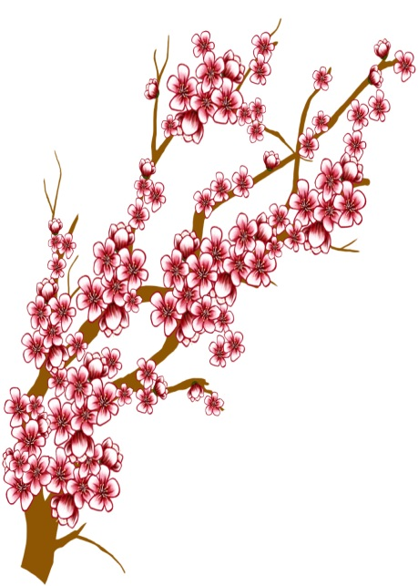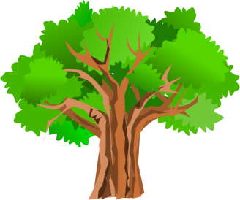How many trees did I collect on my passport?   
How can I get more?**