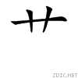
means plant (it is a radical)
竹 zhú bamboo
花 huā flower
米 mǐ rice
山 shān mountain
田 tián field
木 mù tree
林 lín woods
森 sēn forest
水 shuǐ water
牡 丹 mǔ dān peony
熊 猫 xióng māo panda

In the following picture, how many characters for water, field, mountain, tree, rice and bamboo can you find?
山 _______ 木 _______ 米 _______
竹 _______ 水 _______ 田 _______

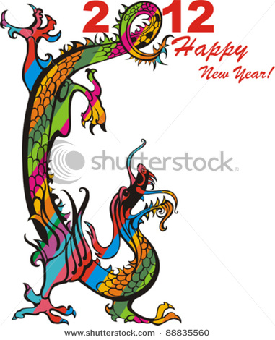
水
水
水
山
米 田
木
木
木
米
米
山

米
竹
竹

田
山

Match the following characters with pinyin/English.
- 山 zhú bamboo
- 木 mǐ rice
- 米 shān mountain
- 竹 tián field
- 水 mù tree
- 熊猫 shuǐ water
- 田 xióng māo panda

Please copy each character 4 times.
山 _______ _______ _______ _______
木 _______ _______ _______ _______
米 _______ _______ _______ _______
竹 _______ _______ _______ _______
水 _______ _______ _______ _______
田 _______ _______ _______ _______
Read the following story and please fill in the correct characters on the line!

Once upon a time, there was a man who lived near the _______(mountains) where the ___________ (pandas) also lived.
In front of his house, he had a _______(field). That is where he grew _______(rice). It rained a lot in his area which was good. Rice needs a lot of ________ (water) to grow.
In the ________(mountains), you could find ____________(pandas) in the __________(forests). There was also a lot of ___________(bamboo) which ____________(pandas) love to eat.
China is famous for beautiful ______(flowers). The most famous flower is the _____________(peony). It is usually red or pink.
Come to China and see our beautiful country!

