**Space Management Policy**

**(1) Statement of Need Guidance**

**Valid from March 2019**

**(Please check that this is the latest version of the document on Space Planning website)**

**Contents**

**1)** **The Statement of Need Process** 2

**2)** **Guidance for completing the Statement of Need form** 5

**3)** **Project Details** [Enter Project Details] 7

**4)** **Project Details** [Project Rooms (with high level budget cost estimate)] 10

**5)** **Project Details** [Adding Room(s) to the Project] 11

**6)** **Completion of Form Sections** 15

**7)** **Section 1:** Description of the Proposal 16

**8)** **Section 2:** University Strategic Objectives 17

**9)** **Section 3:** Delivery of the Proposal 20

**10)** **Section 4:** Financial Considerations 23

**11)** **Submitting the form** 25

**12)** **Review the form before submission** 27

**13)** **Workflow Overview** [Approval Process after submission] 28

**14)** **User Interaction within a Workflow** 30

**15)** **Overview of Workflow Statuses** 31

2. **The Statement of Need Process**
   1. The Statement of Need form is required to be completed by any department which needs to make an application for additional rooms to add to the current allocation of rooms by the University and/or to refurbished existing rooms allocated to the department.
   2. The flowchart on pages 3 and 4 illustrate the decision making process and actions prior and subsequent to submitting a Statement of Need request.
   3. It is important to remember when completing the form that all accommodation belongs to the University and is allocated to departments based on Need.
   4. University policy is to provide departments with accommodation based on need and the purpose of the form is to give departments the opportunity to articulate and demonstrate accommodation needs.
   5. The University needs to control the allocation accommodation to departments, as it is a finite resource.
   6. The budgets to refurbish accommodation are also limited and access to them needs to be prioritised based on relevance to University Strategic Objectives.
   7. The form is designed to be completed and submitted by any member of staff.
   8. Once the form has been completed and submitted it will be sent to the relevant line management staff for approval. The approval process takes place over three levels.
   9. For an Academic department this will be – Head of Department and Dean
   10. For a Professional Services department this will be – Head of Department and either Chief Financial Office, Chief Operating Officer, Chief People Officer or University Secretary and Compliance Officer.
   11. Once this initial line management approval is complete the application will be considered by Estates Services and prepared for submission to the Convenor of Estates Committee. This will involve both a high level technical review of the request in addition to a review of how the proposal addresses strategic priorities of the University and the Estates Development Framework. This may require further clarification of details with the department.
   12. For all departments the final level of approval will be the Convenor of Estates Committee acting on behalf of Estates Committee.
   13. Once a submitted Statement of Need has been sent to line management staff for approval, Estates Services will maintain the open status of the request for a period of six months.
   14. If the request has not been approved by the Head of Department and relevant Senior Officer after six months, Estates Services will contact the originator to identify whether the request is still required.
   15. If the Statement of Need has still not been approved after a further period of three months, (a total of nine months,) then Estates Services will notify the originator that it has been archived.
   16. If the request is still required at a later point a new Statement of Need will be required

**Department Change Request Decision Flow Chart Illustrating the Decisions Prior to Submitting a Statement of Need Request**

|  |  | **Department needs to make a change to existing rooms or access additional rooms** |  |  |
| --- | --- | --- | --- | --- |
| [Estates Maintenance Services System (EMS)](https://www.strath.ac.uk/professionalservices/estates/admin/wemis/) |  |  |  |  |
| **Complete a Service Request using the link above:** Departments will be charged for this type of work | **YES** | Is it a request for billable work such as the installation of new fittings, equipment or enhancements to rooms |  |  |
|  |  | **NO** |  | [Estates Maintenance Services System (EMS)](https://www.strath.ac.uk/professionalservices/estates/admin/wemis/) |
|  |  | Is it a request for non-billable work including faults to electrical fittings, fabric damage, windows, shelves, fixed equipment, plumbing issues, furniture faults etc.? | **YES** | **Complete a Maintenance Request using the link above:** Departments will not be charged for this type of work |
| [Statement of Need](https://ben.mis.strath.ac.uk/controlMenu/control/newApp?menuName=STATEMENTOFNEED) |  | **NO** |  |  |
| **Complete a Statement of Need using the link above:**  Then contact the Business Engagement Manager in Estates Services: Angel Mandujano | **YES** | Is it a request to allocate rooms for a third party organization or a spin out company? |  |  |
| [angel.mandujano@strath.ac.uk](mailto:angel.mandujano@strath.ac.uk) |  | **NO** |  | [Statement of Need](https://ben.mis.strath.ac.uk/controlMenu/control/newApp?menuName=STATEMENTOFNEED) |
|  |  | Is it a request to add additional rooms to the current department area and/or refurbish rooms? | **YES** | **Complete a Statement of Need using the link above:** |

**Department Change Request Decision Flow Chart Illustrating Statement of Need Progress Steps**

| If the request is for a simple change of room function or the allocation of rooms without requiring any refurbishment works, Estates Services will work with the department to identify the best option to resolve the request and agree this with the Vice Principal |  | **Is it a request to add additional rooms to the current department area and/or refurbish rooms?** | **YES** | **Complete a Statement of Need here:** |
| --- | --- | --- | --- | --- |
|  |  |  |  |  |
| If the request is approved by both the relevant Line Manager and Senior Officer, Estates Services will contact the department to clarify any further details to identify a solution |  | Once submitted the Head of Space Planning will identify the relevant Line Manager and Senior Officer to approve the request and confirm receipt of the request |  | Departments should provide as much information as possible at this point, including details of room numbers, (if they are known,) a description of the activities, their financial contribution to the project and relevant dates etc. |
| Process next step |  |  |  |  |
| **Project Initiation**  If the request is for the refurbishment of existing rooms or additional rooms, Project Manager from Estates Services will contact the department for more information, review solution options, establish an initial specification and scope of works and a budget cost to complete the work  **TIMESCALE - 1 to 3 Months (depending on project complexity)** |  | **Funding**  Once a budget cost has been established, Estates Services will work with the Department to agree the Funding package for the project  **TIMESCALE - up to 1 Month** |  | Once Funding has been approved a budget will be set up by Finance and Estates Services will plan the delivery of the project. If required, Estates Services will work with Procurement to appoint a consultant design team who will work with Estates Services and the Department to develop a project design and make applications for any required approvals  **TIMESCALE - Dependent on Project Complexity** |
|  |  |  |  |  |
| **Project Delivery**  Once the contractor has started on site, Estates Services will supervise construction to ensure that the project requirements are delivered to the required standard to meet the completion date  **TIMESCALE - Dependant on project complexity** |  | **Approval to Accept Tender**  Once appointed the contractor will mobilise, (order materials and organise their own labour and sub-contractors,) and arrange to start work on site  **TIMESCALE - 2 to 4 weeks**  **(depending on project complexity)** |  | **Approval to Obtain Tenders**  Once the project design is concluded and a construction budget is agreed Estates Services will work with Procurement to appoint a contractor to deliver the project  **TIMESCALE - 6 weeks for contractor costing, tender evaluation and appointment** |

1. **Guidance for completing the Statement of Need form**

The following guidance breaks down the process for completing the form and collates the help text available online in addition to suggestions on the type of information required to complete it.

* 1. **Accessing the Statement of Need form**
     1. Log in to Pegasus using your normal DS username and password

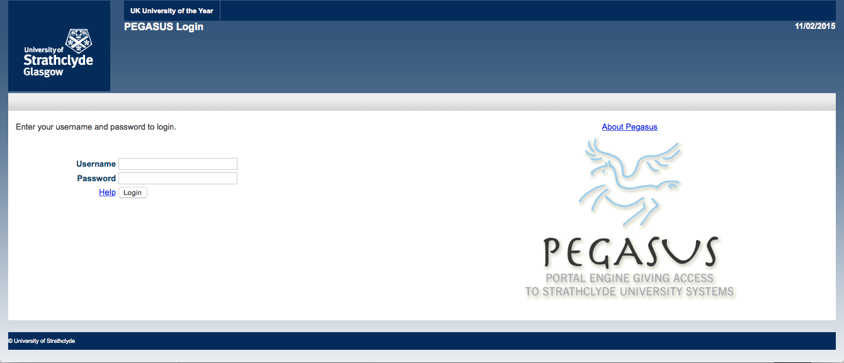

* + 1. On the Pegasus front page select the Estates tab:

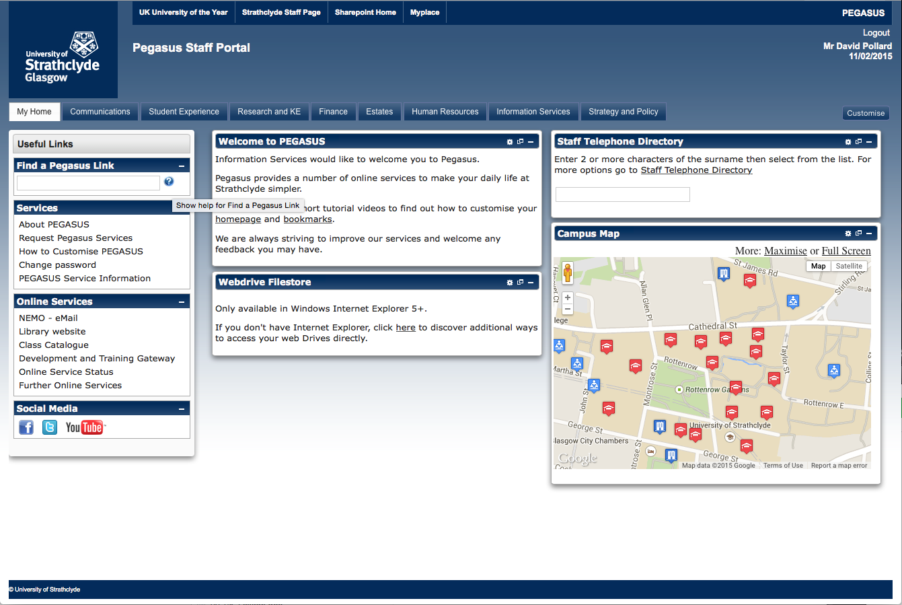

* + 1. In the Estates Services tab click on Statement of Need

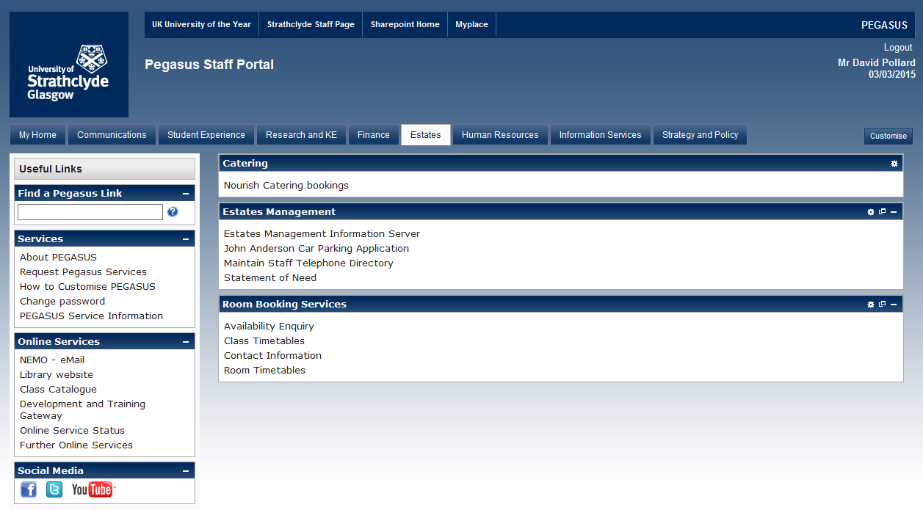

* + 1. In the Statement of Need front page you will see the list of current applications in process and their status
  + If you are going to create a new application click on “Create New Statement of Need”
  + If you have already created an application and have saved it for further editing, or if you have submitted an application and you want to read it again, or if you have saved an application to complete later, you can go back to edit or review it by clicking on the Reference Number in the first column.

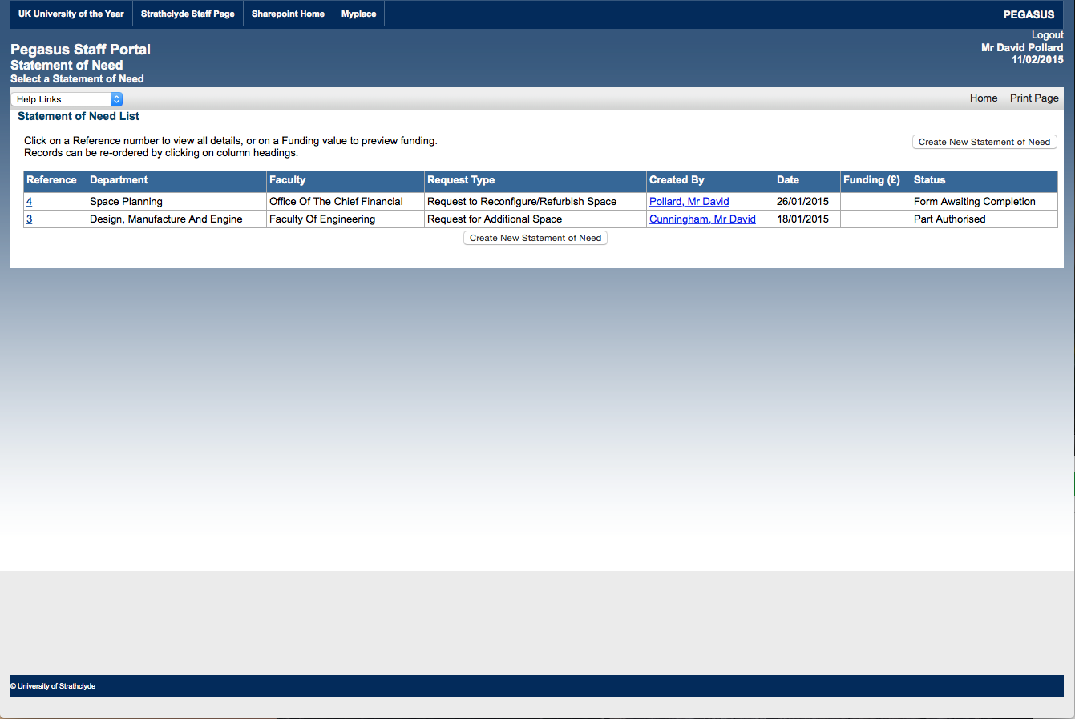

* 1. **The following pages of this guide will take you through the process of completing the Statement of Need form.**

1. **Project Details [Enter Project Details]**

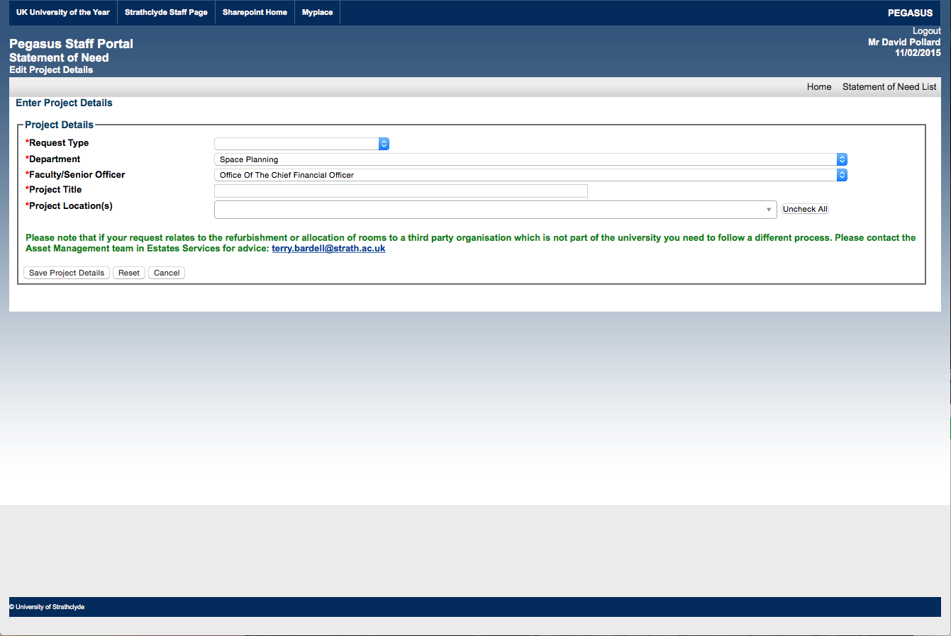

* 1. **There are two options for the Request type**
  + Request for Additional Space
  + Select “**Request for Additional Space**” if you are asking the University to allocate additional rooms to your department where these rooms do not require any reconfiguration or refurbishment before you occupy them, or if the work is minor and would be covered by a Maintenance Request or Service Request.
  + Request to Reconfigure / Refurbish Space
  + Select “**Request to Reconfigure / Refurbish Space**” if you are asking for funding to refurbish existing accommodation and/or if you are asking for additional accommodation which does require reconfiguration or refurbishment.

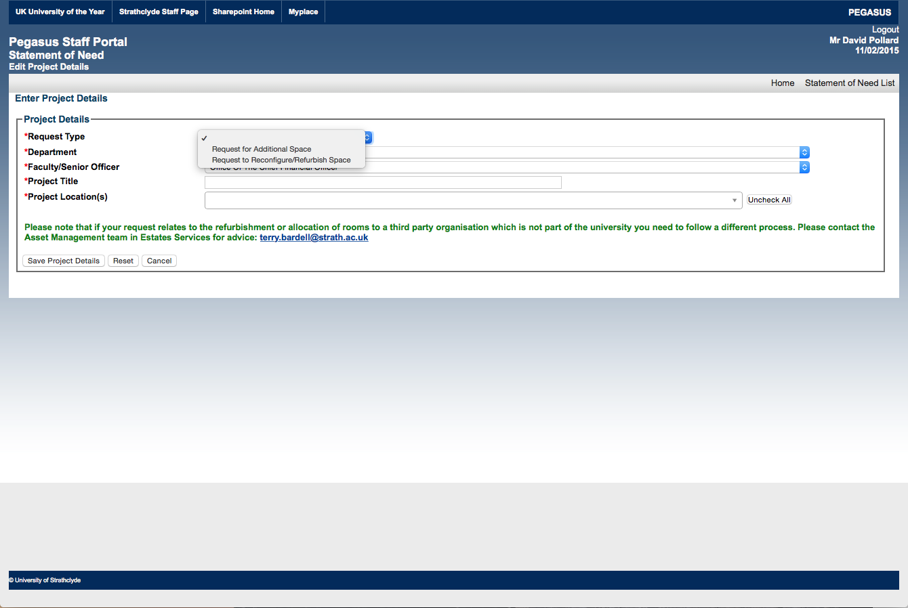

* 1. **Department Name**
  + This field is populated automatically using the DS login details entered when you access Pegasus. The list of departments is derived directly from the University Organisational Hierarchy. Please select another department if that if you are completing this application on their behalf.

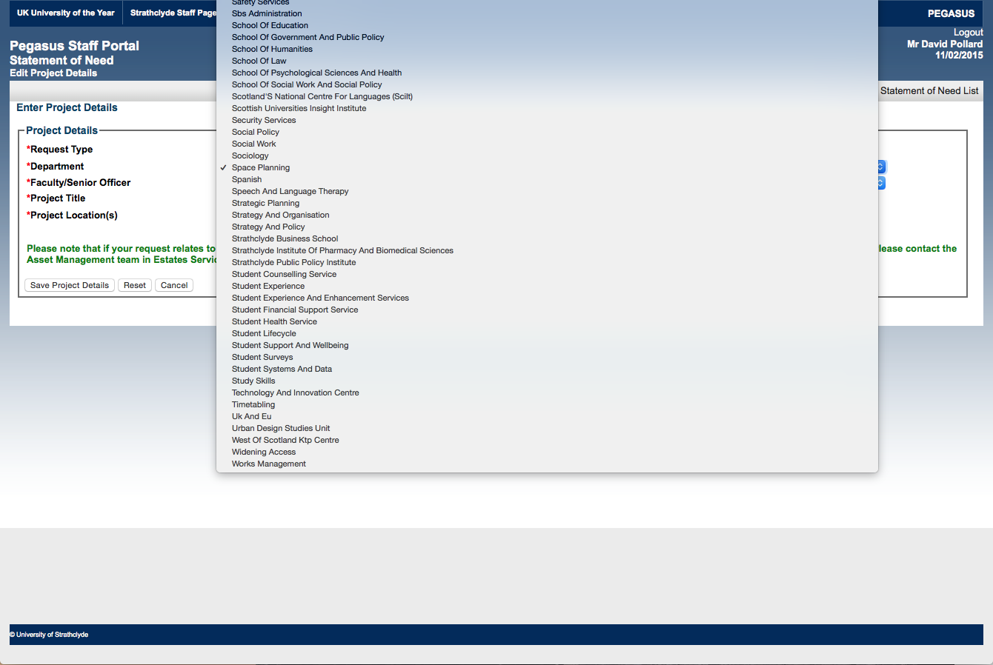

* 1. **Faculty/Senior Officer**
  + This field is populated automatically using the DS login details entered when you access Pegasus on the basis of your Department name and its location in the Organisational Hierarchy.
  1. **Project Title**
  + Please enter a short high level description of your request in the free text field. This text will be used to describe the project through the process and should be both concise and a description of the Estates purpose of the project.
  1. **Project Location(s)**
  + Building specific data in the form is populated directly from the Space Management Database in Estates Services
  + Please select the Primary building location where you are requesting the additional or reconfigured / refurbished rooms.
  + You can select multiple buildings if that is appropriate for your request.

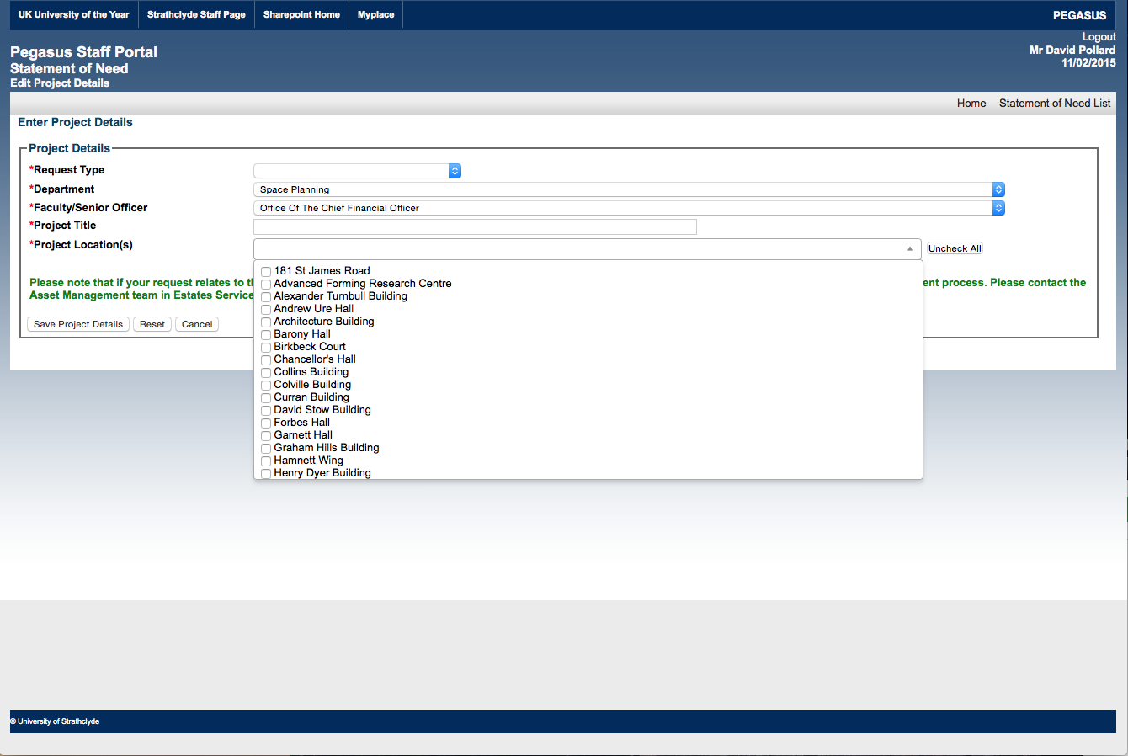

* 1. **Important Caveat**

**Please note that if your request relates to the refurbishment or allocation of rooms to a third party organisation which is not part of the university you need to follow a different process. Please contact the Asset Management team in Estates Services for advice:**

Angel Mandujano (Business Engagement Manager) [angel.mandujano@strath.ac.uk](mailto:angel.mandujano@strath.ac.uk)

* 1. **Completing Section 1**
  + Once you have entered this high level data please select “**Save Project Details**” if you are happy with them.
  + If you need to make any changes to the data please select “**Reset**” and start again as required.
  + If you do not wish to continue with the process at this point, please select “**Cancel**”

1. **Project Details** [Project Rooms (with high level budget cost estimate)]

To submit your Statement of Need for approval you must first complete “**Rooms Included in the Project**” and all form sections below.

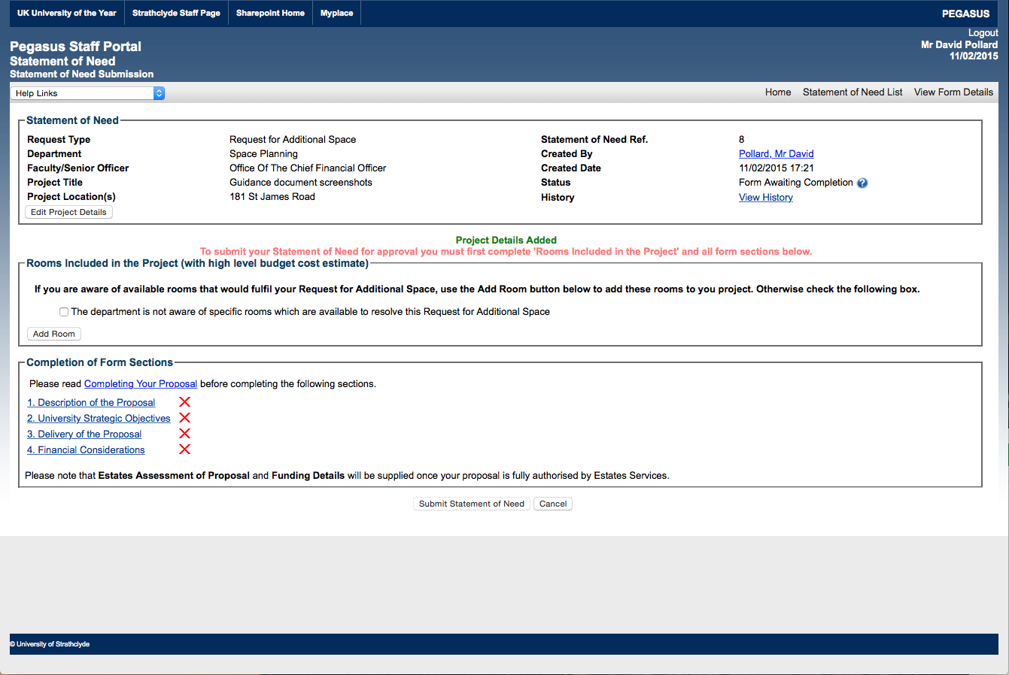

The purpose of this section is to define the proposed project area by identifying the room numbers proposed to be involved in the project. It may be that ultimately the approved project takes a completely different form either because an alternative solution has been identified or for budget reasons, but this section should be completed initially to the best of your ability.

If it is simply not possible to identify the rooms proposed to be involved in your project please check the box:

* The department is not aware of specific rooms which are available to resolve this Request to Reconfigure / Refurbish Space

If you can identify the room(s) proposed to be involved in your project please click on “**Add Room**”

1. **Project Details** [Adding Room(s) to the Project]

There are three components to selecting the room(s) involved in your proposed project and the details should be entered in the order they are presented on the screen to ensure that the data is presented in the correct order.

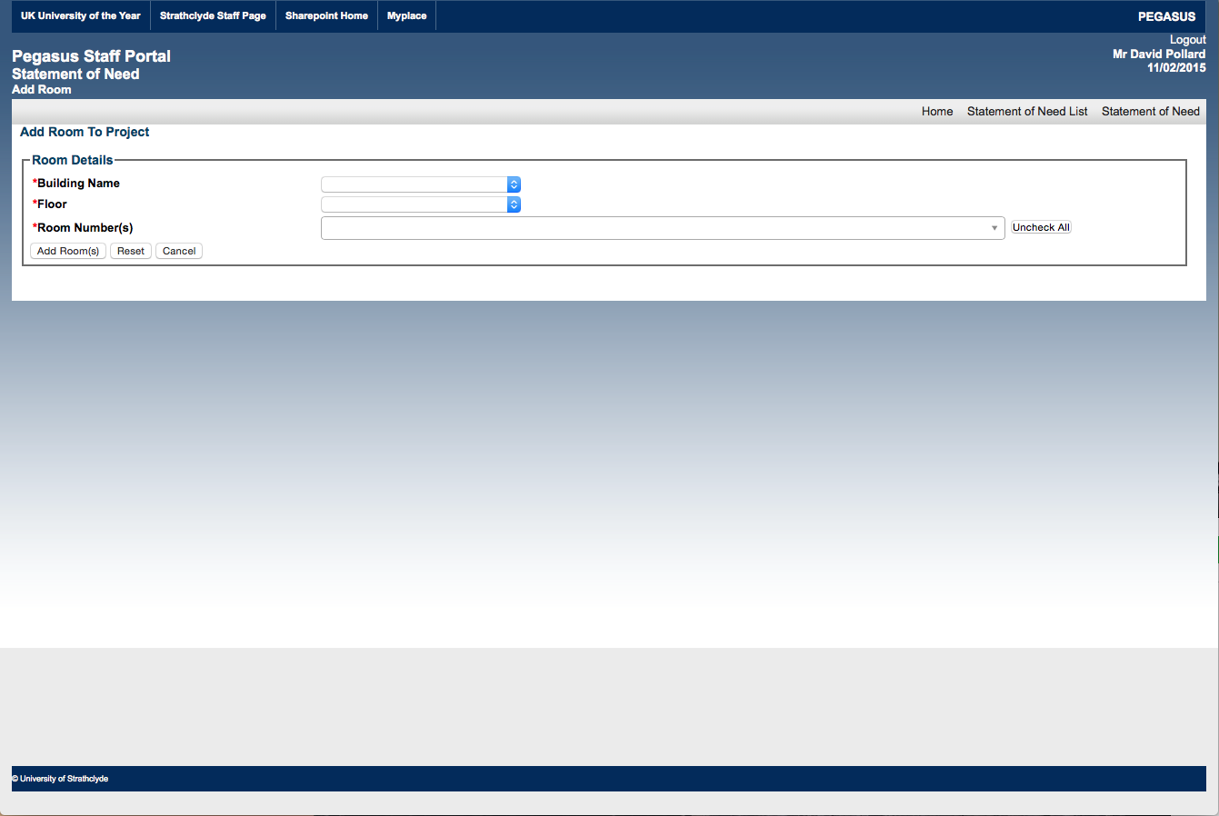

* 1. **Building Name**

To make it easier to identify the rooms involved in the project, the building list will be initially restricted to those selected in project location(s) in the previous “Enter Project Details section.

You will therefore initially only be able to select all the relevant rooms on one floor in this first building. You will have an opportunity to select more as required once you have added your initial selection.

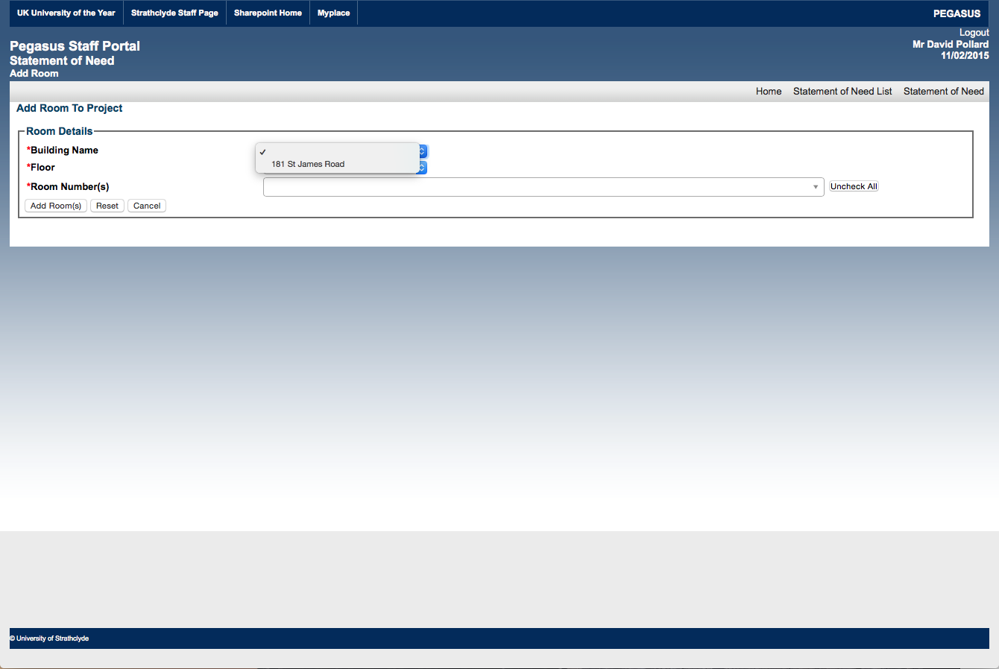

* 1. **Floor**

When you have selected the building the first room(s) is in you will then be presented with the relevant floor numbers for that specific building and you should select the one which contains the relevant room number.

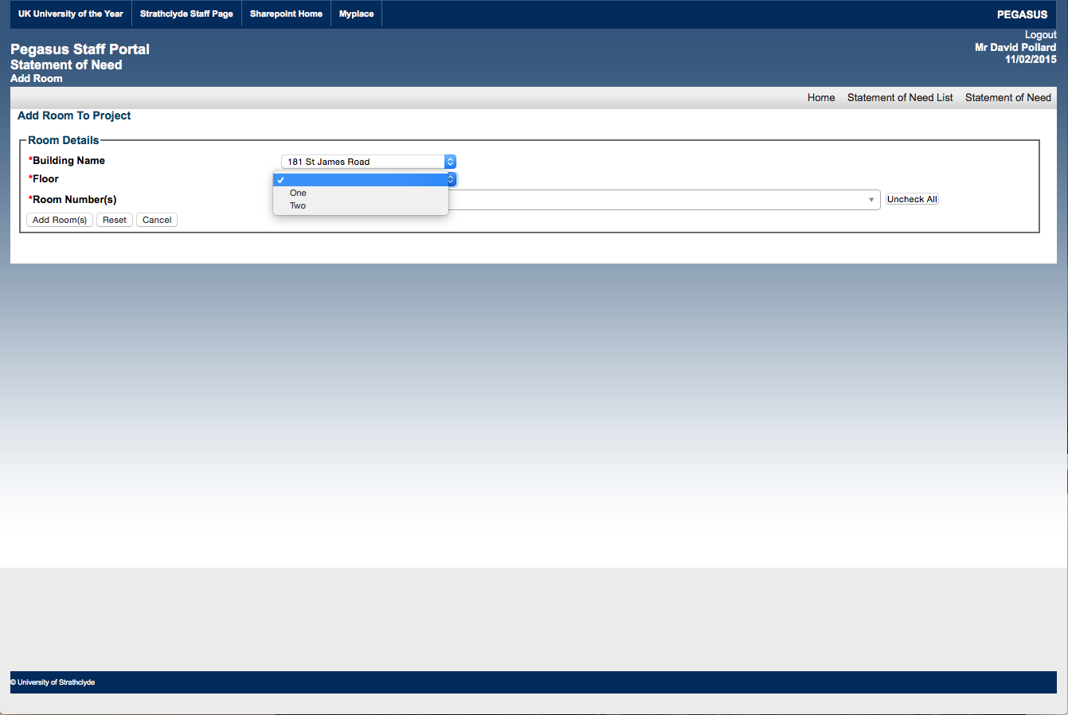

* 1. **Room Number(s)**

Once you have selected the appropriate building and floor number you will be presented with the room numbers relevant for that floor and can select multiple room numbers.

If for any reason you need to redo this process, you can select “**Uncheck All**” to remove the initially selected rooms in addition to selecting “**Cancel**” or “**Reset**” if you need to reverse out of this step of the process entirely.

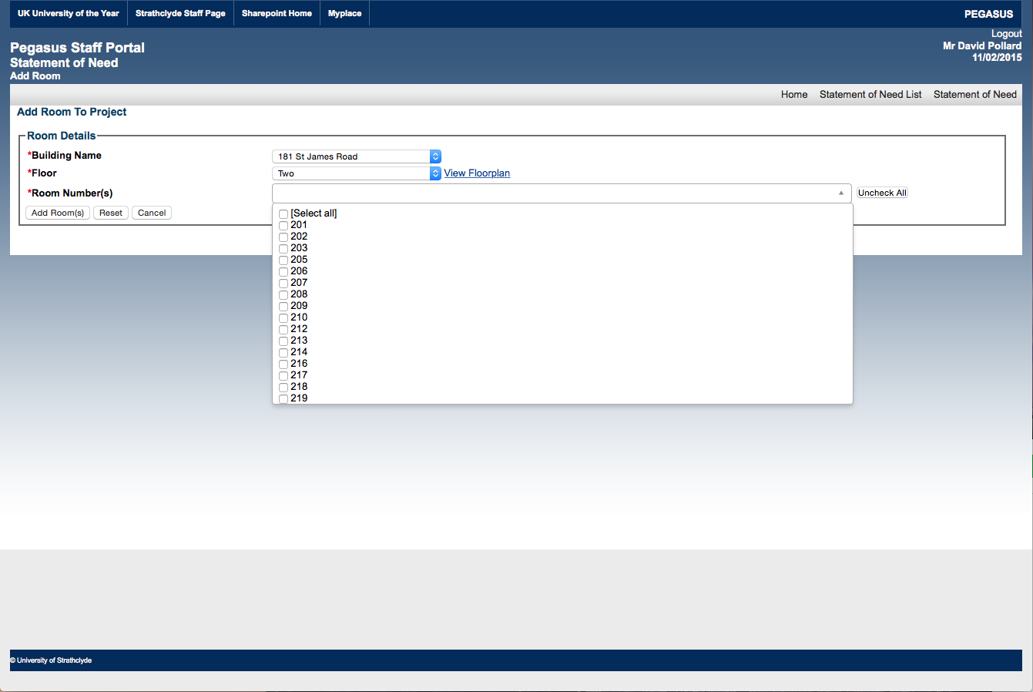

* 1. **Add Room(s)**

When you are happy with your initial selection of rooms click on “**Add Room(s)**” to take you back to the initial screen.

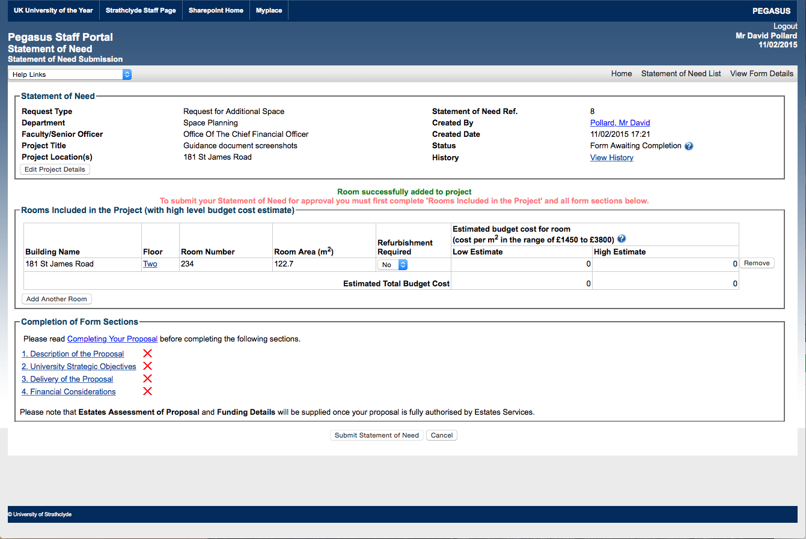

* 1. **Rooms Included in the Project (with high level budget cost estimate)**
  + At this point the front page displays the room area contained in the space management database in addition to the building, floor number and room numbers you have just selected.
  + You are also able at this point to click on “**Yes**” in the “**Refurbishment Required**” column to carry out an initial estimated cost calculation based on low and high costs.
  + There is a list of caveats associated with this “Estimated budget cost for room” calculation:
    1. These budget costs are based on known project costs of many completed projects across the university and include hidden costs like decanting existing activities and 20% VAT.
    2. If this project is approved Estates Services will investigate the actual physical requirements for this specific project and advise on an appropriate budget cost. Estates Services will also investigate the impact of this project on the specific and related building services in this area and allow for works associated with these as required.
    3. The existing function and condition of the rooms in the project area in relation to the proposed function have an impact on the budget cost.
    4. A financial contribution is expected from departments to all proposed projects. The level of this contribution needs to be stated in this statement of need relative to the budget costs noted above.

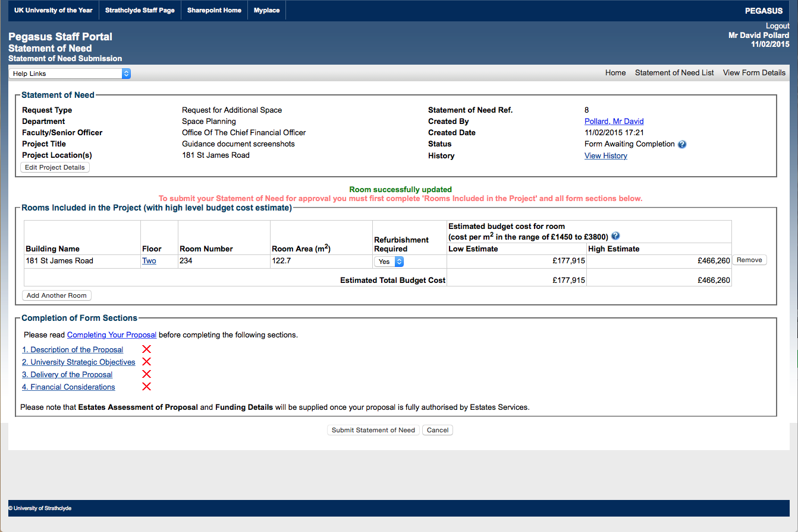

* + It is understood that there will be exceptions to these estimated costs but you should understand that the cost of delivering projects in the University incorporate the Regulatory framework that the University works in and in many cases includes the cost of employing various consultants, design, procurement, site set up etc. (depending on the nature of the project.)
  + The project cost will be refined through the process of approval and review by Estates Services before the final approval stage by the Convener of Estates Committee.
  1. **Add Another Room**
  + At this point you will be able to add more rooms in other buildings or floors as required by clicking on “**Add Another Room**”.
  + For every room you add the room area and estimated costs will be totaled at the bottom of the table.
  + If you need to remove a room for any reason you can do so by clicking on “**Remove**” at the right hand side of the relevant row.

2. **Completion of Form Sections**

You are now ready to complete the remainder of form to describe and support your request.

Before you do so, clicking on “[**Completing Your Proposal**](javascript:help_displayHelp('993','','','','T'))” provides some more background to the process:

* 1. **Completing Your Proposal**

The budget is limited and all applications therefore require to be prioritised. Sections 1 to 4 of the proposal form should be completed after reading the [Space Management Policy](http://www.strath.ac.uk/estates/space/) and bearing in mind the following criteria which will be used to assess, compare and prioritise each application.

* + 1. **Value for Money** - how does the proposal compare with alternative options to deliver the objective.
    2. **Sustainability** - what is the long term impact of the proposal?
    3. **University Priorities** - how does the proposal contribute to delivery of the University's objectives?

Each of these criteria should be considered in terms of the objectives of the proposal but also in terms of the goals of the Estates Development Framework which has key objectives to improve the condition, functionality and flexibility of the estate while reducing the size of the estate, carbon emissions, operating costs and insurance replacement value.

An initial estimation of project costs is required to be calculated by the project champion using typical rates for different project types using data on the area of accommodation held in the Space Management database.

* 1. **Submitting Your Proposal**

Once all required form sections are completed, click on “Submit Statement of Need” to submit your proposal for approval.

Once submitted, your proposal form can be viewed by all staff. You can return to the Statement of Need service in PEGASUS at any time to view the progress of your proposal.

You will be notified by email in any of the following events:

* + 1. You are required to make amendments to details you have entered.
    2. Your proposal has been fully authorised (approved).
    3. Your proposal has been rejected.
  1. **Points of Contact**

If you require further assistance on completing your proposal, please contact one of the following:

David Pollard (Head of Space Planning) [d.pollard@strath.ac.uk](mailto:d.pollard@strath.ac.uk)

1. **Section 1: Description of the Proposal**

There are five parts to this section:

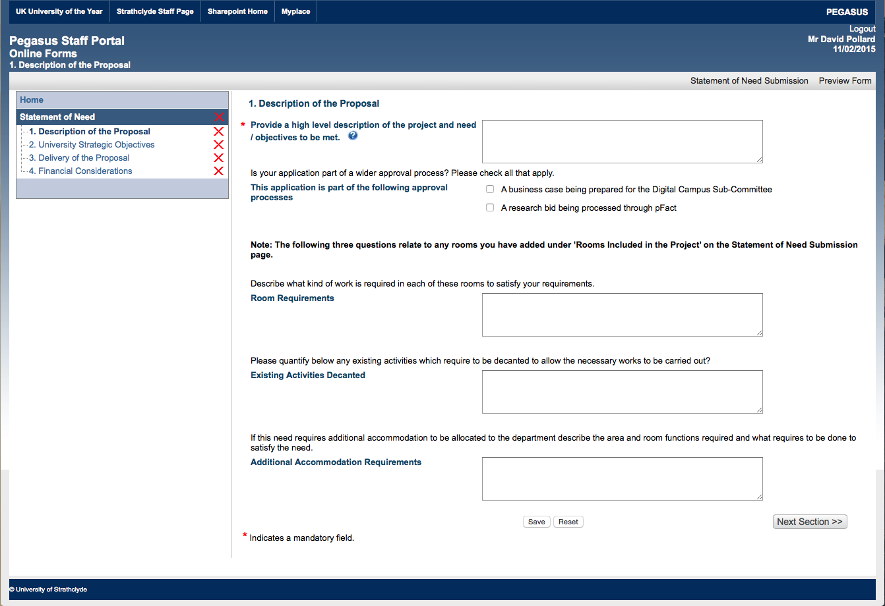

| Section 1. Questions | Description of Section 1. Question responses |
| --- | --- |
| * Provide a high level description of the project and need / objectives to be met. | This is a free text field asking you to provide a full description of your requirements. Please include the purpose of the proposed project, a general description of the configuration of the proposed rooms, the numbers of staff and students involved etc. |
| * This application is part of the following approval processes | Is your application part of a wider approval process? Please check all that apply. |
| The reason for this question is to try to ensure that the processes of related Committees are aligned. | * A business case being prepared for the Digital Campus Sub-Committee * A research bid being processed through pFact |
| * Room Requirements | Describe what kind of refurbishment or building services changes are required in each of these rooms to satisfy your requirements. |
| * Existing Activities Decanted | Please quantify below any existing activities which require to be decanted to allow the necessary works to be carried out? It is imperative that Estates Services understands the full impact of the proposed project not only on the staff, students and rooms directly affected but also on staff and activities that would be affected by any construction works etc. It is necessary for the department to work with Estates Services to accommodate all decanting requirements through the most time and cost effective means possible. |
| * Additional Accommodation Requirements | If this need requires additional accommodation to be allocated to the department describe the area and room functions required, (specifying room numbers where possible,) and what requires to be done to satisfy the need. |

Once you have completed these sections please ensure that you click **“Save”** then click **“Next Section >>”** to proceed. If you need to remove the content, you have added to the form please click **“Reset”.**

Please note that when completing sections, **\*** denotes a mandatory field.

1. **Section 2: University Strategic Objectives**

There are four parts to this section:

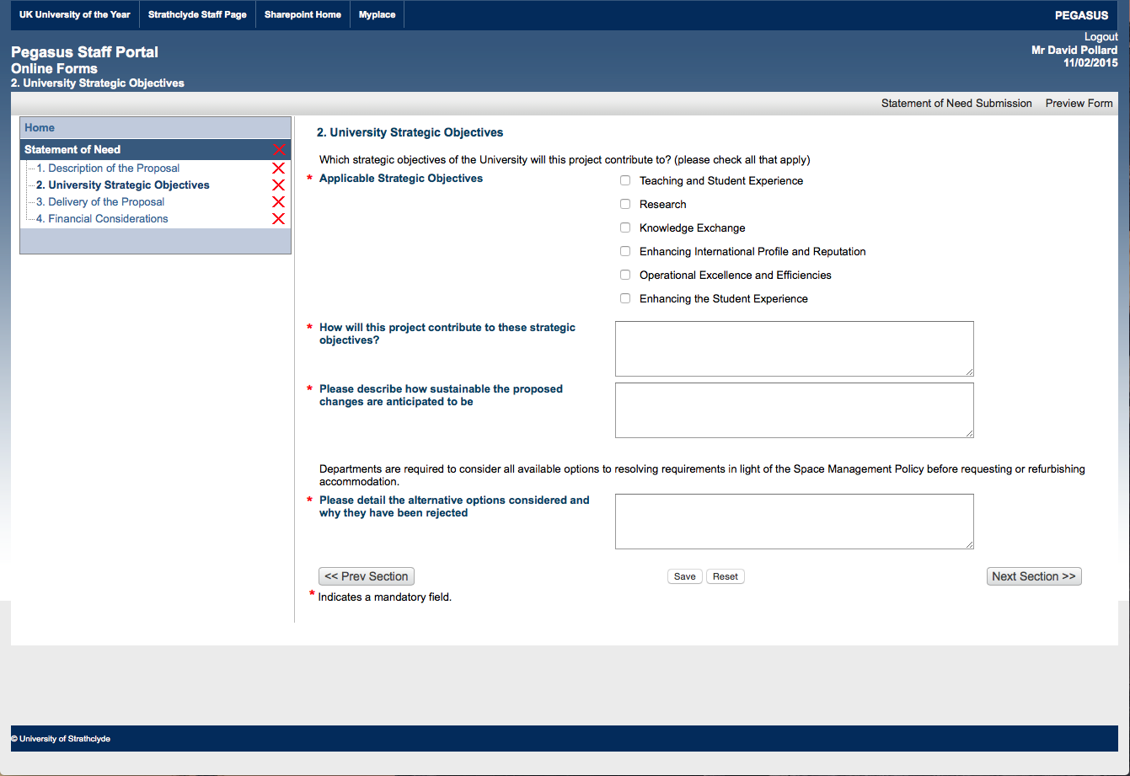

| **Section 2. Questions** | **D**escription of **Section 2. Question** response**s** |
| --- | --- |
| **\* Applicable Strategic Objectives** | Which strategic objectives of the University will this project contribute to? (please check all that apply)   * Teaching and Student Experience * Research * Knowledge Exchange * Enhancing International Profile and Reputation * Operational Excellence and Efficiencies * Enhancing the Student Experience |
| **\* How will this project contribute to these strategic objectives?** | For each of the objectives selected please describe how the project will contribute in as many objective ways as possible. Please ensure that your supporting text is directly related to each objective |
| **\* Please describe how sustainable the proposed changes are anticipated to be** | The University Estate is very large and historically there has been a significant degree of churn, where projects are completed and then work is required to change the area again a short time later. In many cases projects prove to have been a waste of scarce resources that could have been better spent elsewhere. Projects that are able to demonstrate long-term benefits to the Estate will be prioritized over short term changes or requirements unless there is a significant benefit to University Objectives. Please specify to the best of your ability and knowledge either the length of time the proposed room allocation or construction works will be relevant for or how generic the proposal is which would allow it to be easily transferred to another use or department. |
| **\* Please detail the alternative options considered and why they have been rejected** | Departments are required to consider all available options to resolving requirements in light of the Space Management Policy before requesting or refurbishing accommodation. You should note specifically that the Space Management Policy requires offices > 13m2 to be shared before additional office accommodation will be allocated to a department. Proposals that facilitate high utilization either through their primary purpose or through being effectively shared. When describing your proposal, you should also ensure that it supports University objectives and policies. Applications that contravene or do not meet these requirements will not be prioritized for approval. |

Once you have completed these sections please ensure that you click“**Save**”then click“**Next Section >>**”to proceed.

If you need to remove the content you have added to the form please click“**Reset**”. If you need to move back please click “**<< Prev Section**”.

Please note that when completing sections, **\*** denotes a mandatory field

1. **Section 3: Delivery of the Proposal**

There are six parts to this section:

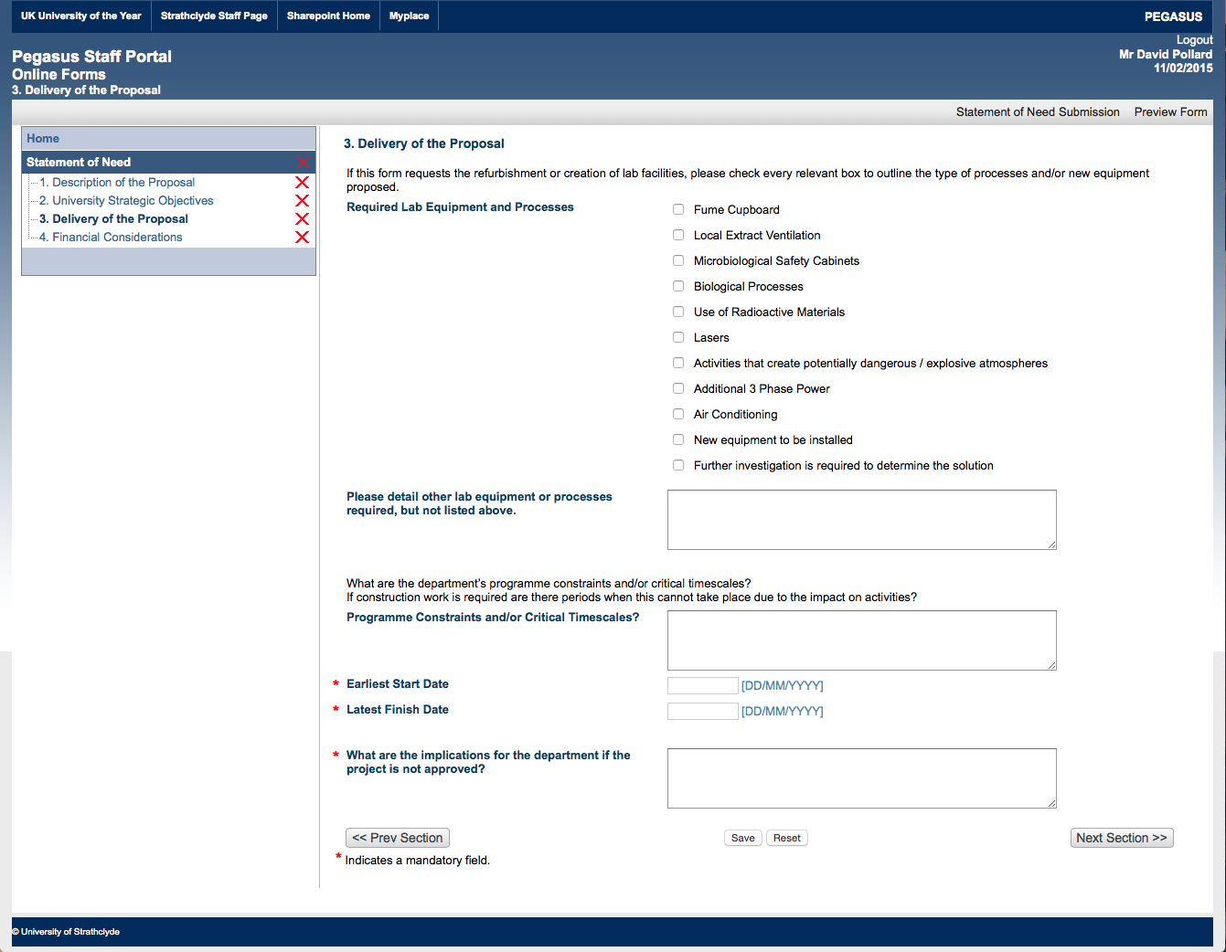

| Section 3. Questions | Description of Section 3. Question responses |
| --- | --- |
| **\* Required Lab Equipment and Processes** | If this form requests the refurbishment or creation of lab facilities, please check every relevant box to outline the type of processes and/or new equipment proposed. |
| Completion of this section will facilitate early collaboration with Colleagues in Safety Services and will facilitate delivery of the completed project. | * Fume Cupboard * Local Extract Ventilation * Microbiological Safety Cabinets * Biological Processes * Use of Radioactive Materials * Lasers * Activities that create potentially dangerous / explosive atmospheres * Additional 3 Phase Power * Air Conditioning * New equipment to be installed * Further investigation is required to determine the solution |
| **\* Please detail other lab equipment or processes required, but not listed above.** | It is important to provide Estates Services with all known room requirements so that the servicing provision and space implications can be assessed and accounted for in the project budget and programme. Identifying or changing these requirements later in the process is likely to incur increased costs and programme delays. |
| **\* Programme Constraints and/or Critical Timescales?** | What are the department’s programme constraints and/or critical timescales?  If construction work is required are there periods when this cannot take place due to the impact on your activities? |
| You should be aware of the timescale that is involved in this approval process and in going through the design processes, regulatory approval, tendering, procurement and contractor mobilization for construction projects. On this basis the shortest period you should consider for delivery of a construction project from the point of approval is 6 months. This period will increase according to the complexity of the project. Simple room allocation requests can be delivered in a shorter timescale depending on the requirements and consequences. |  |
| **\* Earliest Start Date** | Please be realistic when entering dates to allow for sufficient time for the necessary internal and external approval, design and delivery processes. |
| **\* Latest Finish Date** | Please be realistic when entering dates to allow for sufficient time for the necessary internal and external approval, design and delivery processes. |
| **\* What are the implications for the department if the project is not approved?** | Please be clear about the short and long term impact if the project does not proceed. Please ensure that these are as objective as possible and do not rely on the simplistic “damage to the Universities reputation |

Once you have completed these sections please ensure that you click“**Save**”then click“**Next Section >>**”to proceed. If you need to remove the content you have added to the form please click“**Reset**”. If you need to move back please click “**<< Prev Section**”.

Please note that when completing sections, **\*** denotes a mandatory field.

2. **Section 4: Financial Considerations**

There are five parts to this section:

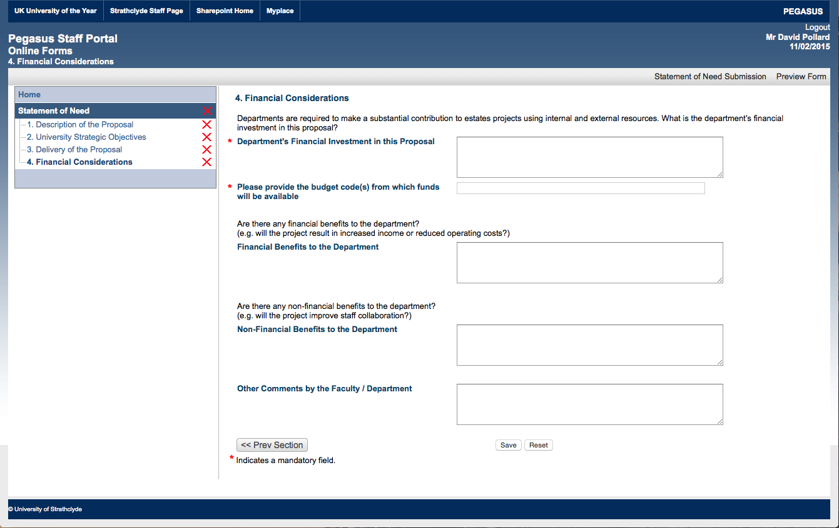

| Section 4. Questions | Description of Section 4. Question responses |
| --- | --- |
| **\* Department's Financial Investment in this Proposal** | Departments are required to make a substantial contribution to estates projects requested through this process. What is the department’s financial investment in this proposal?  The Capital Projects Resource is not intended to fully fund projects but should be considered as a resource to fill out Department / Faculty funding. The specific amount of CPR contribution will depend on the overall benefit of the project to support University objectives and the priority of the application in relation to others. |
| **\* Please provide the budget code(s) from which funds will be available** | Funds will not be deducted from this account until the project has been finally approved and the total budget and contribution has been agreed with the department. |
| **\* Financial Benefits to the Department** | Are there any financial benefits to the department? (e.g. will the project result in increased income or reduced operating costs?)  Essentially the University needs to know if the completion of the proposed project will result in a net financial benefit to the department.  You should describe how you calculated this figure and state what the financial benefit is per annum for each specific activity. |
| **\* Non-Financial Benefits to the Department** | Are there any non-financial benefits to the department? (e.g. will the project improve staff collaboration?)  If the proposed project will improve the delivery or effectiveness of your work or will support additional requirements placed on the department or the University you should articulate these here. |
| **\* Other Comments by the Faculty / Department** | Is there anything else that you can add to support your application?  Please add any further text that has not already been articulated elsewhere to support your application. |

Once you have completed these sections please ensure that you click“**Save**”. If you need to remove the content you have added to the form please click“**Reset**”. If you need to move back please click “**<< Prev Section**”.

Please note that when completing sections, **\*** denotes a mandatory field.

2. **Submitting the form**

When you click “Save” at the end of Section 4 the following message will appear:

**All form sections are now complete.**

**Use the above link to return to Statement of Need Submission.**

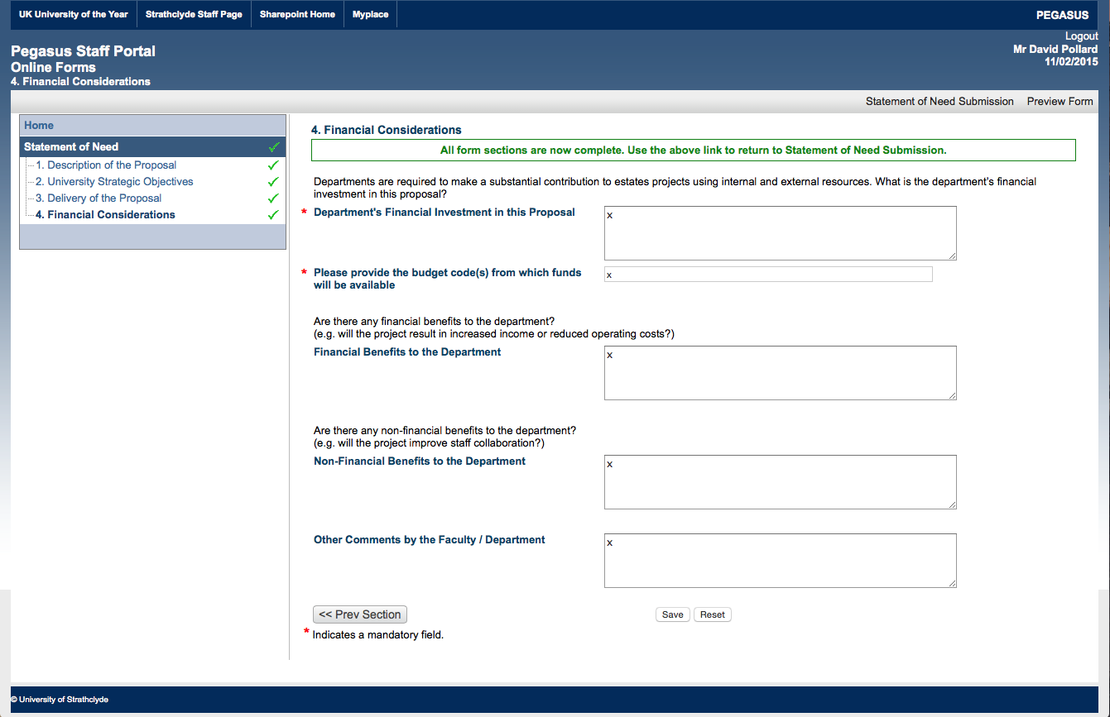

You should now click on “**Statement of Need Submission**” on the top right hand corner of the page.

The message in the middle of the front page of the form now says:

To complete the process of submitting this application please click on the Submit Statement of Need button below.

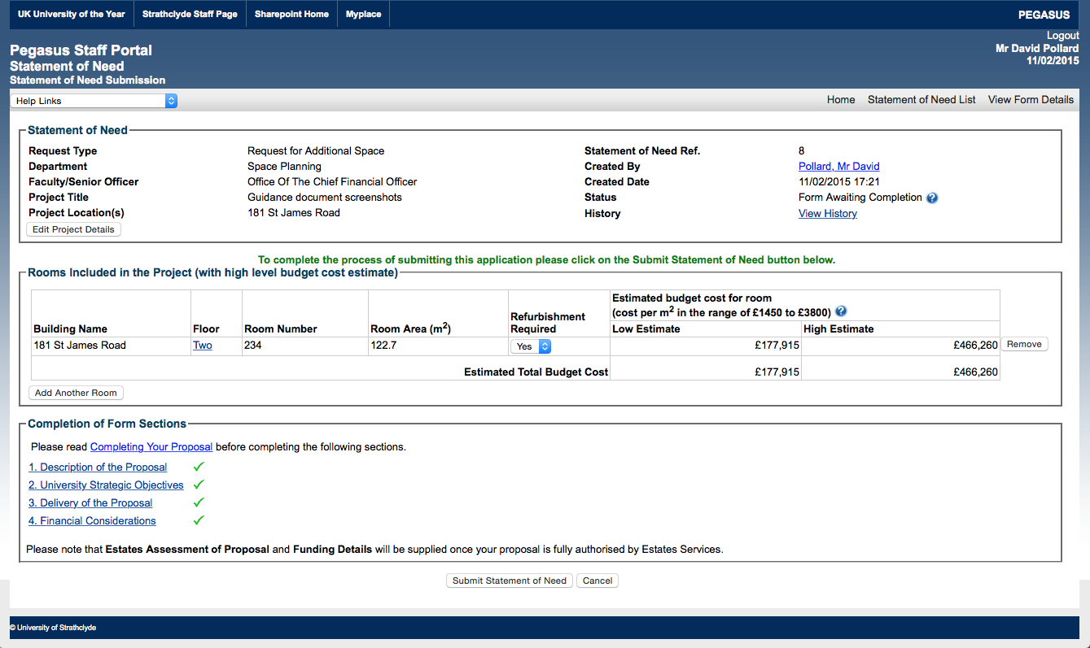

To complete the process and submit the form for approval the final step is to click “**Submit Statement of Need**”.

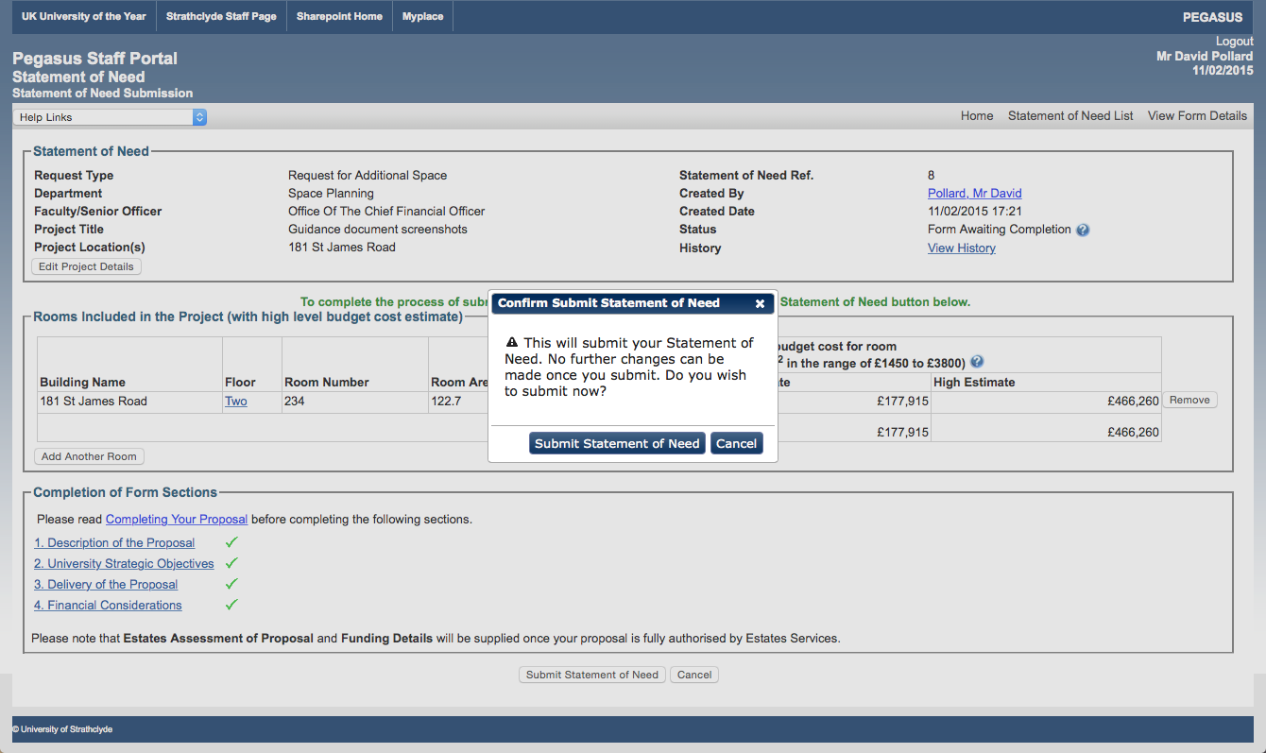

Clicking on “**Submit Statement of Need**” will open a pop up box to confirm this action.

To finalise the process of submitting the form click on “**Submit Statement of Need**” in the pop up box.

2. **Review the form before submission**

If your department operates with a process of reviewing Statement of Need applications before submission, note that you can do this by clicking on “View Form Details” on the top right hand corner of the front page of the application:



This will produce a summary of the content that you have input into the form which can then be printed in pdf for circulation within your Department / Faculty as illustrated on the next page.

Please note that this version of the application should not be submitted to Estates Services. The application will not be considered at all by Estates Services until line managers have approved it.

Once it has been submitted the next step is for Estates Services to identify and confirm the line managers who will be asked to approve the application.

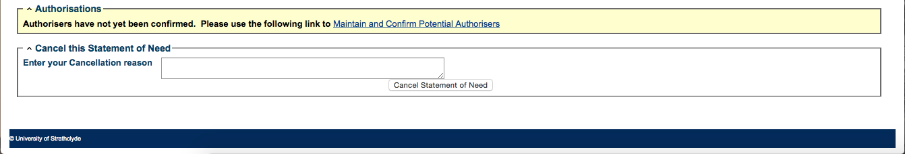

Once your Head of Department and Dean / Chief Operating Officer or Chief Financial Officer have approved the application it will be sent automatically to Estates Services to for a technical and policy compliance review before submission to the Convener of Estates Committee for final consideration.

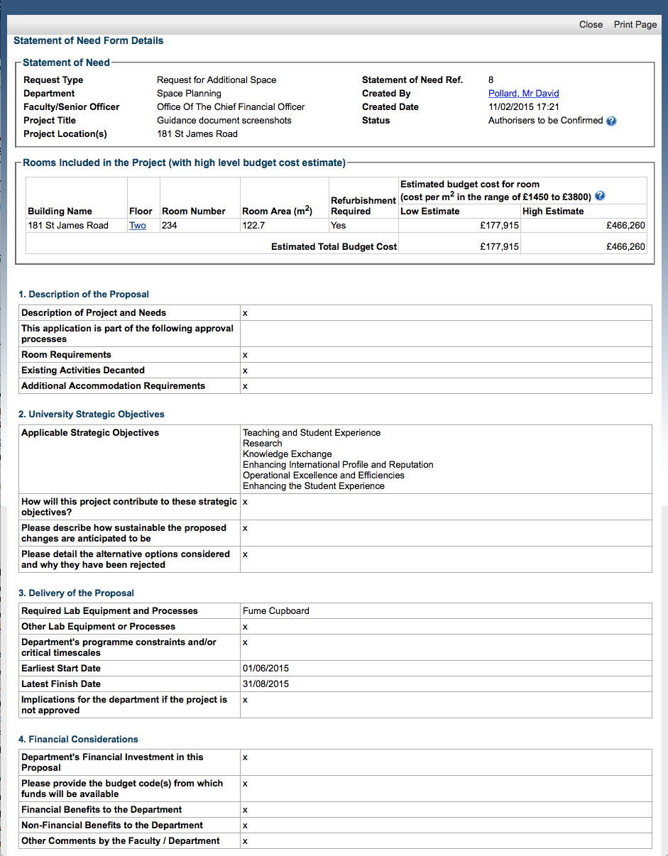

1. **Workflow Overview** [Approval Process after submission]

Once you have submitted the form a message is sent to Estates Services to confirm the members of staff who will be responsible for approving it.

Certain processes within PEGASUS have an associated Workflow where a request or proposal submitted by the user requires key members of staff to authorise or add their contributions before being actioned.

Workflows within PEGASUS consist of a series of authorisation stages each requiring a minimum number of staff authorisations for the workflow to proceed to the next stage.

There are three types of user that participate in a Workflow.

* + 1. **Originator** - Initiates a workflow by submitting a proposal.
    2. **Administrator** - responsible for confirming authorisers in a workflow and ensuring workflow is allocated the appropriate authorisers that will allow it to proceed.
    3. **Authorisers** - members of staff assigned to a stage in the workflow who can give or refuse authorisation for that stage. Some stages may require additional information from the Authoriser before the workflow can be progressed.

2. **User Interaction within a Workflow**
   1. **Originator**:

* Creates a new proposal (usually within or on behalf of a given department).
* Completes their sections of the proposal form.
* Submits the proposal for review (this makes the form available for all staff to view).
* Can cancel their proposal at any time (all staff who made decisions on this proposal will receive email notification of this).
  1. **Administrator:**
* May receive email notification to confirm authorisers for newly submitted proposal. In which case Administrator selects proposal they were notified of then clicks link under “Authorisations” to maintain authorisers.
* Maintain Authorisers screen allows Administrator to:
  + add appropriate staff as authorisers to stages of the workflow for this proposal.
  + create authoriser roles for staff who are permanent authorisers for proposals originating from particular organisations.
  + confirm authorisers for each stage and confirm overall workflow.
* Once authorisation workflow is confirmed, stage 1 authorisers are notified via email and now have access to the proposal form.
  1. **Authorisers**:
* Receive email notification of the proposal that requires authorisation.
* Selects the proposal they were notified of and reviews the details entered.
* Will see their stage in the workflow highlighted with the status 'Authorisation Pending'.
* Can give or refuse authorisation, leave a comment or return the proposal form back to its Originator for amendments.
* If a stage requires additional information from the Authoriser, the stage can only be authorised once this information has been provided.
* Once a stage is fully authorised, workflow proceeds to next stage and authorisers at that stage are notified.

**Once final stage authorisation is given, status of workflow goes to “Fully Authorised” and Originator and all authorisers receive email notification of this.**

2. **Overview of Workflow Statuses**

A proposal can have any of the following statuses within the authorisation workflow

| **Status** | **Meaning** |
| --- | --- |
| **Form Awaiting Completion** | Proposal form has not been submitted or (if form was returned to Originator for amendments) has not been re-submitted. |
| **Authorisers to be Confirmed** | Waiting for the Administrator to allocate/confirm authorisers for the proposal. |
| **Authorisers Confirmed** | Proposal is now available to authorisers to give their approval. |
| **Part Authorised** | Authorisers at one or more stages have given their approval. Workflow still in progress. |
| **Fully Authorised** | Authorisers at all stages have given their approval. Workflow complete. |
| **Rejected** | One or more authoriser has refused authorisation. Proposal has been rejected. |
| **Cancelled** | Proposal was cancelled by its Originator. |