Space Management Policy
(8) Allocating Room Numbers
Valid from 2019

(Please check this is the latest version of the document on the Space Planning website)
Contents
1) Overview 1
a) Project design and development 1
i) The impact of layout changes after initial university room numbers are set 1
ii) Consulting with the university when layout changes are required 1
b) Building Services data (O and M manuals / CAFM) 1
c) Effective Space Management 2
i) Space Management Database and CAFM 2
ii) University administration and statutory reporting 1
d) Wayfinding 1
2) Applying numbers to rooms to support wayfinding 2
a) Overarching room numbering principles 2
b) Some examples of numbering patterns to avoid 3
c) Building codes 3
d) Building levels 3
e) Allocating room numbers 4
i) Room numbers 4
ii) Corridors (basic principle) 5
iii) Corridors (complex layouts) 5
iv) Stairs 6
v) Risers 6
vi) Lifts 7
vii) Voids 7
3) Examples of room numbering 8
a) A straight corridor with stairs and lifts – Duncan Wing level 8 9
b) A straight corridor with a dead end branch – Thomas Graham level 3 11
c) A straight corridor with complex branches – Graham Hills level 6 13
d) A full loop – Livingstone Tower level 7 15
e) Complex arrangements – Curran level 4 17
f) External rooms – Strathclyde Sport level 2 19
g) Numbering Stairs 21
i) Numbering Risers 22
4) Summary 23

- Overview
The purpose of this policy is to articulate the purpose and priorities of allocating room numbers in a University building as well as describing the methodology of doing so. There are four principle University requirements for room numbering:
- As a mechanism to manage project development through the allocation of a unique designation to each room or area.
- To support the maintenance of the completed building. Building Services equipment has asset tags that incorporate the location room number along with fire alarm panel address and mimic charts. These are used in the CAFM system and are linked to the detailed asset data in the operation and maintenance manual.
- To support effective space management by identifying each area of a building which has a distinct function.
- To facilitate effective navigation of a building by University staff and students and by visitors.
Of these requirements, the fourth has absolute priority and there are no circumstances where the development of a project will be allowed to compromise the effective navigation of the resulting accommodation.
Ultimately, the Head of Space Planning in Estates Services has responsibility for all area / room numbering within the University and all room numbers must be explicitly agreed with the space planning team.
Any new build or refurbishment project that does not conform to University room numbering requirements for any reason will be expected to adopt approved University room numbers and to modify all building services, fire panels, lift levels etc. to match.
The Estates Services Space Planning team has responsibility for all room numbering in the University and consultants are requested to liaise with the team through their project manager to ensure that University room numbers are adopted at all relevant stages of a project.

  - Project design and development
The University understands the necessity of this function and will work with consultants to manage the design and construction process in relation to room numbering.
In consultation with the University project manager to determine the appropriate time, the consultant / design team should issue a set of general arrangement drawings to the Head of Space Planning to generate an initial set of university room numbers.
The timing of this first allocation of room numbers in relation to design development is important and should be considered in relation to the point at which design development has reached a sufficient level of stability and are required for the purpose of integrating final building services manuals, fire panel layouts etc.

    - The impact of layout changes after initial university room numbers are set
The construction team should bear the following in mind when making the decision to request university room numbers and the consequences of making changes after this point.
- The number and location of doors is critical to the room numbering process.
- Adding rooms or relocating doors within an otherwise stable room layout can have a significant impact on room numbering for the purpose of wayfinding.
- Making room layout or door number or location changes at the low end of room numbering on a floor e.g. 201, 202 etc. can have a significant impact on every other room number on that floor.

    - Consulting with the university when layout changes are required
If changes to the layout of a floor are necessary after the initial university room numbers are requested due to design requirements or university requests, the construction team can consult with this document to understand the potential implications on room numbering and propose revised numbers.
However, in each case the construction team should ensure that the revised layout is issued to the space planning team to review these proposals and confirm or revised what the final revised room numbers should be in each case.
The space planning team will attempt to mitigate the impact of changes that could ripple across an entire floor to reduce the total number of changes required but sometimes these are inevitable and the construction team must understand the potential for this requirement.

  - Building Services data (O and M manuals / CAFM)
The second consideration for the building development process relates to the building services aspects of a project, the creation of the final Operation and Maintenance manual and how these both are incorporated into the University CAFM system.
The timing of this first allocation of room numbers in relation to building services is important and should be considered in relation to:
- The point at which there is a reasonable expectation that the building or project general arrangement drawings are stable and are not likely to result in significant changes.
  - As a generalisation this would normally be the set of drawings that is prepared for a building warrant application but each project team should discuss what is appropriate.
- The point at which building services design requires a stable set of room / area designations.
  - Ideally building services are identified against a stable room designation so that the as-built drawings are consistent with the operations and maintenance manuals and the resulting CAFM system.
These two points may be in tension with the need to create a consistent and navigable room number signage for the completed building however, again, it is the wayfinding aspect that must always be paramount. University room numbers should be requested from the Space Planning team late enough in the project that design development has stabilised but early enough that technical data can be developed using University room numbers from the start.
  - Effective Space Management
The third aspect of room numbering is the interaction with the space management database. This database contains a record of every distinct area of every building and applies an appropriate code to it to describe its functional purpose.
The space management database is used as the basis of space management activity in the University to manage the allocation and utilisation of department accommodation, requests for additional or different accommodation and Space Charging through the Resource Allocation Model.
It is therefore vital that the designation of all rooms and functionally different areas within each building is:
- Accurate
- Complete
- Recorded in the space management database
Subjective decisions will be required at times to decide how to deal with rooms containing distinct functions e.g. a flexible office containing a kitchen but in the majority of cases room numbers should only be applied to distinct areas that are completely enclosed by walls and doors. Where a defined are contains two functions that area will normally have one room number and the function code will be derived from the predominant function.

    - Space Management Database and CAFM
Since the space management database is the authoritative record of university accommodation, all other systems in the university that require space data are connected to it. The CAFM system is therefore linked to the Space Management database as the source of space data. It is therefore vital that the space management database record of rooms and areas within each building is complete before a project concludes.
Due to the nature of this data link, when new or refurbished areas are occupied by staff or students they are not be able to engage with University systems to make requests for help, (e.g. service or maintenance requests,) until the space record is entered into the space management database. It is therefore necessary for project managers to ensure that consultants and contractors use university room numbers and provide a record of the following information to the space planning team using those room numbers as soon as possible before a project is complete and handed over for occupation to populate the database.
- Room number
- Floor area, (measured in metres to two decimal places)
- Ceiling height, (measured in metres to two decimal places)
- Designed room function, (see Appendix 1 for the current list of database room functions)
- Designed room occupancy

    - University administration and statutory reporting
The University has an obligation to report annually on the area, function and allocation of accommodation to the Higher Education Statistics Agency through the annual Estates Management Record, (EMR,) and also to the Scottish Funding Council through the Transparent Approach to Costing, (TRAC.) The TRAC return is especially important since it has a significant impact on the amount of research funding allocated to the University while the EMR report is also used by funding councils to assess Universities management of their estates.
Space management data is also used extensively in the university’s internal accounting processes.
For both of these reasons a full record of space data associated with room numbers is required to populate the space management database, (in addition to GA AutoCad drawings,) before a new building or project area is handed over and occupied by the University.

  - Wayfinding
The most important aspect of room numbering is wayfinding and the requirements of this aspect of building use supersede any other functional requirement of the construction process or database requirements.
In practice this means that any room number or area designation that is applied through the construction process that does not follow the university room numbering must be changed to meet the requirements of wayfinding.
The University manages wayfinding in hierarchically:
- General campus directional signs (which area of the campus do you need to go to)
- Specific building signs (which specific building are you looking for)
- Floor level signs (which floor of that building is your destination on)
- Floor Area signs (which area of the floor is your destination in)
- Door signs (how do you recognise when you have arrived at the room you are looking for)
In this system, (while it is designed to lead someone to their destination,) it is vital that the room number assigned to each room is logical and can be found intuitively in relation to adjacent rooms when a member of staff, student or visitor is trying to find it for the first time.
The design of buildings does not always support an obvious application room numbering principles due to branching corridors or an open design with a number of route options but the next section lays out approach consistently applied by the University.

- Applying numbers to rooms to support wayfinding
This section is designed to assist in determining the best outcome to support wayfinding through the applications of rules and guidelines for dealing with room numbering.
  - Overarching room numbering principles
    - The person applying the room numbers must put themselves in the shoes of a someone entering the building for the first time and imagine they need to find a specific room without the aid of directions.
    - Consultants should avoid numbering rooms as they appear when physically looking at a GA drawing. To emphasise the previous point, room numbering should be carried out by visualising the completed building and looking at plans of that building in the direction they will be approached by users rather than the way they appear on a drawing. In many cases the visual relationship of rooms on a drawing are not exactly the same when those rooms are translated into walls and corridors.
    - Every enclosed space, (i.e. wholly separated from adjacent spaces by walls and doors,) must have its own unique room number.
    - Rooms should be numbered in a clockwise direction wherever possible.
    - Rooms should be numbered to take into account that they will be referenced by building directional signs. It should be possible for the building signage to easily point to blocks of room numbers to give users a clear understanding of where they need to go within each level.
    - Pay attention to corridor fire doors etc. as these can have an impact on user comprehension of wayfinding and room numbers. Imagining how you would walk around the building is helpful again here.
    - All rooms that are accessed from a common building corridor should have a whole number as the room number with no suffixes, (e.g. a, b, c,) visible as room numbers from a corridor.
    - Suffixes should therefore be primarily reserved for application to rooms within rooms.
    - The only scenario where it is permissible to have suffixes to a room number e.g. WW510a and WW510b would be where these were teaching rooms with a moveable wall between them. Allocating suffixes in this instance allows the whole room to be booked as WW510 and each side of the moveable wall to be booked separately.
    - Where suffixes are required, they should be applied from left to right as you would look at the room doors.
    - Where there are rooms that are not accessed from the normal arrangement of corridors, e.g. plant rooms accessed only from outside of a building or rooms in the central core of a building, these should be given a number which jumps from the normal sequence of room numbers.
      - E.g. if room numbers went from XX101 to XX120 but there was a plant room accessed from outside of the main building, the plant room should jump to XX150 for example.
      - Similarly, if room numbers went from YY101 to YY135 either side of a corridor around a central access core, any rooms in the core e.g. toilets, should be numbered YY150 onwards for example.
      - The actual numerical jump will depend on both the number of rooms involved and the required jumps.
    - If it was the case that a building had more than one main entrance and the layout of rooms accessed from each entrance were distinct e.g. separated by an access core, consideration should be given to separating each block of rooms. The first block might go from ZZ101 to ZZ135 and the second block accessed from another entrance on the same floor from ZZ150 to ZZ185
    - Where design development requires doors to be relocated to a different wall or the insertion of a room into a previously numbered layout this can have a significant effect on a room numbering scheme.
    - As noted previously, while all aspects of room numbering are important, the primary objective is for final room numbers to support natural wayfinding by applying them in a logical sequence to facilitate staff, students or visitors finding their destination when they might have never been in a building before.
  - Some examples of numbering patterns to avoid
    - An example of room numbering that is historic and not appropriate is in the Royal College where the low number begins on each floor in the middle of the George Street elevation above the main entrance. From that point in the Royal College the building is numbered separately on each side. The West side of the building has even numbers and the east side of the building has odd numbers. In practice this is very confusing for everyone who is not very familiar with the building and is a process that is not acceptable.
    - Similarly, it is not appropriate to allocate room numbers on a single corridor with even numbers on one side and odd numbers on the other side. The result of this practice is that the numbers on either side of the corridor rarely relate to each other and this is exacerbated if there are future changes to divide or consolidate rooms.
  - Building codes
    - Every room or area within a building must have its own unique number
    - Every room number is prefixed with the relevant two letter building code
    - The building code is derived from the building name so that when someone sees a room number with a building code prefix it helps them to recognise the building the room is in.
      - This is especially important since some University systems are not able to illustrate both the building name and the room number.
    - The University will decide on the building name and the building code
    - For some new buildings it may not be possible for the University to decide on the building name before the initial set of room numbers are created.
      - If that is the case, then Estates Services will identify the most appropriate prefix from the available information at the time.
      - If the final building name is significantly different from the initial prefix, there may be a requirement to change that prefix at a later date.
  - Building levels
    - The University operates a consistent system of building level numbering across all buildings.
    - These building levels are then applied to the coding of rooms and spaces on each level and to lifts.
    - In the vast majority of cases, the lowest level of a building will be level 1, regardless of where the building entrance is in relation to that.
    - Building levels are then numbered consecutively from there e.g. level 1, level 2, level 3 etc.
    - Where there is any doubt about the numbering of building levels, (these should be discussed with the Space Planning team in Estates Services.
    - The only exceptions to this rule are as follows:
      - Where the lowest building floor should not normally be accessible to a member of staff, students or visitors.
        - This would only normally be the case where the lowest level of a building was only used for building plant and only accessed by University Estates Services staff or maintenance contractors.
        - In this case the University would consider adding a basement level so that members or the public are not generally made aware of its presence in the building.
        - Any designation of a building floor as a basement should be discussed with and approved in writing by the Space Planning team in Estates Services.
      - Where two or more buildings operate together as a complex and are therefore linked together in terms of pedestrian access.
        - Regardless of the natural level of a building if the building levels were applied in isolation, building levels joined together by corridors should have the same level number.
        - Where any new building is constructed with access into an existing building, to an adjacent new building, or if a new access is created between two existing buildings, the level numbering should be discussed with and approved by the Space Planning team in Estates Services.
  - Allocating room numbers
Different types of room number are allocated to space or room type in the space management database
    - Room numbers
      - Two-letter prefix
      - Three-digit room number
      - The first number is the building floor
      - There is no punctuation, (dots, dashes, hyphens etc.) between the characters of a room number.
      - The door nearest the main access point for the floor is room 01
      - The first room on level one of the Livingstone Tower is designated LT101 followed by LT102 etc.
Building Code | Floor | Room Number
LT | 1 | 01

    - Corridors (basic principle)
      - Each corridor has a unique number applied horizontally and consecutively as they are arrived at by walking naturally through a building level from the main point of entry.
      - When walking down a corridor, each successive room should be given the next available room number regardless of which side of the corridor it is on.
      - Be aware of multi-functional spaces at a building entrance
        - In some cases, these will require corridor codes just like any other on that floor
        - In other cases, where there are several functions taking place in the entrance e.g. a reception desk, the entrance area might require a room number so that it can be allocated a function code to describe the active use of that space
      - Corridor designations are prefixed with CRD followed by the relevant floor number and finally the relevant corridor number
      - The first corridor on level one of a building is therefore CRD01/01 followed by CRD01/02 etc.
Corridor Code | Building level | Corridor Number
CRD | 01 | 01
    - Corridors (complex layouts)
      - While the principle of room numbering is simple, in practice the vast majority of buildings are not arranged in one long corridor but have branching corridors or open spaces to contend with.
      - Corridors could also be arranged around a courtyard or light well, with perhaps even multiple of these scenarios in one building.
      - In these more complex cases, room numbering should be applied logically with a view to how directional building signage will be installed.
      - On that basis, if there was one main corridor with a branch corridor to the right half way down.
        - The first leg of the main corridor should be numbered as normal until reaching the branch corridor.
        - If the branch corridor is a dead end, the room numbering sequence should continue down that corridor with a direction sign illustrating that block of room numbers is to the right of the main corridor.
        - The room numbering will then continue as before along the main corridor.
        - Examples of room numbering to illustrate potential scenarios are provided in section 3.

    - Stairs
      - Each stair has a unique number applied consistently as it rises through a building
      - In the case of stairs, you should think of the numbering vertically
      - Stairs are numbered starting from the lowest floor of the building
      - The main stair that starts on the lowest floor should be stair 1
      - Additional stairs on the same floor are given subsequent numbers
      - The main stair that starts on each floor should have the next available room number
      - Care should be taken to ensure that there is continuity of stair numbering as they rise through a building e.g. the same riser should have the same riser number on every floor.
      - Stairs designations are prefixed with STR followed by the relevant stair number and finally the relevant floor number
      - The first stair on the lowest floor of a building is therefore STR01/01 followed by STR02/01 etc.
      - The same stairs on the next floor of the building will therefore be STR01/02 and STR02/02
Stair Code | Stair Number | Building level
STR | 01 | 01
    - Risers
      - Risers are very similar to stairs as each riser also has a unique number applied consistently as it rises through a building.
      - In the case of risers, you should therefore also think of the numbering vertically
      - Risers are numbered starting from the lowest floor of the building
      - The first riser that starts on the lowest floor should be riser 1
      - Additional risers on the same floor are given subsequent numbers
      - Risers that start on each subsequent floor should have the next available riser number
      - Care should be taken to ensure that there is continuity of riser numbering as they rise through a building e.g. the same riser should have the same riser number on every floor.
      - Riser designations are prefixed with RSR followed by the relevant riser number and finally the relevant floor number
      - The first stair on the lowest floor of a building is therefore RSR01/01 followed by RSR02/01 etc.
      - The same risers on the next floor of the building will therefore be RSR01/02 and RS02/02
Riser Code | Riser Number | Building level
RSR | 01 | 01

    - Lifts
      - Lifts are similar to stairs and risers as each lift also has a unique number applied consistently as it rises through a building.
      - However, in the case of lifts there is no building level designation as the same lift travels through all floors.
      - Lift numbers are allocated by the Building Services team in Estates Services and you should contact them directly to identify the number of any existing or new lift.
      - Lift designations are prefixed with LFT followed by the relevant lift number
Lift Code | Lift Number
LFT | 101
    - Voids
      - The purpose of designating voids is so that Estates Services can remove the relevant m2 area from calculations of net internal area.
      - Voids that require to be numbered include things like a large open area surrounding a stair or the open space on the same floor level as a mezzanine that only partially occupies a floor level.
      - As a general rule of thumb, areas that would be designated as voids are those which could in theory have a floor constructed over them to turn that area into useable space.
      - Voids are similar to risers in that you should think of the numbering vertically and voids that sit vertically above each other on successive floors should have the same number.
      - Void designations are prefixed with VOID followed by the void number and finally the relevant floor level.
      - The first void found on level two of a building would therefore be VOID01/02. If there was a similar void immediately above this on level 3 it would be designated VOID01/03 etc.
Void Code | Void Number | Building level
VOID | 01 | 02

- Examples of room numbering
The following pages are real examples from around the University illustrating some of the challenges of room numbering. These examples are not perfect, (change to building layouts have compromised some,) but they help to illustrate how to deal with different situations.

  - A straight corridor with stairs and lifts – Duncan Wing level 8
This first example comes from the Duncan Wing of the Strathclyde Business School. The main stair entrance onto the floor is one third of the way along so in this case numbering goes round the bottom of the plan before proceeding sequentially above the staircase entrance. Normally the room numbers from DW801 to DW806 would have been allocated sequentially to the end of the corridor. However, since the main leg of the corridor goes in the other direction, in this case, the decision was made to number around the corridor so that room numbers joined the higher numbers from DW807 onwards. This is also an example of a building where the level numbers have been altered so that pedestrian access ties in to the same floor on adjacent buildings.

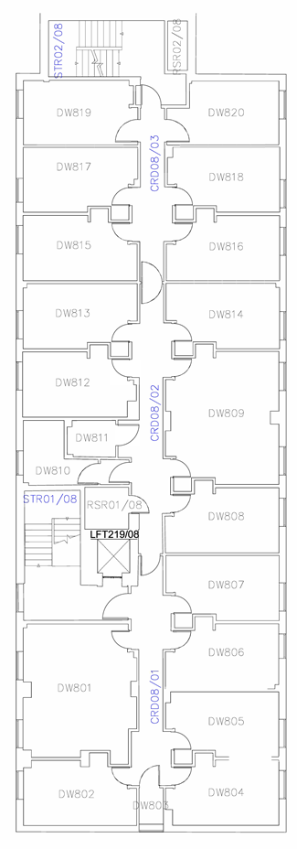
8.
6.
5.
4.
8.
7.
3.
2.
1.
6.
Duncan Wing level 8
1. Room numbers start at the point the floor is accessed via the main stair STR/01/08
2. Initially the room numbers go round the bottom leg of the floor so that they don’t end up in a dead leg but join up with the main leg at DW807
3. This first set of room numbers is therefore sequential around the walls and not along the corridor
4. Once the room numbers deal with the short leg of the floor at DW807 they revert to the normal pattern and travel to the end of the corridor at DW820 by giving the next number to the next door on either side of the corridor
5. There are three corridor numbers each within a contained corridor space bounded by walls and fire doors
6. In this floorplan you can see the top of two staircases – STR01/08 and STR02/08
7. This floor also illustrates the top of the lift shaft – LFT219/08
8. In this particular building there are two risers – RSR/01/08 and RSR02/08

  - A straight corridor with a dead end branch – Thomas Graham level 3
The second example is from level 3 of the Thomas Graham building which, on the lower floors, is straight corridor with a branch. In the first instance the numbering starts at the head of the main staircase and deal with a consistent stack of toilets to the left of the stair as you arrive on each floor before numbering around the small dead leg, TG308 to TG315. On the upper floors of the building the remaining rooms are a straight leg that is numbered consecutively but on these lower floors this branch that must be dealt with first. Numbering the branch before proceeding to number the rest of the floor from TG316 beyond the fire doors allows building directional signage to point to the branch and identify that the group rooms TG308 to TG315 are in that area.
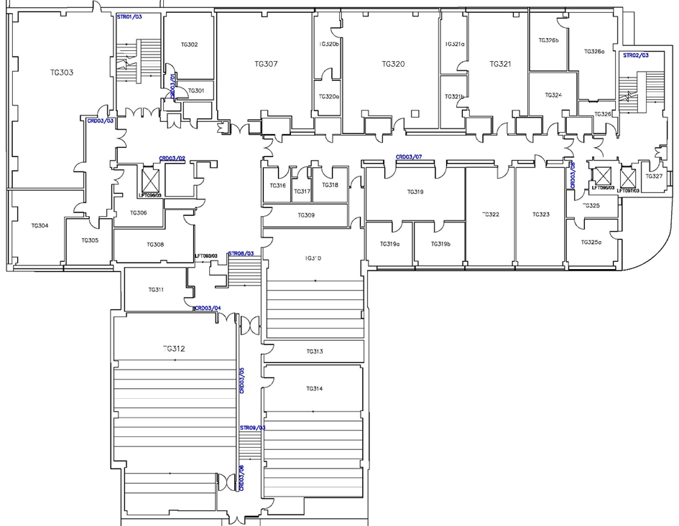
7.
6.
5.
4.
3.
1.
2.
Thomas Graham level 3
1. Room numbers start at the point the floor is accessed via the main stair STR/01/03 | 5. Since all floors have a layout that extends towards STR02/03 the rooms from TG308 to TG315, (off of the drawing,) are treated as a branch first
2. Initially the room numbers address the stack of toilet facilities, (accessed from the stair fire lobby,) that are common to most floors of the building, TG301 and TG302 | 6. This allows direction signage to be placed in the open area to highlight the room numbers in the branch
3. Numbering then proceeds to go round the small dead leg to the right of the stair from TG303 to TG306 | 7. Room numbering then proceeds sequentially with the next door on either side of the corridor getting the next room number from TG3136 to TG327
4. After entering the open space beyond the lift there is a decision to be made as to which direction to take.

  - A straight corridor with complex branches – Graham Hills level 6
The third example is from level 6 of the Graham Hills building forms a complex, (broken,) figure of eight. The strategy here is to treat the long straight corridor at the top of this plan as baseline, numbering other areas in reference to it. In the first instance the numbering deals with the dead leg in the top left had corner and then proceeds to the right. Since in this case the room numbers beyond both the first and second branches the best solution was to it was necessary to do that first before stepping back to go round the branched loop. Numbering in this way allows building signage to point to the branch and identify that rooms GH622 to GH634 are down that leg. On the right the same type of building directional signage identifies that rooms GH634 to GH647 are down that leg.

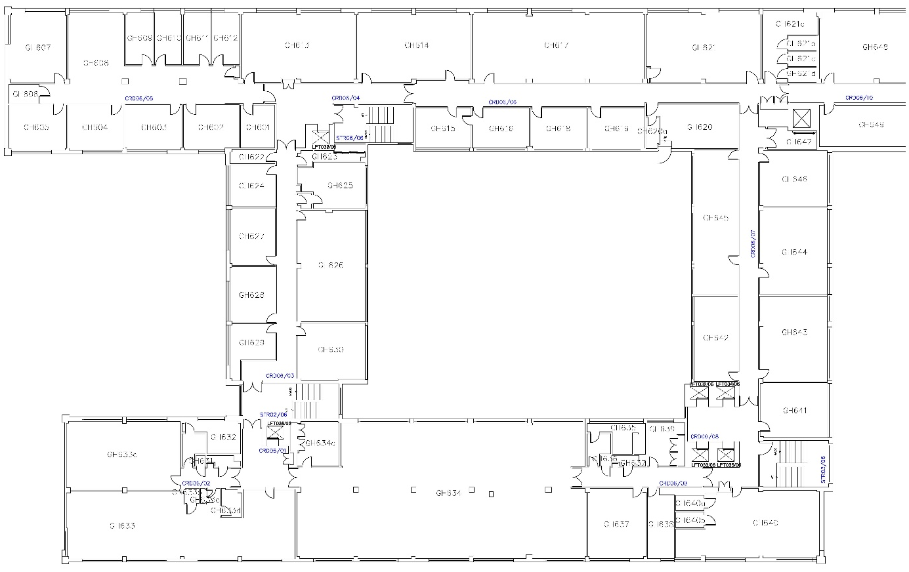
4.
3.
6.
8.
1.
5.
7.
2.
Graham Hills level 6
1. Due to the nature of this building where there are multiple entrances starting on multiple levels, room numbers start with the suite of rooms at the head of STR06/06 | 5. Having numbered the straight leg the room numbers now double back to deal with the loop.
2. First of all the room numbers deal with the “dead” leg by numbering around that area, just like example 2 in the Duncan Wing. | 6. The numbers actually proceed completely round the loop in the normal fashion, (numbering each successive door on either side of the corridor,) till it joins back up with the top straight corridor.
3. Room numbers then extend to the right to DW621 to complete that length of corridor for this section of the building. | 7. Directional signage can then be placed in the corridor identifying that complete sets of rooms are found in a particular direction. In this case GH622 to GH634 are down the first branch.
4. It’s interesting to note here that there is a room off of a corridor with an alphabetical suffix, GH621a. This was only implemented to deal with the division of a room long after the room numbering was completed. | 8. The directional signs indicate that GH634 to GH647 are down the second branch.

  - A full loop – Livingstone Tower level 7
A full loop with no branches is very straightforward and should simply be treated as a straight corridor that cranks round corners. In the example below from the Livingstone Tower, the rooms are mainly on the outside but attention is paid to rooms on the inside of the corridor to number them in sequence as they appear.
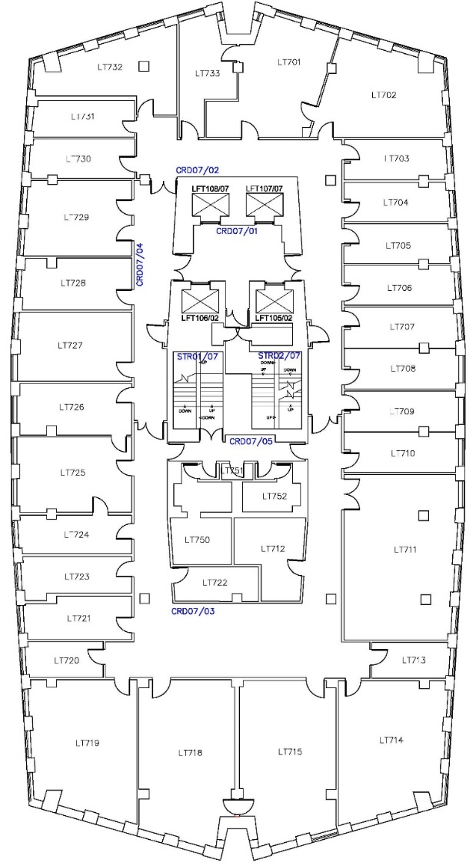
5.
3.
2.
1.
1a.
1b.
4.
Livingstone Tower level 7
1. In this case it was decided to commence numbering at the top middle of the floorplan rather than immediately outside a main access point. This was for a number of reasons. | 3. Most rooms are on the outside of the corridor here but where the next room in the sequence is on the inside of the corridor it receives the next room number.
1a. Commencing outside of the main access, in this case the lifts, would have started numbers in the middle of a long bank of rooms. | 4. Room numbering continues around the plan until it joins back up with the original number. These two room numbers are then adjacent to each other.
1b. Secondly, we also wanted to ensure that room numbers could start at the same point on every floor and since there are variations in all of the floors the simplest place to start consistently was at the top of the plan as it is represented here. | 5. In this case where rooms are in the central core and out with the normal sequence of numbers they have been given a higher number, (LT750.) This allows for changes to the arrangement and numbering of the main ring of rooms without affecting room numbers for the core.
2. Room numbering continues in a clockwise direction with each successive door receiving the next available room number.

  - Complex arrangements – Curran level 4
The Curran building is an example of a layout which is essentially split in relation to building access points at different levels. The primary purpose of the building is as the University library and on the upper levels especially there is a physical and functional division between the two vertical halves on the plan along the line of the risers, (illustrated by the vertical red dashed line on the plan below.) While we would not normally account for the allocation of a room or its function when considering room numbering, the fact that there is a physical division in this space makes it necessary. The room numbering here has evolved over time and is not perfect by any means but the principle of number separation is relevant.

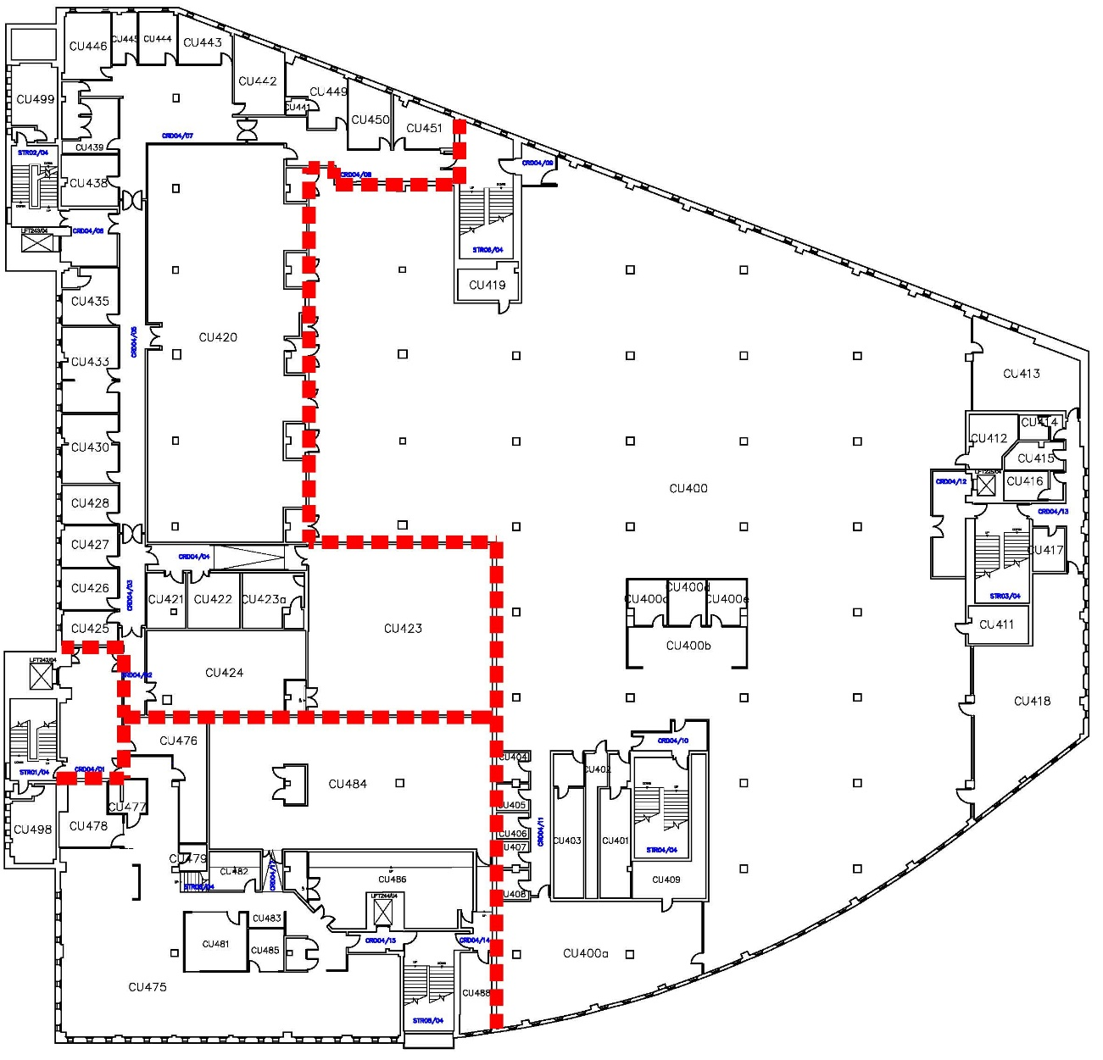
3.
4.
2.
1.
5.
Curran level 4
1. The main stair entering the library at this floor is STR04/04 and room numbering for the floor commences there. | 4. CU421 to CU451 deals with the numbering of the area to the right of CU424 first before the main corridor of rooms are numbered sequentially towards STR06/04.
2. Room numbers CU400 to CU419 are contained to the right of the dividing line of rooms and risers | 5. CU475 to CU488 are numbered sequentially from the entrance of the area towards STR05/04
3. Two further blocks of rooms are accessed from the lobby of STR01/04. | 6. As noted previously this building is a good example of the consequences of significant room numbering changes and where jumps in numbers between each block might be appropriate.

  - External rooms – Strathclyde Sport level 2
Level 2 of the Strathclyde Sport building illustrates how the University deals with room numbers for areas that are accessed from outside of the building. In this case the room numbers on the general floor plan range from SH201 to SH218. There are then four plant related rooms accessed from the service yard and these are given distinct room numbers from SH250 to SH253. The reason for this is twofold. First of all, it provides flexibility for room number changes within the building should that be required. Secondly, the difference in room numbers provides a clue to University staff and maintenance contractors that the room they are looking for is accessed from outside.
This building illustrates the challenge of identifying the final building code for use as a room number prefix. The original name of the building was due to be Sport, Health and Wellbeing which resulted in the SH prefix. The name of the building was subsequently changed to Strathclyde Sport before it opened. Ordinarily that would have required the prefix to be changed to SS, but due to the associations of those letters and the fact that SH was a unique code on campus and still suggested “Sport” it was decided to retain the prefix since it had been used throughout the construction process.
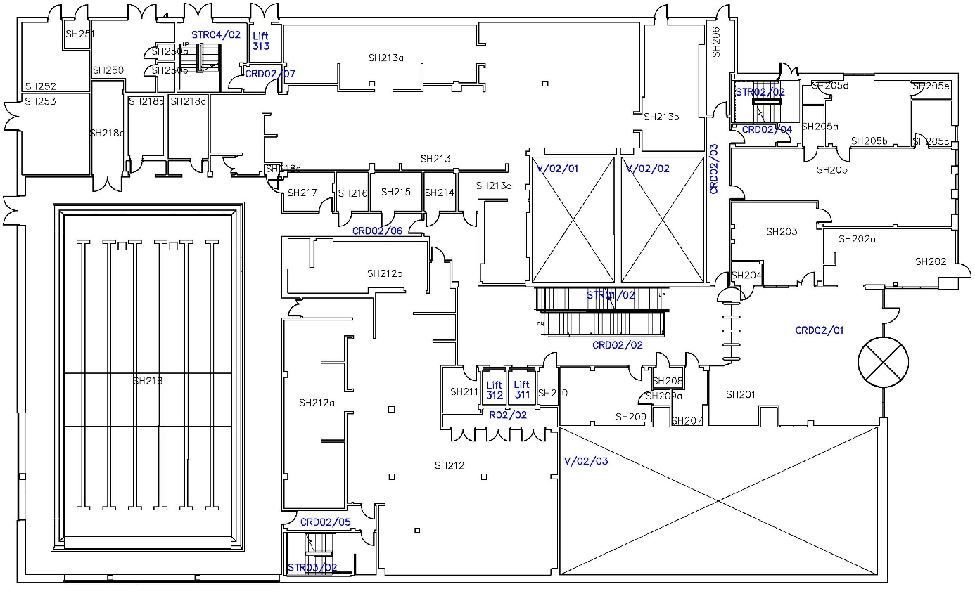
3.
1.
2.
5.
3.
4.
6.
7.
Strathclyde Sport level 4
1. Room numbering begins at the entrance area, CRD02/01 with the reception area being SH201 | 5. SH206 does not have a distinct room number like the plant rooms since this room is accessed from an internal corridor and just has a separate exit door.
2. There is small area of distinct rooms, SH203 to SH205 above this entrance area. | 6. SH250 to SH253 are numbered distinctly from the rest of the floor to illustrate that these rooms are not accessed from inside the building.
3. The rest of the internal floor area is numbered sequentially as you move through the building from SH207 to SH218. | 7. The general rule of thumb for these distinct room numbers for externally accessed rooms would be that they are not capable of being accessed from inside the building.
4. SH218a, SH218b and SH218c are numbered from left to right as you stand in front of the rooms which is the natural way you would expect to read those numbers.

  - Numbering Stairs
As noted previously, stairs should be numbered as they appear on floorplans from level 1 upwards e.g. the first stair on level 1 is Stair 01, the next stair on level 1 or subsequent floors would be Stair 02 etc. If there are multiple stairs starting on level 1, the stair closest to the main entrance should be identified as Stair 01.

Stairs do not need to rise between floors to be given a designation as a staircase. Where there is a relevant change in floor level on one floor each distinct set of steps should be identified with the next stair code.

The stair designation should also be applied to any ramps within a building.
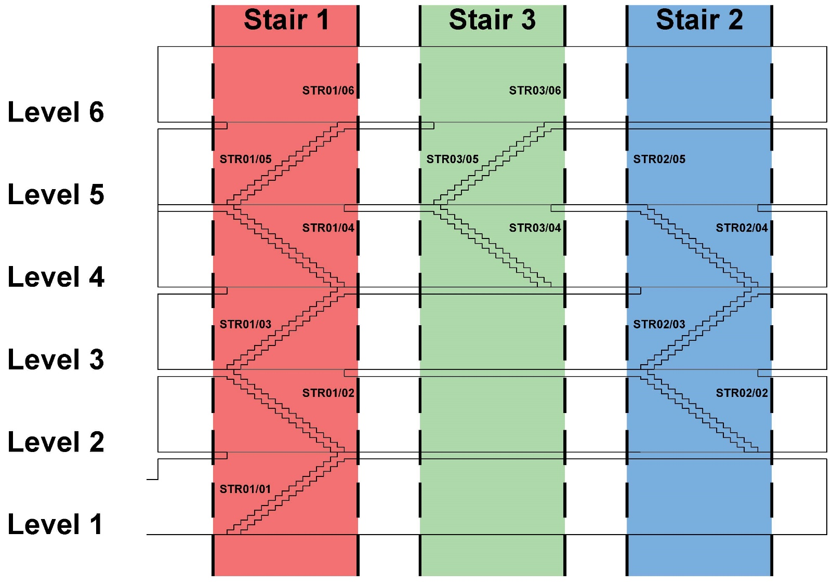
3.
2.
1.
Entrance
1. This stair begins on level 1 and is the closest stair to the entrance so this is STR01.
2. Although furthest away from stair 1, this stair is the next in terms of numbering since it starts on level 2 and is therefore designated SDR02.
3. The third stair starts further up the building than either Stair 01 or Stair 02 and this is therefore STR03.

  - Numbering Risers
Numbering risers is very similar to numbering stairs. Again, risers should be numbered as they appear on floorplans from level 1 upwards e.g. the first riser on level 1 is Riser 01, with the next riser on level 1 or subsequent floors identified as Riser 02 etc. Care should be taken to ensure that there is continuity of numbering for each riser as it rises through the building.

In terms of identifying which areas of the building should be designated as risers the consultant team should discuss this with the Building Services team in Estates Services via the Project Manager.
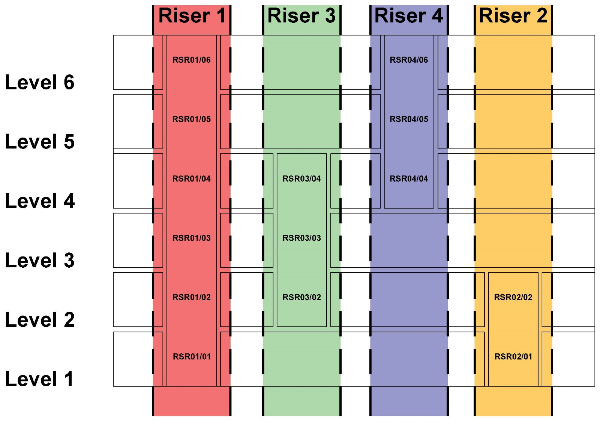
2.
4.
3.
1.
1. There are two risers that start on level 1 in this example. Both could be called riser one but the first one rises through the whole building while the second only travels through two floors so in this case the first one is designated RSR01. | 3. The third riser is the one that starts on the next floor, in this case level 2 and is therefore designated RSR03.
2. The second riser also starts on level 1 but since it only travels through two floors it has been designated RSR02. | 4. The final riser is the one that starts on the highest floor and is designated RSR04.

- Summary
Each building layout presents its own challenges and its always best to have at least one person assigning numbers and then have someone to review them.
Initial and final room numbers will always be set by the Space Planning team in Estates Services.
To avoid a scenario where final room numbering need to make significant changes to the working room numbers in a new building or refurbishment area, consultants should contact the Space Planning team for advice on the implications of design changes, (additional rooms or relocated doors,) on room numbers and adopt any required alterations.

