Space Management Policy
(4) Key Facts and Figures
Valid from March 2019
(Please check the Space Planning website to ensure that this document is still the latest version)

Contents
Key Facts and Figures 2
University of Strathclyde 3
A general description of the data included in each figure 4
Figure 1: University of Strathclyde Sites 5
Figure 2: Campus buildings by size and year 6
Figure 3: Total Building Area by Construction Period 7
Figure 4: Total Building Area by Space Type 8
Figure 5: Faculty of Engineering Building Occupancy 9
Figure 6: Humanities and Social Sciences Building Occupancy 10
Figure 7: Faculty of Science Building Occupancy 11
Figure 8: Strathclyde Business School Building Occupancy 12
Figure 9: Total Faculty Area 13
Figure 10: Total Room Area by Analysis Group 14
Figure 11: Teaching Facilities Area by Department 16
Figure 12: Research Facilities Area by Department 17
Figure 13: Office Area by Analysis Group 18
Figure 14: Office Area by Room Function 19
Figure 15: Office Facilities Area by Room Function 20
Figure 16: Infrastructure Areas by Room Function 21
Figure 17: Total Building Area by Space Type 22
UK Context 23
A general description of data included in each figure 24
Figure 18: Total Campus Building Area 25
Figure 19: Total Campus Building Area (Non-Residential / Residential) 26
Figure 20: Total Research, Teaching and Support Areas 28
Figure 21: Building Condition by Category (A, B, C and D) 30
Figure 22: Building Age (Grouped in years) 31
Figure 23: Area of Research, Teaching and Support Offices 34
Figure 24: Research, Teaching and Other Income 35
Figure 25: Total Staff and Student FTE 38
Figure 26: Taught and Research Student FTE 40
Figure 27: 10 Year Capital Investment 42
Figure 28: Total Property Costs 44

Key Facts and Figures
The aim of this document is to provide a better understanding of the quantity, composition and allocation of space in the University of Strathclyde campus and to illustrate this in the wider context of all UK HEIs and with those institutions are focussed on Research.

The data used to create these illustrations is derived from two locations.

University of Strathclyde data
This is sourced from the Space Management Database which records all campus room data, including area, function, space type, allocation and occupancy. This data is from the current year academic, (AY 2018/19.)

UK HEI data
This is sourced from the Higher Education Statistics Agency which collects data from all UK HEIs annually. This data is validated by HESA then compiled for the use of all institutions. The nature of the timing of the collection, validation and publication of this data means that the charts in this document illustrate the latest data set which is from AY 2016/17.

Research HEIs
In recent years there have been efforts to categorise and analyse HESA data by the Association of University Directors of Estates in a more relevant way and currently institutions are allocated to four groups based on the following criteria.
Large Research Institutions: are those which generate over 20% of their income from research and have an academic income, (teaching and research income,) greater than £300M.
Research Intensive Institutions: are those which generate over 20% of their income from research and have an academic income, (teaching and research income,) less than £300M.
Large Teaching Institutions: are those which generate over 80% of their income from teaching and have an academic income, (teaching and research income,) greater than £100M.
Specialist Teaching Institutions: are those which generate over 80% of their income from teaching and have an academic income, (teaching and research income,) less than £100M.
Charts in the UK HEI section of the report which indicate they illustrate “Research HEIs” include data from both Large Research institutions and Research Intensive institutions.
The scale of the dataset on the UK HEI charts makes representation of the names of individual institutions impossible, the chart is provided to illustrate the general relationship of the University of Strathclyde to the wider context of the UK. Where a more meaningful comparison between Research Institutions is provided the names of individual institutions is provided to allow for more detailed comparisons.

University of Strathclyde
This section of the document is able to break down data to a Faculty and Department level in a way that the UK HEI data cannot because the Space Management database records the Department allocation for each room.
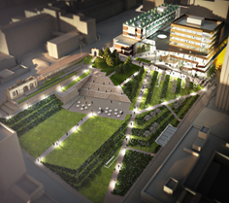  Heart of the Campus  (Rottenrow Gardens) | 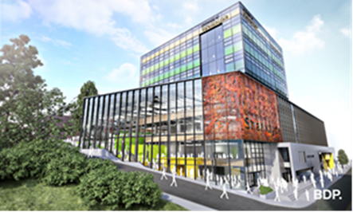  Learning and Teaching Building |  | 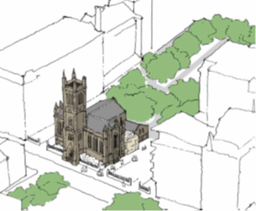  Confucius Scotland  in the Ramshorn Theatre
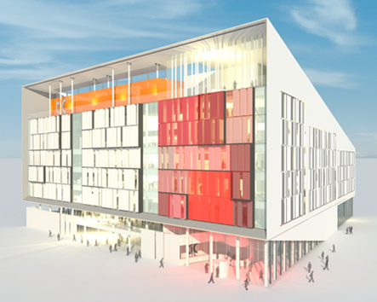  Technology and Innovation Centre |  | Over the last decade, £600M has been invested in the campus with new projects under construction
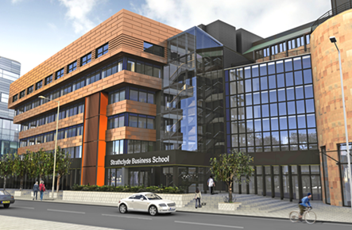
Strathclyde Business School
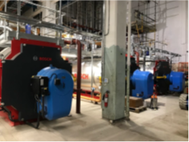  Combined Heat and Power | 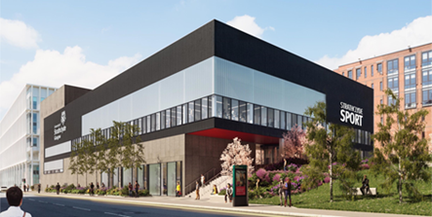  Strathclyde Sport |  | 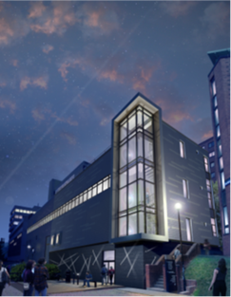  John Anderson (Extension)
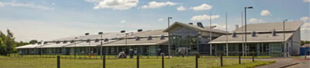  Advanced Forming Research Centre  (Phases I and II) |  | 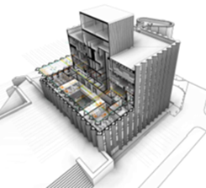  Wolfson Centre
Power Networks Demonstration Centre |  |  | The campus transformation  supports our vision as a  leading international  technological university

A general description of the data included in each figure
Figure 1: University of Strathclyde Sites
A visual comparison of the relative area of each of the sites where the University owns buildings.
Figure 2: University of Strathclyde Building Area by Year
An illustration of the number and size of buildings owned by the University for each year.
Figure 3: Total Building Area by Construction Period
Illustrates the total m2 area of each building in the age categories used by the Higher Education Statistics Agency.
Since 2000 / 1980 to 1999 / 1960 to 1979 / 1940 to 1959 / 1915 to 1939 / 1840 to 1914 / Before 1840
Figure 4: Total Building Area by Space Type
Illustrates the total m2 area of each of the space types used in the Resource Allocation Model for each building. Every area of the University is identified by one of four space types 0, 1, 2 and 3. Space type 0 is a room with few services whereas space type 3 is a highly serviced room.
Figure 5: Faculty of Engineering Building Occupancy
Figure 6: Humanities and Social Sciences Building Occupancy
Figure 7: Faculty of Science Building Occupancy
Figure 8: Strathclyde Business School Building Occupancy
Figures 3 to 6 illustrate the total area m2 allocated to each department in each buildings they occupy e.g. Pure and Applied Chemistry are in the Royal College, Thomas Graham and TIC.
Figure 9: Total Faculty Area
The m2 area allocated to each Faculty and each of the four Professional Services areas
Figure 10: Total Room Area by Analysis Group
Every room in the University is allocated one of 116 function codes. To make it simpler to analyse each of these functions is allocated to an analysis group. This chart illustrates the total campus area allocated to each group.
Figure 11: Total Room Area by Analysis Group (excluding Infrastructure)
This chart illustrates the total campus area allocated to each analysis group while excluding Infrastructure areas such as corridors, stairs and lifts etc. that are not occupied.
Figure 12: Teaching Facilities Area by Department
Illustrates the total teaching room area allocated to the Central Pool in relation to the teaching rooms allocated to all other departments.
Figure 13: Research Facilities Area by Department
Illustrates the total research room area allocated to each department.
Figure 14: Office Area by Room Function
Illustrates the total m2 area of offices within each Analysis Group.
Figure 15: Office Facilities Area by Room Function
Illustrates the total m2 area within each of the room functions associated with office accommodation.
Figure 16: Infrastructure Areas by Room Function
Illustrates the total m2 area within each of the room functions associated with Campus Infrastructure
Figure 17: Total Building Area by Space Type
Illustrates the total m2 area allocated to each space type on campus.

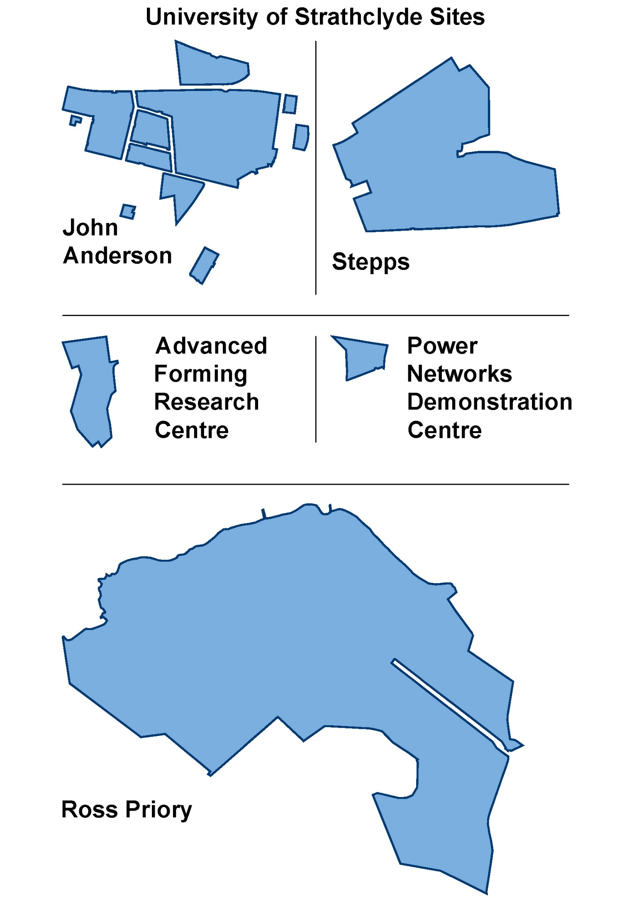

Figure 1: University of Strathclyde Sites

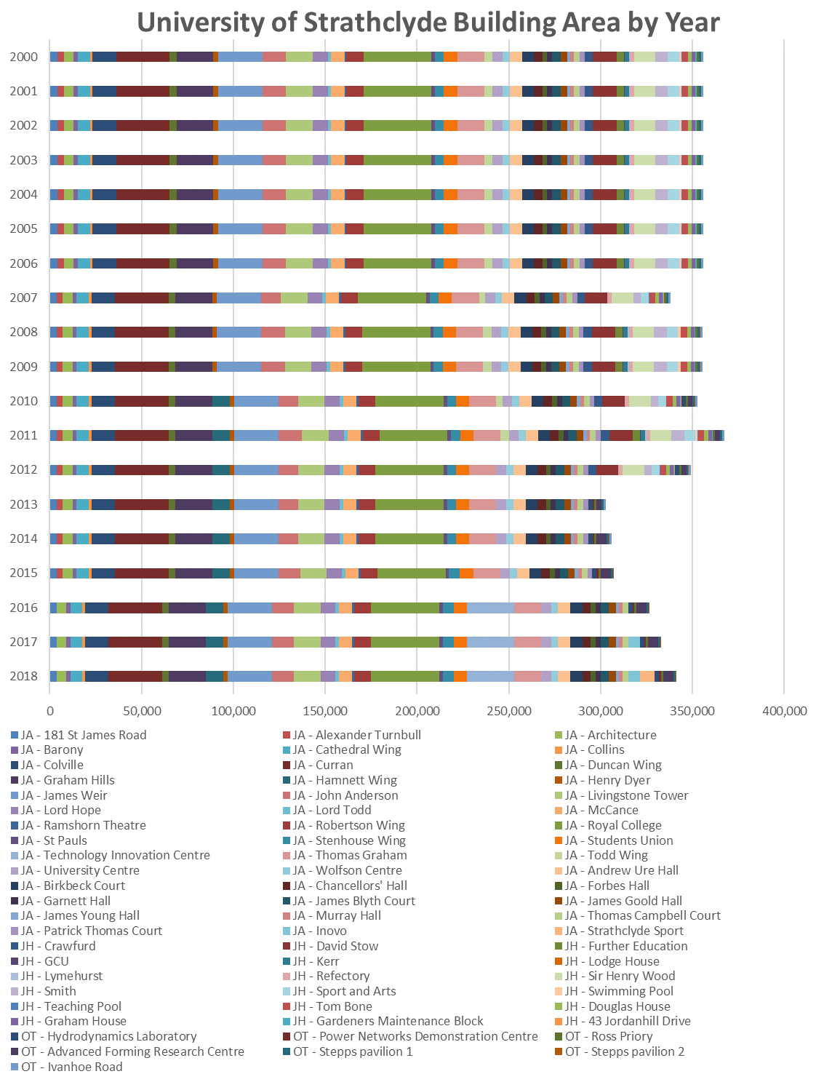

Figure 2: Campus buildings by size and year
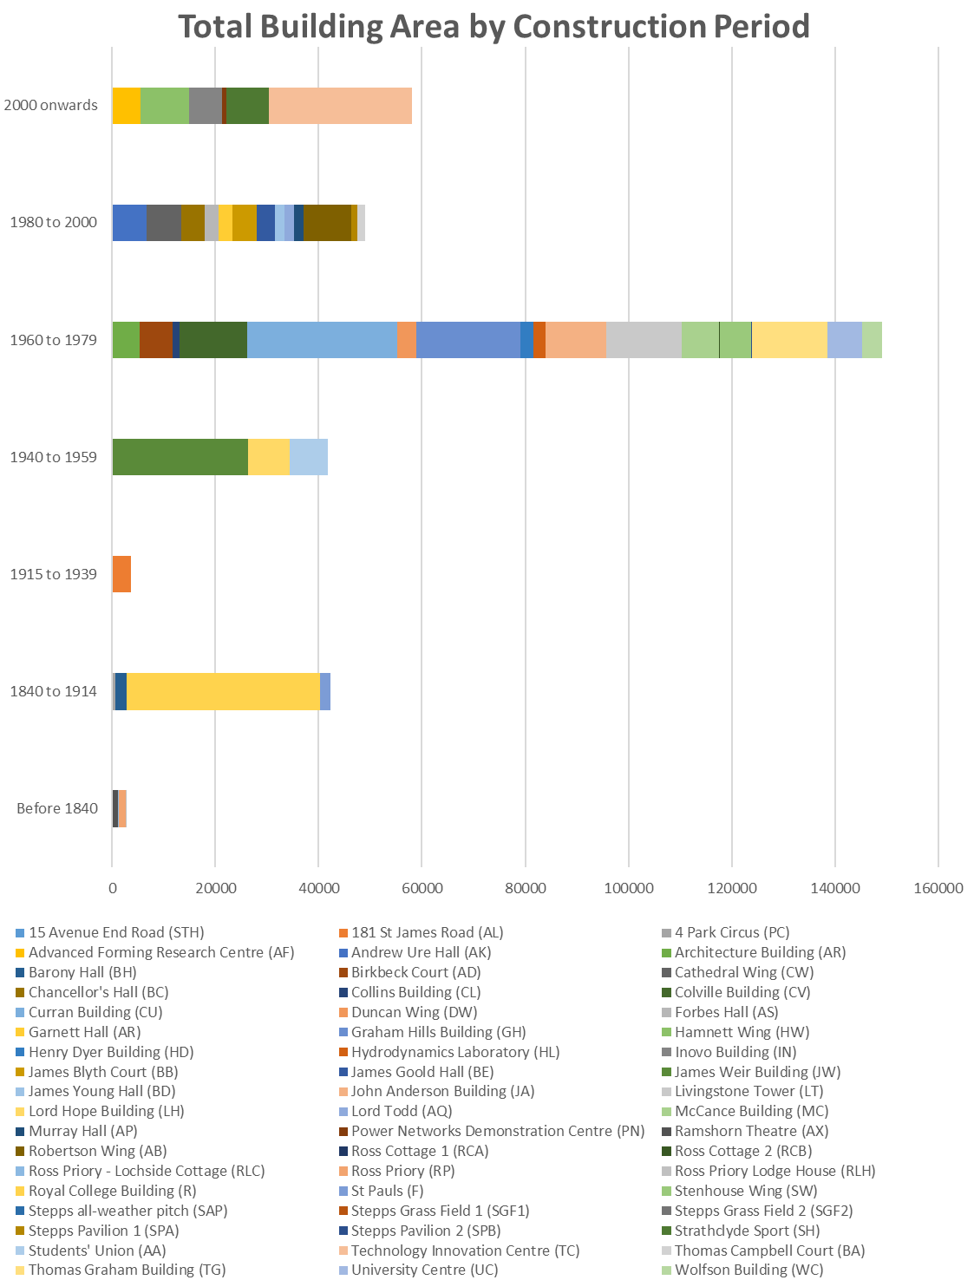

Figure 3: Total Building Area by Construction Period
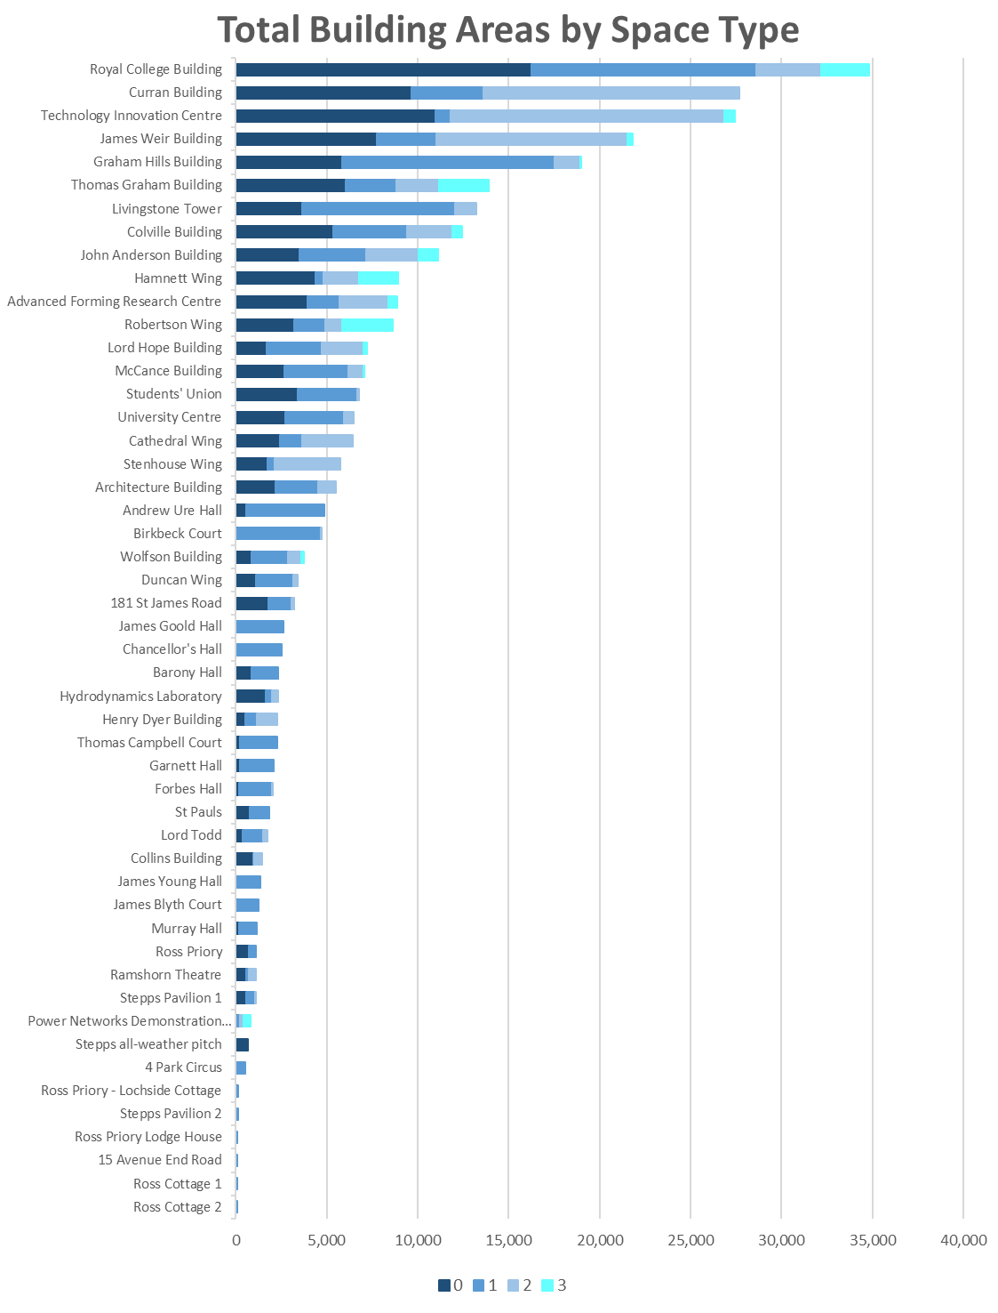

Figure 4: Total Building Area by Space Type
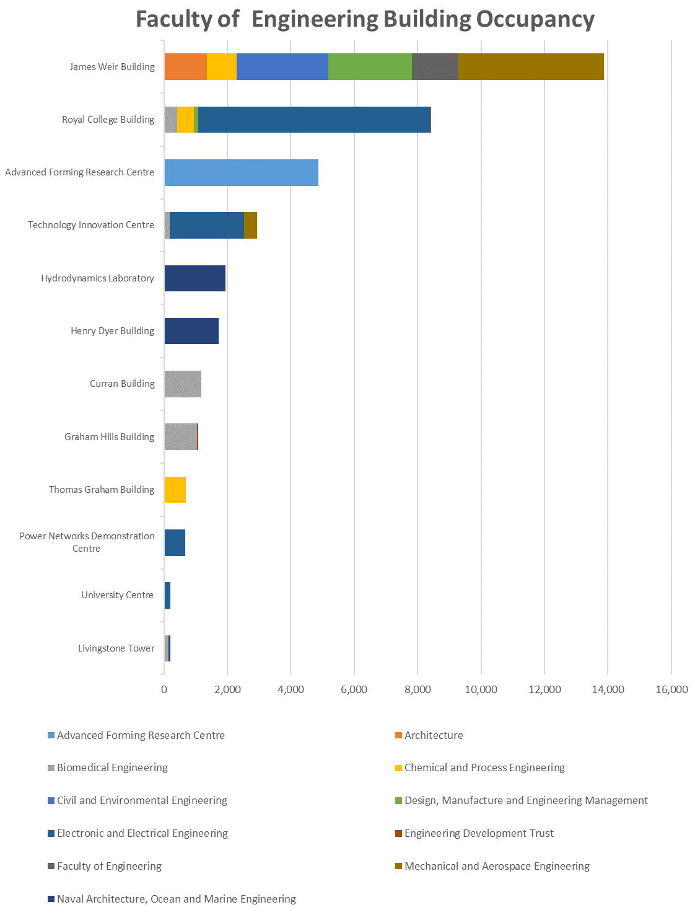

Figure 5: Faculty of Engineering Building Occupancy
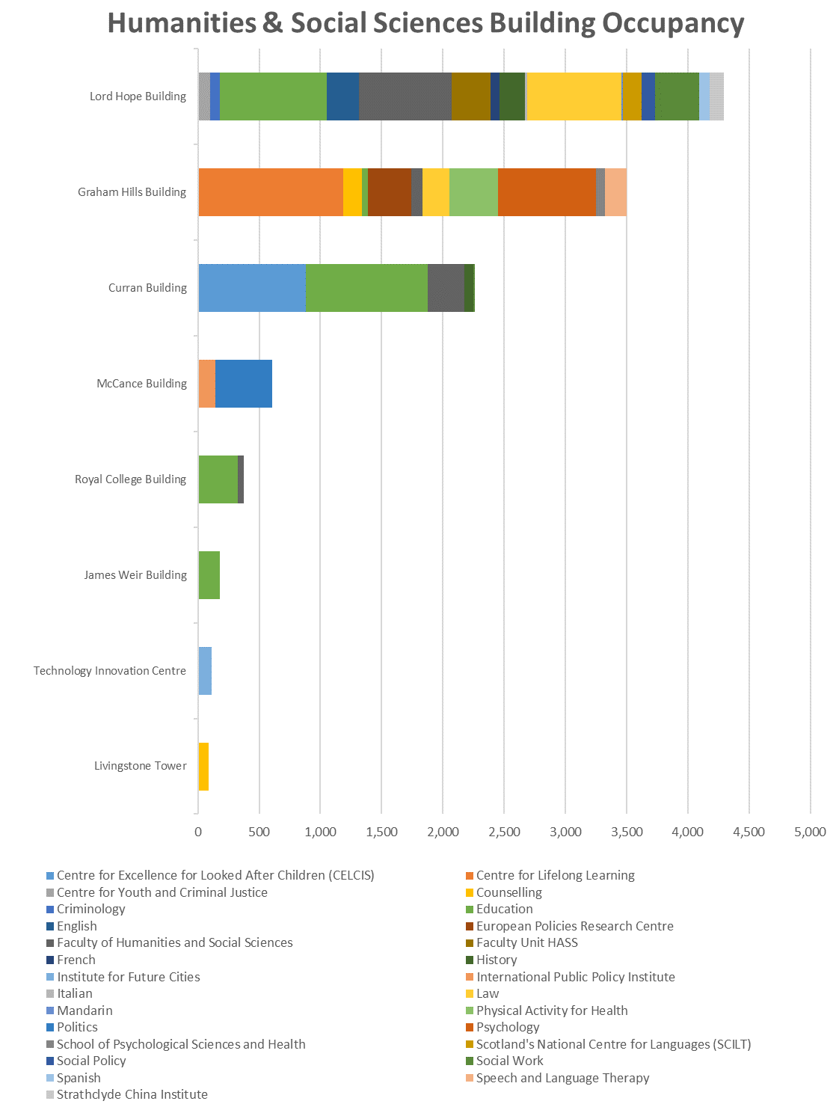

Figure 6: Humanities and Social Sciences Building Occupancy
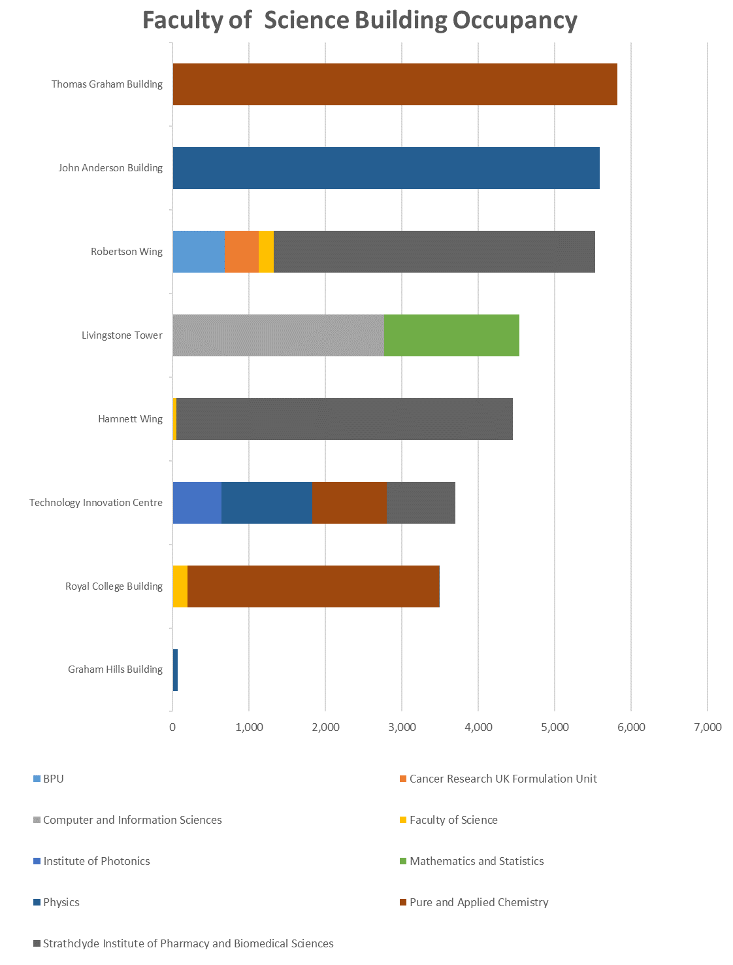

Figure 7: Faculty of Science Building Occupancy
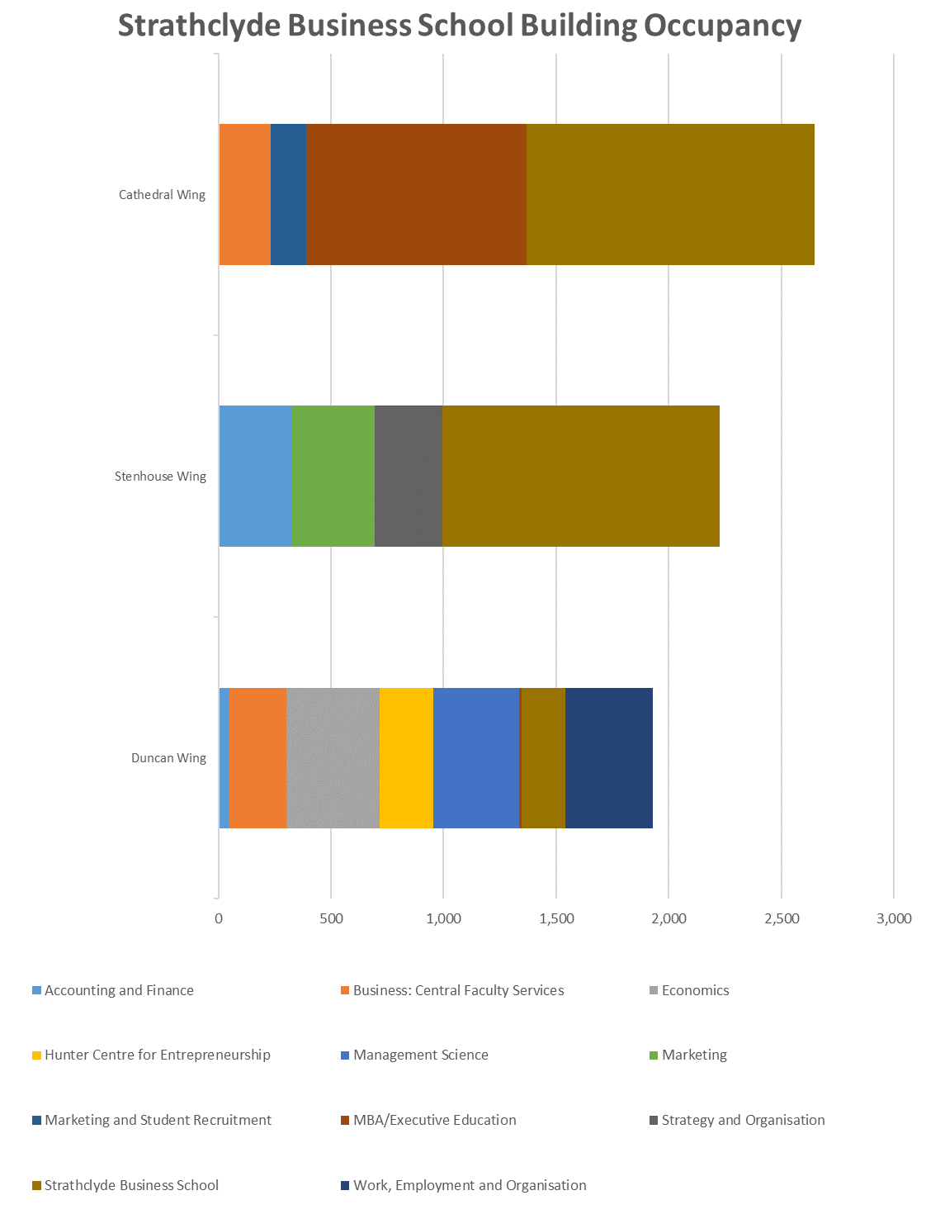

Figure 8: Strathclyde Business School Building Occupancy
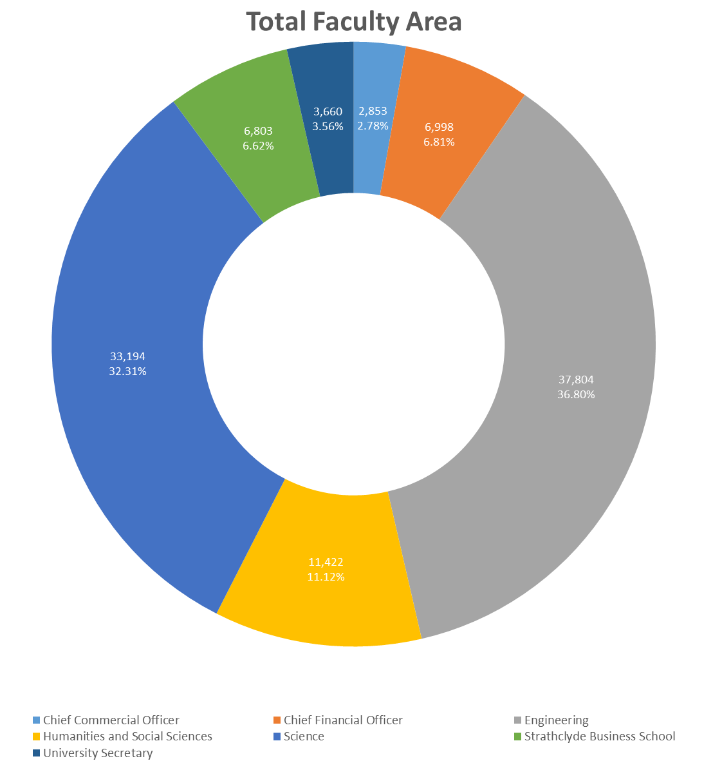

Figure 9: Total Faculty Area
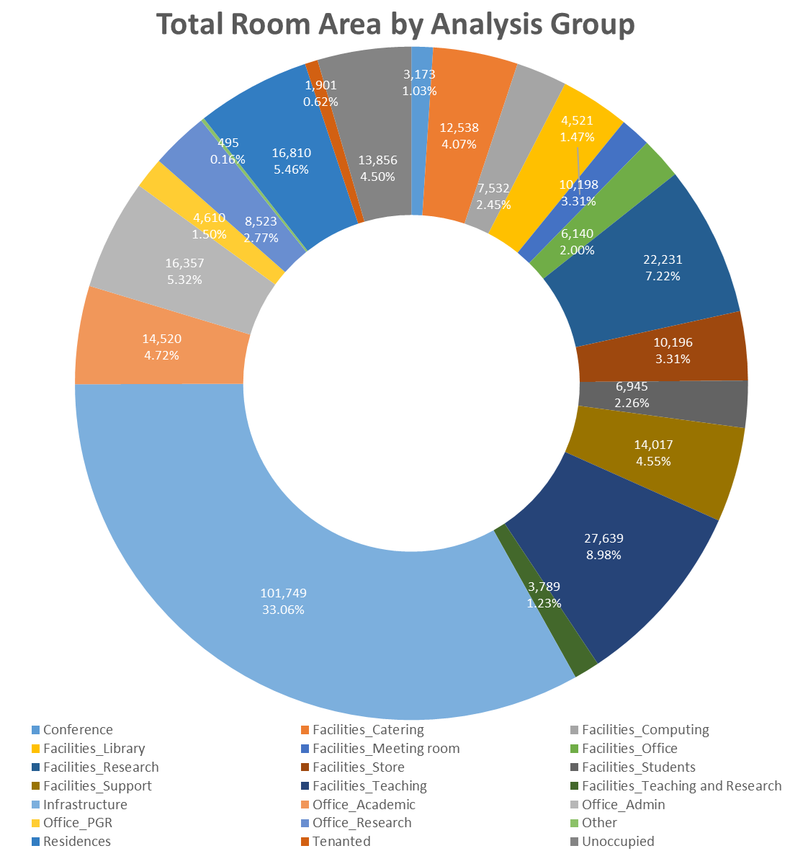

Figure 10: Total Room Area by Analysis Group

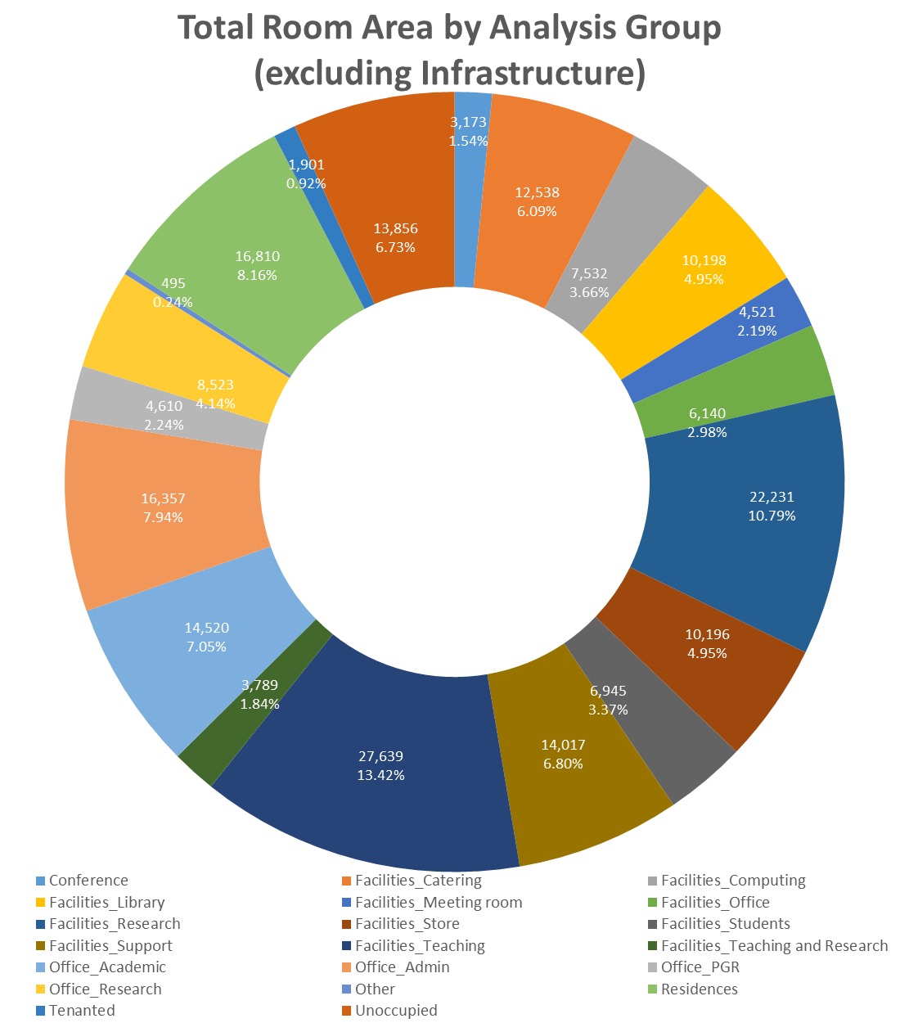

Figure 11: Total Room Area by Analysis Group (excluding Infrastructure)
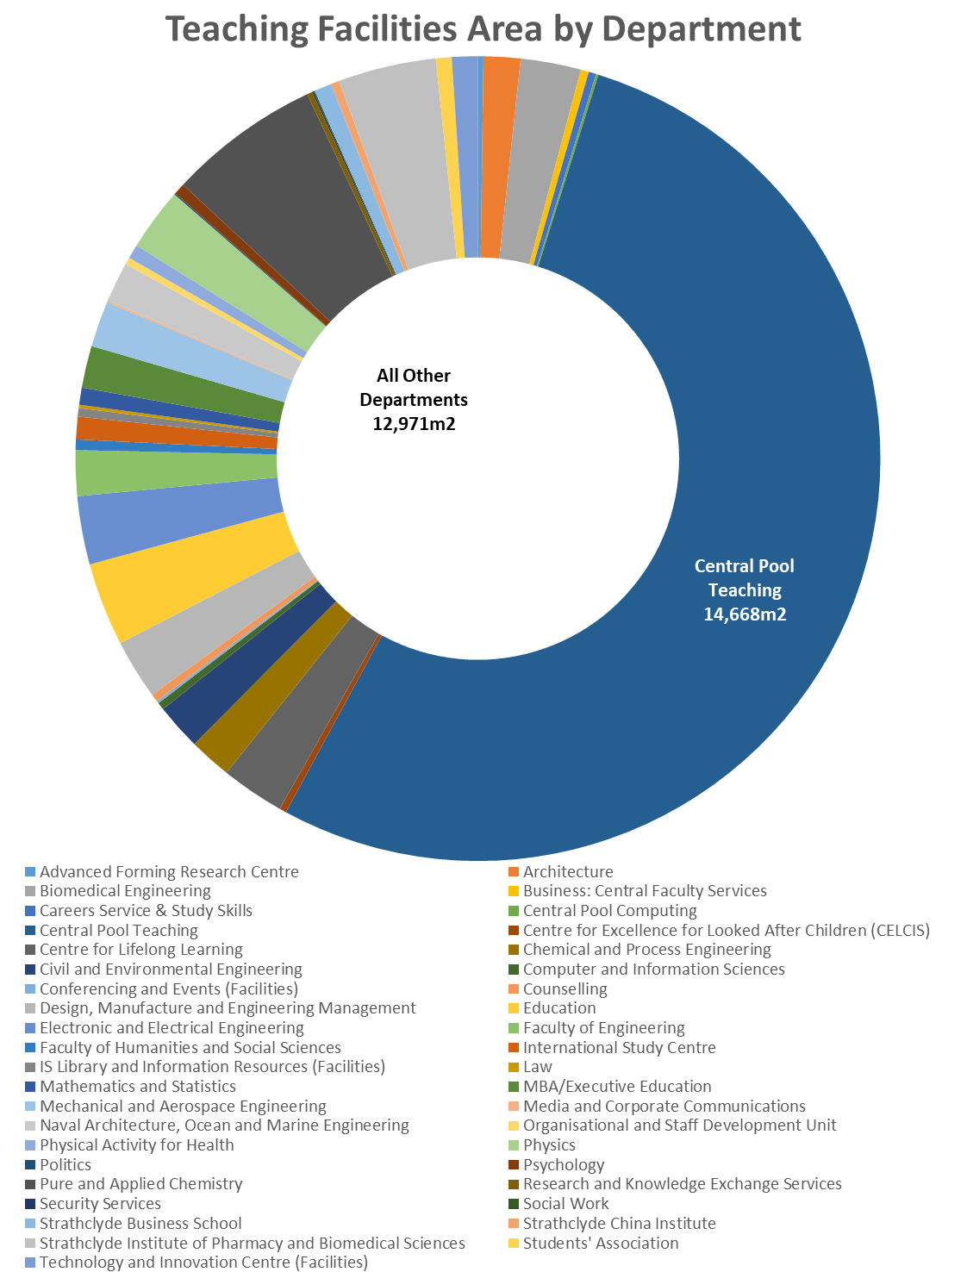

Figure 12: Teaching Facilities Area by Department
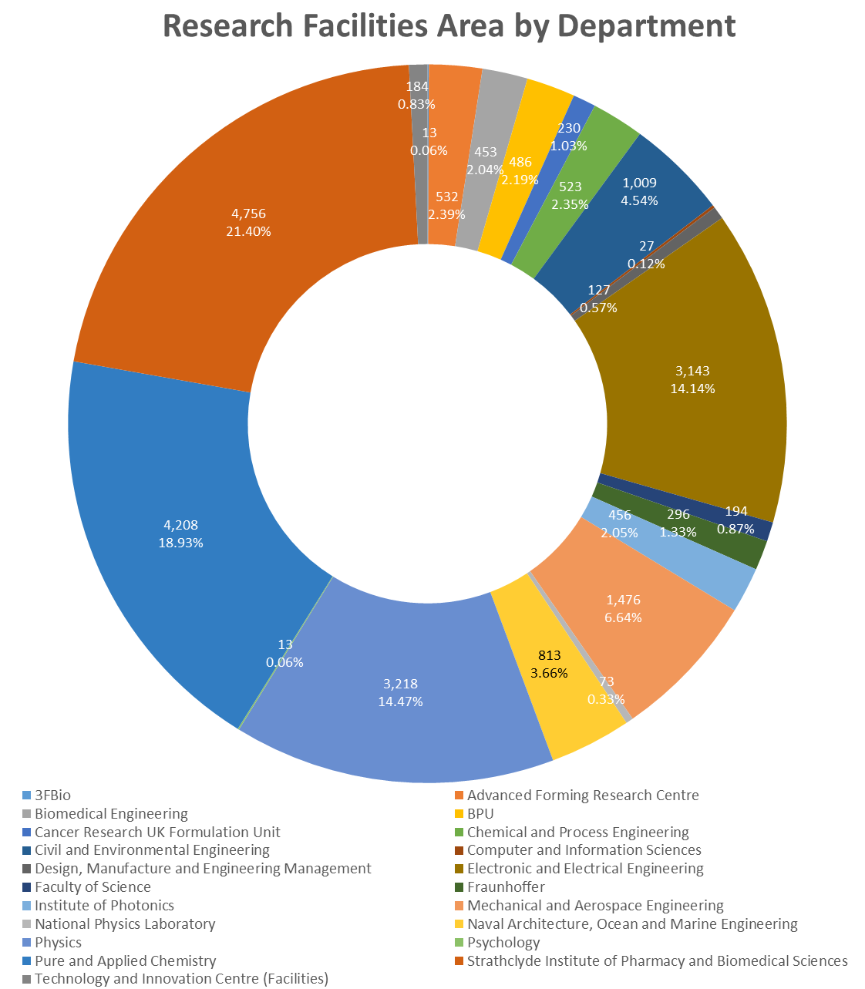

Figure 13: Research Facilities Area by Department
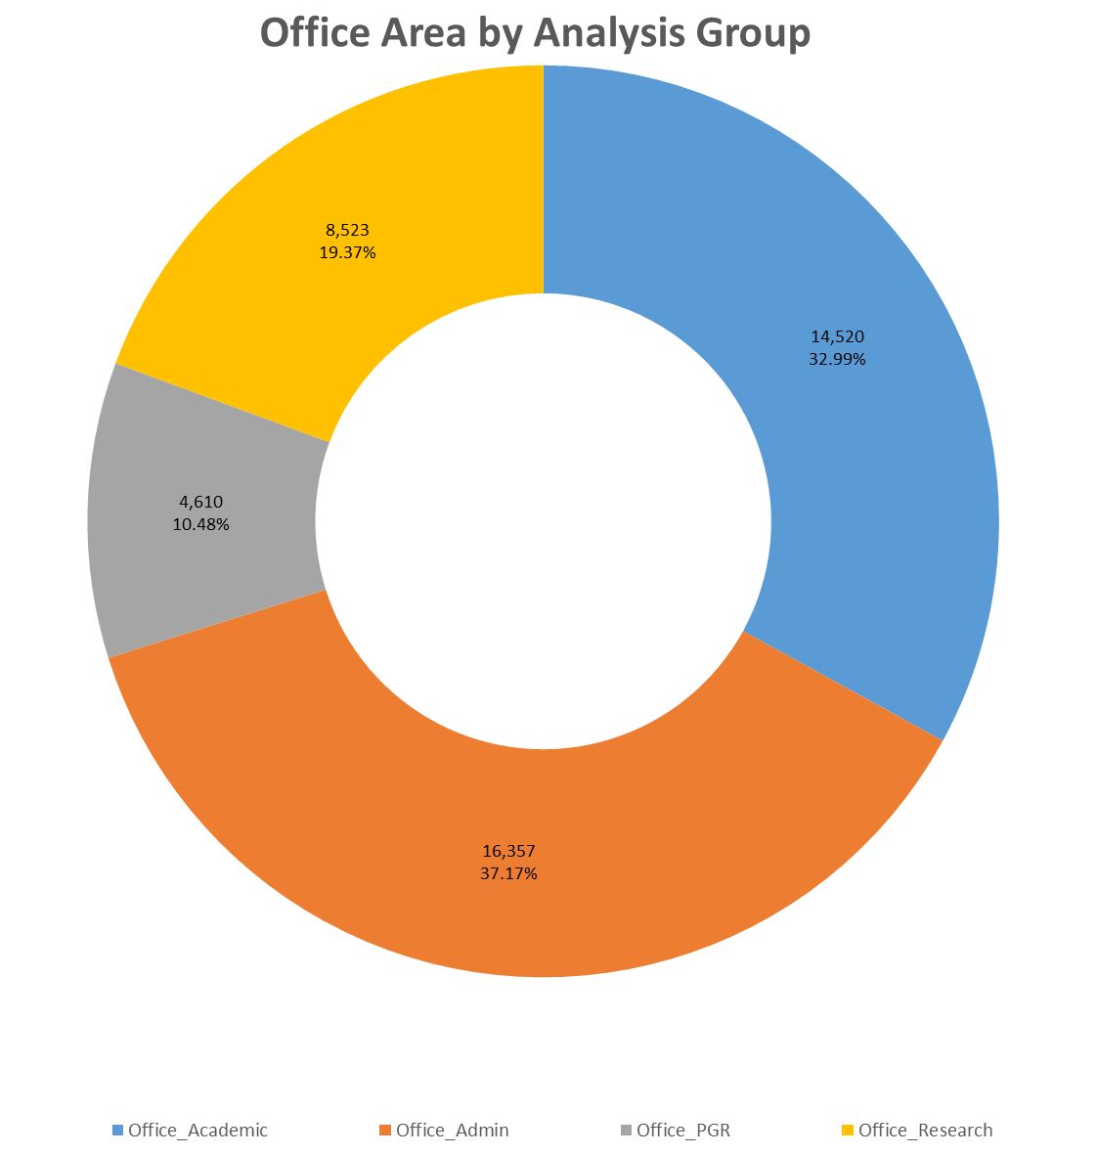

Figure 14: Office Area by Analysis Group

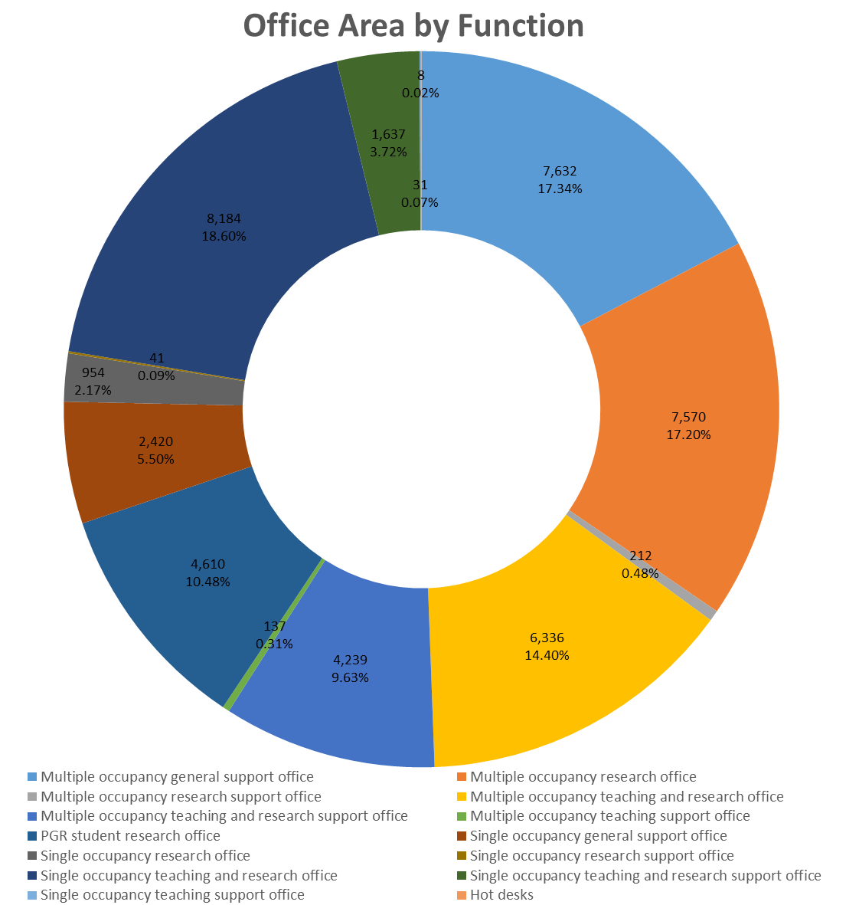

Figure 15: Office Area by Room Function
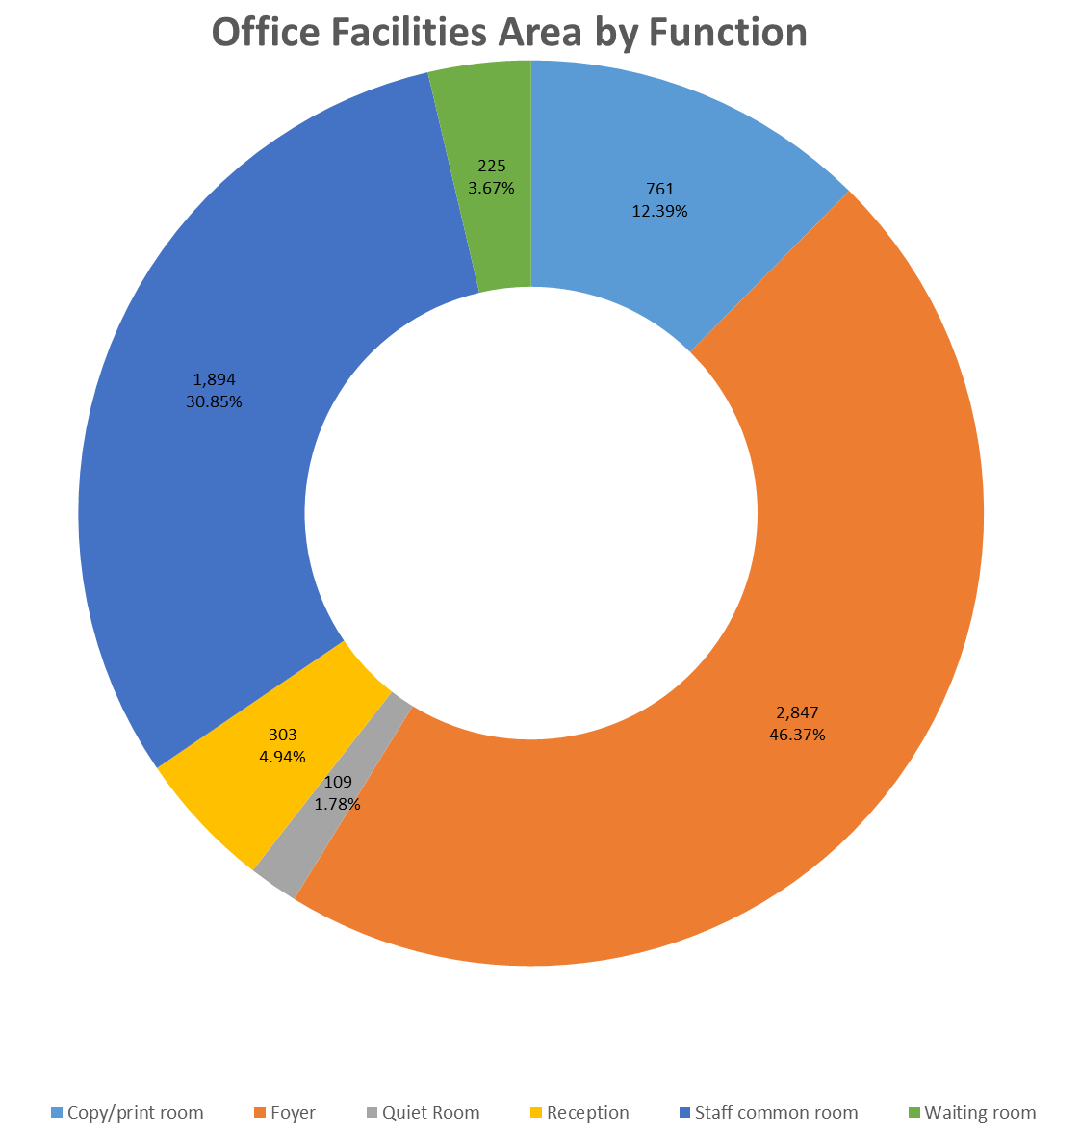

Figure 16: Office Facilities Area by Room Function

Pie chart - 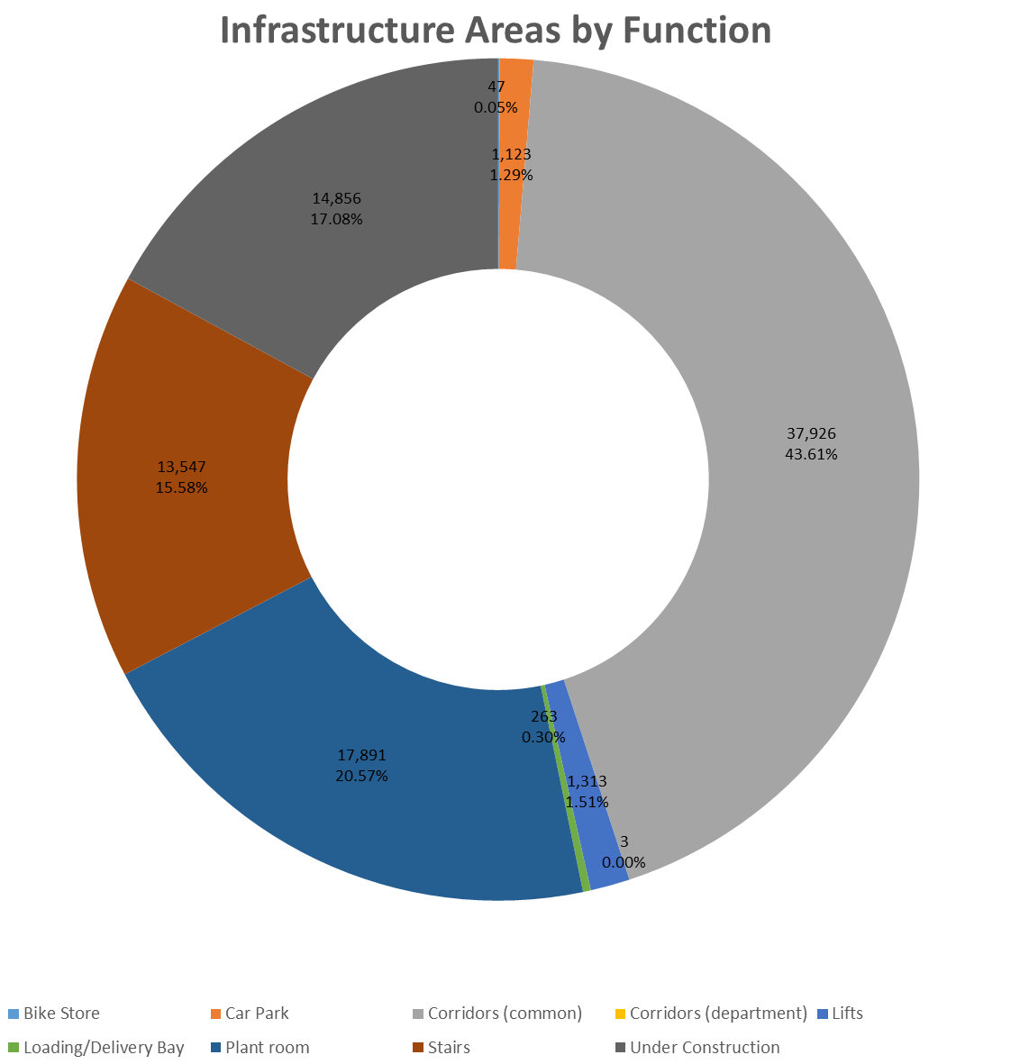

Figure 17: Infrastructure Areas by Room Function

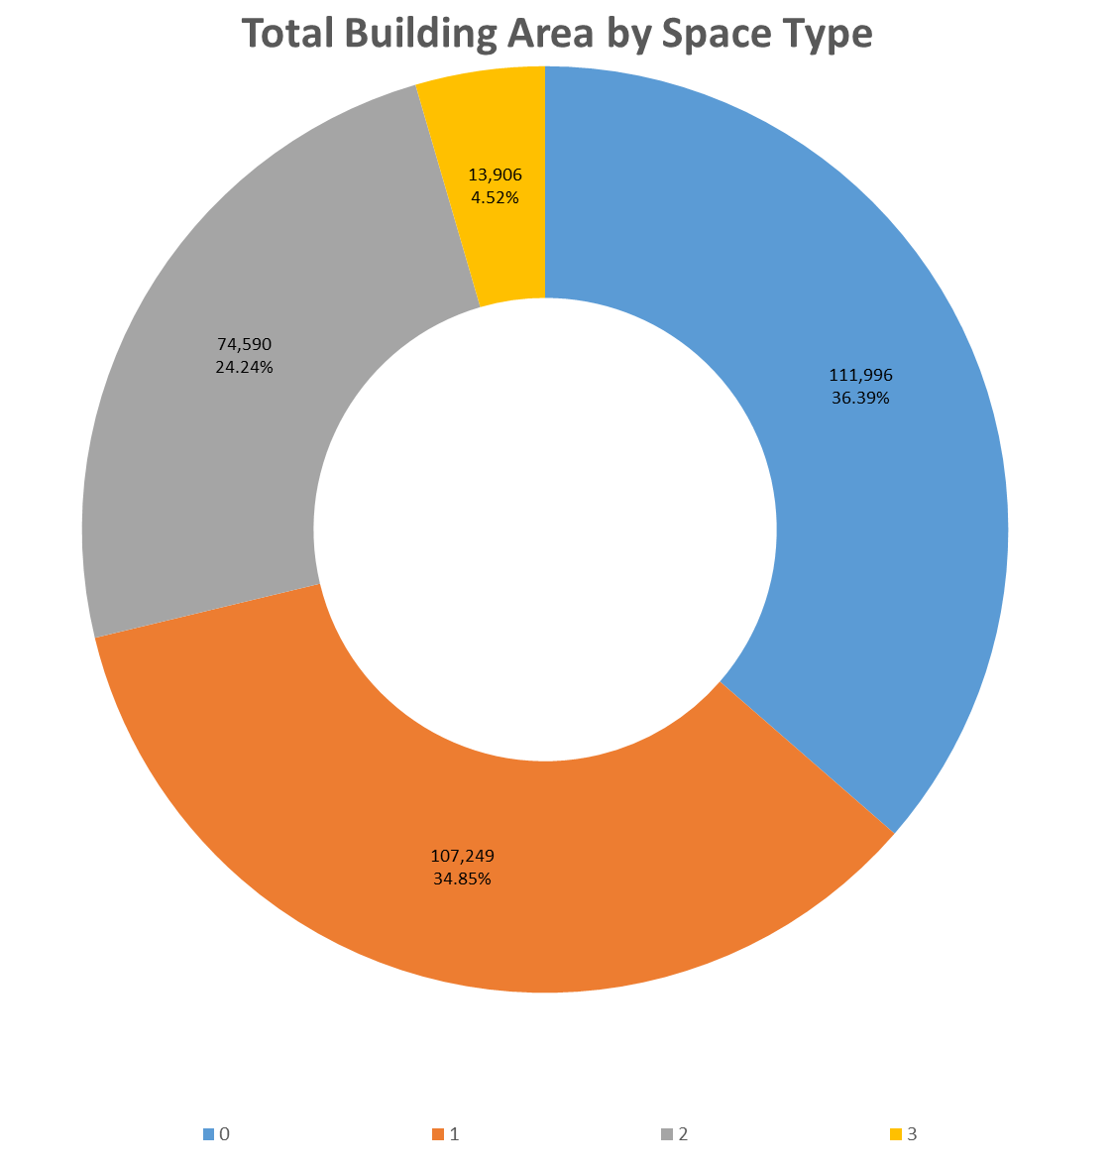

Figure 18: Total Building Area by Space Type

UK Context
The data contained in the Higher Education Statistics Agency, (HESA,) annual collection of Estates Management Data, (EMR,) is very broad and is also connected to financial and population data, (though not broken down in a way that illustrates any academic trends.) The dataset has been expanded in recent years to include elements of sustainability as well as reaching out to a number of specialist institutions so that the dataset is as broad as possible.
Each year the Association of University Directors of Estates, (AUDE,) publishes a summary report illustrating key messages and these are some of their conclusions:
Large Research institutions have seen  their capital expenditure grow from  £1.25BN to £1.35BN |  | Teaching institutions and research intensive institutions have all seen their levels of capital expenditure REDUCE
SIX INSTITUTIONS  spent more than  £100M  last year, with 12 spending between £50M and £100M. The median expenditure is a more modest £10M | Energy consumption remains relatively level  With Research institutions using more energy  300 – 350 kWh/M²  compared to teaching institutions at  200 kWh/M²
Large research institutions spend more on their estate, at  £103/M² |  | …contrasting with small teaching institutions at £76/M²
Of the 20 institutions which generate the highest income per m²,  16 of these are in LONDON | The overall HE estate  has grown to over  22,000,000 M²  Representing an increase from the previous year of  209,000 M²  (or just less than 1% growth) | In terms of the age of the estate,  32%  of the HE estate was built during the great expansion experienced during  the 1960’s & 1970’s
28%  Of the UK estate has  been built since 2000 |  | Institutions are investing between 4% &  5.5%  Of the insurance replacement value of their estate each year

A general description of data included in each figure
Figure 19: Total Campus Building Area
This is the total building area of the whole campus for each institution
For each of the following Figures, the first chart illustrates data for every HEI in the UK while the second chart only includes institutions that have been categorised as either Large Research or Research Intensive institutions. The University of Strathclyde is currently categorised as a Research Intensive institution.
Figure 20: Total Campus Building Area (Non-Residential / Residential)
Essentially the same data as Figure 16 but in this case there is a separation of Academic building area and Residential building area. The chart is ordered by Academic area.
Figure 21: Total Research, Teaching and Support Areas
These charts illustrate the area of each institution that has been categorised as either Research, Teaching or Support. Not every institution is able to make this distinction, (for various reasons,) as can be seen in the second chart illustrating Research institutions. The chart is ordered by Research Income.
Figure 22: Building Condition by Category (A, B, C and D)
Every HEI is asked to categorise all of its accommodation in one of these four categories which range from A, (a brand new building or one that has had a major refurbishment,) to D, (a building that is virtually unfit for occupation.) For most institutions the general goal is to ensure that they have a range of accommodation in categories B and C, (a new building or major refurbishment can only be categorised as such for 10 years after occupation.) The chart is ordered by the total building area in Condition A.
Figure 23: Building Age (Grouped in years)
Illustrates the construction date of buildings grouped into general periods of 20 years:
Since 2000 / 1980 to 1999 / 1960 to 1979 / 1940 to 1959 / 1915 to 1939 / 1840 to 1914 / Before 1840
Figure 24: Area of Research, Teaching and Support Offices
Similar to Figure 19 but only illustrating areas allocated to offices, (ordered by Research offices.)
Figure 25: Research, Teaching and Other Income
Illustrates the total income associated with each of these activities, (ordered by Research income.)
Figure 26: Total Staff and Student FTE
Illustrates the total FTE of all staff and all categories of student, UG, PGT & PGR, (ordered by staff FTE)
Figure 27: Taught and Research Student FTE
A breakdown of the total FTE of both UG + PGT and PGR students, (ordered by UG + PGT student FTE)
Figure 28: 10 Year Capital Investment
Illustrates the total capital investment made by each HEI in their campus buildings over the last 10 years
Figure 29: Total Property Costs
Illustrates the Operation Cost of running an estate including the following categories of spending, (ordered by Energy Costs.)
Energy, Water & Sewerage, Repairs & Maintenance, Cleaning, Rates, Insurance Premiums, Service Charges, Internal Management and External Management

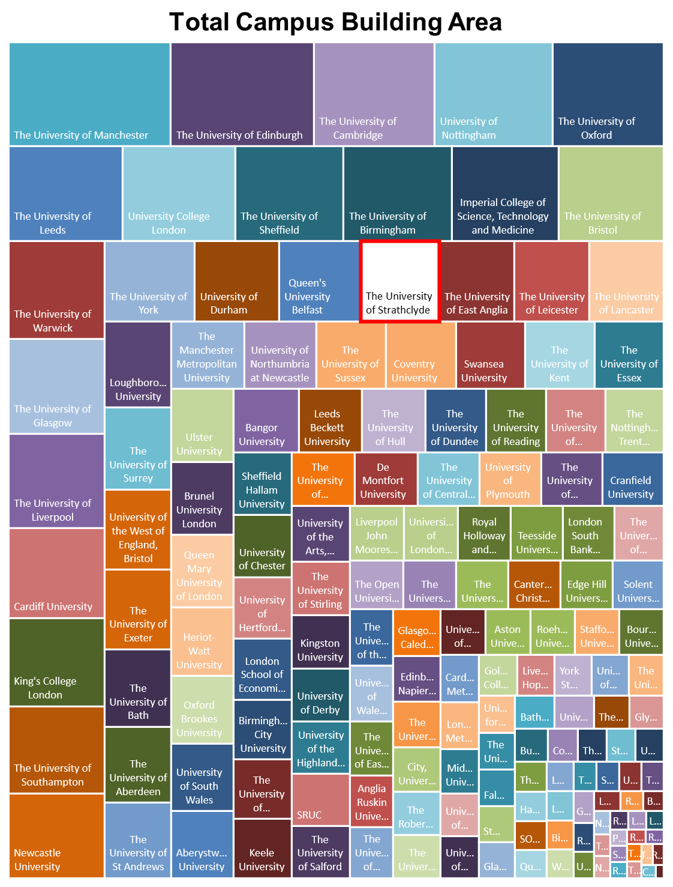

Figure 19: Total Campus Building Area
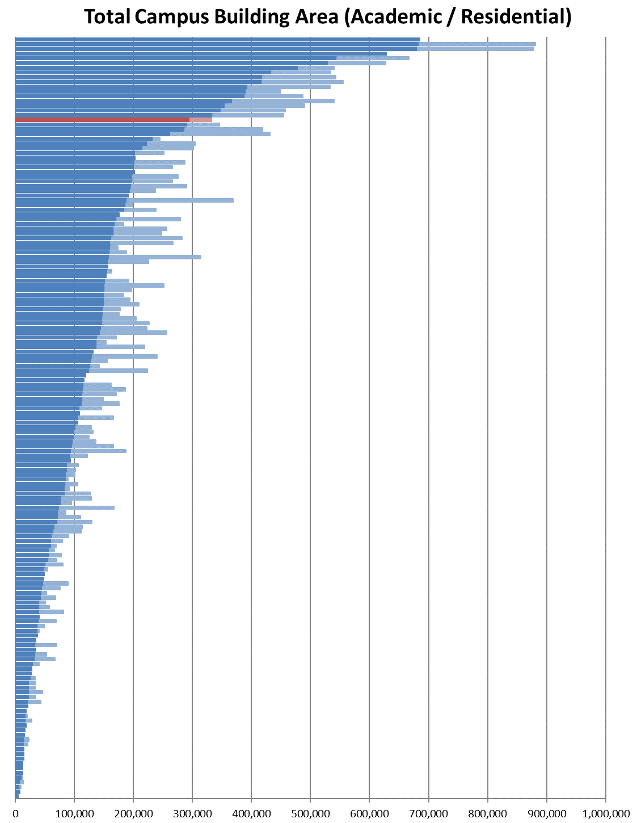

Figure 20: Total Campus Building Area (Non-Residential / Residential)

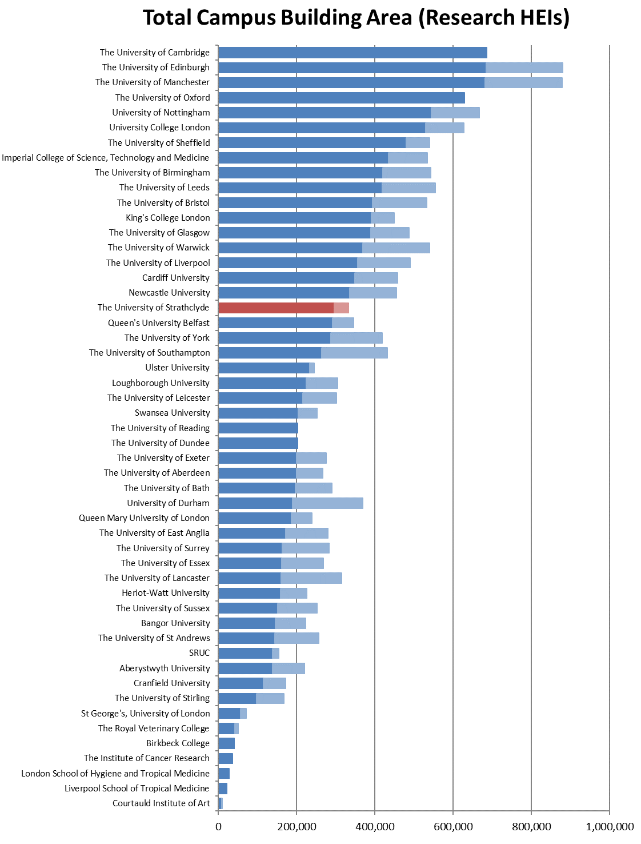
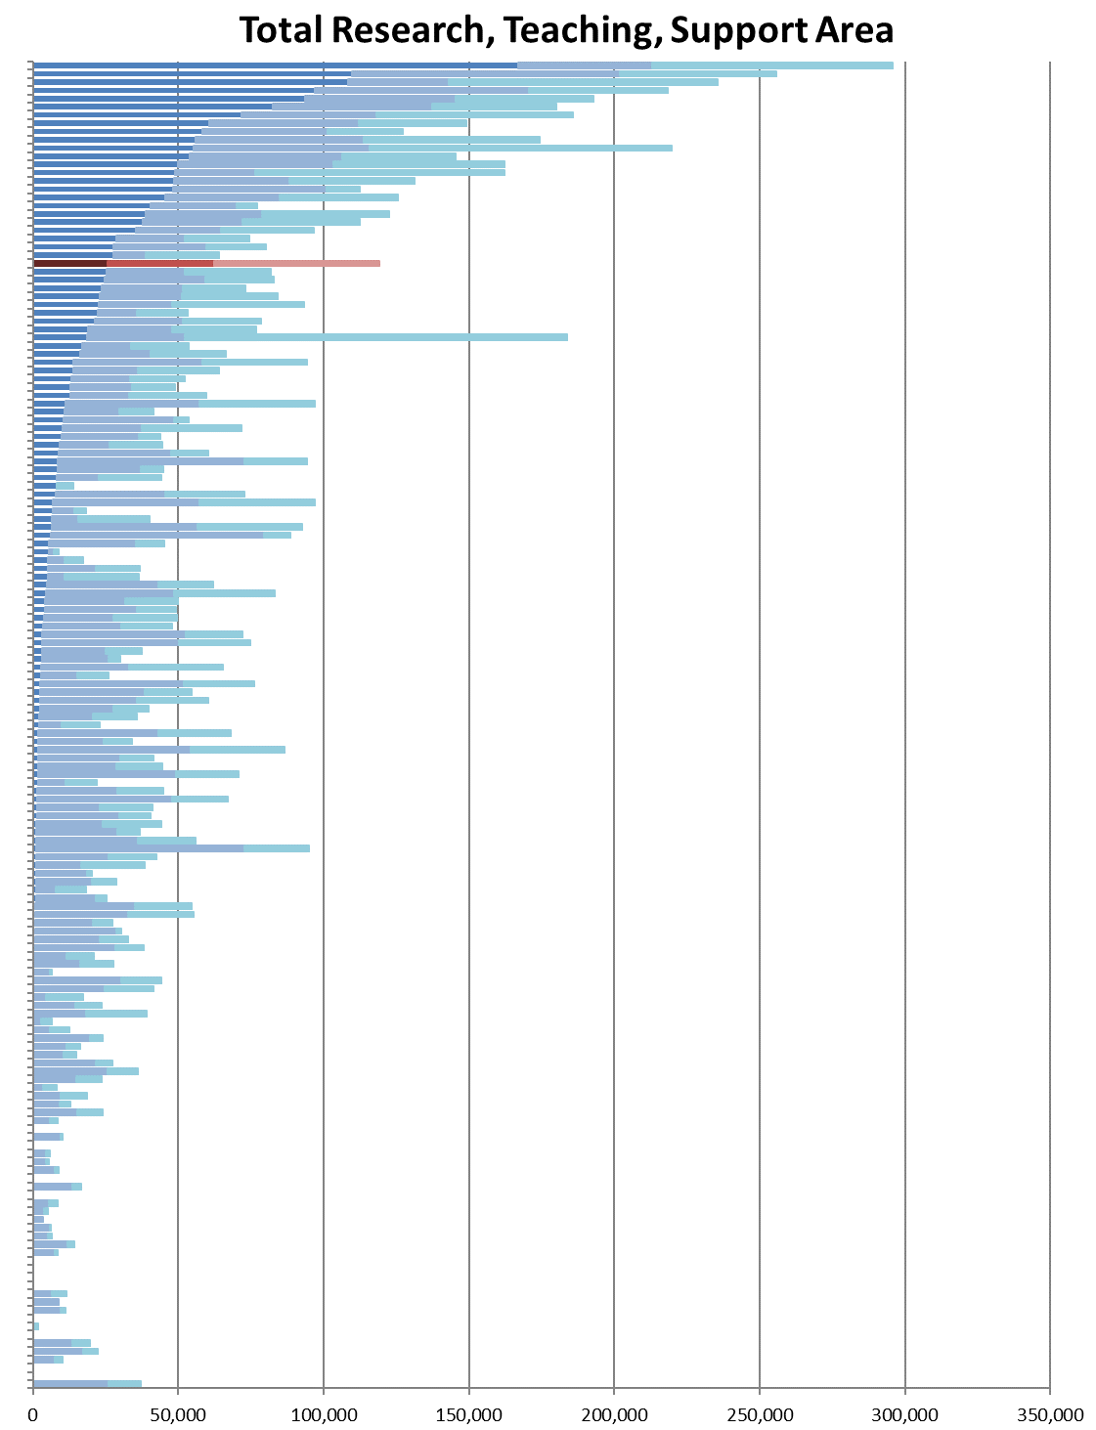

Figure 21: Total Research, Teaching and Support Areas

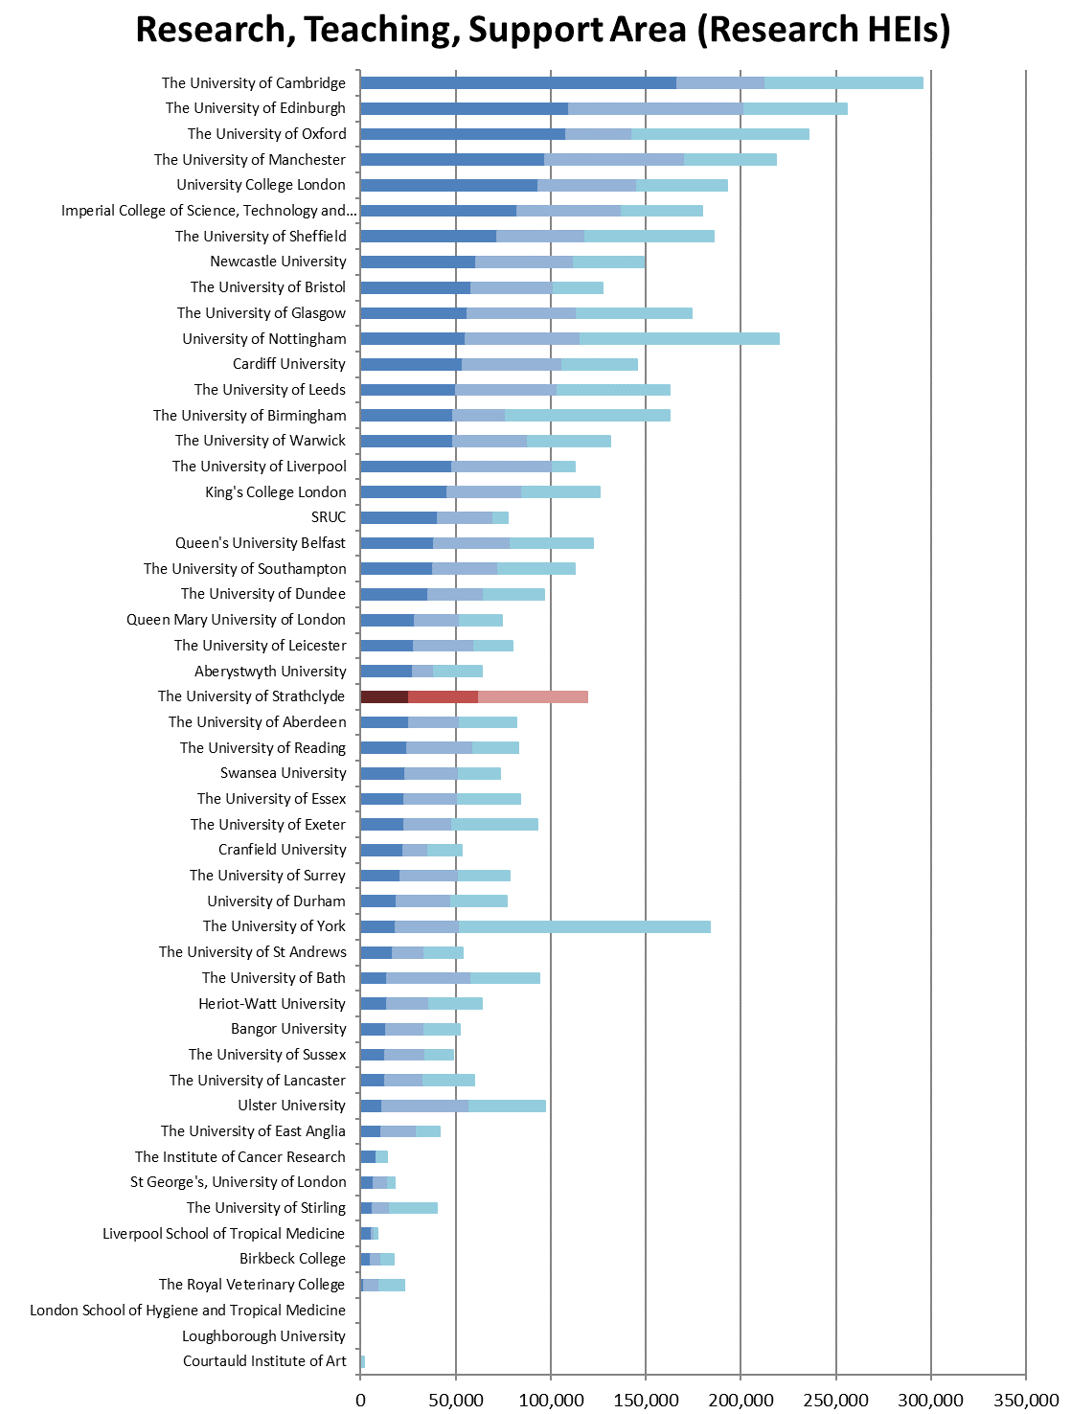

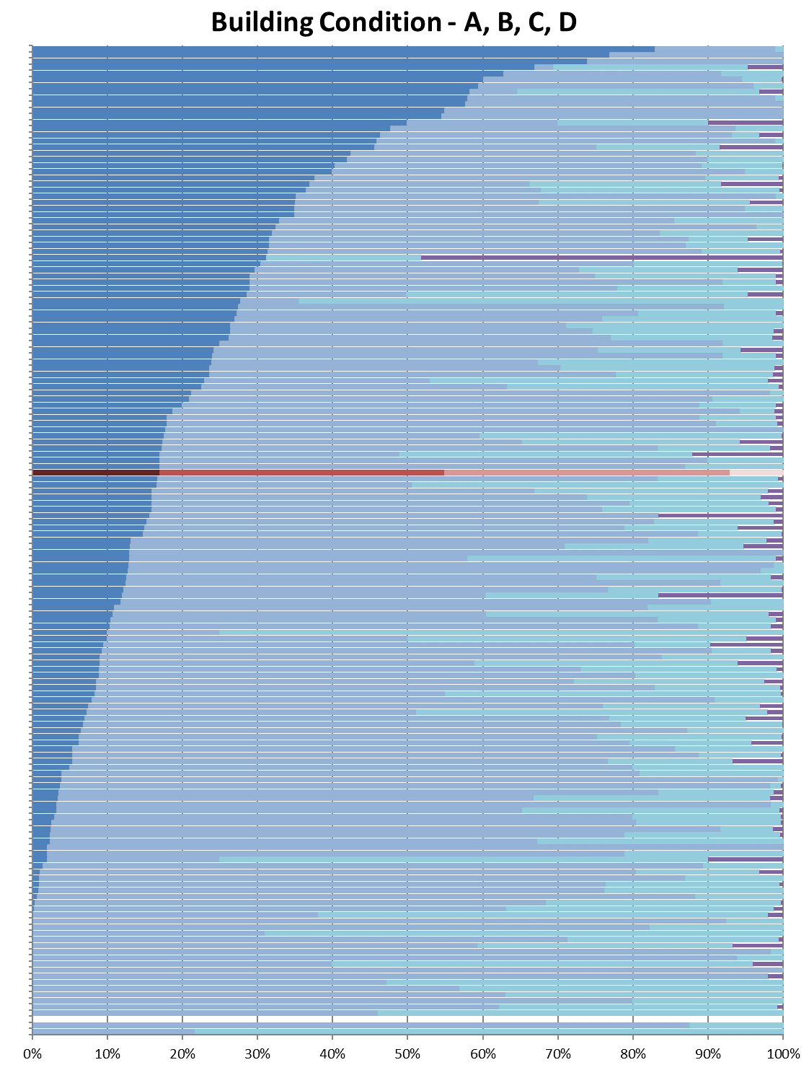

Figure 22: Building Condition by Category (A, B, C and D)

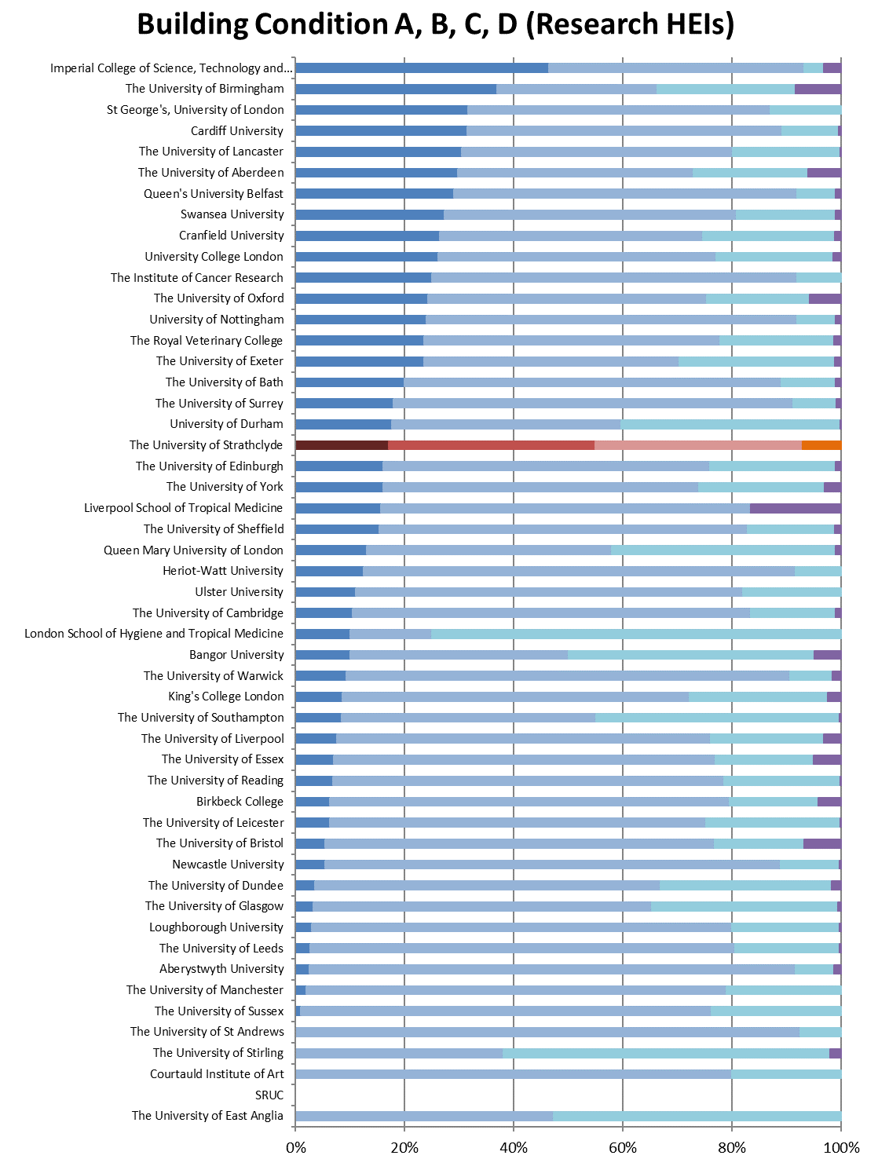

Figure 23: Building Age (Grouped in years)
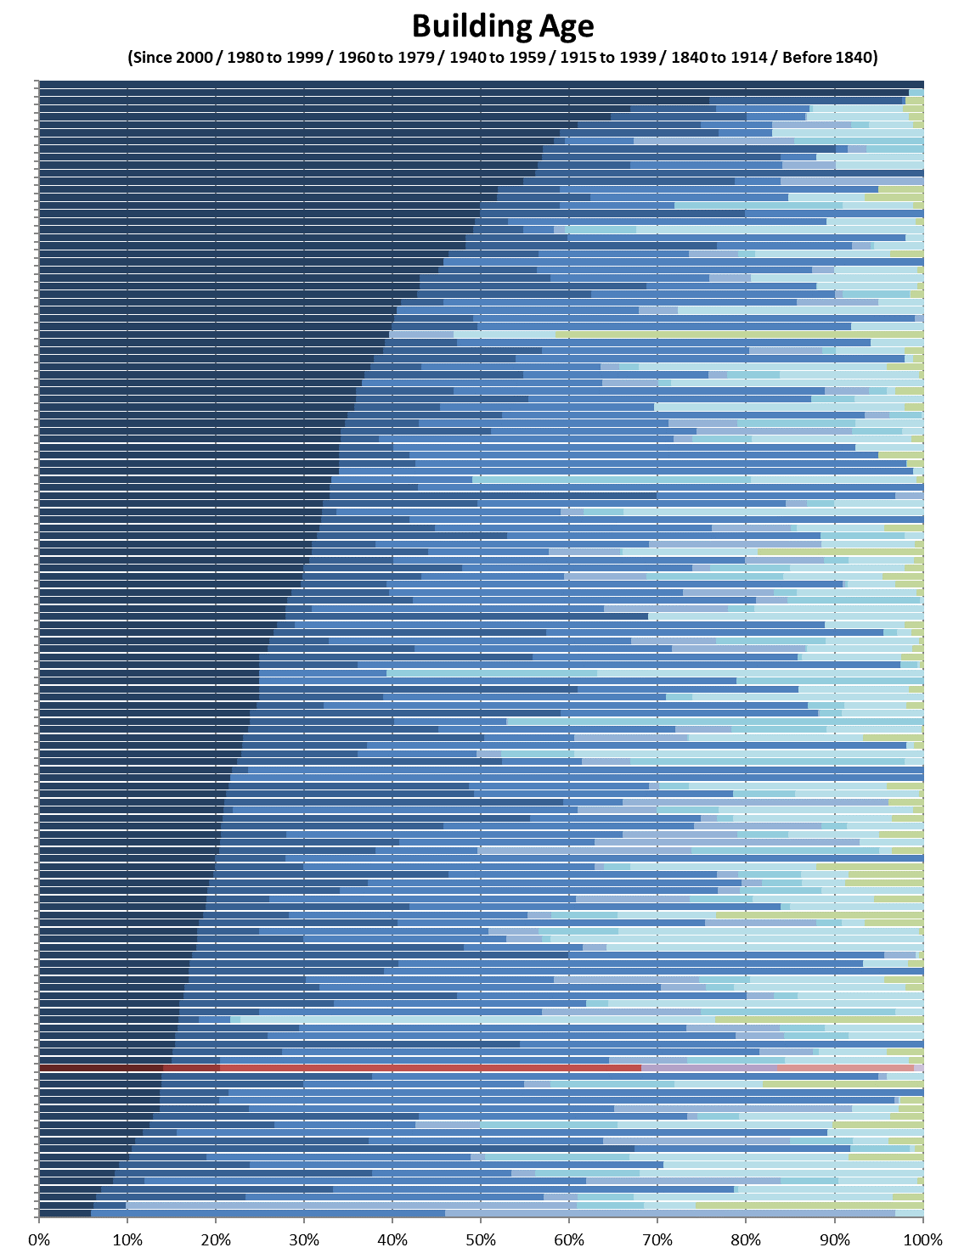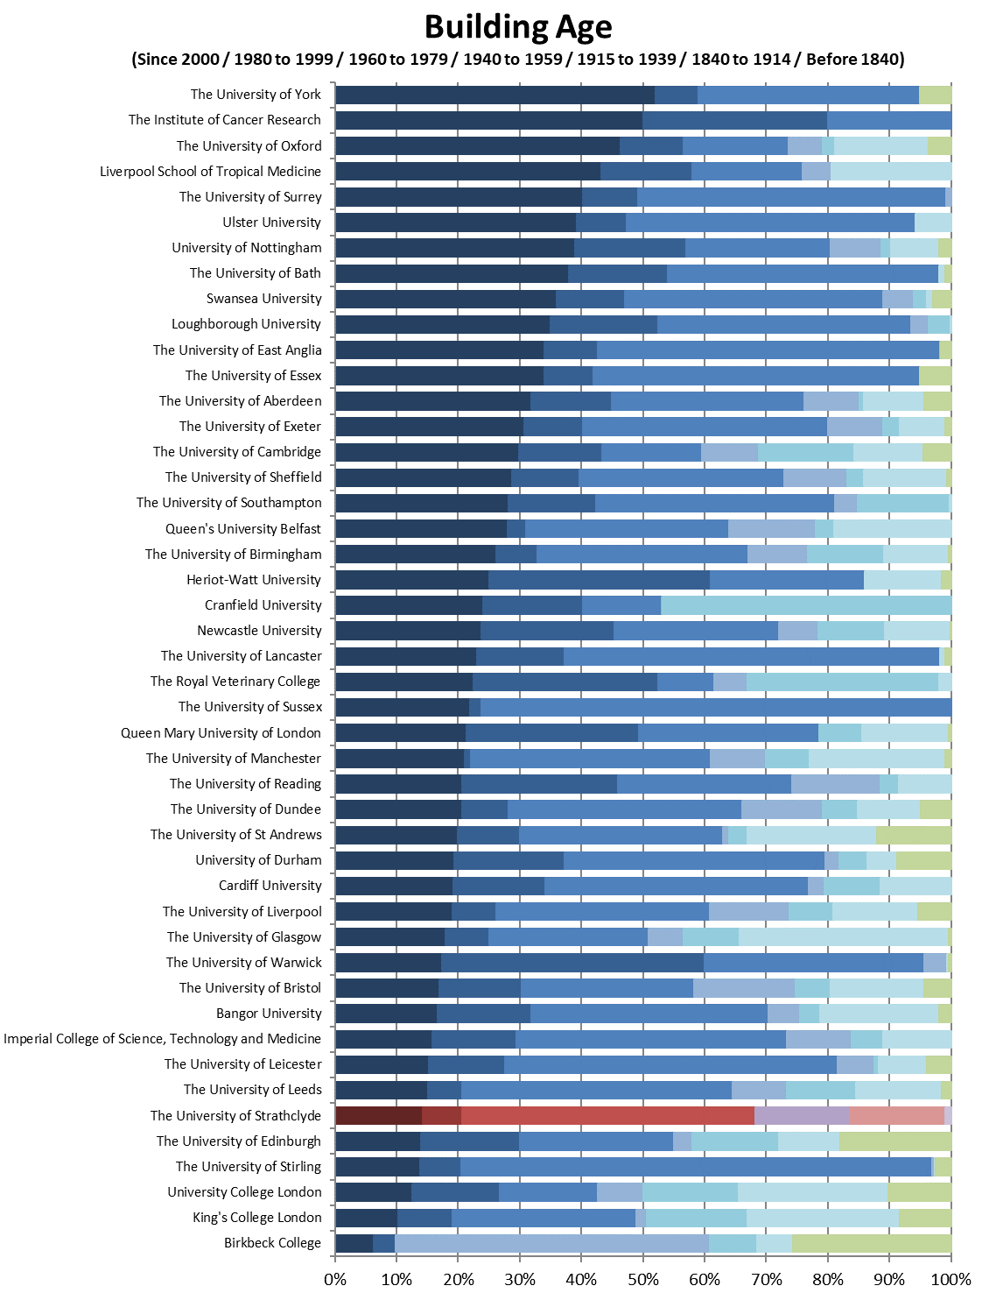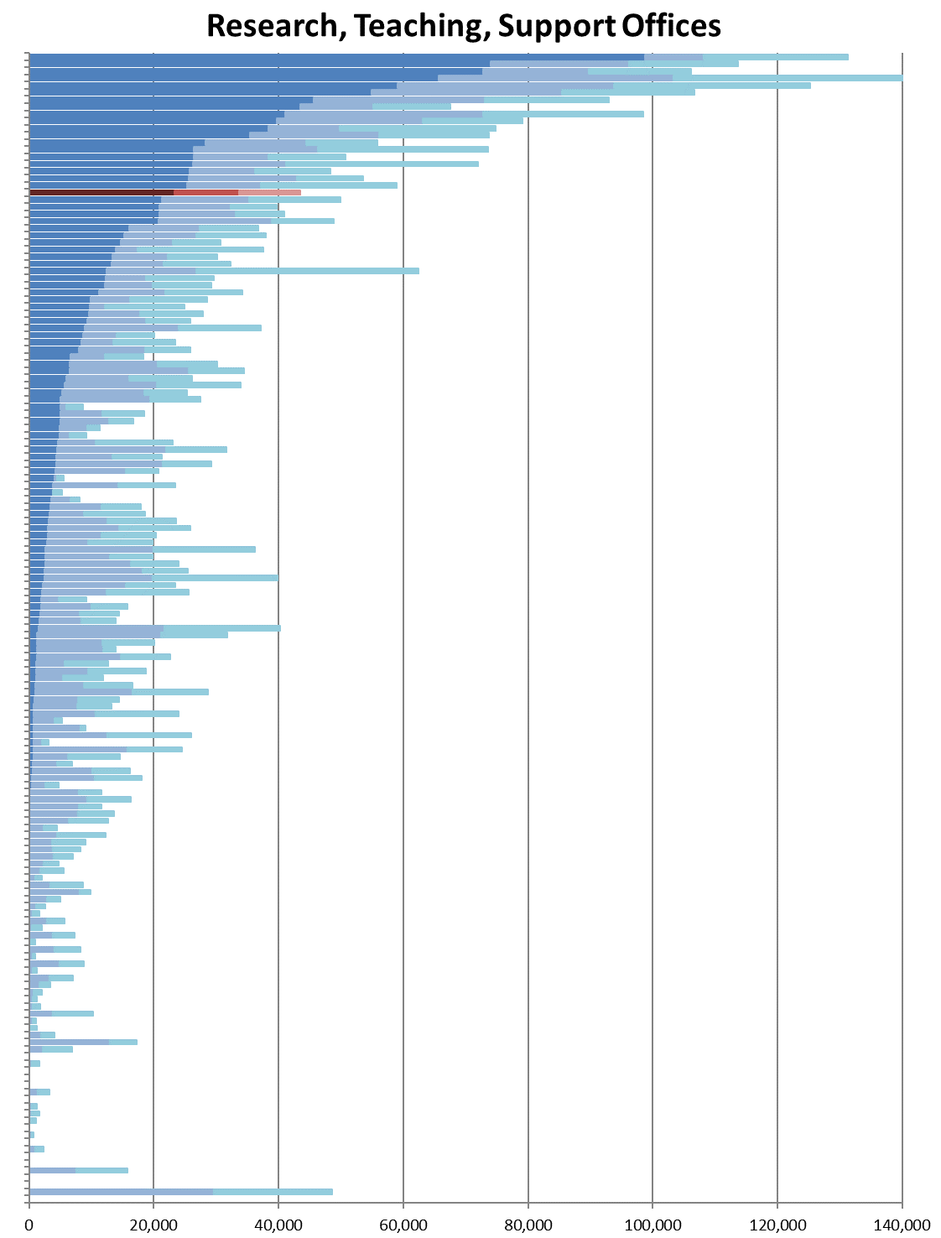

Figure 24: Area of Research, Teaching and Support Offices
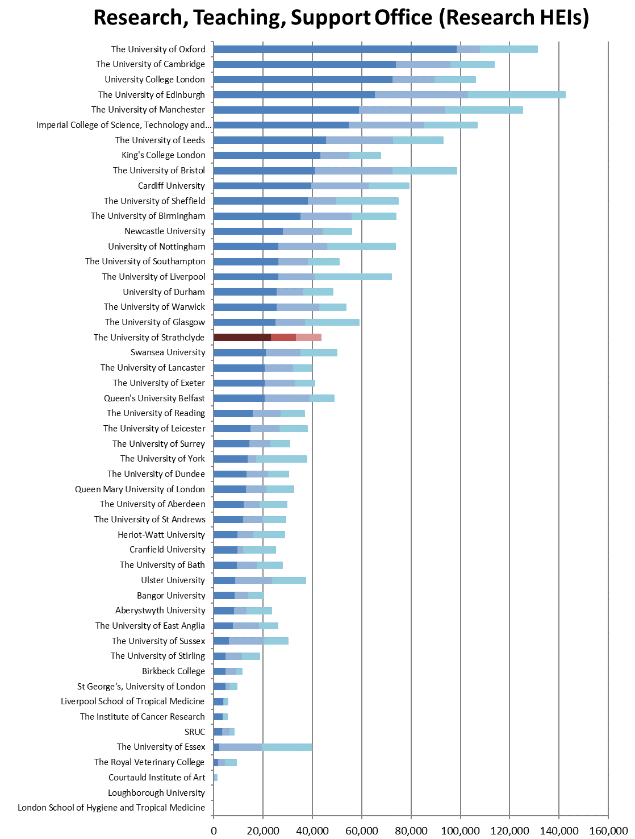

Figure 25: Research, Teaching and Other Income
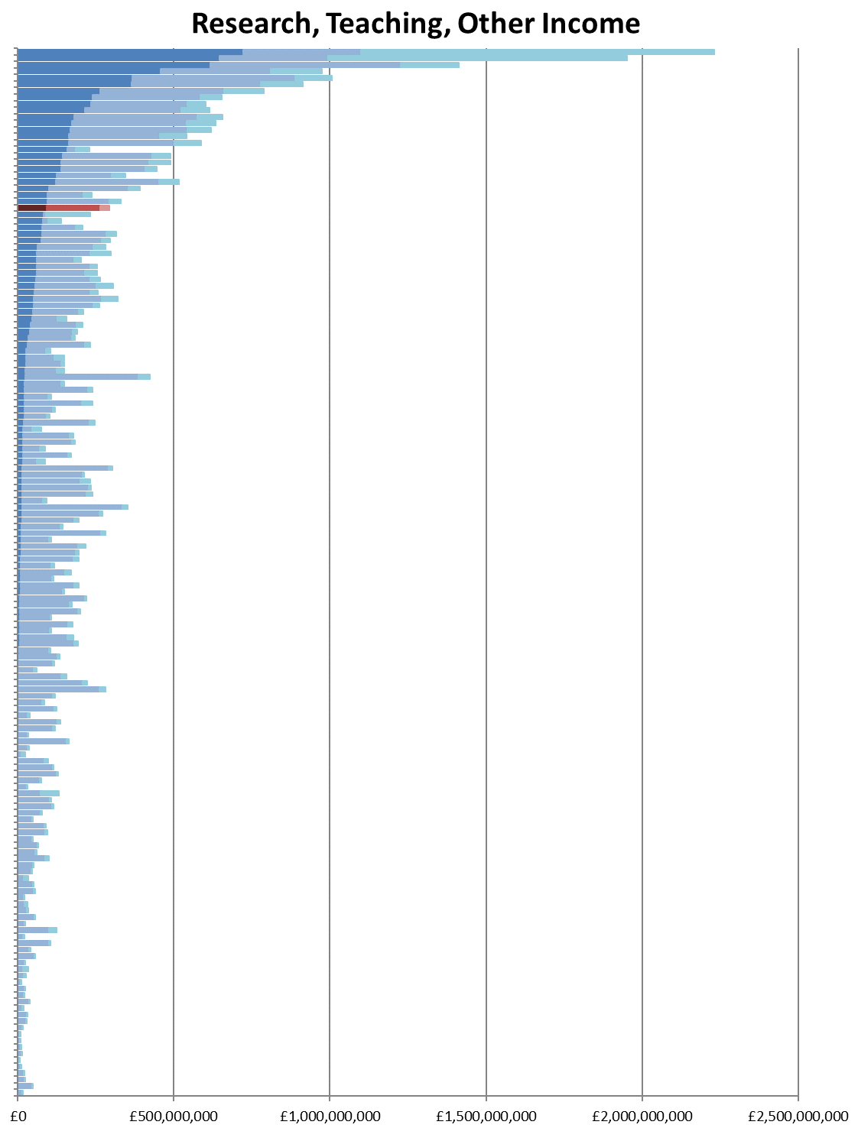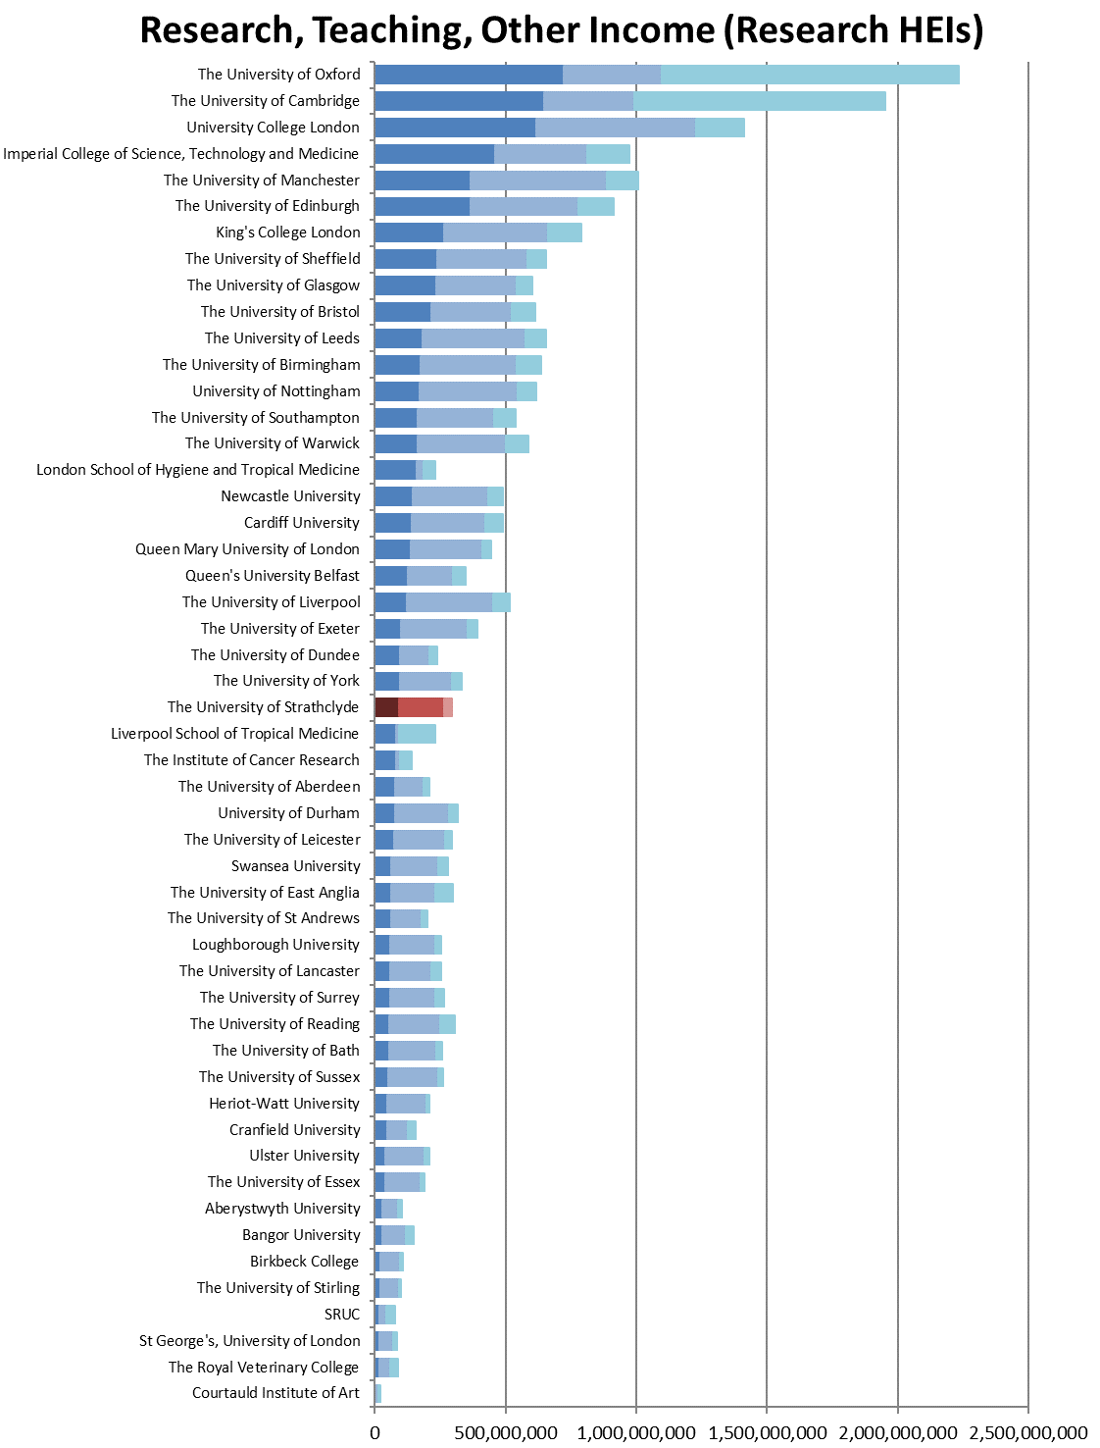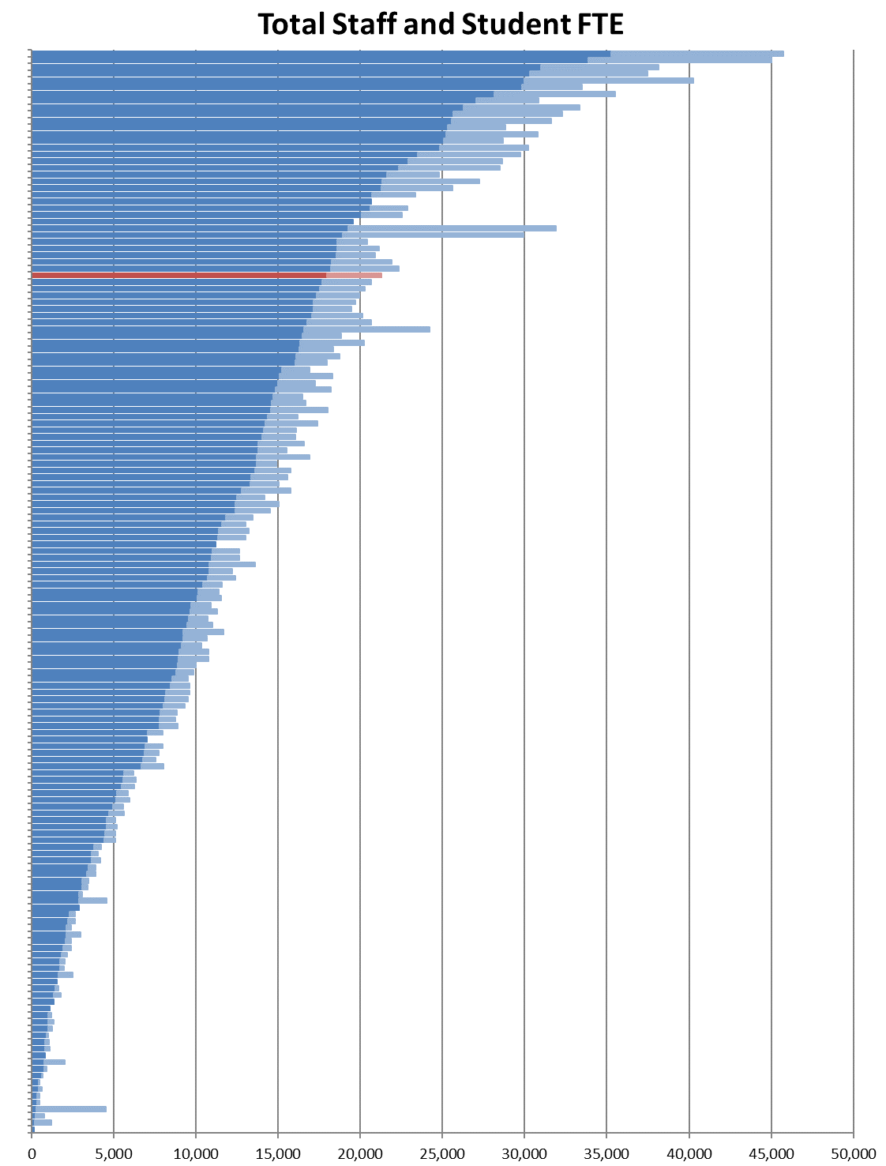

Figure 26: Total Staff and Student FTE
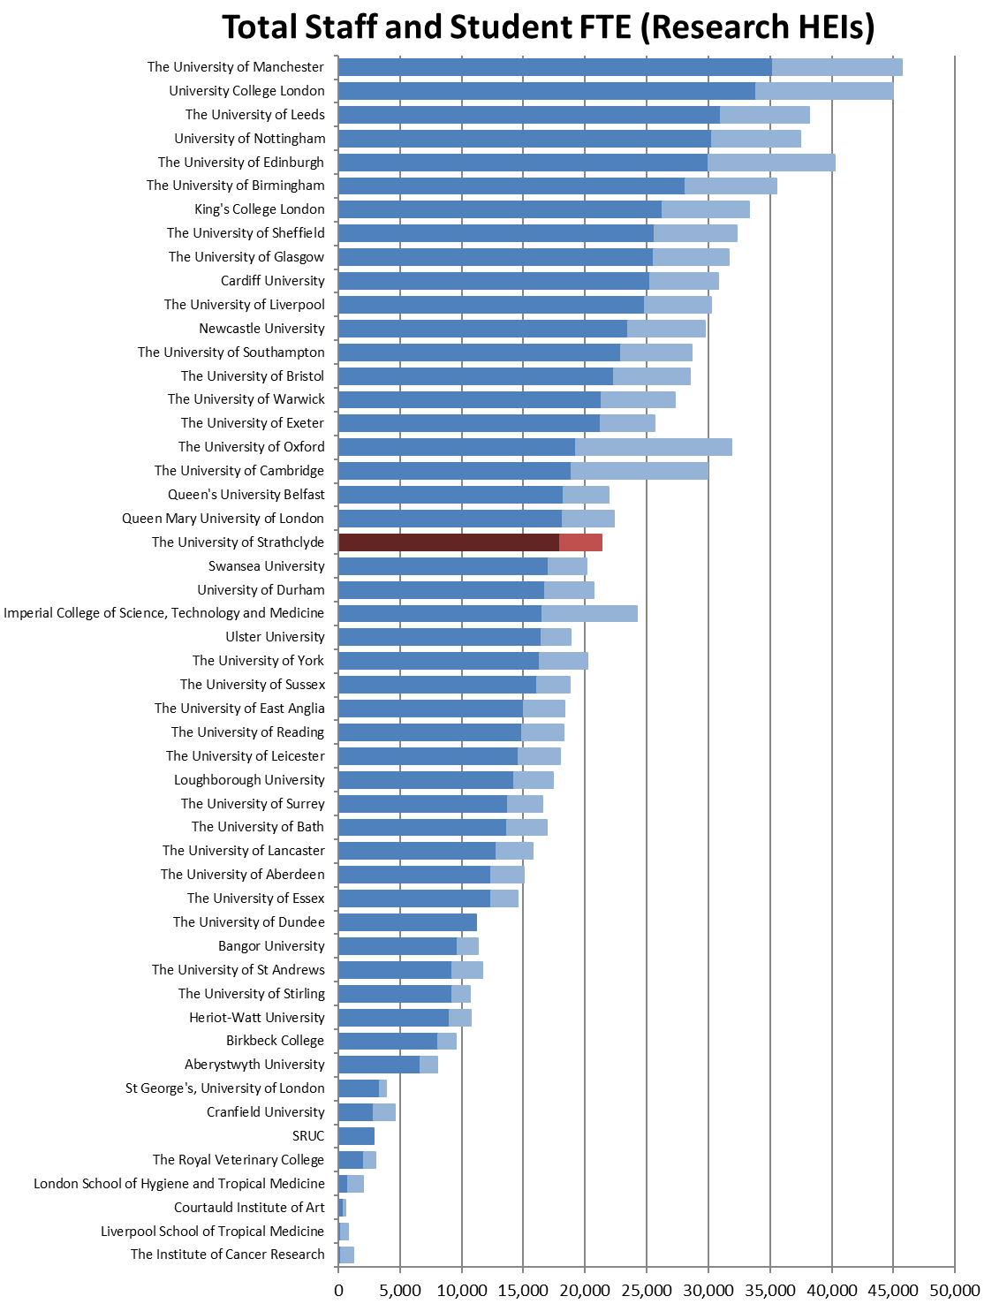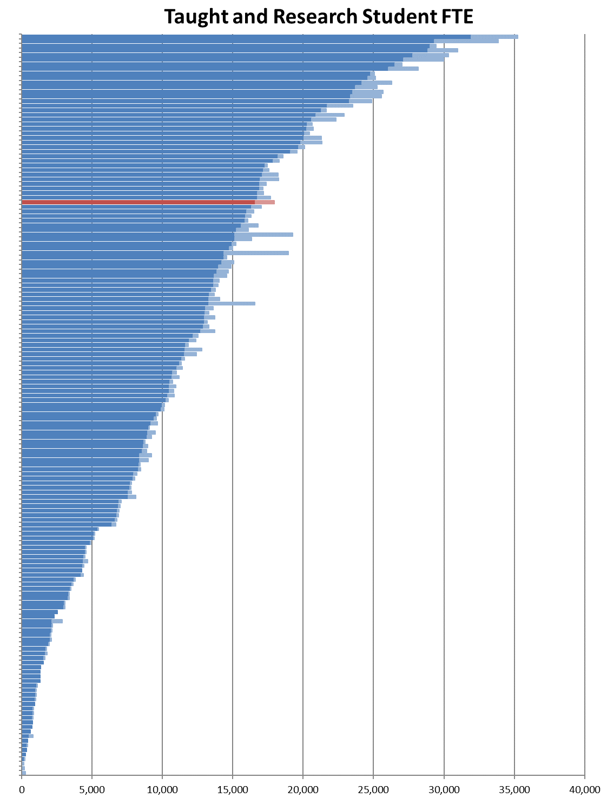

Figure 27: Taught and Research Student FTE
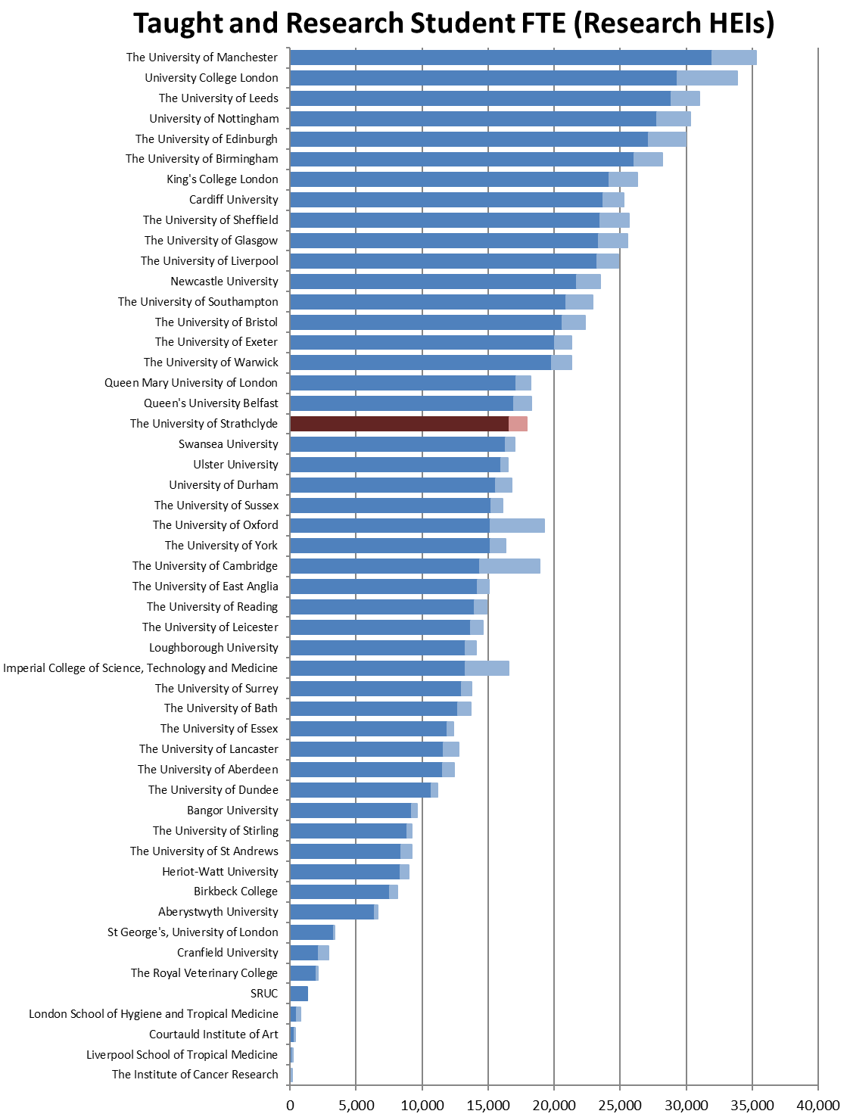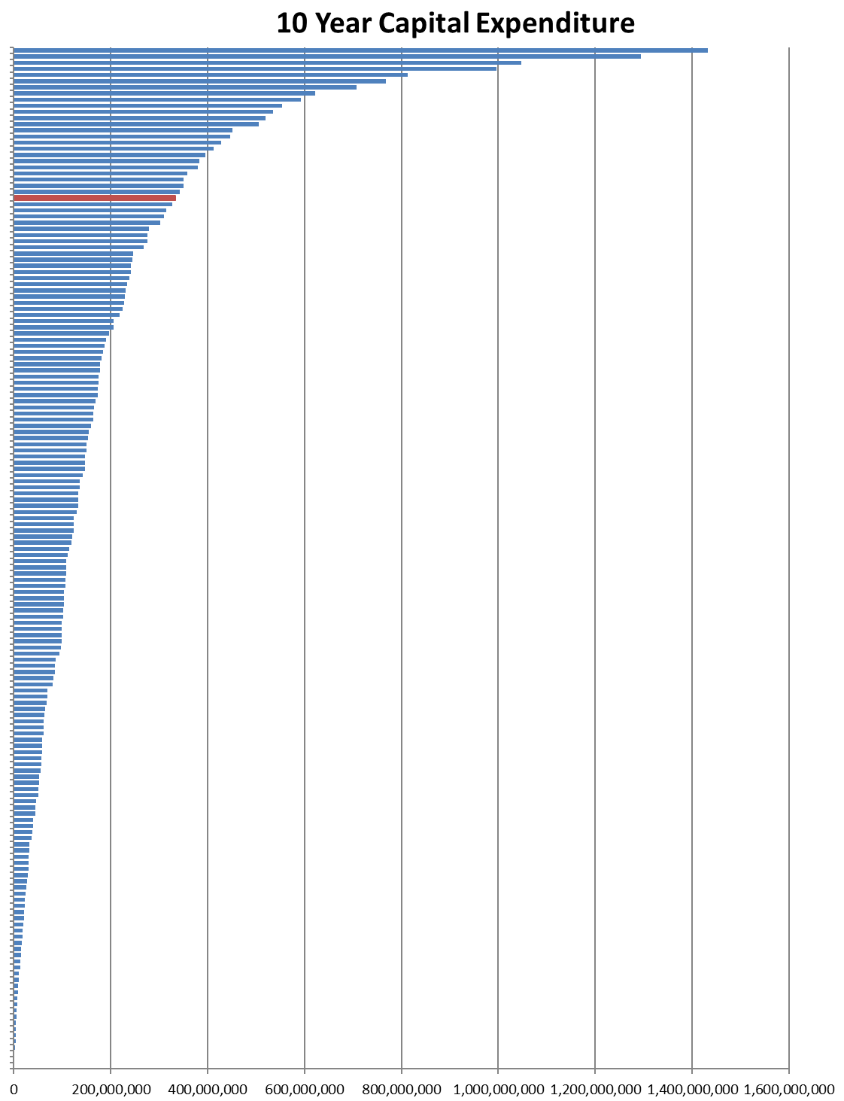

Figure 28: 10 Year Capital Investment
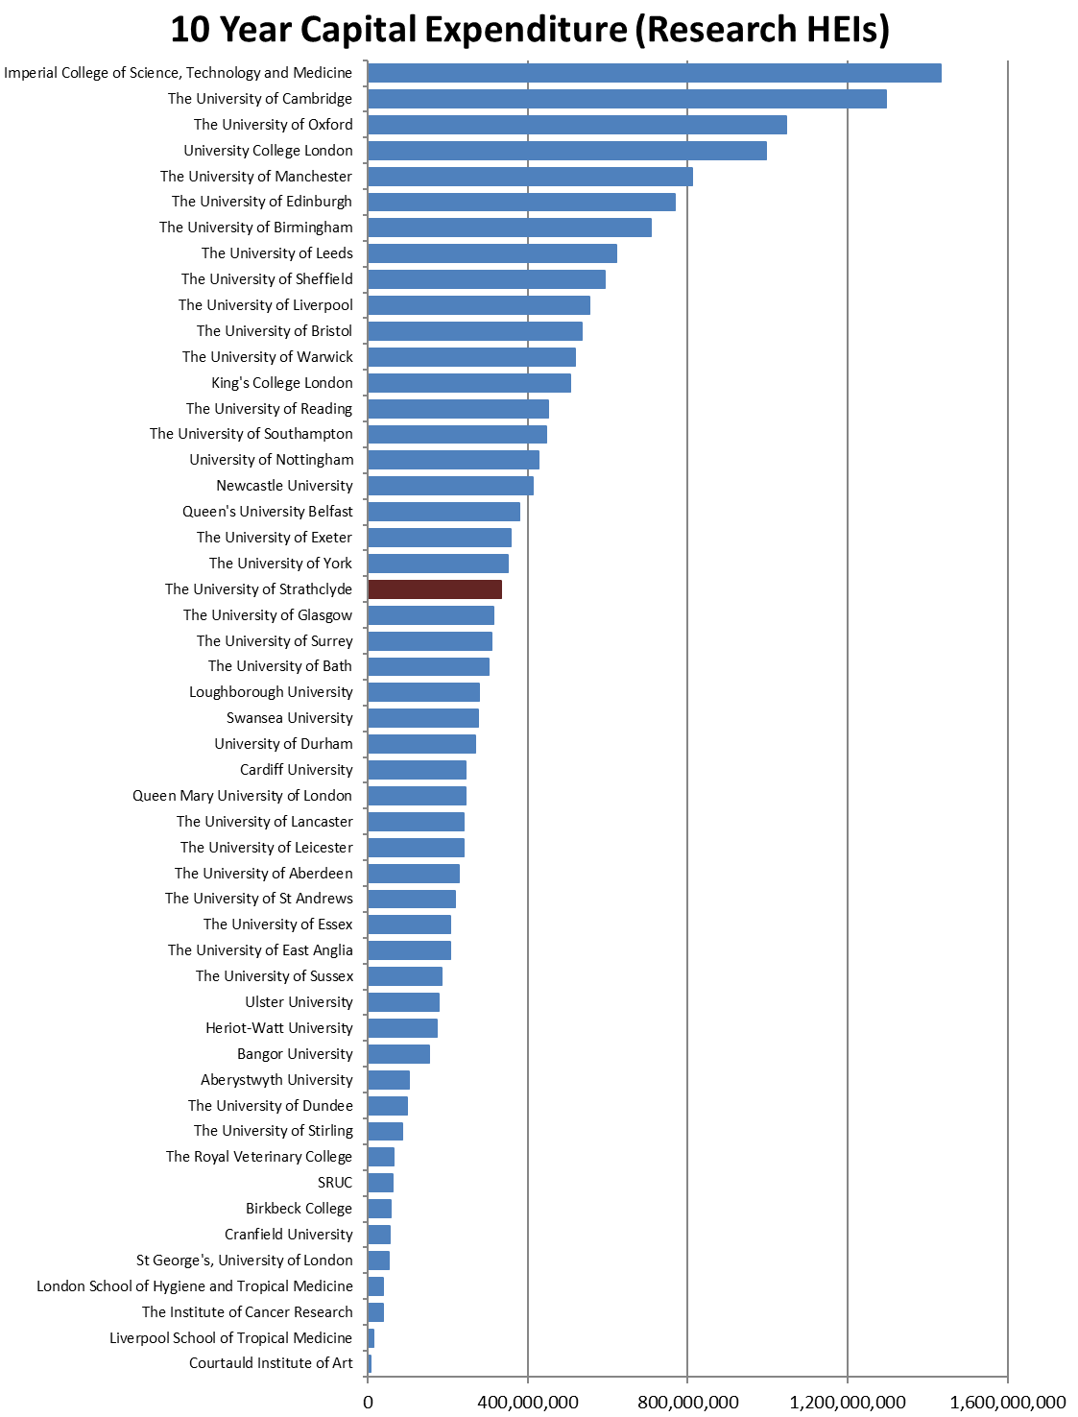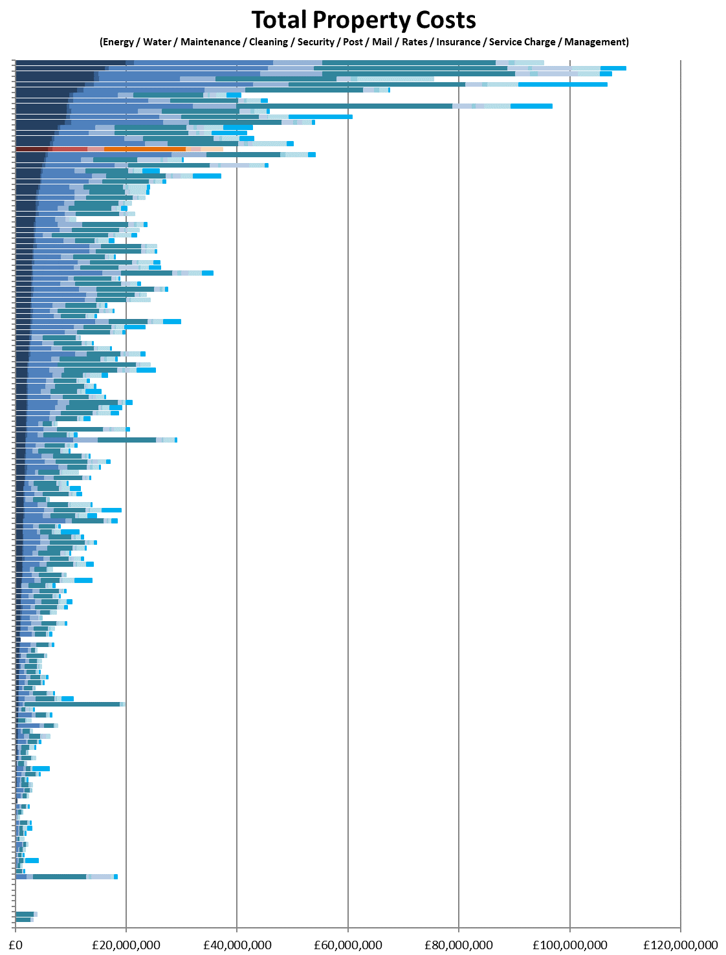

Figure 29: Total Property Costs
