**Space Management Policy**

**(5) Telephone Directory Administration**

**Workplace Location Guidance**

**Valid from March 2019**

**(Please check the Space Planning Website to ensure that this document is still the latest version)**

**Contents**

1) Telephone Directory Administrators 2

2) Accessing the Telephone Directory Administration area 3

3) Updating Staff details and Workplace Locations 5

4) Why should you update staff / PGR student workplace locations? 6

**1.** **Disaster Scenarios requiring the Emergency Services** 6

**2.** **Disaster Recovery Scenarios** 6

**3.** **Estates Management** 6

**4.** **Space Management** 6

5) How do you update staff / PGR student workplace locations? 7

6) Maintaining Divisions on the Telephone Directory 10

**Creating a new Division** 10

**Editing a Division name or Deleting a Division** 14

7) Editing Department Building Address 17

8) University Building Addresses 19

1. **Telephone Directory Administrators**
2. Department Telephone Directory Administrators (identified by their red names on the telephone directory) are appointed by departments to manage:
   * The visual structure of the telephone directory as it appears online
   * The phone extension and telephone number for staff
   * The workplace location of department staff and PGR students
   * The address of the building the department is located in
3. Departments should contact the Information Services helpdesk if they have any requirements to add or amend the list of telephone directory administrators
4. The following guide illustrates the tools available for administrators and the process involved in updating this data

1. **Accessing the Telephone Directory Administration area**
2. First of all you need to login to **Pegasus** here: [Pegasus login](https://but.mis.strath.ac.uk/login/)

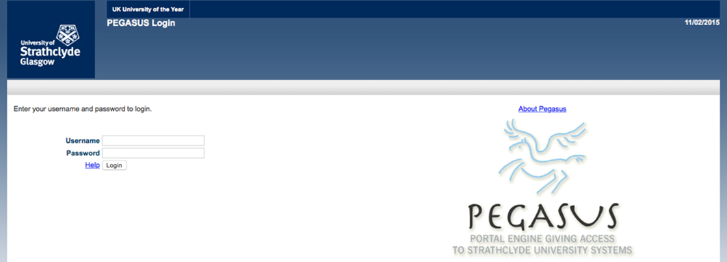

1. On the Pegasus front page select the “Estates” tab

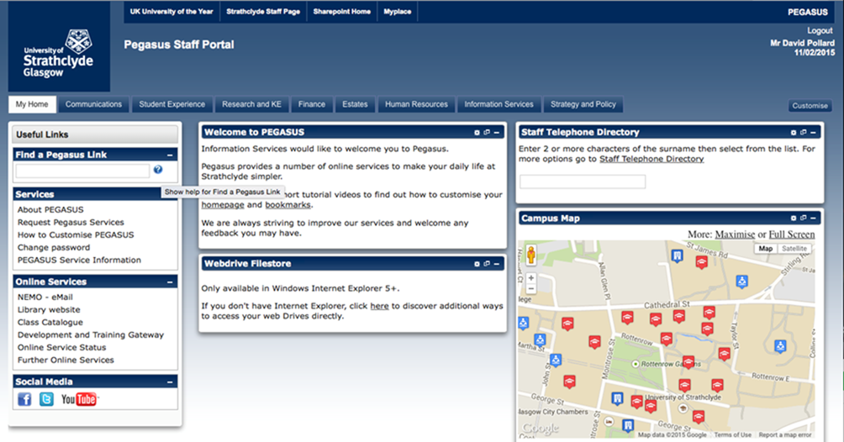

1. On the Estates tab select “Maintain Staff Telephone Directory”

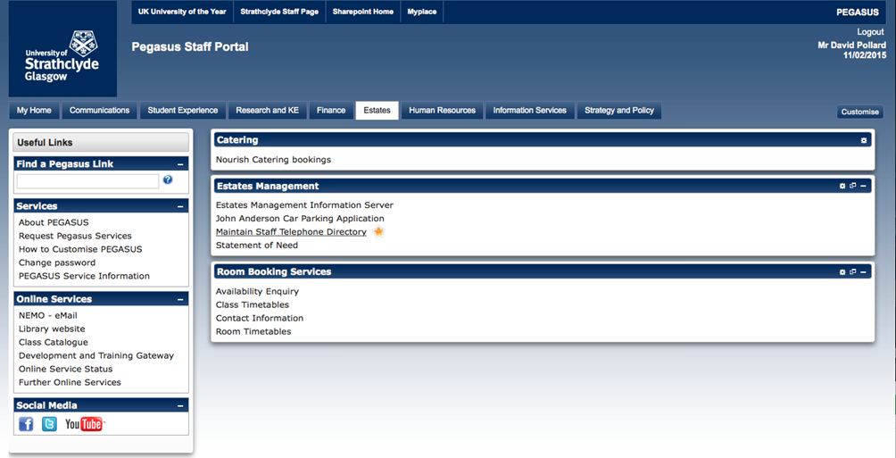

1. Then search for your Department name

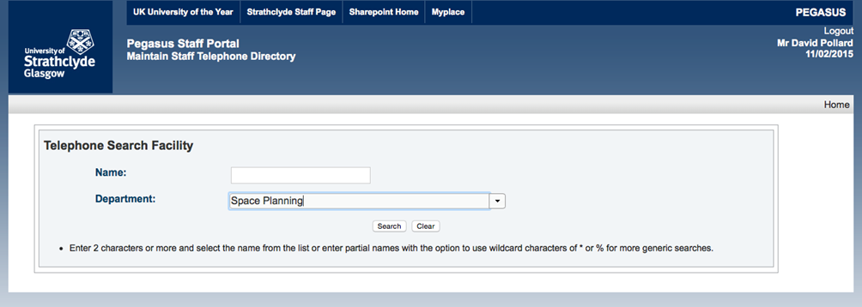

1. When you click on search you will arrive at the Department admin page titled “**Telephone Directory – Maintain Staff Details**
2. It is possible to search for individual members of staff from this page but:
   * There are no editing options at the individual level
   * Selecting one member of staff will take you to their telephone directory details
   * The department view gives you more context for making changes and allows you to make multiple changes more efficiently.
3. **Updating Staff details and Workplace Locations**

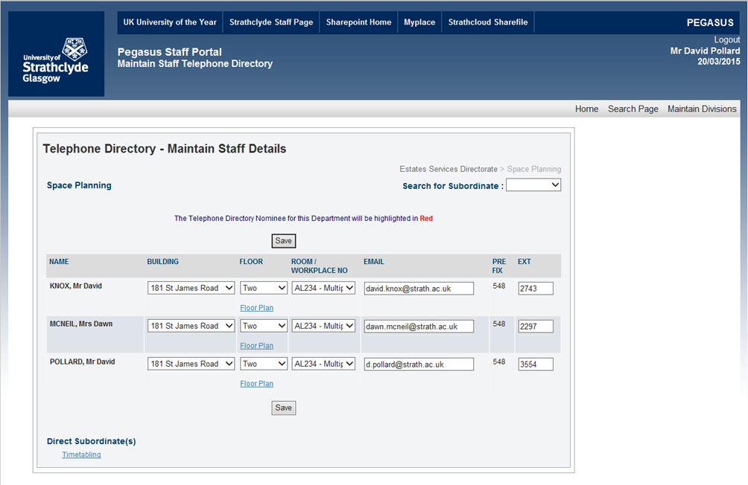

1. The first element of responsibility for Telephone Directory Administrators on these administration pages is to ensure that the contact details and workplace locations for staff are correct.
2. To do this need to be on the “**Maintain Staff Details**” page.
3. If you have moved to the “**Maintain Divisions**” page you need to click on the “**Maintain Staff Details**” link on right hand side of the grey bar towards the top of the screen.

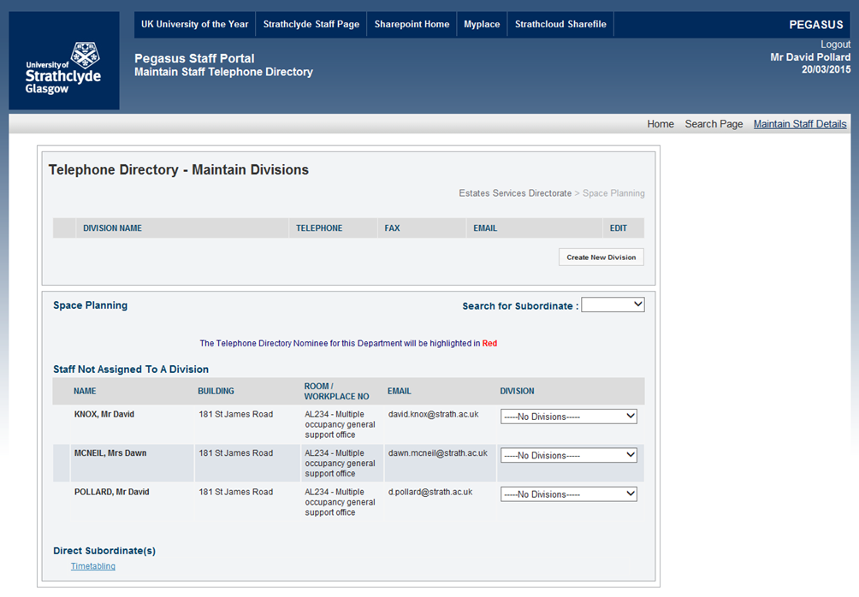

1. **Why should you update staff / PGR student workplace locations?**

There are four primary reasons why you should record / update your workplace location

1. **Disaster Scenarios requiring the Emergency Services**
   * In the event of a disaster scenario it is vital that the University is able to identify the staff and PGR students who would normally work in a building
2. **Disaster Recovery Scenarios**
   * Should a disaster scenario take place on campus it is also vital that the University is able to quickly identify the staff and PGR students who need to be relocated to alternative accommodation
3. **Estates Management**
   * The Estates Services Helpdesk issues emails to all members of staff in a building when notification is necessary for, maintenance works, opening hour restrictions etc. that may affect access or use of a building – these emails can only be sent to staff where workplace locations have been identified
4. **Space Management**
   * An accurate record of the location of both staff and PGR students provides Estates Services with an understanding of how office space allocated so we can provide advice and guidance to departments on the provision of office space

In addition to this, staff and PGR student workplace location data identified in the Teledir Maintenance area will also be illustrated on the annual Department Accommodation Survey that is sent to Heads of Department to update during the month of July.

A correct record of workplace locations will give Heads of Department a better understanding of how accommodation allocated to the department is occupied and used.

1. **How do you update staff / PGR student workplace locations?**
   1. There are four, (or potentially five,) areas of contact details available for you to edit for each member of staff and you should endeavor to ensure that all of these are correct.
      * Building
      * Floor (used to limit the list of room numbers to a manageable list)
      * Room / Workplace No
      * Workstation

(If members of staff or PGR students are based in the TIC building there will be an option after selecting the appropriate Room Number to select the number of the Workstation they have been allocated in that room)

* + - Ext (telephone extension number)

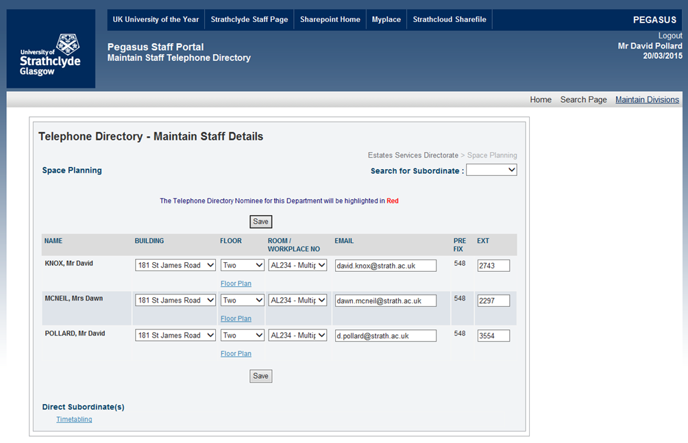

* 1. Previously it was possible to edit the email addresses of staff but this functionality has now been removed.
  2. Any enquiries about staff email address should be directed towards [help@strath.ac.uk](mailto:help@strath.ac.uk)
  3. Changes to these criteria can be made for multiple members of staff from the same screen but you should remember to click on save at regular intervals to ensure that your changes are recorded.

**Step 1:** Select the building the member of staff is based in

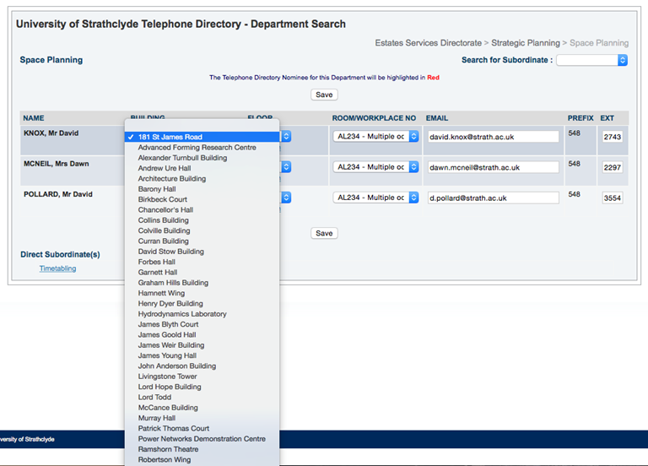

**Step 2:** Select the floor number the member of staff is based on

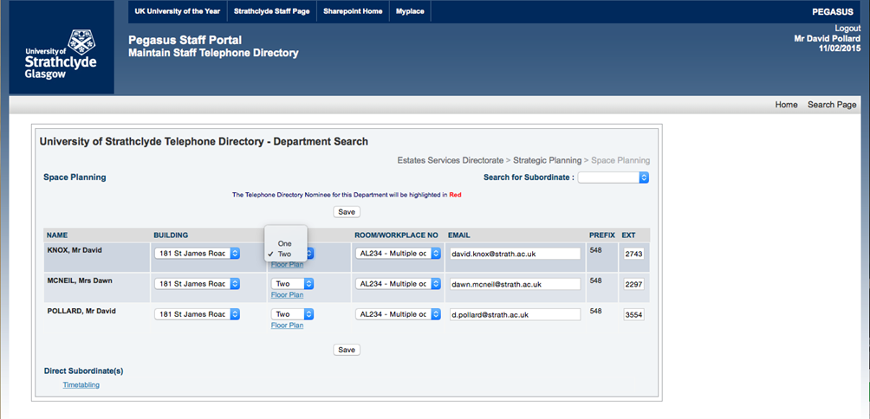

Selecting the floor number will not result in this being visible anywhere, it is simply a devise used to restrict the number of room numbers available for you to select to a manageable list for the relevant floor.

* 1. **Step 3:** Select the Room / Workplace No the member of staff or PGR Student is based in

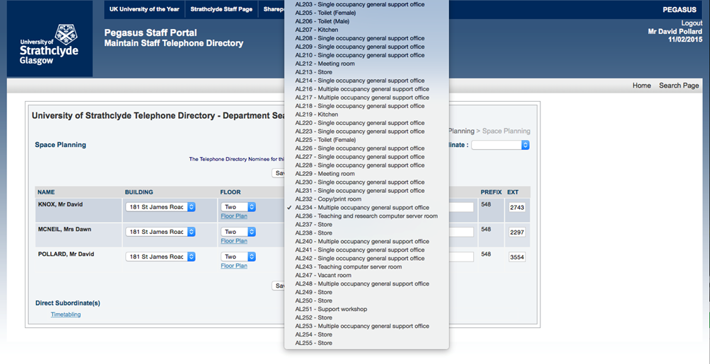

* 1. The **Room / Workplace No** data is linked live to the Space Management database
  2. Each room number is therefore followed by the function code description of the room which should assist you in selecting the correct location
  3. If, while going through this process, you identify rooms with incorrect function codes, or if the room numbers you use in your area differ from those held in Estates Services records, please contact the Head of Space Planning

– [d.pollard@strath.ac.uk](mailto:d.pollard@strath.ac.uk)

**Step 4:** Ensure that the staff telephone extension number is correct

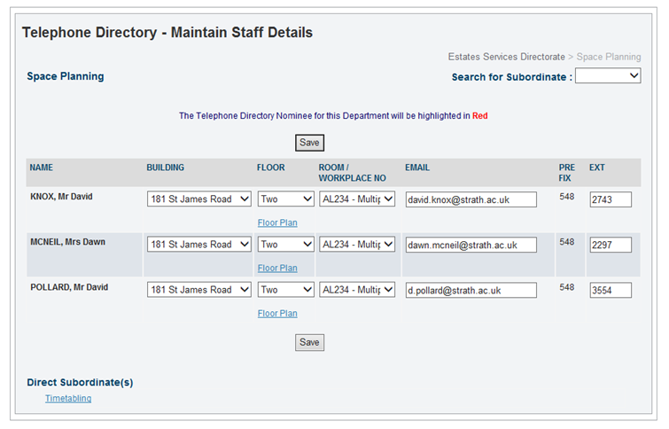

* 1. Individual members of staff can also change these details themselves by going to the Human Resources tab on Pegasus and selecting the “My Personal Details” link
  2. There are separate guidance documents for staff and PGR students to follow a similar process that are also available on the Estates Services website

1. **Maintaining Divisions on the Telephone Directory**

**Creating a new Division**

* 1. At this stage we want to look specifically at the structure of staff names in the department telephone directory
  2. Creating / modifying divisions and allocating staff to them in Pegasus will change the structure and order of staff names on the telephone directory
  3. To create or modify this structure you need to click on “**Maintain Divisions**” on the right hand side of the grey bar towards the top of the screen

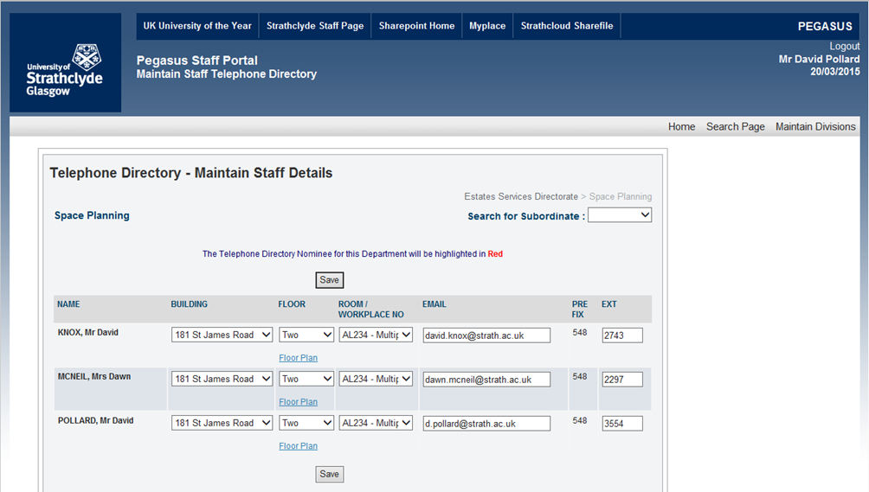

* 1. In this illustration at this point the Space Planning page has no subdivisions.
  2. You can create as many divisions as are required but please:
* Bear in mind that divisions need to make sense to visitors to the telephone directory who are unfamiliar with your department
* Make divisions at as high a level as is relevant
* Avoid creating too many incremental divisions
* Since it is possible for Estates Services to utilize this data to create reports using this structure, please also consider what would be most useful e.g. is it more beneficial to illustrate the structure of research groups or staff appointment types
  1. The first thing to do on this page is to “Create New Division”

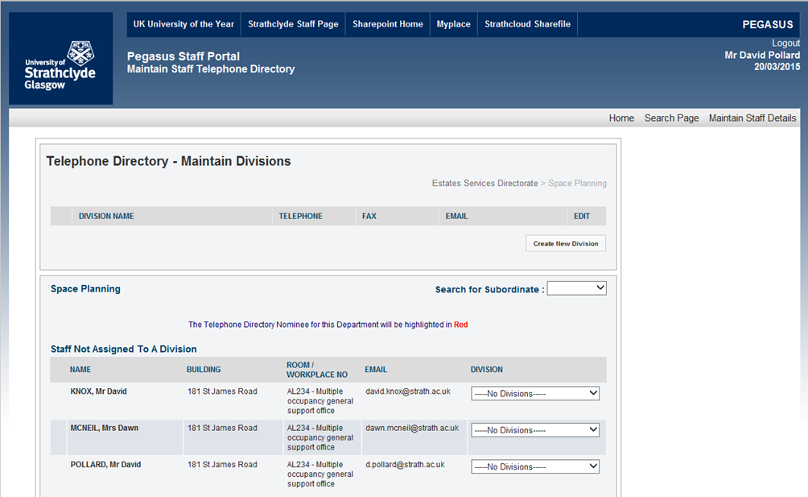

* 1. Clicking on “**Create New Division**” greys out the background and presents you with the “**Create Division**” input box with four fields

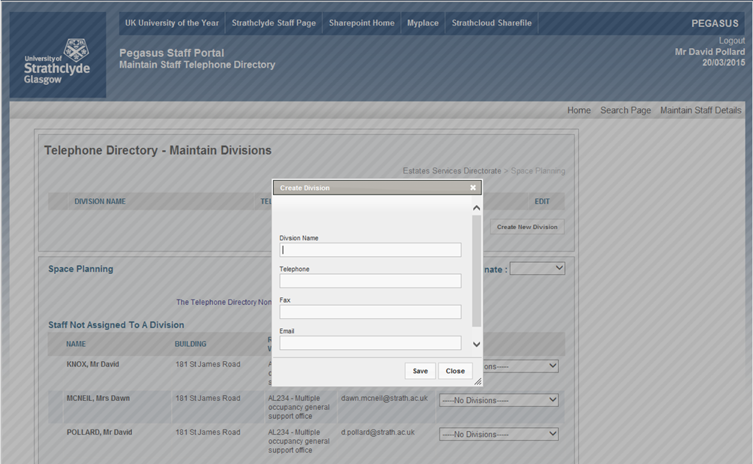

Red outline - Highlighting

* **Division Name –** This should be self-explanatory to visitors to the Telephone Directory e.g. Research Structure, Research themes, Head of Department, Administrators, Professors, etc. etc.
* **Division Name** is a required field but the next three are optional
* **Telephone –** You can enter a dedicated contact telephone number for the division
* **Fax -** You can enter a dedicated contact fax number for the division
* **Email -** You can enter a dedicated contact email address for the division
  1. When you are happy with these details you have entered - click “**Save**”
  2. “**Save**” completes the process for creating the division and the text “**Division Created**” now appears at the top of the input box
  3. To confirm this - Clicking “**Close**” will now take you back to the staff page

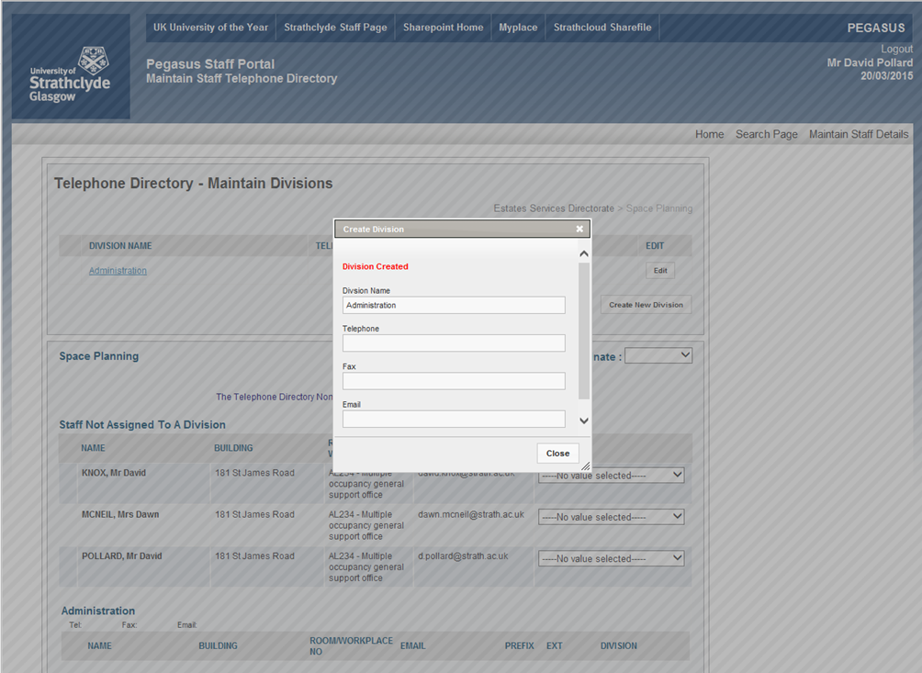

* 1. The drop down list in the “**Division**” column on the right hand side has been populated with the created options
  2. A new section (in this case titled “Administration”) has also now appeared at the bottom of the page

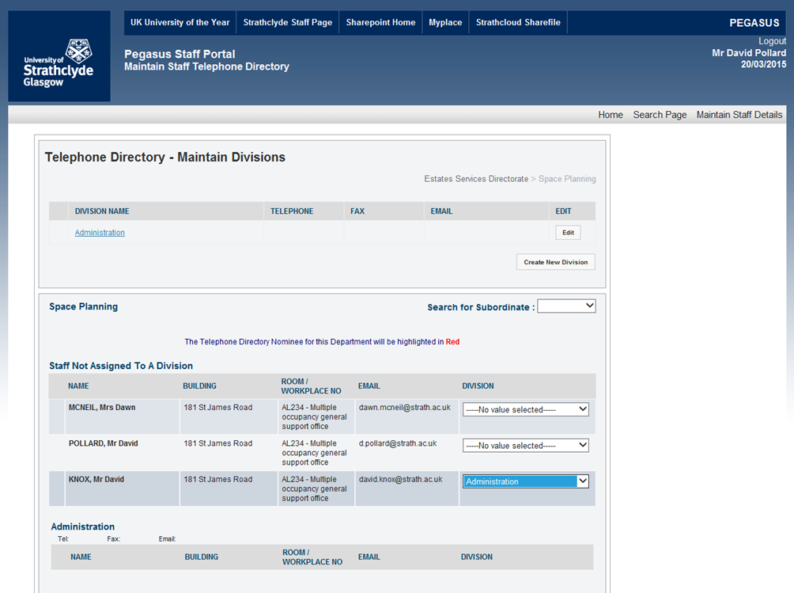

* 1. You can now use the drop down list to move all of the staff required into each of the divisions you have created

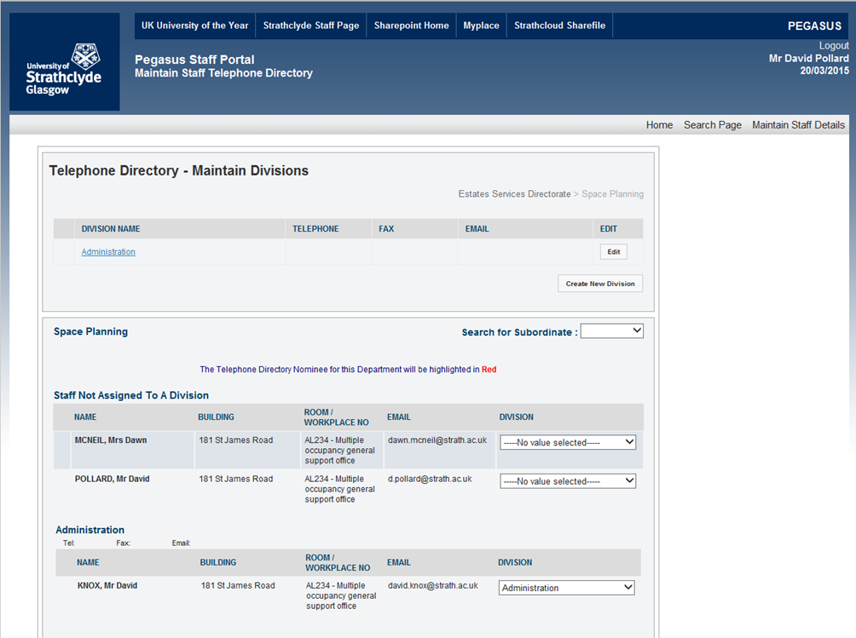

1. **Editing a Division name or Deleting a Division**
2. To edit or delete existing divisions select the Edit button in the same row as the division you want to change



1. Clicking “Edit” here brings up the same text box that you used to create your Division(s)
2. You can now either edit the details of the division or use the “Delete” button to remove this division

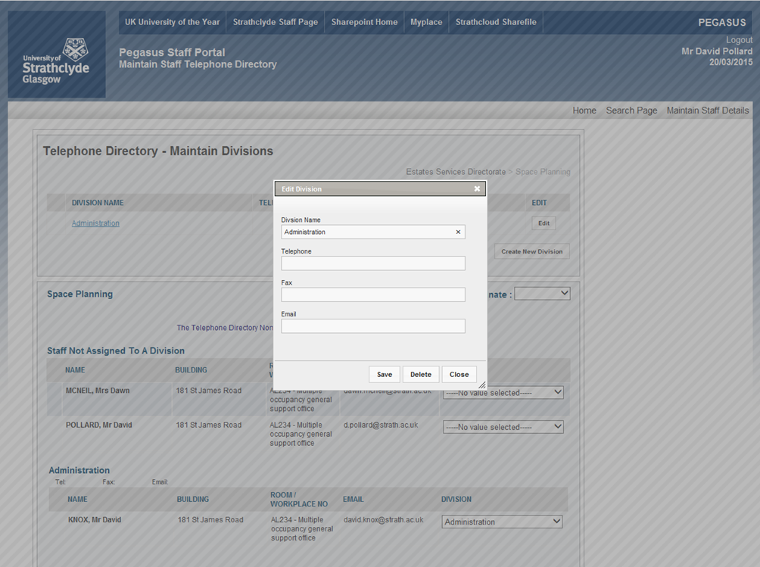

1. Clicking “**Delete**” will bring up a request for confirmation– “**Are you sure that you want to delete this division?**”

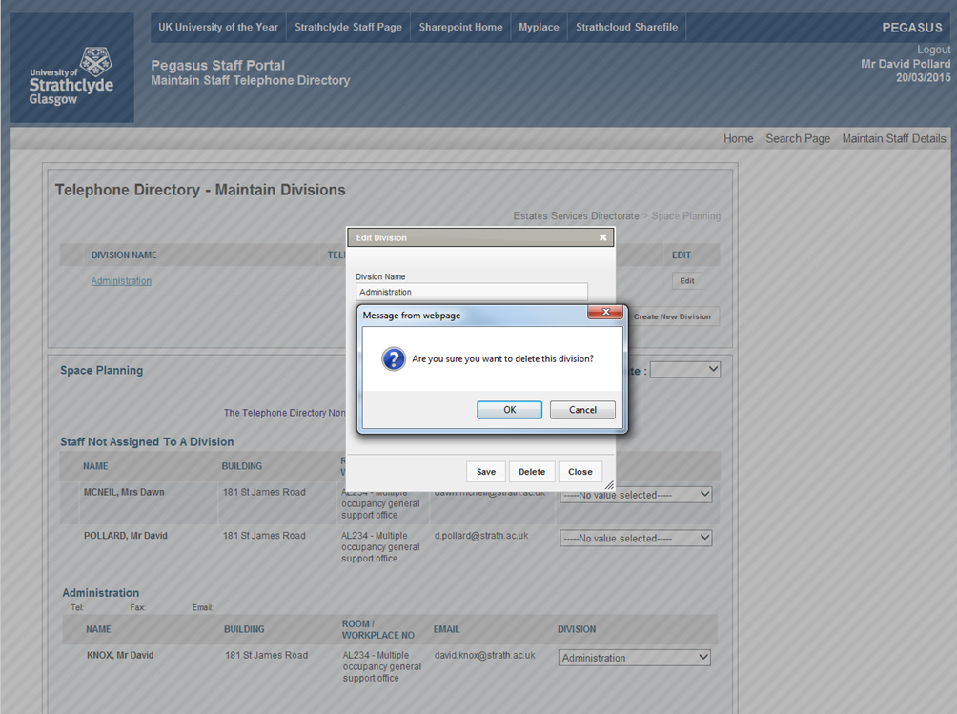

1. Clicking “**Ok**” here should delete this division
2. However, if there is still a member of staff assigned to the Division you will see an error message “**Error deleting division, remove staff records first**”

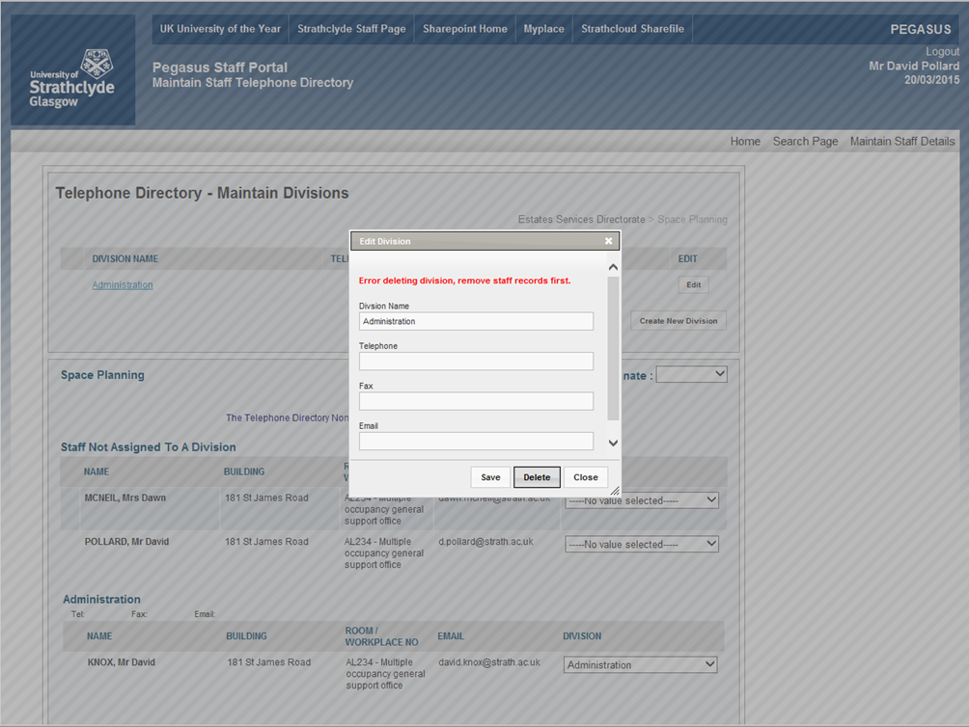

1. To complete the deletion of the division name you will need to go back to the remaining members of staff in the division and remove them first
2. You can do this either by:
   * + Assigning them to another division that you have created or:
     + Select “**-----Remove from Division-----**“ which will move that member of staff back to the “**Staff Not Assigned To A Division**” section.

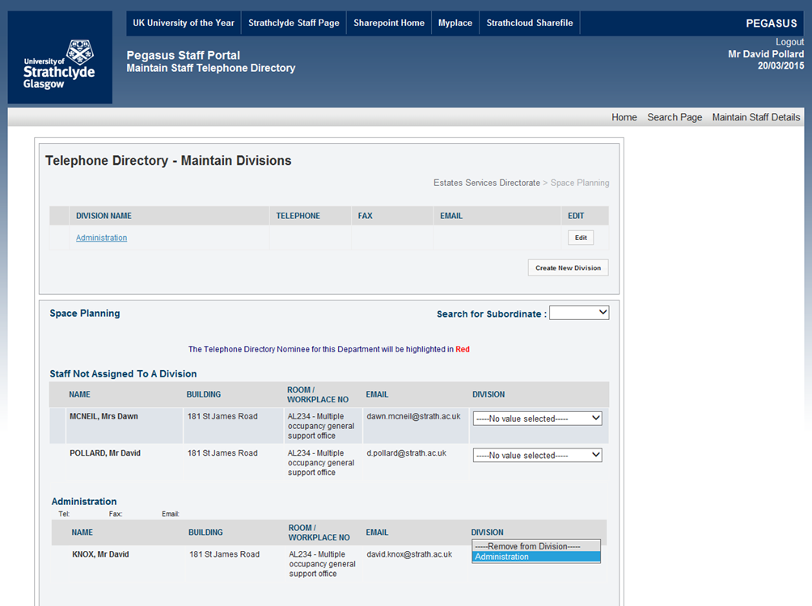

1. Successfully completing this process will result in a new message “**Division Deleted**” and clicking “**Close**” will return you to the staff edit page

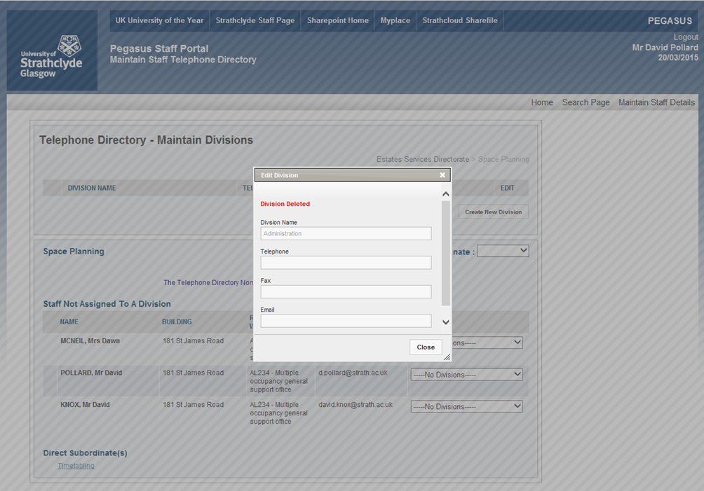

1. **Editing Department Building Address**
   1. In addition to staff details, it is now also possible to edit the primary building address for your department.
   2. **Step 1:** Click on **“Maintain Divisions”**

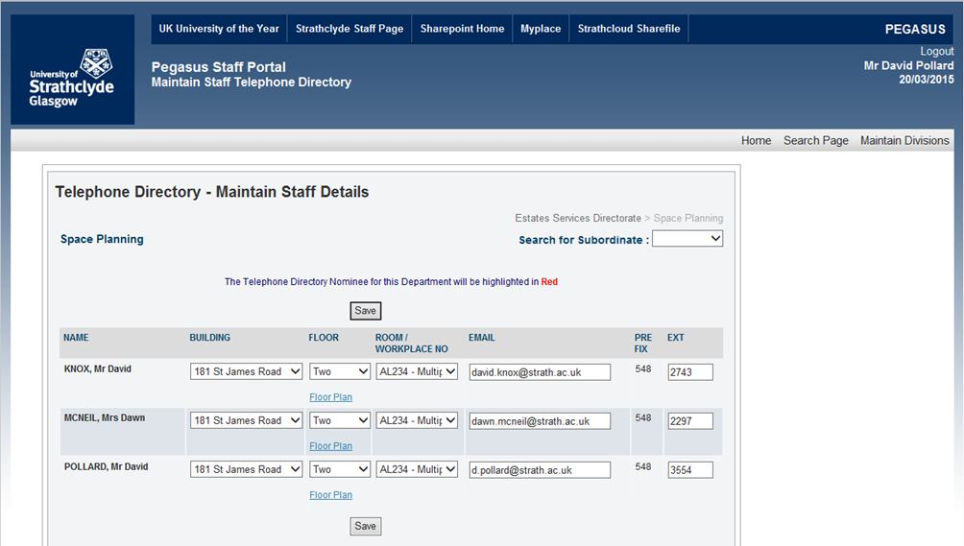

* 1. **Step 2:** Click on “**Edit Address**”

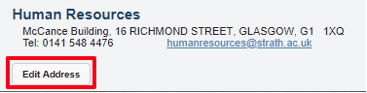

* 1. **Step 3:** Select the building you want to set as your primary department address from the drop down list.

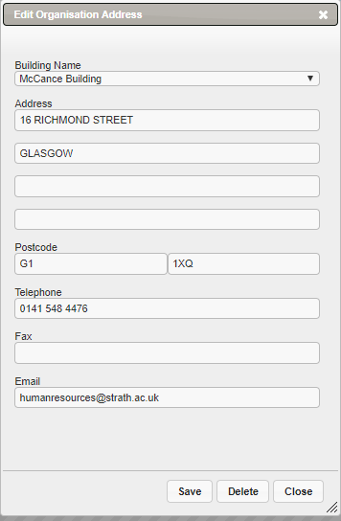

* 1. **Step 4:** The remaining fields are free text, however, the list of official postal addresses have been added as an appendix to this document so you can identify the correct street number and postcode etc.

1. **University Building Addresses**

| Building | Code | Address | City | Postcode |
| --- | --- | --- | --- | --- |
| 181 St James Road | AL | 181 St James Road | Glasgow | G4 0NT |
| Advanced Forming Research Centre | AF | 85 Inchinnan Drive | Renfrew | PA4 9LJ |
| Architecture | AR | 131 Rottenrow | Glasgow | G4 0NG |
| Barony Hall | BH | 1 MacLeod Street | Glasgow | G4 0RA |
| Cathedral Wing | CW | 199 Cathedral Street | Glasgow | G4 0QU |
| Collins | CL | 22 Richmond Street | Glasgow | G1 1XQ |
| Colville | CV | 48 North Portland Street | Glasgow | G1 1XM |
| Curran | CU | 101 St James Road | Glasgow | G4 0NS |
| Duncan Wing | DW | 130 Rottenrow | Glasgow | G4 0GE |
| Graham Hills | GH | 50 George St | Glasgow | G1 1QE |
| Hamnett Wing | HW | 161 Cathedral Street | Glasgow | G4 0RE |
| Henry Dyer | HD | 100 Montrose Street | Glasgow | G4 0LZ |
| Hydrodynamics Laboratory | HL | 100 Acre Road | Glasgow | G20 0TL |
| James Weir | JW | 75 Montrose Street | Glasgow | G1 1XJ |
| John Anderson | JA | 107 Rottenrow East | Glasgow | G4 0NG |
| Livingstone Tower | LT | 26 Richmond Street | Glasgow | G1 1XH |
| Lord Hope Building | LH | 141 St James Road | Glasgow | G4 0LT |
| Lord Todd | AQ | 11 Weaver Street | Glasgow | G4 0NS |
| McCance | MC | 16 Richmond Street | Glasgow | G1 1XQ |
| Power Networks Demonstration Centre | PN | 62 Napier Road | Cumbernauld | G68 OEF |
| Ramshorn Theatre | AX | 98 Ingram Street | Glasgow | G1 1ES |
| Robertson Wing | AB | 27 Taylor Street | Glasgow | G4 0NR |
| Royal College | R | 204 George Street | Glasgow | G1 1XW |
| St Pauls | F | 2 Martha Street | Glasgow | G1 1JN |
| Stenhouse Wing | SW | 199 Cathedral Street | Glasgow | G4 0QU |
| Students' Union | AA | 90 John Street | Glasgow | G1 1JH |
| Technology Innovation Centre | TC | 99 George Street | Glasgow | G1 1RD |
| Thomas Graham | TG | 295 Cathedral Street | Glasgow | G1 1XL |
| University Centre | UC | 347 Cathedral Street | Glasgow | G1 2TB |
| Wolfson Building | WC | 106 Rottenrow East | Glasgow | G4 0NW |