Space Management Policy
(6) Staff Workplace Location Guidance
Valid from March 2019
(Please check the Space Planning website to ensure that this document is still the latest version)
Contents
Why should you record / update your workplace location? 2
Guidance on how to update your workplace location in Pegasus 3
Estates Services: Space Management Database Room Function Codes 9

Why should you record / update your workplace location?
There are three primary reasons why you should record / update your workplace location
- Disaster Scenarios requiring the Emergency Services
  - In the event of a disaster scenario it is vital that the University is able to identify the staff who would normally work in a building
- Disaster Recovery Scenarios
  - Should a disaster scenario take place on campus it is also vital that the University is able to quickly identify the staff who need to be relocated to alternative accommodation
- Estates Management
  - The Estates Services Helpdesk issues emails to all members of staff in a building when notification is necessary for, maintenance works, opening hour restrictions etc. that may affect access or use of a building – these emails can only be sent to staff who have identified their workplace locations.
- Space Management
  - An accurate record of staff locations provides Estates Services with an understanding of how office space allocated so we can provide advice and guidance to departments on the provision of office space
In addition to this, staff and PGR student workplace location data identified in the Teledir Maintenance area will also be illustrated on the annual Department Accommodation Survey that is sent to Heads of Department to update during the month of July.
A correct record of workplace locations will give Heads of Department a better understanding of how accommodation allocated to the department is occupied and used.

Guidance on how to update your workplace location in Pegasus
- Recent upgrading of the systems supporting staff data have improved the process for staff maintaining the data through live links to the Space Management Database and drawings in Estates Services.
- Rather than free text fields or isolated lists, the selection of Building Name, Floor level and Room number are now linked to live data to assist staff with the accurate selection of your workplace location.
- This data is now also linked to record drawings for each building floor level which illustrate both the room numbers contained in the space management data base and also the department each room is allocated to.
- The following short guide illustrates the location of these resources and the process involved in updating them.
- Login to Pegasus here - Pegasus login
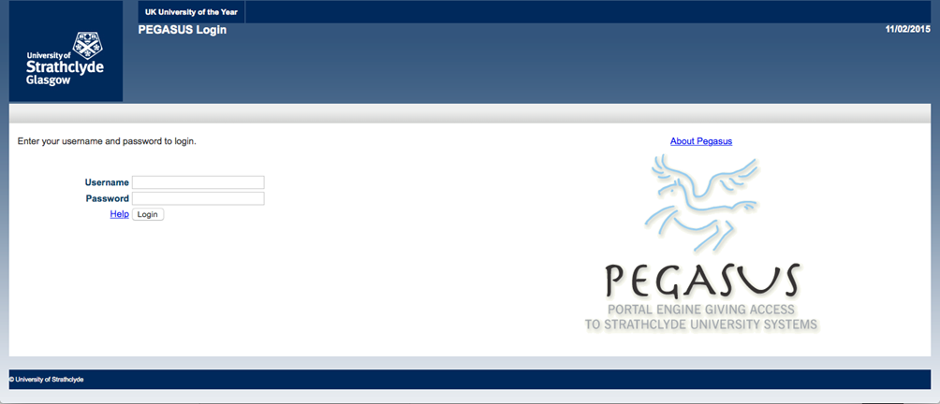
- On the Pegasus front page select the Human Resources tab
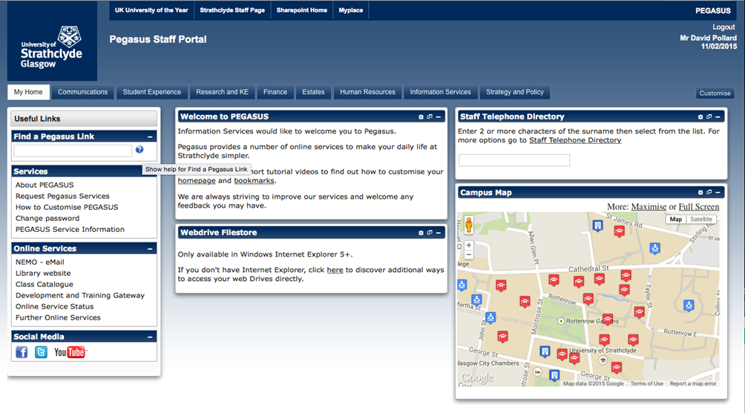

- In the Human Resources tab select My Personal Details
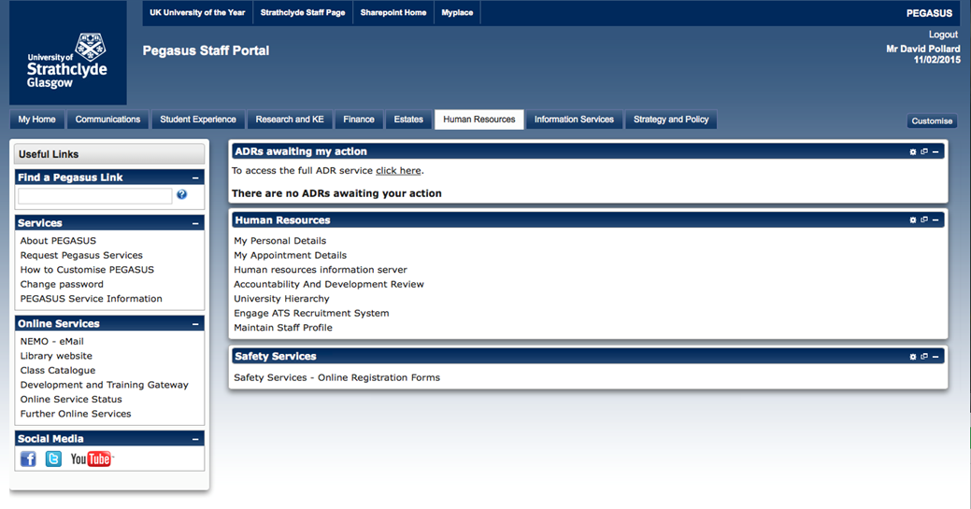
- In My Personal Details please first take the time to check that the various elements of data are correct
- If they are correct there is nothing else to do
- If any of your details are not correct please take the time to update these by selecting the edit button on the bottom right hand corner of the relevant section
- This guide is specifically interested in the accuracy of your Work Location Details
- If the data here is not correct please take the time to update it by selecting the edit button on the bottom right hand corner of the Work Location Details section at the bottom of the page (illustrated on page 4)
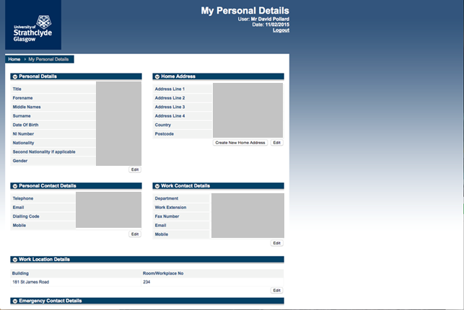
- Selecting the edit button brings up a box where you can update your Work Location Details through options to change the Building, Floor Level and Room Number.
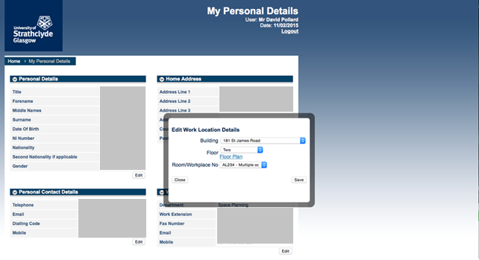

- The data is updated in the order it is displayed: Building, Floor Level and Room Number. Please select and edit them in that order. In each case you will be presented with a list of available options.
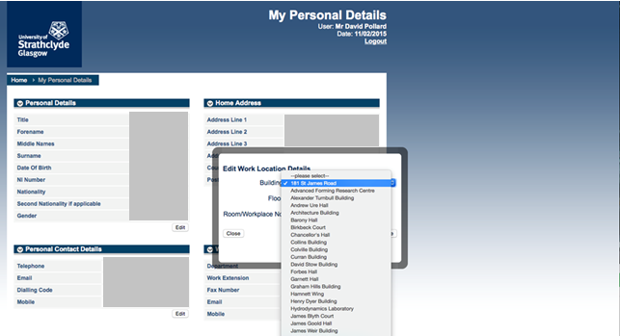
- The list of Building Names includes all available buildings, once you select your Building Name the list of resulting Floor Numbers will relate directly to that building.
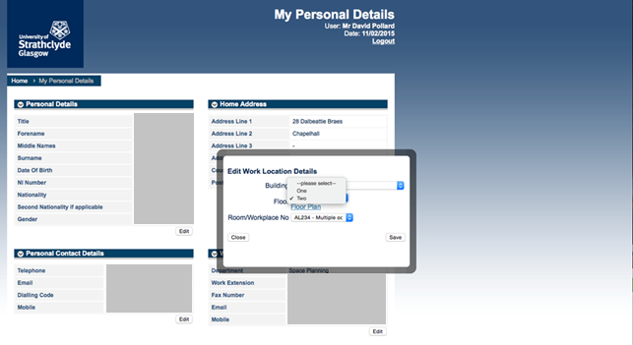
- Once you have entered the Building Name and Floor Level the Floor Plan link is also enabled.
- Clicking on this will open a new tab in your browser with a drawing of the floor plan which contains all of the room numbers on that floor and has been coloured to match the departments each room is allocated to.

- Once you have entered the Building Name and Floor Level the Room/Workplace Number field is populated with the room numbers for that level of the building.
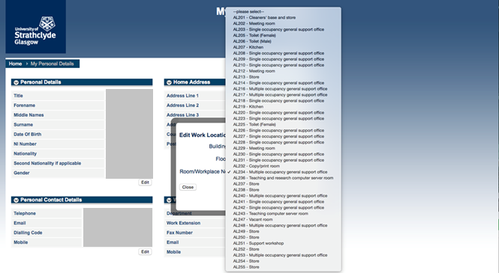
- Attached to each room number is the specific room function for that room contained in the Space Management Database managed by Estates Services.
- If the room function attached to your Work Location Room Number does not accurately reflect the function or the occupancy of your room please email the Head of Space Planning in Estates Services: d.pollard@strath.ac.uk and copy david.knox@strath.ac.uk.
- E.g. if the room is identified as a single occupancy room but it is in fact multiple occupancy or if it is a research office but it is identified as teaching and research office please contact the Head of Space Planning with the correct room function and occupancy capacity.
- If the list of room functions related to the room numbers in Pegasus does not provide you with sufficient information to understand how your current accommodation is represented in the Space Management Database you can view the current list of room functions on page 8.
- If you are satisfied with the original Workplace Location details you can either click on Close
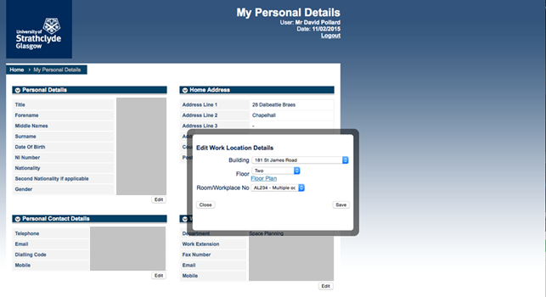
- If you have made changes and you are happy with the revised data you should click Save
- Attached to each room number is the specific room function for that room contained in the Space Management Database managed by Estates Services.
- Please also ensure that any future changes to your workplace location are also updated in Pegasus using the same methodology.

Estates Services: Space Management Database Room Function Codes
Code | Research Accommodation:
R01 | Single occupancy research office
R02 | Multiple occupancy research office
R03 | PGR student research office
R04 | Research Laboratory
R05 | Write-up room
R06 | PGR student common room
R07 | Research computer laboratory
R08 | Research computer server room
R09 | Central Library
R10 | Department Library
R11 | Research Workshop
R12 | Research Preparation Laboratory

Code | Teaching Accommodation:
T01 | Teaching room (fixed seating)
T02 | Teaching room (flexible seating)
T03 | Teaching laboratory
T04 | Learning Resource Centre
T05 | Sports Hall
T06 | Music Practice Room
T07 | UG student common room
T08 | PGI student common room
T09 | Projection booth
T10 | Teaching workshop
T11 | Recording / editing suite
T12 | Teaching computer laboratory
T13 | Teaching computer server room
T14 | Central Library
T15 | Department Library
T16 | Teaching Preparation Laboratory
T17 | Specialist Teaching Laboratory (non-bookable)
T18 | Open access Computer Laboratory (non-bookable)
T19 | Open access student study room (non-bookable)
T20 | Open access student study room (bookable)

Code | Teaching and Research Accommodation:
TR01 | Single occupancy teaching and research office
TR02 | Multiple occupancy teaching and research office
TR03 | Teaching and research laboratory
TR04 | Teaching and research specialist laboratory (non-bookable)
TR05 | Teaching and research computer server room
TR06 | Teaching and research computer laboratory
TR07 | Central library
TR08 | Department Library
TR09 | Teaching and research workshop
TR10 | Single occupancy teaching and research support office
TR11 | Multiple occupancy teaching and research support office
TR12 | Teaching and Research Preparation Laboratory
TR13 | Faculty Outreach Activities
TR14 | Hot Desks: Teaching and Research

Code | Support Accommodation:
S01 | Foyer
S02 | Waiting room
S03 | Single occupancy general support office
S04 | Single occupancy research support office
S05 | Single occupancy teaching support office
S06 | Multiple occupancy general support office
S07 | Multiple occupancy research support office
S08 | Multiple occupancy teaching support office
S09 | Meeting room
S10 | Staff common room
S11 | Store
S12 | Support workshop
S13 | Copy/print room
S14 | Kitchen
S15 | Bar/Servery
S16 | Dining room
S17 | Cold room/Refrigerator
S18 | Coffee area, games room
S19 | Assembly Hall
S20 | Sports hall
S21 | Changing Room
S22 | Car Park
S23 | Loading/Delivery Bay
S24 | Medical room, Wellbeing room, crèche
S25 | Plant room
S26 | Cleaners' base and store
S27 | Toilet (Male)
S28 | Toilet (Female)
S29 | Toilet (Accessible)
S30 | Toilet (Shared)
S31 | Bedroom
S32 | Bathroom/Shower room
S33 | Laundry
S34 | Under Construction
S35 | Unknown function
S36 | Vacant room
S37 | Decant room
S38 | Unavailable room
S39 | Reflection Room
S40 | Quiet Room
S41 | Baby change room
S42 | Reception
S43 | Shower (Male)
S44 | Shower (Female)
S45 | Shower (Accessible)
S46 | Shower (Shared)
S47 | Bike Store
S48 | Comms room
S49 | Bathroom (non-residential)
S50 | Bedroom (non-residential)
S51 | Consulting room
S52 | Hot desks (Support)
S53 | Swimming Pool
S54 | Steam Room
S55 | Sauna
S56 | Recycling Point
S57 | Kitchen (Residences)

Code | Other / Third Party Accommodation:
O01 | Chapel
O02 | Theatre
O03 | Gallery
O04 | Tenanted Accommodation
O05 | Exhibition area
O07 | Conference centre
O10 | Tenanted: Foyer
O11 | Tenanted: Waiting Room
O12 | Tenanted: Reception
O13 | Tenanted: Single occupancy office
O14 | Tenanted: Multiple occupancy office
O15 | Tenanted: Meeting room
O16 | Tenanted: Staff common room
O17 | Tenanted: Laboratory
O18 | Tenanted: Workshop
O19 | Tenanted: Catering outlet
O20 | Tenanted: Store
O21 | Tenanted: Copy/Print room
O22 | Tenanted: Kitchen
O23 | Tenanted: Comms room
O24 | Tenanted: Accessible toilet/shower
O25 | Tenanted: Female toilet/shower
O26 | Tenanted: Male toilet/shower
O27 | Tenanted: Staff lockers
O28 | Tenanted: Corridors

