Annual Climate Change and Social Responsibility Performance Report

An update on headline climate change performance for the financial year 2019/2020.

- Introduction

This note reports on initiatives and actions being taken to tackle climate change mitigation and adaptation across the University estate for the financial year 2019/2020. It also outlines performance against the University’s Climate Change and Social Responsibility Policy and Plan.

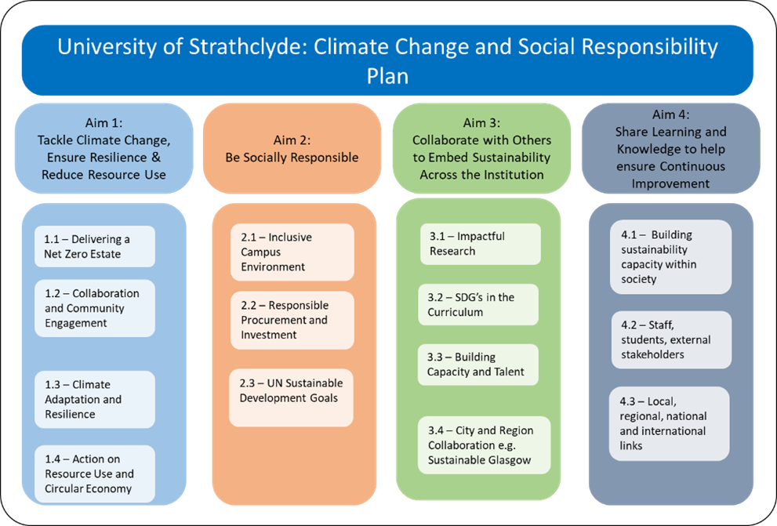

- University Strategic Plan Carbon Reduction Target

The University’s Strategic Plan 2015-2020 carbon target required a reduction of CO₂e of 25% by 2020 based on a 2009/2010 baseline. This equated to a reduction from 30,000 tonnes of CO₂e to 22,500 tonnes by 2020.
The target is essentially a measure of the gross carbon emissions across the whole of our estate relative to the gross internal area of our campus and it is made up of two main emissions sources: a) grid electricity, and b) fossil fuel combustion. That includes electrical consumption in buildings, gas consumption for heating and hot water, gas consumption in labs, and petrol and diesel consumption in University fleet vehicles and standby generators. In simple terms, grid electricity consumption accounts for 26% of our emissions and natural gas consumption for 74%.

  - Commentary on Current Target Performance

At the end of the financial year 2019/2020, the University’s direct carbon emissions were 20,878 tonnes of CO₂e, a reduction of 30% since the baseline year as illustrated in Figure 1, exceeding our 2020 carbon target. Reductions have been achieved through a number of major projects over the period. These include the right-sizing of the estate; investment in energy efficiency; investment in a refurbished University Energy Centre and; the creation of a district heating system connecting 18 buildings. The decarbonisation of the electricity grid across the UK has also been a major factor.
However, these reductions and efficiencies are being offset by continued growth in built development with more highly serviced buildings and greater hours of occupancy. This will continue to be a challenge in the years to come and a significant effort will be needed to ensure that existing building efficiency is improved and that any new buildings are designed to be low carbon exemplars.

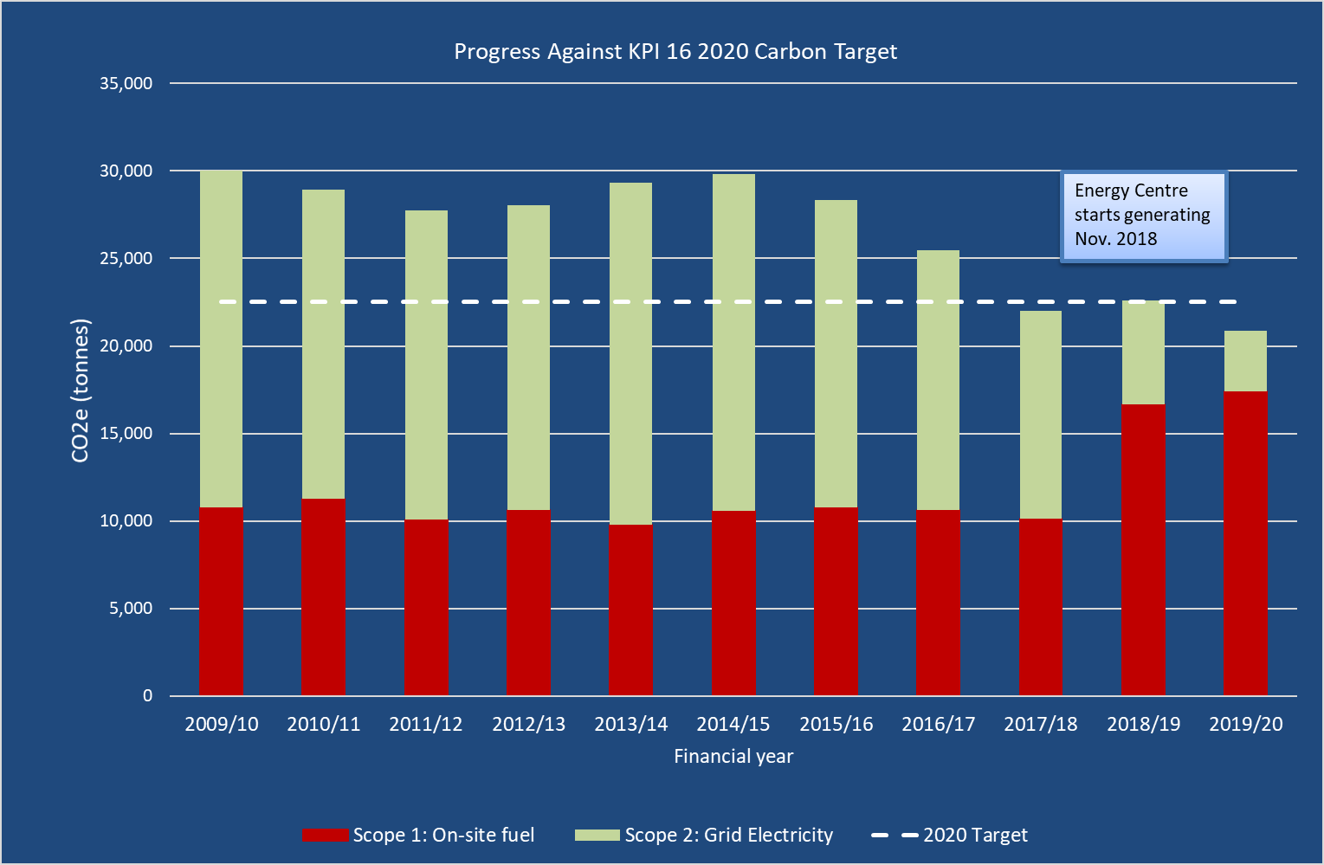
Figure 1 - Strategic Carbon Reduction Target Performance – target achieved

  - Factors Affecting Current and Future Performance
2.2.1 Current Performance
- There has been a continued downward trend in grid electricity emissions factors in 2019/20 as more UK renewables come online, and this has reduced campus emissions associated with electricity purchases.
- As we expand our estate, the Gross internal area (GIA) rises. This GIA figure has a major impact on the emissions KPI. How much depends on the scale and pace of investment and divestment.
- Construction: Changes in our building stock e.g. new buildings, divestment of buildings, refurbishment, all have a large impact on our emissions KPI. Generally, new buildings have higher energy demands but are more energy efficient.
- Demand Growth: Within our existing spaces energy demand tends to increase over time e.g. increases in energy demand from I.T. systems, laboratory cooling and mechanical ventilation.

2.2.2 Future Plans
- Further emissions reductions are anticipated in 2020/2021 from the continued operation of the district heating project and SALIX enabled energy efficiency projects.
- An increase in emissions will result from new developments that are more highly serviced and used more intensively, for example, the new Centre for Sport and Health building (+1,230 TCO₂e), and the pending Learning and Teaching and Wolfson redevelopments. Taking on more buildings will add to this challenge and increase our emissions.
- Future step changes in carbon emissions will be dependent on city-wide solutions and collaboration with others. This ambition has been captured in the University’s ‘Climate Neutral Districts Vision’
- The new Climate Change and Social Responsibility Plan will take into account the University’s ‘2025 Vision’ and Net Zero target date of 2040.

- Vision 2025 Strategic Plan and Net Zero

The University’s new strategic target is included within our Strategic Plan, Visoon 2025. The target is noted below:
“Year on year reduction in greenhouse gas emissions, leading to a 70% reduction by 2025, 80% by 2030 and Net Zero by 2040 at the latest”.
Work is underway to inform the target and how we will achieve this. A draft Climate Change and Social Responsibility Plan was endorsed by University Court in June 2020 and the Plan has been mapped to the UN Sustainable Development Goals. Its focus is on Strathclyde achieving net zero as a campus and as a community, in the context that Covid-19 has brought dramatic and unforeseen change in our ways of working which will impact on our future use of space, approach to travel, and many other aspects of how we work and live. This Plan’s focus on the near term to 2025, set within a net zero by 2040 context, is in recognition that continuous evolution and refinement will be required as longer-term plans and post-Covid19 ways of working and economic circumstances become clearer.
Our Climate Change and Social Responsibility Plan will therefore evolve over time as we develop our thinking and better understand how we can enable positive change. We need everyone to play their part and we are looking to engage every member of the Strathclyde community in this critical work.

4.0 District Energy Scheme Update
With support from Scottish Government funding, in 2018 we completed the installation of a state-of-the-art combined heating and power system. CHP allows Strathclyde to generate up to 50% of its electricity on campus and use the resultant heat produced to heat campus buildings.
The project involved the installation of several kilometres of large-scale pipework and cabling, as well as the refurbishment of the John Street Energy Centre where heat and power are generated. As of December 2019, 18 buildings on our campus are now connected to the scheme.
The system helps the University create significant financial savings and reduce its carbon footprint. Generating our own direct electricity for use on site is a benefit but the University recognises that the energy source (gas) is not sustainable in that form. So while the district energy network and its ability to connect to a wider city district heating scheme is positive, we need to focus on decarbonisation as a priority. This is why the University is collaborating with city stakeholders on the creation of a city network that will use water source heat available ion the River Clyde.

- Cost of Utilities and Water reduction

During 2019/20 there was a further saving in utilities costs of £400,000. This was primarily due to the lockdown restrictions introduced in March 2020 to combat the Coronavirus pandemic. We saw rates reductions of 7% for gas, whereas rates for electricity and water increased by 35% and 7% respectively.

- Community Benefits – The Strathclyde Commitment

As part of the University’s Climate Change and Social Responsibility Policy, the University is committed to ensuring the delivery of socially progressive outcomes through its procurement processes.
https://www.strath.ac.uk/media/ps/estatesmanagement/sustainability/SD_and_Climate_Change
_Policy_Web_Version.pdf
https://www.strath.ac.uk/media/ps/purchasing/procurementmanual/Socio_Economic_Impact_and_Community_Benefits_Strategy_200318.pdf
This commitment includes taking the opportunity to include a range of community based benefits as a result of procurement activity. This will be achieved through the inclusion of specific clauses within procured contracts known as, the ‘Strathclyde Commitment’ clauses.
- Climate Change Adaptation

The Climate Change Reporting Duties require institutions to bring forward plans to cope with the impacts of climate change adaptation, increased rainfall, extreme weather events and installation of more robust infrastructure. A number of initiatives are now underway to adapt to climate change issues and these are noted below:
- The University continues to deliver the aspects outlined in our Climate Adaptation Plan. https://www.strath.ac.uk/sustainablestrathclyde/policyguidelines/.
- Climate Change Adaptation solutions are being integrated into new building designs, e.g. a green roof on the new Learning and Teaching Building.
- The University is represented on the Board of Climate Ready Clyde, a collaboration between a range of organisations in the River Clyde catchment including Local Authorities, NHS, Universities and Scottish Government.

- Waste Resource Management
Figure 2 - Annual Waste Composition Comparison

The University continues to make good progress on recycling waste, increasing waste recovered and mixed recycling from 51% in 2018/19 to 67% in 2019/20. Waste arisings across the university have decreased from 1034 tonnes in 2018/19 to 683 tonnes in 2019/20, a reduction of 34%. This is attributed to reduced operations after the Covid-19 outbreak.

Resource Reuse, Recycling and Last Mile Delivery
The Reuse, Recycling and Resource Centre at Corn Street, close to the University continues to be a valuable asset in terms of reuse, waste and material management. Our plans are to further enhance the facility to enable bulk recycling to add to the furniture reuse. We plan to expand the reuse function. We also plan to consolidate University deliveries at Corn Street as part of a Last Mile Delivery scheme. Bulk deliveries would be routed to the facility and the last mile delivery would be made by the university using E transport. This plan would reduce city centre congestion by removing the need for large lorries and good vehicles to come onto campus. The University would be able to control its own deliveries and enhance our pedestrian first ethos for students and staff.
Single Use Plastic
The University has successfully removed single use plastics from all ‘Nourish’ catering outlets. Vegware and compostable catering supplies have been introduced in 2018/19 and have now replaced non-compostable items. It is anticipated that in 2020/21, food waste and compostable items will be able to be disposed of through food waste, working with our University Waste contractor.
The successful plastic waste reduction project in the Robertson Building conducted in 2018/19 has been rolled out to additional laboratories in 2019/20. This has seen a number of disposable plastic items identified and diverted from the laboratory general waste stream and accepted into the Dry Mixed Recycling collection. A further study on laboratory wastes is currently being prepared and results and next steps to further reduce waste from laboratory activities is expected this year.

- Staff, Student and Wider Stakeholder Engagement

During the 2019/20 academic session, engagement activities continued to attract staff and students to get involved with sustainability aspects. There were four main engagement activities conducted this year. Firstly, Fairtrade Fortnight involved widespread social media engagement as well as engagement with suppliers and university stakeholders to ensure and celebrate the fact that a growing proportion of all products sourced by Strathclyde are Fairtrade. We have joined up with our Students Association and together have brought together our two Fairtrade accreditations into one overall University Fairtrade status. This work contributed to the university being awarded Fairtrade University status in June 2020. In March every year the University of Strathclyde collaborates with the University of Glasgow, Caledonian University and Glasgow School of Art to run the Glasgow Goes Green festival aimed at students and members of the public. However, due to COVID19, this couldn’t go ahead as usual so was reimagined as a social media campaign centered around #Imagine2030 where visions for a sustainable future were submitted by students from across Glasgow. Through our ongoing collaboration between the Strathclyde Student’s Union and the National Union of Students, the “Student Switch Off” which achieved a 17% reduction of energy and saved 22 tonnes of CO2e.
Finally, the “Jump” engagement and behavioural reward programme was rolled out this year to an increased number of 310 staff across Strathclyde and, through the actions that they recorded, avoided 108 tonnes of CO₂ (over 2 times more than last year), saved 32,994 disposable cups (4.7 times more than last year) and facilitated 38,000 sustainable commutes. A detailed breakdown of initiatives is included at Appendix 1.
  - Student Focused Activities
The main student focused activity has been our ongoing partnership with the Management Development Programme students from the Business School. Eight students had bi-weekly meetings with members of the Sustainable Strathclyde team to develop and implement the Sustainable Strathclyde Student Society. Students created social media video content which reached over 1,000 views per video and students developed and introduced a series of engagement campaigns for students. Their involvement continues through their contributions to the development of the Jump programme.
In January 2020, the university released a MOOC course available to all students themed around the sustainable development goals. Each module of this course was presented and introduced by a Sustainable Strathclyde team member and is now open to all students at the university.
  - Sustainable Labs (S Labs)
S-Labs is a national environmental accreditation programme that aims to make labs safer, successful and sustainable.
Over the past year the S-Labs programme has focused on activities aligned with the strategic Vision 2025 and the Climate Change and Social Responsibility Plan. This has included a review of scope 3 emissions within labs including the purchase of equipment, water use and waste management processes. Work on compiling a greenhouse gas inventory of labs was also started to understand and quantify fugitive emissions from lab-based research.
Engagement with lab departments has continued throughout 2019/20 and now also includes Physics and staff at the Advanced Forming Research Centre.
The Sustainable PhD credit course which was implemented in 2018 and is part of the Doctoral School professional and personal development opportunities continues to be run annually.
  - Living Lab Initiatives
The Sustainable Strathclyde team also works with academic colleagues to enable students to undertake campus-based sustainability projects integrated with course curriculum, research activity, or as a volunteering opportunity. To date, more than 130 students across a number of faculties have worked on projects in partnership with the Sustainability Team across several faculties covering a wide range of social, environmental, technical and commercial practice areas.

- Sustainable Transport

  - Cycling Infrastructure and Initiatives
Since 2015, the University has steadily increased the number of bike parking spaces available on campus, more than doubling them by 2018/19. This year has seen less focus on increasing the number of spaces, but more on improving security, with the Sustainability team securing £22k of Cycling Scotland funding to install a secure swipe access cage around the McCance bike parking racks. This will also include installation of another double tier cycle rack, bringing the total number to approx. 660 spaces.
The existing cycle hubs in Royal College Cartway, Curran Building internal car park, and the Business School continue to be maintained and used. These secure parking and bike maintenance facilities help improve bike storage security on campus for students and staff, as well as providing indoor areas to change, maintain bikes and hep users to get information pertaining to active travel in Glasgow.
Image 1 – New Cycle Racks outside TIC on George Street.

    - Cycle to Work Scheme
The University’s Cycle to Work scheme has been reviewed. We have sought to ensure that our scheme enables value for money, additional benefits for cyclists, a strong range of bikes to meet user needs. We also engaged a supplier who has good relationships with local suppliers to encourage staff to buy local when choosing a bike. CycleScheme who have since run an engagement webinar for staff with questions about the scheme have also appointed a dedicated account manager able to help with promotion and future engagement with the scheme.

    - Active Travel Coordinator
The University secured ‘Paths for All Smarter Choices, Smarter Places’ funding the previous Campus Cycling officer to continue on as an Active Travel Coordinator. This provided a member of the team who could drive the development of cycling infrastructure and uptake of cycling across all University facilities. Initiatives launched to date include:
- Dr. Bike sessions;
- Led bike rides across the city;
- Social Walking Group
- “Do It Yourself” bike maintenance sessions;
- Promotion of Active travel to staff and students
- Bike Security Tagging
- Lock Swaps
- Police Scotland, close pass workshop
    - Cycle Friendly Employer Award
Following on from the success in 2018 of the University becoming a Cycle Friendly Employer, the University facility at Ross Priory has now also achieved this award. The improvements made to achieve this award make it easier for people to access the facilities needed to cycle to work.
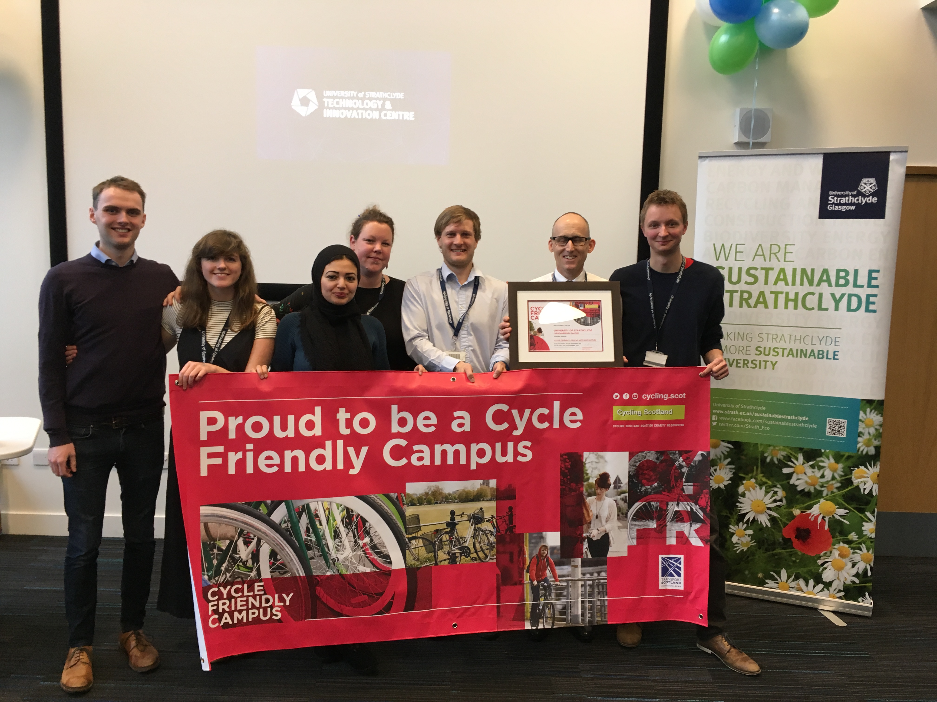
Cycle Friendly Campus Award Ceremony
  - Electric Vehicles
Following the successful trial of a Nissan electric van in 2015 the University successfully secured funding through the Switched-on Fleets programme to procure 4 electric vans for use across the University. These vans will replace diesel vans and they begin a process of transition away from fossil fuels for our fleet.
    - Staff pool vehicles
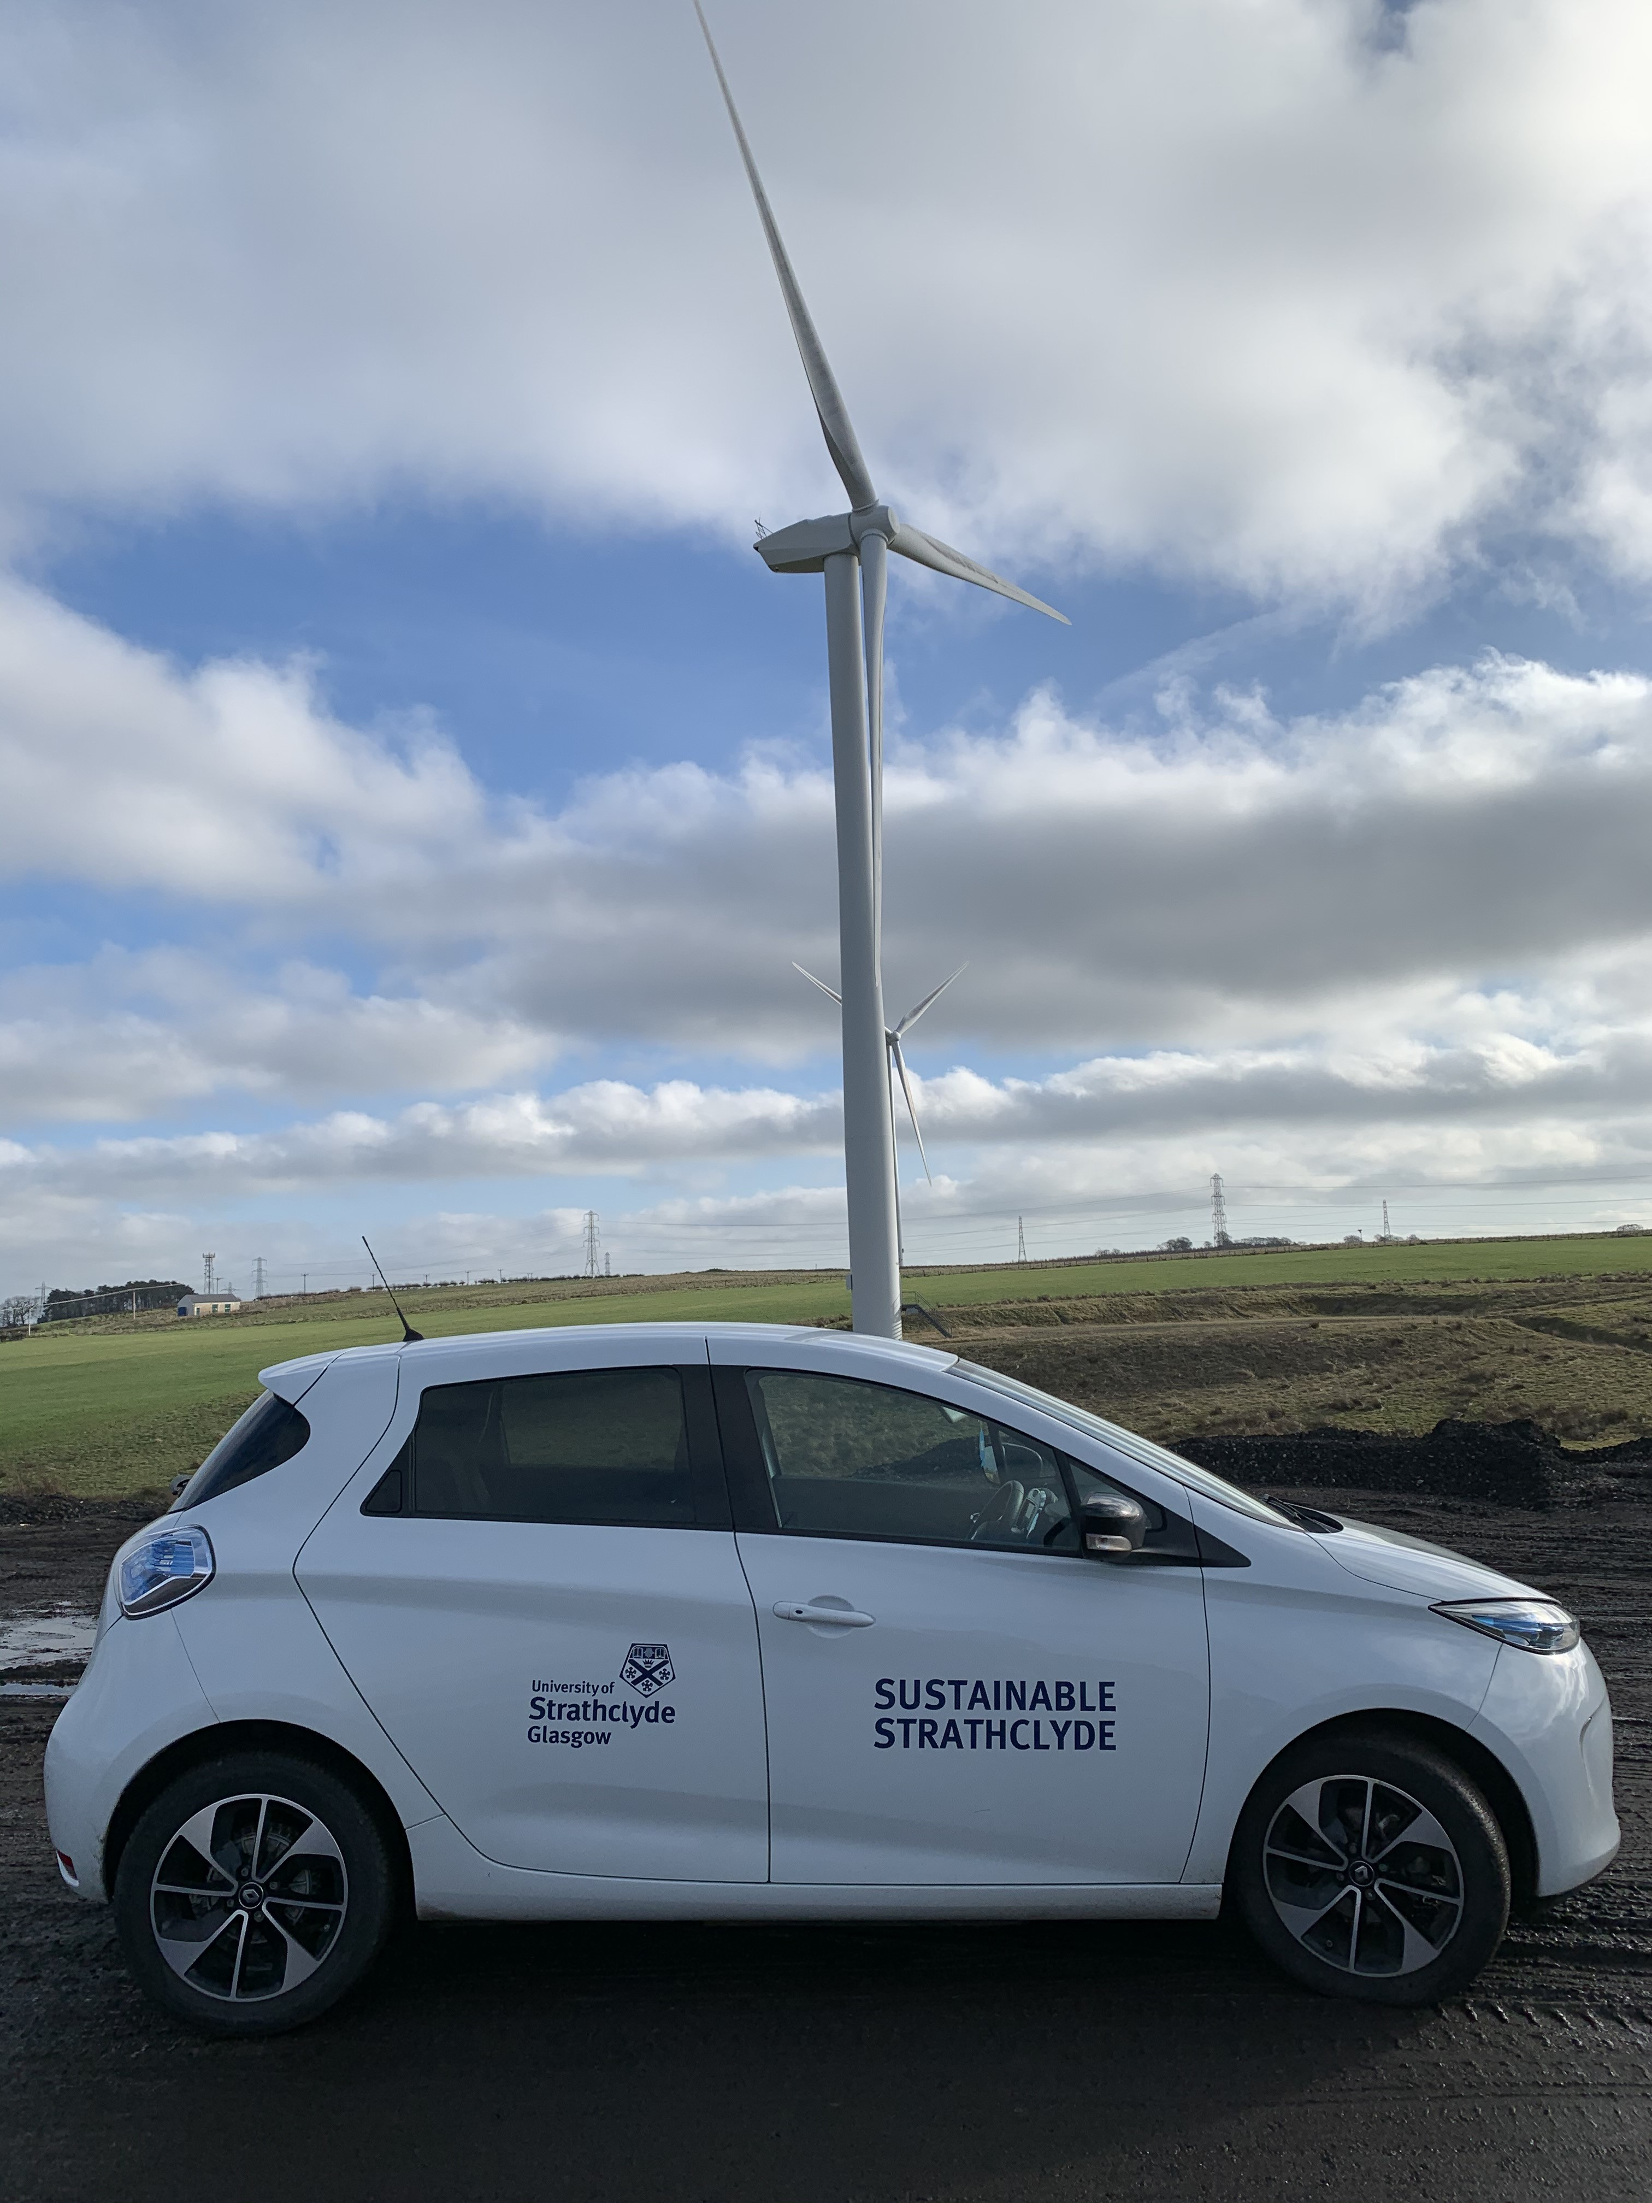
This year was the first full year of operation of the two electric staff pool cars located on Richmond Street. In total, the two cars were used for 5765 miles, avoiding another 1.6 Tonnes CO2e compared to a standard petrol vehicle. This was a good result and an increase on the usage in the previous year, despite 3 months from April-July of low use due to Covid. Staff Induction and familiarisation training for the vehicles also continued, and over the period of 2019/20 another 65 members of staff were trained, bringing the total trained users to 183. The Sustainability team also ran an engagement day for the EV’s in January with staff from Energy Savings Trust, Glasgow City Council’s Low Emission Zone team and Co-Wheels to speak to staff about EV charging opportunities, the council’s plans, and home charging support.
Image 3 - Staff EV on a Research Visit
    - Charging Infrastructure
This year, approx. £40k funding was secured to install additional charging infrastructure at Ross Priory, and the Advanced Forming Research Centre to support the operation of the electric Vans being procured through the Switched on Fleets programme mentioned above. Installation of these posts will take place in 2020/21

  - Business Travel Monitoring
As part of the new Vision 2025 Strategy Net Zero target, the University has committed to widening the scope of reported emissions. One of the largest single streams of emissions to be included in this new scope are business travel emissions. As with other elements of the Vision 2025 reporting strategy, the baseline for these emissions has been taken as 2018/19, being the most recent full year of data available before Covid related reductions.
    - 2018/19 Baseline Data
The following table shows the emissions based on type of travel. In total, flights were responsible for 9503 Tonnes CO2e and other business travel for just 421.
Type of Business Travel | Tonnes CO2e
Long-haul flights | 4871
International flights | 3444
Short-haul flights | 1060
Car - Own Mileage | 270
Domestic flights | 127
Rail Travel | 87
Taxi | 43
Bus | 20

    - Progress in 2019/20
This year saw a dramatic reduction in business travel, due mainly to the Covid-19 Lockdown.
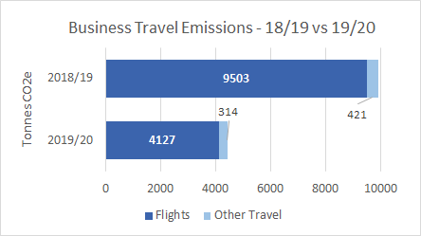

While only the last 4-5 months of the year were affected, this is historically the busiest period for business travel bookings (as seen in the second figure) resulting in a decrease on the previous year of 55%.
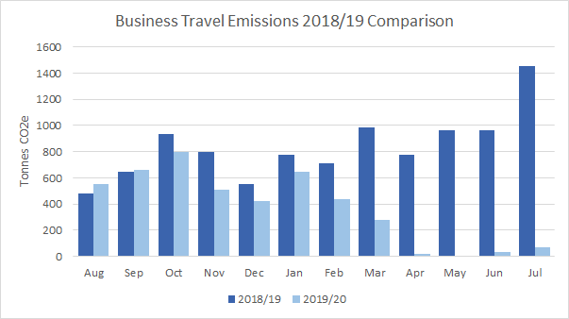
    - Further Improvements
The Sustainability team are working with Strategy and Policy colleagues to improve business travel monitoring and reporting. Travel is currently booked through a variety of different methods, all with different formats of reporting that must be checked and combined to give total figures. A new Business Travel policy is under review this year which will seek to implement lessons learned from the Covid Pandemic and minimise future business travel emissions.

- Ecology and Biodiversity

During the year, planning for the integration of rain gardens, green roofs, green walls have begun. A green roof is being built as part of the Learning and Teaching Building. Our new Heart of the Campus project will also deliver extensive biodiversity and climate adaptation benefits in its design and construction. These climate adaptation and biodiversity solutions will be integrated within new and emerging capital projects as part of the University Sustainable Design Quality Standards.

- Fairtrade and Sustainable Supply Chain

The University achieved full Fairtrade reaccreditation in 2017. A Fairtrade Steering Group consisting of representatives from the Environment Team, the Students Association and Catering teams is now working on the creation of a joint set of Fairtrade Policy statements. Through this group, guidelines on sustainable and Fairtrade purchasing are discussed and have now been implemented across the university. For this to work, external partnerships with suppliers are crucial and the university has engaged regularly with Matthew Algie who supply a large proportion of the coffee beans that are used on campus. Through working towards the National Union of Students’ Fairtrade Accreditation, a SMART Action Plan has been created.

- Awards and Achievements

The following environment and sustainability awards and accreditations were secured by the University during the year.
- Green Business Tourism Scheme Gold Award for the Conference and Events Team at The Innovation Centre
- Cycle Friendly Campus Award for the John Anderson Campus
- Cycle Friendly Employer award for AFRC and PNDC.
- Scottish Funding Council University Carbon Reduction Fund awarded £852,528 for CHP enhancement works.
- Sustrans Community Links Fund (now Places for Everyone) awarded £50,000 grant funding, joint collaboration with the City of Glasgow College and Glasgow City Council for active travel and urban realm improvement works in the Learning Quarter zone of the city.

Appendix 1
Stakeholder Engagement Activities

Events and Networking 2019 - 2020
Name | Date | No. of people engaged
Go Green Week 2020 | April – May 2020 | >1,000 mainly students on the day and through social media
Fairtrade Fortnight 2020 | 24th February-8th March 2019 | ~300, mainly students
Strathclyde Fresher’s Week 2020 (Virtual Stall and Jump comms campaign) | September 2020 | 500+ students
Stationery Stations | ongoing | 1000+ students over the course of the project since September 2016
EAUC Participation | ongoing | 30+
Climate Ready Clyde Participation | ongoing | 50+

Engagement Initiatives 2019/2020
Name | Date | No. of people engaged
Green Impact/ Sustainable Laboratories | 2019/2020 | 80+
Student Switch Off | 2019/2020 | Potential reach of 1500 students every year
JUMP | 2019/2020 | Currently 400+ staff and growing
Campus Community Garden | Continuous from 2016 | 30+
Online Newsletter | Continuous from 2016 | 300+

Strategic Engagement Activities
Considerable effort has been made to engage with stakeholders that can help to positively influence the University’s ability to tackle climate change. Much of this focus has been on communications with Glasgow City Council (GCC), particularly with respect to the District Heating Scheme, future campus plans and City Deal. The proposals to pedestrianise a number of streets across campus have and will continue to require dialogue with the Council. A note of the stakeholders and aspects discussed is noted below:
- Glasgow City Council (GCC) Roads Department – road safety, more disabled bays, pedestrianisation, pedestrian safety, drop kerbs, crossing points, district energy.
- GCC Planning – Heart of the Campus Project relandscaping of Rottenrow Gardens and pedestrianisation of Richmond Street, North Portland Street, Rottenrow.
- GCC City Deal Team – to engage with and comment on the opportunity for collaboration on the investment in urban realm works at John Street, Cathedral Street and George Street.
- GCC ‘Ruggedised’ Team – to determine a methodology for the creation of a city wide Energy Services Company that may enable heat to be traded with the Council as part of a city centre district heating scheme.
- Sustainable Glasgow – Climate Neutral Innovation District vision.
- Community Planning Partnerships – funding of £54K was secured from three of our Local Authority partners to fund 5 electric vehicles across our learning and teaching facilities.
- Climate Ready Clyde – the University is represented on the Climate Ready Clyde Board
- Scottish Government – the University continues to engage with the Low Carbon Infrastructure Transition Programme that aims to allocate funding to organisations and groups that can bring forward low carbon energy projects.
- SSN and EAUC: Joint publishing of the “Guidelines to Climate Change Communication” document produced by Sustainable Strathclyde.

