Issues Accessing FMS with Google Chrome

If you experience ‘Web page cannot be found’ / ‘Bad Request’ error messages when accessing FMS then follow the guidance below :

Press to the settings icon. The three line icon on the right.

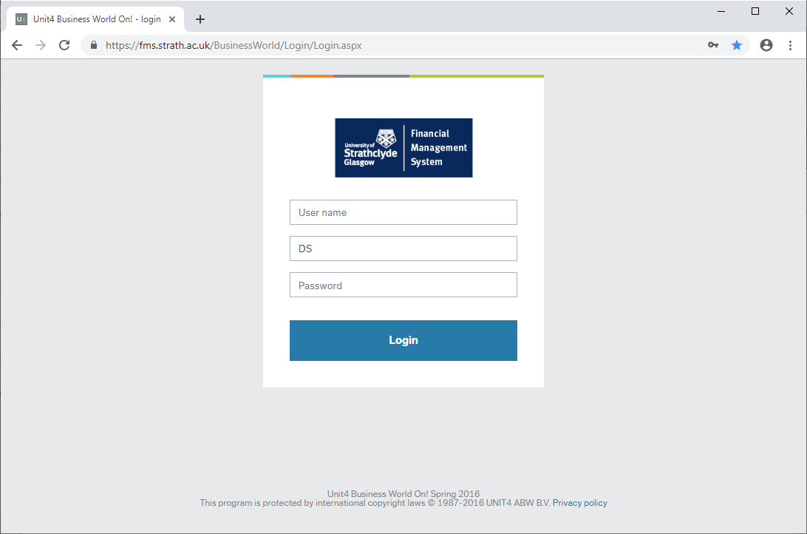

Place your cursor over History History (or Ctrl + H). This should pop up another history tab.
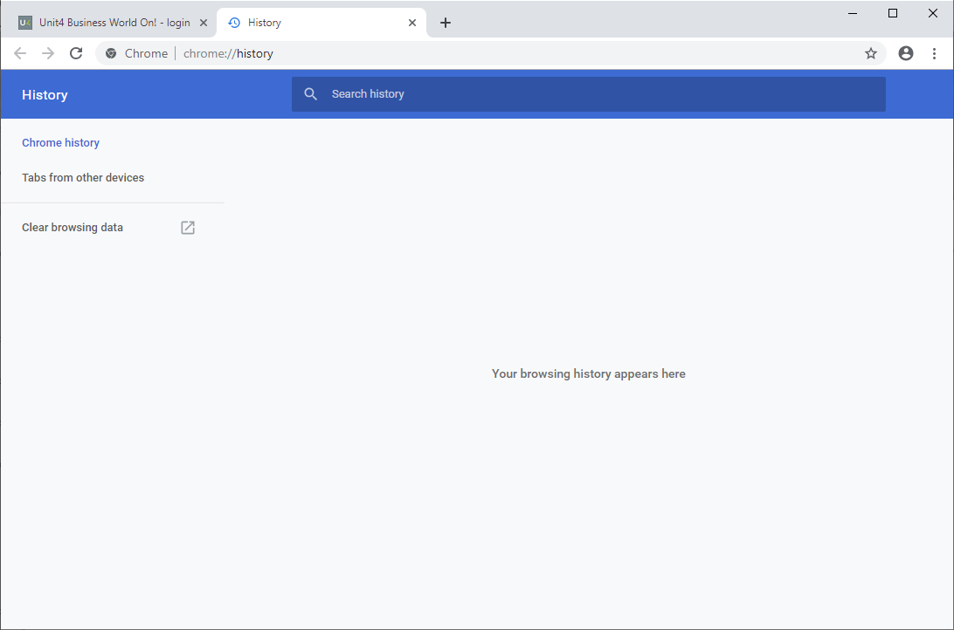
Click on ‘Clear browsing data’ option.

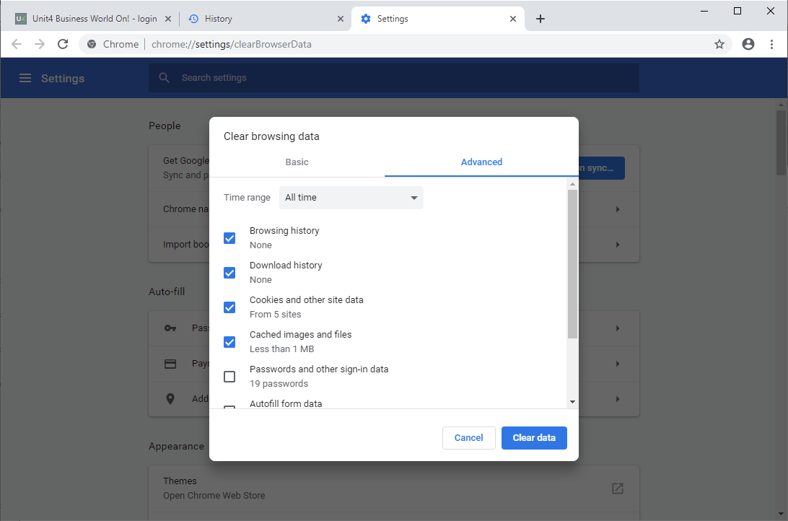
This will make the following window appear. Select ‘All time’ from the drop down. Make sure all relevant boxes are ticked and select ‘Clear Data’.
Shut down chrome and restart a new chrome session.

