GL Posting String Explained
Financial transactions on FMS are coded using a General Ledger (GL) Posting String. The GL posting string determines where in the General Ledger the transaction will be recorded. The information contained in the GL posting string, are some of the key building blocks to enable reporting of information from FMS, for various purposes (e.g. Financial Statements, External Reporting, Budget Statements and other Management Information).
There are a number of elements to the posting string and the key elements are noted below:
GL Posting String | Format | Example | Text
Cost Centre | 5 Digits | 17165 | Finance
Sub Project | combination of letters and digits | GEN1568-105 | Department Running Costs
Activity | 3 Digits | 100 | General
Account | 4 Digits | 3001 | Travel
Product | 2 Letters + 3 Digits | TB001 | Rail Travel

The Cost Centre and the Sub Project may be seen as identifying where income is generated or costs are incurred, while the Activity, Account and Product codes identify, to varying levels of granularity, what the income or costs relate to.
In addition to these key elements, the posting string can sometimes differ depending on the account being chosen. In these instances, it will be necessary to add some additional information. These Other Posting String Values are set out in Appendix 1.
The following paragraphs provide some additional description of each of the key elements of the posting string.

Cost Centre
The Cost centre identifies the organisational area of the University to which a transaction belongs and is associated with a department, school or directorate. The cost centre code comes from the University’s Organisational Hierarchy as maintained by Strategy & Policy and used within other University systems. Within FMS the cost centre is normally derived from the sub project (i.e. this part of the posting string is automatically populated when the sub project is chosen).
The Cost centre has a number of purposes including:
- It is a key element in enabling reporting of financial information at different levels within the University (e.g. Faculty/School/Department).
- It is used to allow/restrict user access to create and view transactions relating to their cost centre(s). This is known as data control.

A report showing the Organisation Structure can be found in the Reports section:

Reports>Your Reports>General Information>List of Codes>Organisational Structure

Sub Project
A sub project represents a discrete business activity for which it is useful to track income and expenditure. Sub projects are linked to a named budget holder (sub project manager) who is responsible for monitoring income, expenditure and commitment of spend, against the allocated funds for the sub project. All sub projects are linked to a project. This allows related sub projects to be grouped and managed by a project manager. This would not necessarily be the same person as the sub project manager (for example a Head of Department may be the project manager for the department running costs but may have allocated funds to separate sub projects, managed by separate sub project managers, for different types of running costs e.g. staff training, equipment etc.).
When entering transactions on FMS, only the sub project is required with the project being automatically populated.

Further guidance on project structures can be found in the managing sub projects training manual FMS Web Managing Projects and Sub projects and in Appendix 2.

Activity
The activity code allows further breakdown of the budget where there are additional funder requirements. This is common in research and SFC (Scottish Funding Council) sub projects, where funding has been granted and the funder specifies how the allocation of funds is split.
An example of an Activity code is 302 - Travel and Subsistence.
However, for most sub projects, there are no such requirements and the activity code is set at 100, which is a general fund.

Account
The Account code is the most important part of the posting string. Transactions cannot be entered into the system without an Account code. Account code is used to provide detailed analysis of the types of income and expenditure processed through FMS, which allows us to understand where the University receives money from and exactly what we spend it on. For example, whether expenditure relates to travel, consumables, staff costs and so on.
An example of an account code is 3001 - Travel.
For purchases and sales orders, FMS automatically populates the account code based on the product code.

Products
Products are detailed values set up in the sales module and the purchase module to identify specific income and expenditure transactions.
An example of a product code is TB001 Rail Travel.
When entering transactions on the sales or purchase modules within FMS the relevant product will be chosen and the account code (e.g. 3001 for product TB001) will be derived from the product.

Example Of Gl Posting String On Fms
Below are some examples of how the GL posting string looks on FMS:

- Stationery is purchased from FMS for the Finance Directorate. This is coded to the general running costs budget. The GL posting string would show as:

Cost Centre | Sub Project | Activity | Account | Product
17564 | GEN1564-100 | 100 | 4000 | OA001

- Expenses are charged to a research account (Chemical and Process Engineering) to cover rail travel to a conference.

Cost Centre | Sub Project | Activity | Account | Product
11012 | R130021-101 | 302 | 3001 | TB001

The majority of processes on FMS will require departments to enter only a sub project, product code and if necessary the activity code (which will default to 100 and only requires amendment, where this is not appropriate e.g. for Research and KE sub projects). All other information for the transaction should be automatically populated from the information you enter. Journal entries are the exception, requiring the relevant account code to be entered as well as entering the sub project, product and activity code
The GL posting string and terms are explored further in the various FMS training courses especially FMS Web Managing Projects and Sub projects.

All transactions on FMS will be posted to a period.

The period in FMS appears as 201901, 201902 etc. where 201901 is the first period of financial year 2018/19 (i.e. August 2018).
FMS also provides the codes available for users to select in a number of University systems such as Payroll, Undertaken Duties, Online Student Payments and Authority to Appoint (ATA)

APPENDIX 1 - OTHER POSTING STRING VALUES

Additional information will appear on the posting string under certain circumstances. The posting string is driven by the Account code and for some types of income and expenditure, additional information is required for reporting purposes. This information will not appear on standard reports but can be added to specific reports where appropriate. The other possible posting string values are:
Resource (RESNO) – this is the Staff ID no. and will appear against detailed salary costs (only certain staff will have access to this information) and travel related costs.
Staff Grade Higher Grouping (GRADEHG) – this is used to group staff costs per grade group. This attribute will only appear for payroll costs
Sponsor ID (SPONSOR) – this appears against student related transactions (e.g. tuition fees) where appropriate
Purchase Card (PCARD) – this appears against purchase card transactions
Academic Session (STSESSION) - this identifies the relevant academic session (e.g. ACAD 2017/2018) and appears against student related transactions (e.g. tuition fees) where appropriate.
Revenue Type (STREV) – this appears against income transactions to describe the type of income (e.g. Commercial Income, Tuition Income)

Appendix 2 - Project Structures

Depending on the project type, there may be several projects and sub projects set up. Below is an example of the relationship between Main Project, Project and Sub Project in its simplest form a project will have a main project (the same as the project) and a sub project.

PROJECTS – EXAMPLE STRUCTURE – GENERAL

General Projects will tend to have one project and one or more sub projects.

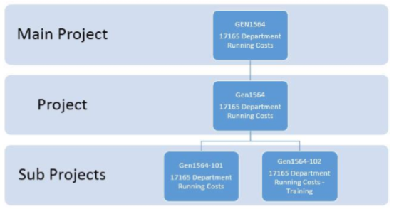

Research Projects Structure
There are two types of structures for research projects within FMS:

- Structure 1 - One funder type, one or more departments
- Structure 2 - Multiple funder types, one or more departments

PROJECTS – EXAMPLE STRUCTURE – RESEARCH STRUCTURE 1

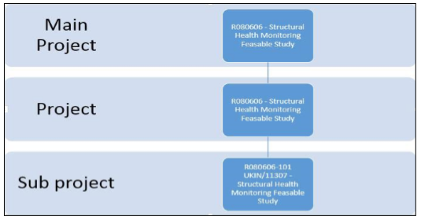

PROJECTS – EXAMPLE STRUCTURE - RESEARCH STRUCTURE 2

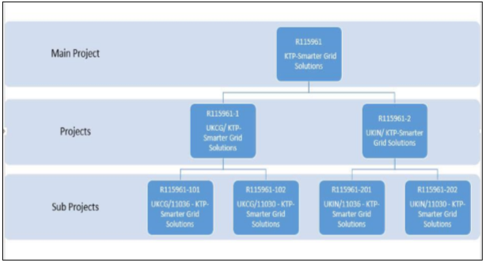

Knowledge Exchange Project Structure
There will be several structures for Knowledge Exchange (KE) and ERASMUS Plus projects in FMS:

- Structure 1 – one Funder Type, one department
- Structure 2 – multiple funder types, one or more departments
- Structure 3 – one funder type, multiple departments

Structure 1 will be the most commonly used type for Knowledge Exchange projects.
Generic KE projects will be set up within FMS and Sub Projects should be created within SAM with the details imported to FMS.
Structures 2 and 3 will require a new project (or projects) to be created by the interface with SAM.

PROJECTS – EXAMPLE STRUCTURE – KNOWLEDGE EXCHANGE STRUCTURE 1

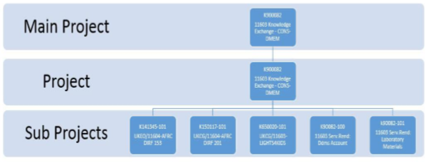

Project Coding
Generally, there is a connection between the project code (normally 7 characters) and the sub project code (always 11 characters).
The project coding also relates to the Project Type as per examples below:
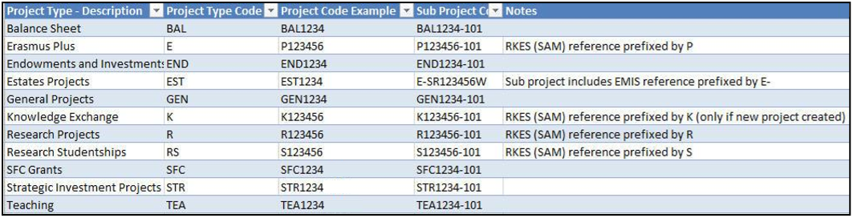

Appendix 3 – Further information on Project Types and Categories
Project types are used to separate out the different groupings of activity, specific to the University.

PROJECT TYPES:
- General Projects
- Knowledge Exchange
- Research Project
- Research Studentships
- SFC (Scottish Funding Council) Grants
- Strategic Investment Projects
- Teaching
- Balance Sheet
- Endowments and Donations
- Estates Projects
- Erasmus Plus

PROJECT CATEGORIES:
Project categories are a sub group of project types and are used for further analysis. For example, within General projects there are many categories including:

- General – Running Costs
- General - Core Salaries
- General - Research Fund
- General - Department Funds: General
- General - Department Funds: Earmarked*

*used where the project relates to a named individual rather than the department as a whole.
All sub projects will be linked to the relevant Project Type and Project Category.

The GL posting string and terms are explored further in the FMS activities training courses.

