Payment Portal for Students

- Introduction
The University of Strathclyde’s ERP Portal allows you to view your outstanding balances and make payment of all your current student fees.

- How to login

- You can login to the portal is via the link below:

https://strathclyde.erpportal.com/login

- You will see there is an option to ‘Sign in with Microsoft. This will sync your student Microsoft account and will ask for your permission to do so:

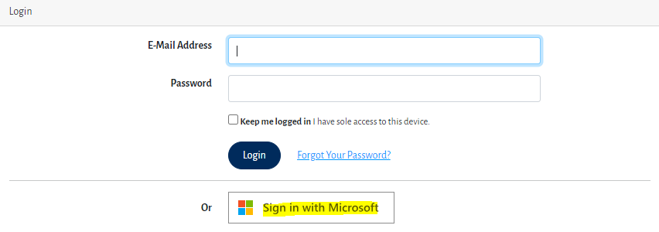

- Click on ‘Accept’
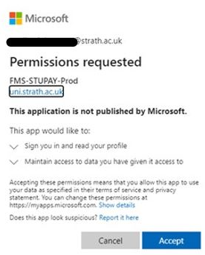

- You will now be able to view your transactions and make payment of your outstanding invoices.

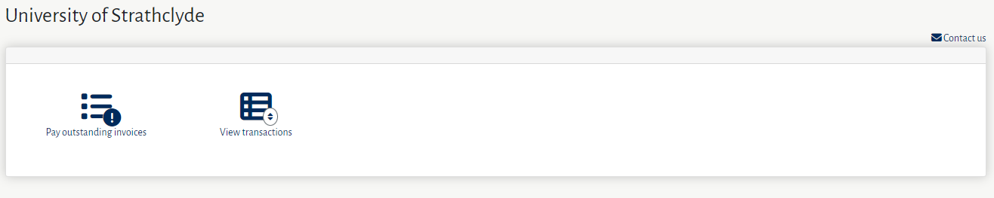

- To pay an outstanding invoice

- Please select the option Paying outstanding invoice, this will then display your outstanding balances

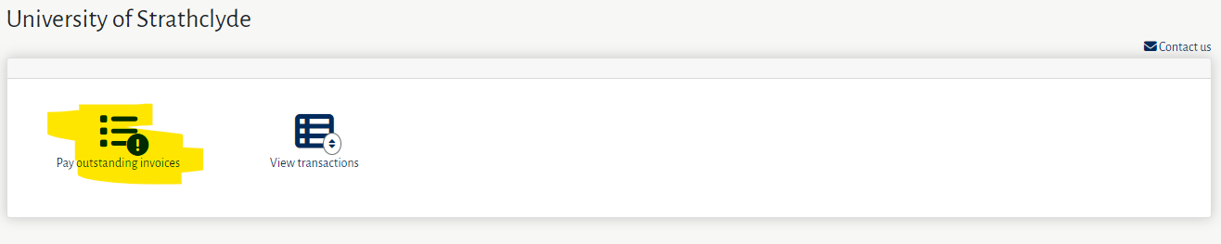

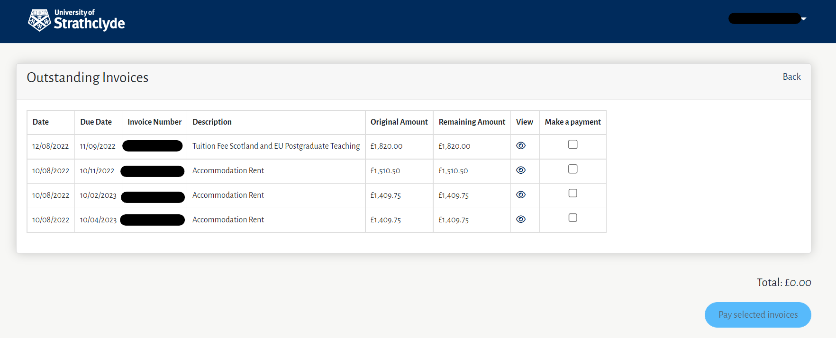

- Please select the invoice or invoices you wish to pay and enter the amount being paid. Then select Pay selected invoice and this will display a summary of your payment

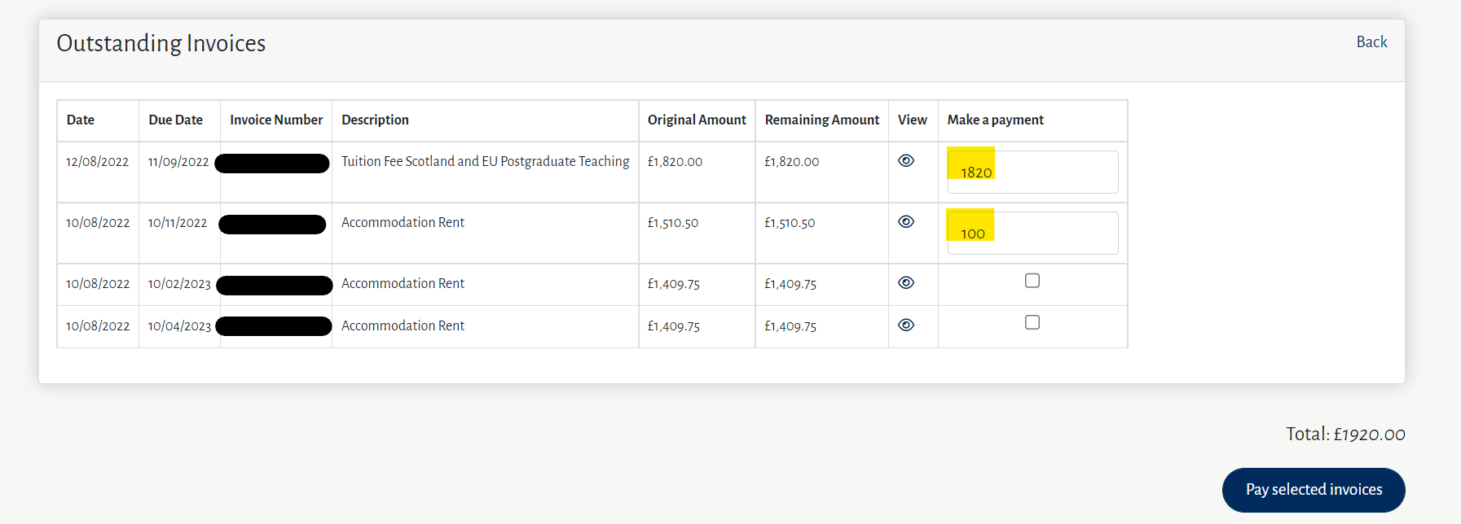

- Select Proceed to payment

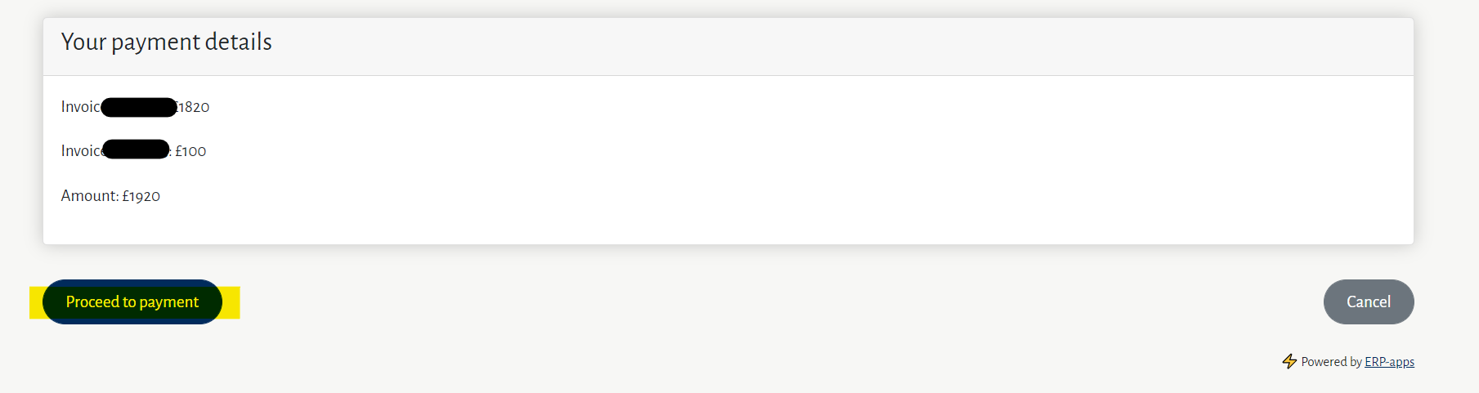

- Please check the amount being paid is correct then select Continue to enter your personal and payment card details

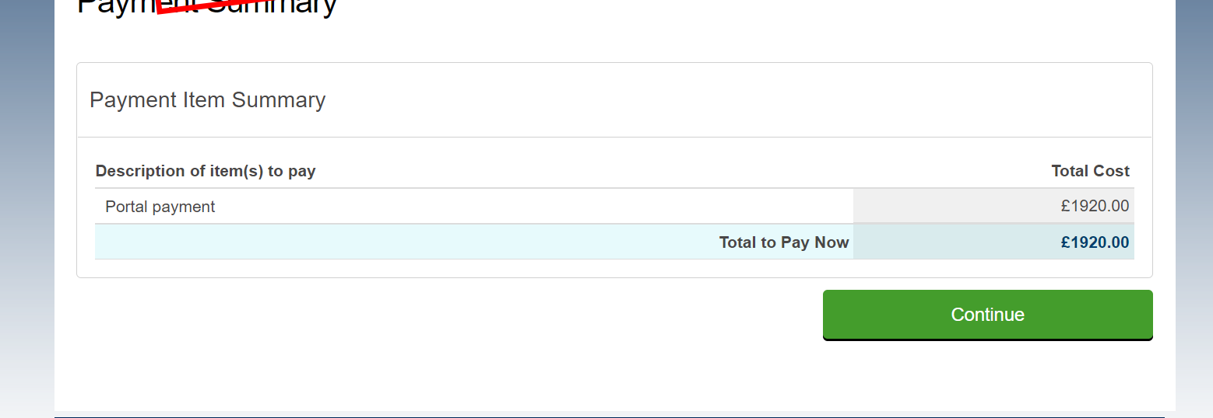

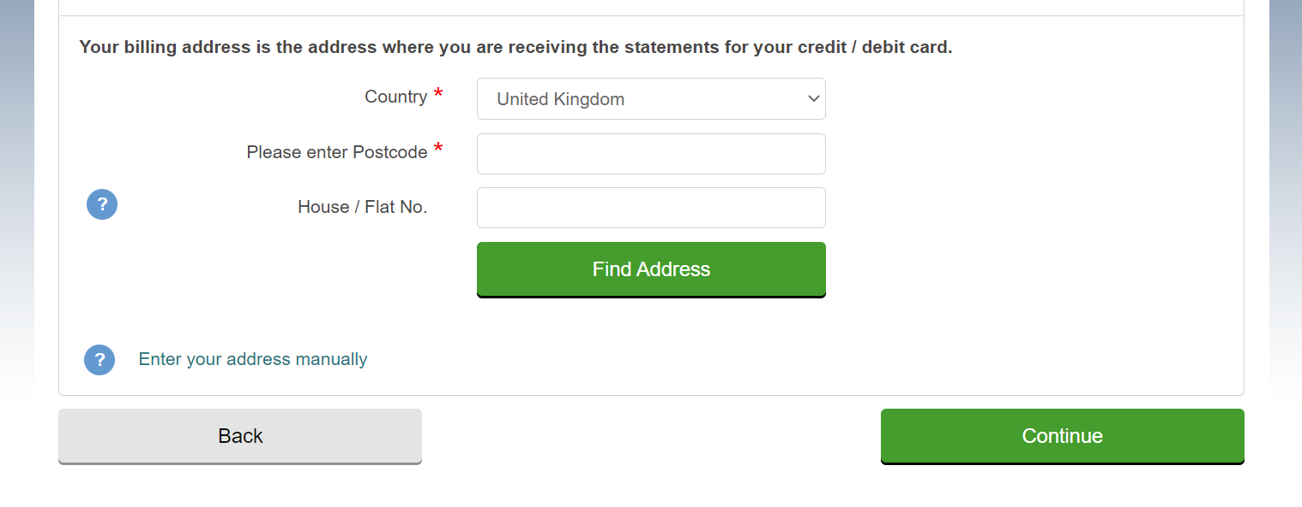

- When your payment has been processed successfully you will see the undernoted confirmation screen and you will receive a payment receipt by email.

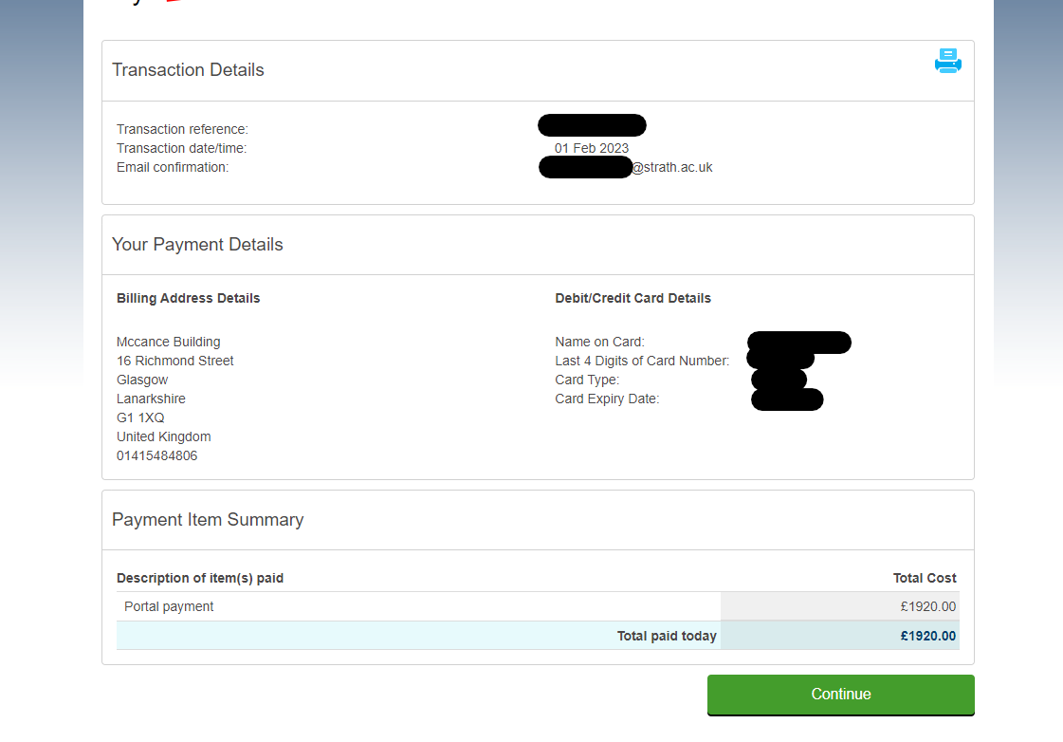
- Please select Continue to return to the portal homepage

- To view transactions on your account

- Select the option View transactions
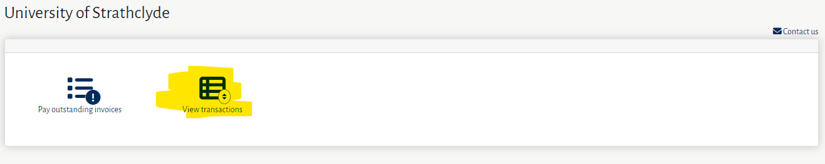

- You will now be able to view all invoice and payment transactions on your account, please note payments and credit transactions will be displayed as a negative value eg. -1000

