Payment Portal for Students

1. **Introduction**

The University of Strathclyde’s ERP Portal allows you to view your outstanding balances and make payment of all your current student fees.

1. **How to login**

* You can login to the portal is via the link below:

<https://strathclyde.erpportal.com/login>

* You will see there is an option to ‘Sign in with Microsoft. This will sync your student Microsoft account and may ask for your permission to do so:

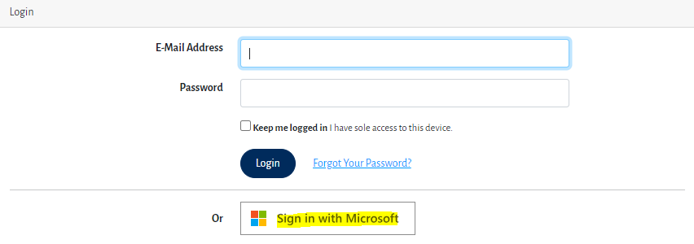

* Click on ‘Accept’

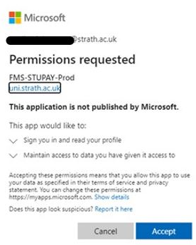

* You will now be able to view your transactions and make payment of your outstanding invoices.

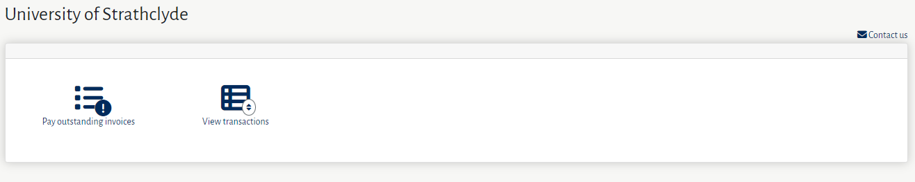

1. **To pay an outstanding invoice**

* Please select the option Paying outstanding invoice, this will then display your outstanding balances

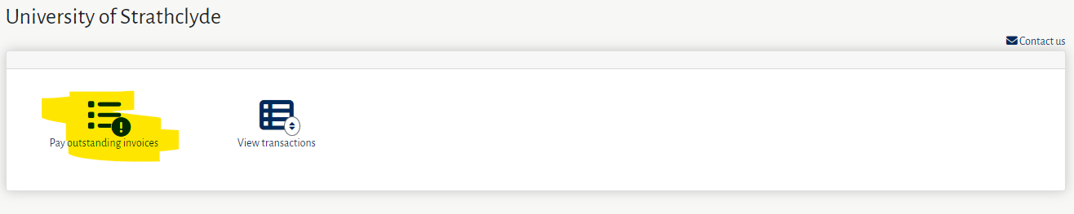

* Please select the invoice or invoices you wish to pay and enter the amount being paid. Then select Pay selected invoice and this will display a summary of your payment

* Select Proceed to payment

* Please check the amount being paid is correct then select Continue.

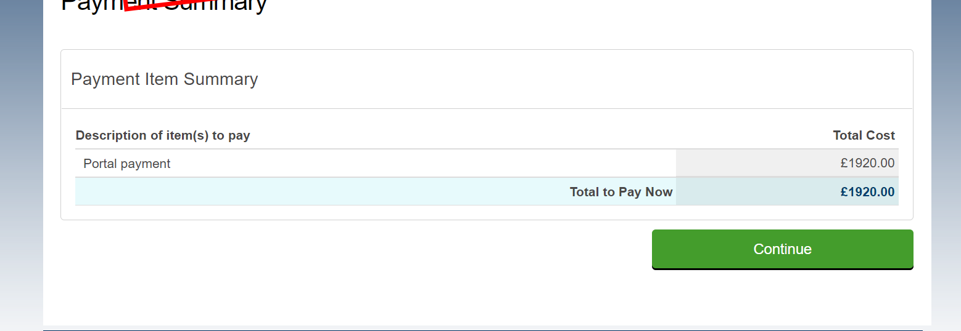

* You will now be prompted to enter the details of the person making the payment.

* When you proceed to the next screen, you will be asked to enter the contact details for the person making the payment and also the details of the student whom the payment is being made on behalf of. Once these details are completed, select the ‘Proceed to summary’ option.

* You will now be prompted to select your payment method. Select the ‘Debit/Credit Card in GBP’ option. Ensure you read the Terms of Use and privacy and tick the box to say you agree to them. Once this section is completed click on ‘Next’.

* You will now be asked to add the payment details. Enter as appropriate and once completed click on the ‘Pay’ button.

* You may be asked to verify a payment of ‘GBP 0.0’ and may receive a message similar to the below. This is called a This is called Zero-Value Authorization, a common practice of card issuers/banks. You should be able to enter the verification code you have received from your card issuer and it should allow you to proceed with the payment

* When your payment has been processed successfully you will see the undernoted confirmation screen and you will receive a payment receipt by email.

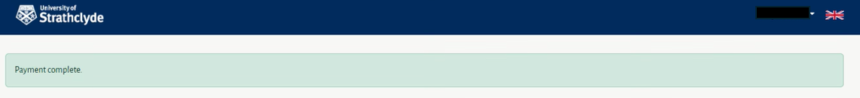

1. **To view transactions on your account**

* Select the option View transactions

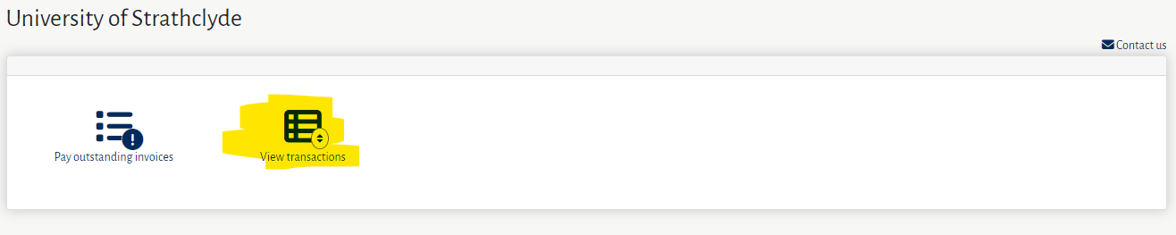

* You will now be able to view all invoice and payment transactions on your account, please note payments and credit transactions will be displayed as a negative value eg. -1000

