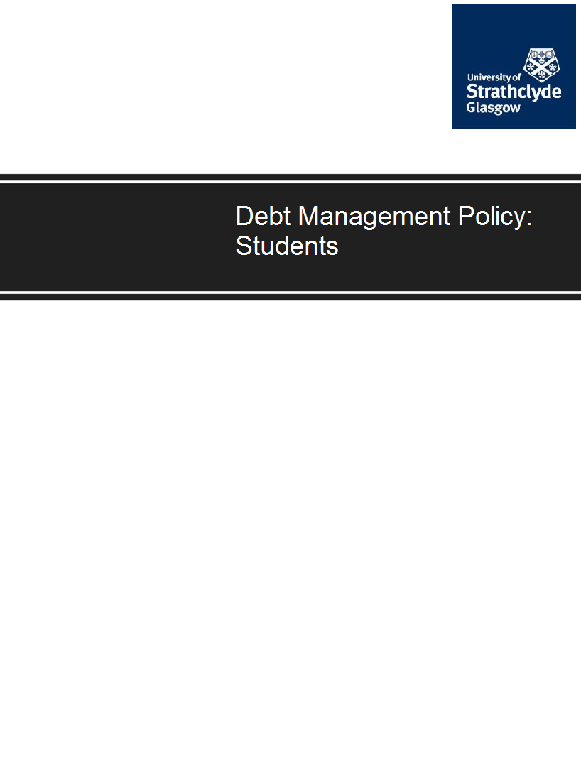
Latest version July 2023

Contents

Page

- Introduction 3
- Support to Students 3
- Communication with Students 4
- Fees: Key Points to Note 4
- Tuition Fees 5
- Accommodation Fees 6
- Library Charges 6
- Graduation Fee 7
- Other Fees and Charges 7
- Payment Default Charges 7
- Debt Management Procedures 8
- Former Students 12
- Bad Debt Write Off 12
- Dissemination of the Policy 12

1. Introduction

1.1 This document sets out the policy of the University in relation to student debt, along with the debt management procedures that will be followed.

1.2 The University has many sources of income, which are collected by different methods. This policy specifically covers the collection of fees and charges payable to the University by current and former students for tuition, accommodation, library and other miscellaneous services.

1.3 The policy applies to all students – including full and part-time, undergraduate, postgraduate, home and overseas students.

1.4 The Policy is designed to ensure that all students are treated in a fair and equitable manner.

1.5 The aim of the policy is to minimise levels of student debt, and of bad debts, in order to protect the overall financial health of the University and to allow it to continue to invest in teaching and research excellence.

1.6 The Chief Financial Officer is responsible for managing and reviewing this policy; Finance staff are responsible for the effective operation of debt management procedures; all staff are expected to be familiar with this policy and to contribute to its effective implementation

Support to Students

2.1 In applying the policy, the University will at all times seek to be sympathetic to, and understanding of, individual students’ financial circumstances. However, for the University to do so, students must engage in dialogue with the University if they are experiencing difficulties.

2.2 Action to enforce settlement of debt for outstanding fee and charges will be taken against all current and former students who have failed to engage with the University to find a solution to settle any outstanding debt and who have failed to honour agreements to pay.

2.3 Students experiencing difficulties in paying any fees and charges should seek help at the earliest opportunity through:

• Making contact with Finance
Finance staff can be contacted by various means.
E-mail: finance-helpdesk@strath.ac.uk
Telephone: 0141 548 4500
Appointments can also be made to meet Finance staff to discuss any fee related issue.

• Making contact with Accommodation
Accommodation staff can be contacted by various means.
E-mail: student.accomodation@strath.ac.uk
Telephone: 0141 548 3561 or 0141 548 3742 or 0141 548 4328

• Making contact with Student Experience and Enhancement Services (SEES)
SEES staff via, the Funding and Financial Support Team, can provide information on a number of finance-related issues. SEES staff can be contacted by various means.
E-mail: financial-support@strath.ac.uk
Telephone: 0141 548 2805.

3. Communication with Students

3.1 The main form of communication from Finance to students regarding outstanding fees and other charges will be via the student’s University email address. Announcements from Finance regarding particular groups of students may also be made via PEGASUS. Students are expected to check for messages on their University email address and on PEGASUS at regular intervals (i.e. as a minimum on a weekly basis).

3.2 Where necessary posted communications may be used. Posted communications from Finance are normally sent to the student’s term-time address during the standard term and to the student’s home address at other times. However, Finance reserves the right to send communications to either or both addresses, within or outside standard term dates, as appropriate. Students are expected to collect or arrange to forward mail where appropriate.

3.3 Students are reminded that they must notify the University immediately there is any change in either their home or term-time address. Students can use the University’s online facilities to notify change of address. The University’s central records will then be updated.

4. Fees: Key Points to Note

4.1 Under Ordinance 3.5 of the University Regulations, no degrees, diplomas or certificates may be conferred upon persons unless they have paid the fees prescribed and any other sums due to the University.

4.2 As well as preventing students from graduating, under Regulation 6.4, students who fail to pay the fees due will have their registration terminated and will be unable to register in a subsequent academic year.

4.3 Students in debt to the University will not be notified of any assignment/examination marks until the arrears have been cleared or there has been an agreement to reschedule the remaining amounts due.

4.4 Students are personally responsible for ensuring that all appropriate fees, fines and other charges, including any element of fees payable by sponsors, are paid. In accepting the offer of registration, the student accepts a contractual liability to pay the tuition fee. Students are also contractually responsible for paying fees, fines and other charges on time. In the event that that the provider of the support/funding fails to pay, the student will be held personally liable for the full amount due to the University.

4.5 If the student has a debt to the University and makes a payment, this will be applied against the oldest tuition fee debt first, then any accommodation debt and then any other debt to the University, unless advised otherwise.

5. Tuition Fees

5.1 Students become liable for the payment of the full annual fees at Registration. The annual fees cover registration, tuition and entrance to examinations.

5.2 The University therefore does not invoice students for tuition fees. Full details on how to pay Tuition Fees can be found on the Finance web pages https://www.strath.ac.uk/studywithus/feesfunding/howtopay/tuitionfees/

5.3 Many students receive full or partial support for their fees, either from

Students Awards Agency for Scotland (SAAS) – New and continuing students are permitted to register on the condition they have applied and expect to receive a letter of award confirming the required tuition fee by 15 November 2023. Failure to provide proof of funding by this date renders the student personally liable for payment of the fee. Any payment made shall be refunded back to source on production of award letter.

Local Education Authority (LEA – via Student Finance, England, Wales or NI) – New students must provide proof of funding in order to register. Continuing students are permitted to register on the condition they have applied and expect to receive a letter of award confirming the required tuition fee by 15 November 2023. Failure to provide proof of funding by this date renders the student personally liable for payment of the fee. Any payment shall be refunded back to source on production of award letter.

It is the student’s responsibility to ensure that the awarding body has received an application timeously and that it is being processed. Many grant awarding bodies require students to reapply each year for funding prior to published cut off dates beyond which funding awards will not be made.

5.4 Employer/Embassy/Other – Students must provide a signed letter of sponsorship before they are permitted to register.

5.5 If a student receives no support, or only partial support, they will be required to make arrangements for paying their fees/balance of fees.

5.6 The University offers self-funding students the facility to pay their full fee (or balance of fee if partially supported) over three equal instalments provided the amount due is greater than or equal to £250. For academic year 2023/24 the instalment dates are as follows:

Instalment 1: Before date of registration
Instalment 2: Before 1st December 2023
Instalment 3: Before 1ST March 2024

5.7 For 2023/24 students whose course commences out with the start of the academic year please refer to Finance for alternative instalment dates.

5.8 The University has the right to refuse an application to pay by instalments for subsequent years if student has a poor payment record for previous year(s).

6. Accommodation Fees

6.1 Full details on how to pay Accommodation Fees can be found on the Accommodation Office website and also on the Finance web pages https://www.strath.ac.uk/studywithus/feesfunding/howtopay/accommodationfees/

6.2 Accommodation offered by the University is dependent on the student signing an Occupancy Agreement for the period of accommodation and paying an Advanced Rent Prepayment The rent prepayment will be deducted from the sum due on the first payment date.

6.3 The Occupancy Agreement is a legally binding document. Breach of any of the conditions of the Occupancy Agreement may result in the University seeking recovery of possession of the accommodation from the student.

6.4 The University has the right to refuse an application for residences from a returning student if the University deems they have a poor payment record for accommodation fees.

6.5 The University offers students the facility to pay their accommodation in one of three ways:

1. A single payment in full at the start of the occupancy agreement.

2. Termly, by either 3 instalments for a 39- or 43-week occupancy agreement or 4 instalments for a 51-week occupancy agreement. For academic year 2023/24 the instalment due dates are as follows:

Instalment | 39 & 43 week Occupancy Agreement | 51 week  Occupancy Agreement
1 | 10 November 2023 | 10 November 2023
2 | 10 February 2024 | 10 February 2024
3 | 10 April 2024 | 10 April 2024
4 | N/A | 10 July 2024

3. Eight monthly instalments can be set-up by Recurring Card Payment (RCP), due on the 10th of each month from October 2023 – May 2024.

6.6 Regarding accommodation fees, students who have not paid their accommodation fees by the due dates will be subject to the debt management procedures detailed in Section 11 below.

7. Library Charges

7.1 Library users have an obligation to respect the rights of others by returning Library materials on time. To encourage this, fines are charged on items returned late. Details of fines charged at John Anderson Library are detailed on the Library website (Library Regulations Section 3.45). It is the student’s responsibility to avoid fines by keeping track of their own loans via SUPrimo, the Library’s search service, to check regularly what they have on loan and when it is due. This can be done via the “Your Library Account” option.

7.2 Use of the Library is conditional on abiding by its regulations. These allow suspension of borrowing rights for non-payment of charges.

7.3 If any fine is outstanding after a period of ten weeks from the date when the material first became overdue (six weeks for short loan collections), the Librarian will refer the matter to Finance who will institute procedures to recover the money owed. As for Tuition and Accommodation fees, students who have not paid their Library charges in full will be subject to the debt management procedures detailed in Section 11.4 below.

8. Graduation Fee

8.1 All students wishing to graduate or be presented must enrol to graduate by completing an on-line form.

8.2 Postgraduate Diploma students may, if they wish, be “presented” at a November ceremony only. To do so, they are required to complete a Graduation Enrolment form.

8.3 The closing date to register for graduation in November 2023 is 29 September 2023 and for graduation in June 2024 the closing date is TBC.

8.4 As detailed at 4.1 in order for the student to graduate all outstanding fees owed to the University must be settled in full.

9. Other Fees and Charges

9.1 Payment for the use of other University facilities or provision of resources is due for payment within 30 days of the date from when the University invoice is raised.

10. Payment Default Charges

10.1 The University may levy additional charges for the non-payment of debt. To deter non-payment these charges are set appropriately. These charges are set high in order to act as a deterrent. As detailed previously within this Policy (2.1) the University is sympathetic where there is a genuine problem and students are strongly advised to keep Finance staff informed of any difficulties.

10.2 A charge of £50 will be levied against a student’s account for the following reasons-

- For failure to pay each tuition fee instalments when they become due
- For failure to pay a University invoice for the use of University facilities or provision of resources within 30 days of the invoice date

10.3 Should the student cancel their Occupancy Agreement before the agreed dates of occupancy the University will be entitled to retain the Advanced Rent Prepayment as a Cancellation Charge.

10.4 Should the student fail to take up occupation under the terms of their Agreement within 7 days of the commencement date the University will be entitled to retain the Advanced Rent Prepayment as a Cancellation Charge.

10.5 Accommodation – A default charge of £50 is applicable on any instalment/balance of instalment unpaid by the due date.

11. Debt Management Procedures

11.1 If any student falls into arrears with any fees or charges, the University will take the following steps to recover the debt.

11.2 Tuition fees

- Day -7 (before due date)
Finance staff will issue an email to remind the student of their due payment date. Students will also be reminded that for those who have made arrangements to pay by instalments, failure to make the second instalment by the due date will result in them forfeiting the option to pay by instalments, and the full amount of the Tuition Fee becomes due immediately. Failure to pay by the due date means that students are in breach of the conditions under which they were permitted to register.

- Day 0 (Due Date)
Tuition fees due

- Day 1 (after due date)
Finance staff will issue an email asking the student to pay any arrears within 10 days from the date of the e-mail or to contact Finance within that time period to discuss their arrears position. The additional charges as detailed in Section 10 of this Policy may come into effect from this point onwards.

- Day 11 (after due date)
If there is no response to the first e-mail, Finance will issue a second e-mail asking the student to contact Finance within 5 days from the date of the e-mail to arrange for the student to come to Finance in person to discuss their arrears position with a senior member of Finance staff. The student is notified in the e-mail that if the student fails to contact Finance within the specified 5-day period, Finance will contact their department by e-mail regarding their arrears position.

- Day 16 (after due date)
Finance staff will issue an e-mail to the student’s department notifying them of the student’s arrears position and requesting confirmation of any extenuating circumstances that the department may be aware of that may have impacted on the student’s ability to pay their tuition fees as agreed at Registration. The department is asked to respond within 10 days of the date of this e-mail. Contact with Finance by the department or the student at this stage can still result in there being an agreement to reschedule the remaining amounts due.

- Day 26 (after due date)
The final sanctions per this policy of deregistration will be carefully assessed on a case by case basis before any final action is implemented. Finance staff will issue a final e-mail to the student notifying them that the final step for de-registration from the University will be put in place. The student is notified that Finance staff will e-mail Student Experience and Enhancement Services and request that they process a de-registration notice against the student’s record due to the non-payment of tuition fees. The consequences of this action are also further explained to the student i.e.

  - They will no longer be classified as a student of this University
  - They will be unable to use any University facilities
  - There will be an impact upon their ‘leave to remain’ in the UK ( Visa status) under the Points Based System
  - Details of their outstanding account will be passed to a commercial collection agency to obtain the payment due to the University and they will be liable for all costs incurred in raising this action
  - The University may also terminate any Occupancy Agreement on giving 14 days written notice in the event that the occupier ceases to be a person who is pursuing a course of study provided by the University.

- Day 40 (after due date)
Procedure for de-registration from the University will be put in place if the debt is still not cleared or the student still fails to contact Finance to put an acceptable arrangement in place. Finance Staff will issue an e-mail to Student Experience and Enhancement Services requesting that a de-registration notice be processed against the student’s record due to the non-payment of tuition fees.

- Post De-registration
Former student accounts are passed to one of the University’s commercial collection agencies. The University may also terminate any Occupancy Agreement that the former student may have on giving 14 days written notice.

11.3 Accommodation fees

- Day -7 (before due date)
Finance staff will issue an email to remind the student of their due payment date. Students will also be reminded that for those who have made arrangements to pay by instalments, failure to pay by the due date means that students are in breach of the terms of the Occupancy Agreement which can result in the University terminating the Agreement.

- Day 0 (due date)
Accommodation fees due.

- Day 1 (after due date)
Finance staff will issue an email asking the student to pay any arrears within 10 days from the date the e-mail was sent or contact Finance within that time period to discuss their arrears position. The additional charges, as detailed in Section 10 of this Policy, will come into effect from this point onwards.

- Day 11 (after due date)
If there is no response to the first email, Finance will issue a second e-mail asking the student to contact Finance within 5 days from the date of the e-mail to arrange for the student to come to Finance in person to discuss their arrears position with a senior member of Finance staff. The student is notified in the e-mail that if the student fails to make contact with Finance within the specified 5 day period, Finance will contact Residence Services by e-mail (normally the University Housing Officers) regarding their arrears position.

- Day 16 (after due date)
Finance staff will issue an e-mail to Residence Services (via the University Housing Officers) notifying them of the student’s arrears position and requesting confirmation of any extenuating circumstances that the Service may be aware of that may have impacted on the student’s ability to pay their accommodation fees.

- Prior to Day 35 (after due date)
Residence Services will issue an e-mail asking the student to contact them within 10 days from the date of the e-mail to arrange for the student to come to Residence Services in person to discuss their arrears position with the University Housing Officer and investigate the circumstances for non-payment and, where appropriate, obtain payment. The student is notified in the e-mail that if the student fails to make contact with Residence Services within the specified 10 day period, the Accommodation Services Manager will require to write to them under the University’s Regulations for Student Discipline.

- Prior to Day 45 (after due date)
The Accommodation Services Manager will notify the student in writing to attend a Disciplinary Hearing on a specified date and time.

- Post Day 45 (after due date)
Having gone through the full process outlined above to recover accommodation debt from the student, and payment has still not been made, the Accommodation Services Manager will, in consultation with senior Finance staff and other senior managers, where appropriate, implement other such actions as are deemed necessary to recover the outstanding debt, including issuing a notice to quit.

11.4 Library Charges

The University Library has a comprehensive debt follow up system in place. However, if any fine is outstanding after a period of ten weeks from the date when the material first became overdue (six weeks for short loan collections), the Librarian will refer the matter to Finance who will institute procedures to recover the money owed.

- University invoice raised to recover outstanding Library charges
The invoice must be paid on or before 30 days from the date of the invoice.

- Day 0 (due date)
Invoice due to be paid on or before this due date

- Day 1 (after due date)
Finance staff will issue an email asking the student to pay any arrears within 10 days from the date of the e-mail or contact Finance within that time period to discuss their arrears position. The additional charges as detailed in Section 10 of this Policy will come into effect from this point onwards.

- Day 11 (after due date)
If there is no response to the first email, Finance will issue a second e-mail asking the student to contact Finance within 5 days from the date of this e-mail to arrange for the student to come to Finance in person to discuss their arrears position with a senior member of Finance staff. The student is notified in the e-mail that if they fail to make contact with Finance within the specified 5 day period, Finance will contact their department, by e-mail, regarding their arrears position.

- Day 16 (after due date)
Finance staff will issue an e-mail to the student’s department notifying them of the student’s arrears position and requesting confirmation of any extenuating circumstances that the department may be aware of that may have impacted on the student’s ability to pay. The department is asked to respond within 10 days of the date of this e-mail. Contact with Finance by the department or the student at this stage can still result in there being an arrangement to pay the outstanding invoice.

- Day 26 (after due date)
Finance staff will issue a final e-mail to the student notifying them that failure to pay the outstanding invoice may result in them being unable to register for their next year of study.

11.5 Other Fees and Charges

- University invoice raised
Payment for the use of other University facilities or provision of resources are due for payment within 30 days of the date from when the University invoice is raised.

- Day 0 (due date)
Invoice due to be paid on or before this due date

- Day 1 (after due date)
Finance staff will issue an email asking the student to pay any arrears within 10 days from the date the e-mail was sent to the student or contact Finance within that time period to discuss their arrears position. The additional charges as detailed in Section 10 of this Policy will come into effect from this point onwards.

- Day 11 (after due date)
If there is no response to the first email, Finance will issue a second e-mail asking the student to contact Finance within 5 days from the date of the e-mail to arrange for the student to come to Finance in person to discuss their arrears position with a senior member of Finance staff. The student is notified in the e-mail that if they fail to make contact with Finance within the specified 5 day period, Finance will contact their department by e-mail regarding their arrears position.

- Day 16 (after due date)
Finance staff will issue an e-mail to the student’s department notifying them of the student’s arrears position and requesting confirmation of any extenuating circumstances that the department may be aware off that may have impacted on the student’s ability to pay. The department is asked to respond within 10 days of the date of this e-mail. Contact with Finance by the department or the student at this stage can still result in there being an arrangement to pay the outstanding invoice.

- Day 26 (after due date)
Finance staff will issue a final e-mail to the student notifying them that failure to pay the outstanding invoice may result in them being unable to register for their next year of study.

12. Former Students

12.1 If a student leaves their course with debt still owing to the University, Finance will continue to pursue recovery of the debt. If the former student fails to make arrangements to settle the outstanding amounts they will be referred to one of the University’s debt collection agencies for further action (up to and including court action).

12.2 Former students who later decide to return to the University to study are not allowed to do so unless any former debt is paid in full before registration. This includes any outstanding amounts at one of the University’s debt collection agencies.

12.3 The University also has the right to refuse an application to pay by instalments from a returning student if the University deems they have a poor payment record.

13. Bad Debt Write Off

13.1 Throughout the year once it is established that debts are likely to be irrecoverable or uneconomic to pursue the debt further, the debt will be classified as a bad debt and recommended for write off.

13.2 The annual provision for student bad debts is 50% for debts over 6 months and 100% for debts over 12 months.

13.3 The delegated authority limits for the writing off of bad debts are as specified in the University’s Financial Regulations.

134 All decisions to write off an account are based on a thorough review of the collection efforts that demonstrate due diligence was exercised in the pursuit of payment per this Policy.

13.5 Each proposed Student bad debt will be reviewed by the Student Finance Team Leader and Deputy Director of Finance-Operations (following consultation where relevant for particular student cases, with Faculty, Student Experience and International Office colleagues). These debts will then be presented to the Chief Financial Officer/Director of Finance for write off approval.

13.6 Where student debt has been written off the individual record will have an appropriate debtor flag attached.

13.7 The University can reinstate debts and attempt to collect them if new information becomes available and the debt has not become legally prescribed.

14. Dissemination of the Policy

14.1 The Policy will be regularly reviewed and updated.

14.2 The Policy will be disseminated to all Court members, Deans, Heads of Department and University Staff and Students.

14.3 The Policy will be published on the University’s web site.

