**Troubleshooting Phone Sync**

YOUR

LIBRARY

**YOUR LEARNING…**

|  |  |
| --- | --- |
| **Date** | 11/01/2021 |
| **Author** | United De Barros |
| **Version** | V1.0 |

Revision History

|  |  |  |
| --- | --- | --- |
| **Version** | **Date** | **Change** |
| V1.0 | 11/01/2021 | Original version |

Contents

iPhone 3

Remove Existing University Account 3

Add in the University Account Again 4

Final Configuration 6

Android 7

# Introduction

Some people may already have University email, contacts, notes and calendars setup to sync to their native phone apps. When MFA is enabled, this may stop working. The reason is likely to be that it was setup to use an outdated connection protocol that is no longer supported. The following documentation shows how you can go about attempting to fix this, but please note that very old phones may not support the modern secure connection requirements.

We always recommend Installing the Outlook app (from your phones app store) and configure following the advice here <https://support.microsoft.com/en-us/office/set-up-the-office-app-and-outlook-on-ios-devices-0402b37e-49c4-4419-a030-f34c2013041f> this should at least ensure that you have access to the data, although it may not be in the app you prefer. If your phone can not take the Outlook app, it is a good indication that your phone may not be able to use the new modern secure connection. This means you may no longer be able to get your University data on your phone (although trying the steps below should be attempted), however you can still use your phone as a second factor of authentication.

# iPhone

Go to your accounts setting, delete the existing University account and add it in again. Depending on the version of iOS this maybe done in a slightly different manner. The following guide was made on iOS 14.3

## Remove Existing University Account

Go to Settings->Mail->Accounts

Click on the account for your University email

Click “delete account”

Reboot your phone

## Add in the University Account Again

Go to Settings->Mail->Accounts

Click “add account”

Select “Microsoft Exchange”

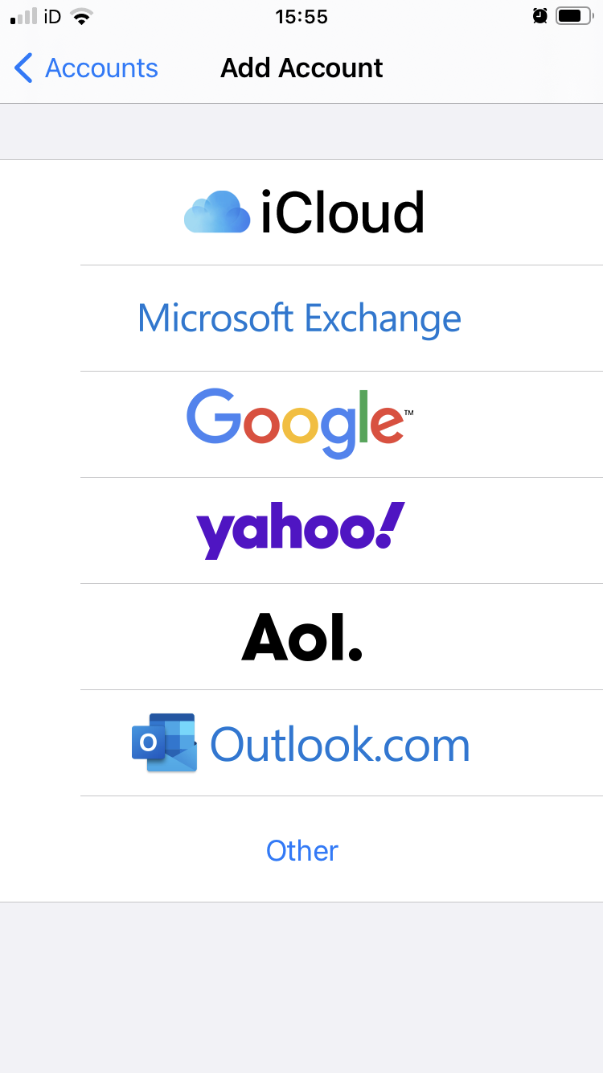

Follow the wizard

At the end of the wizard select what items you want to sync to your native phone apps by sliding the corresponding switch to green

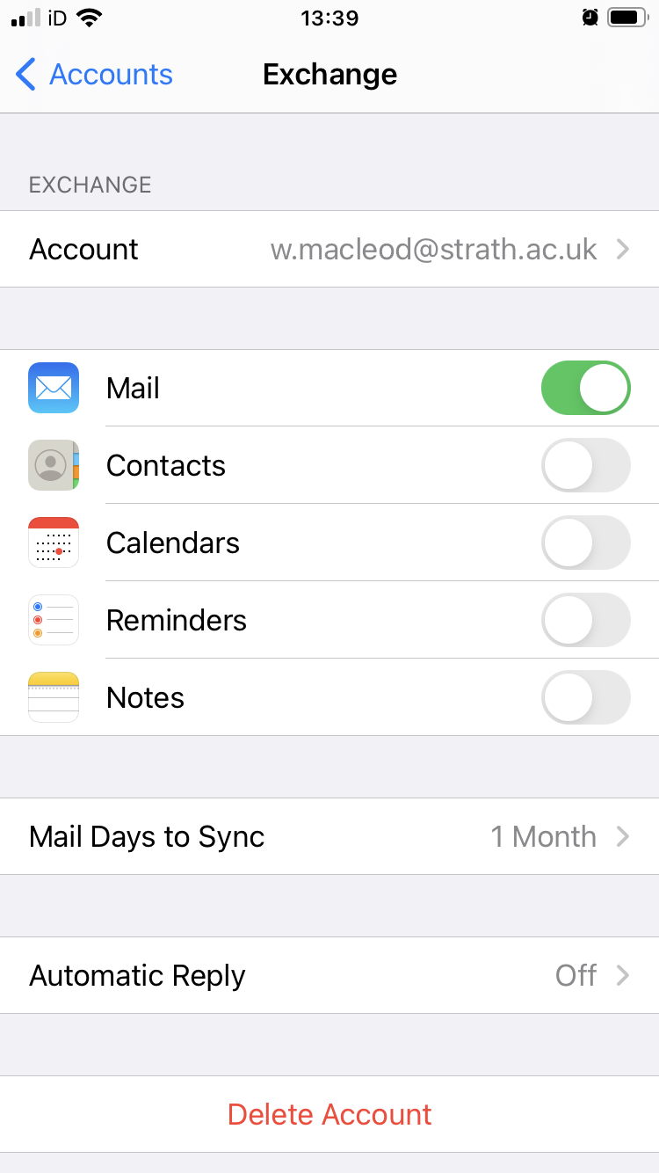

## Final Configuration

Go back to your Accounts page and ensure that “fetch new data” is set to “push”

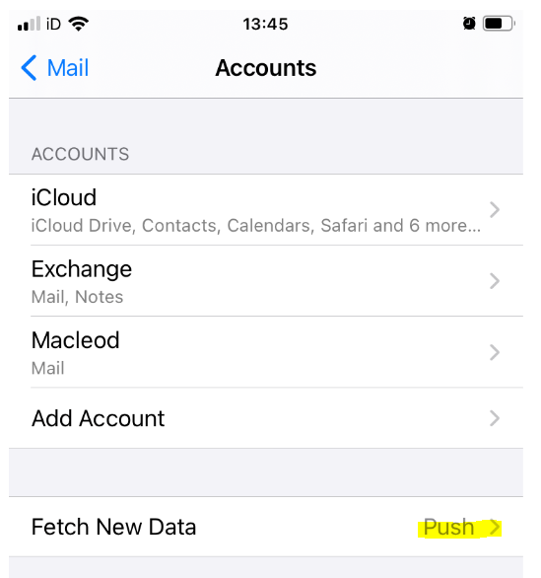

Your chosen data should now start to sync to your native apps.

If you still have issues, please contact your helpdesk

# Android

1. Open the Outlook app
2. Click on your profile icon.
3. Then click on the gear icon (settings icon)
4. Select your office 365 Account (Works mailbox) and enabled the sync contacts and calendars as per below image:

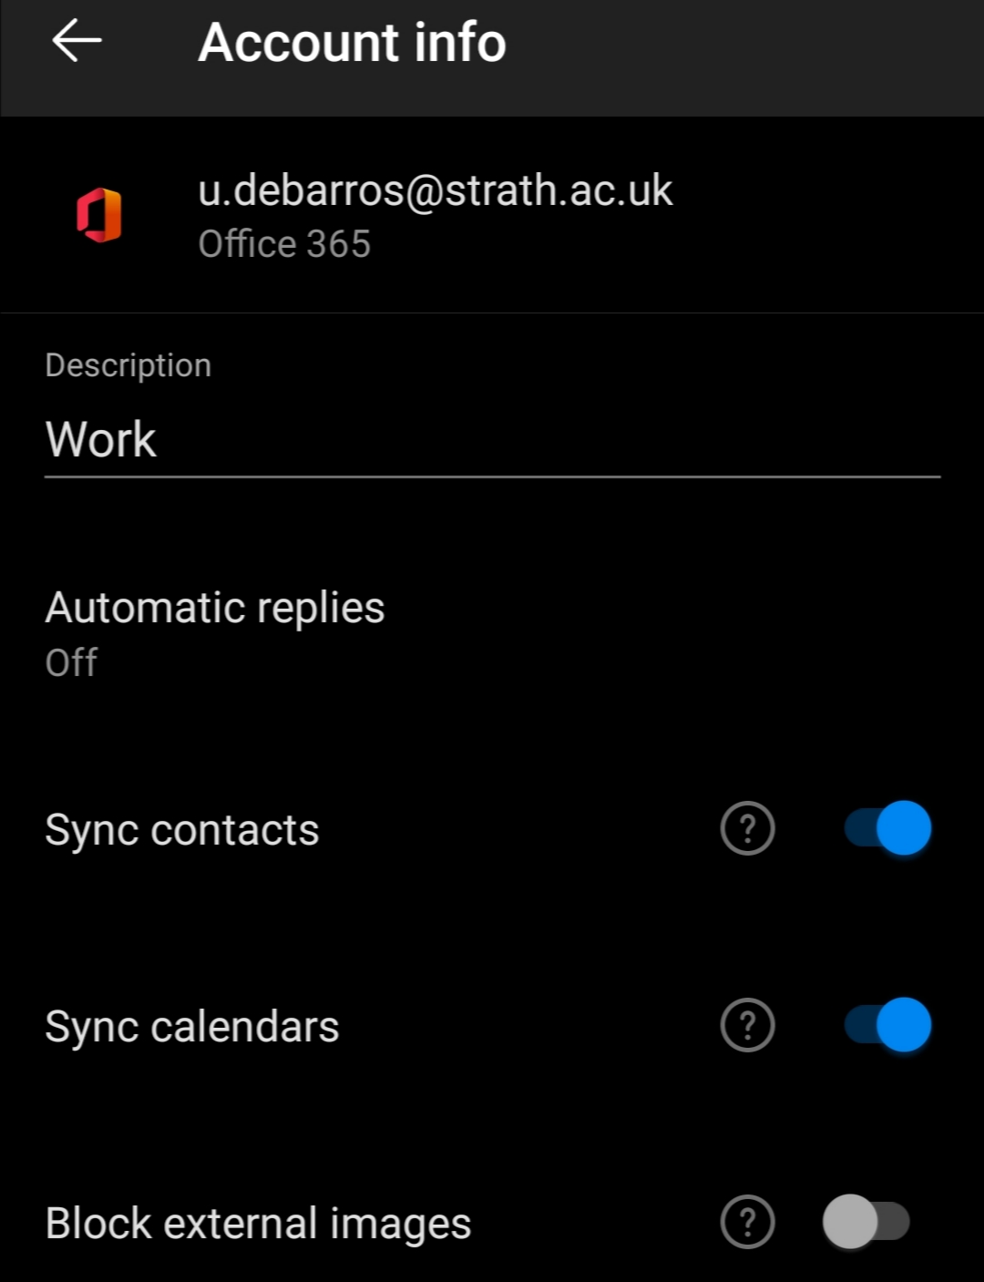

Your chosen data should now start to sync to your native apps.

If you still have issues, please contact your helpdesk