FortiClient VPN Install
This document describes the installation of FortiClient VPN software on a Windows system, and the installation of the Strathclyde configuration. Steps and screenshots may vary depending on your own local setup.
If you are using the Strathclyde Managed Desktop (the “lock screen” is an image of the SIPBS building) then there is a simple “one click” installation procedure – please contact the your local helpdesk for guidance if needed. Do not use these instructions. The procedure here is appropriate to users who are using their own personal Windows machines, or who have local administrative access.
Please save all files on your machine before proceeding as the following steps may enforce a reboot on your device.

- 1. Download the profile file from https://resource.net.strath.ac.uk/vpn/FortiClientNov2020.conf
(Please note where you have saved this (probably in your downloads folder) as you will need to find it later).

- Go to the FortiClient website https://www.fortinet.com/support/product-downloads and download the “FortiClient VPN” application for your type of device. | 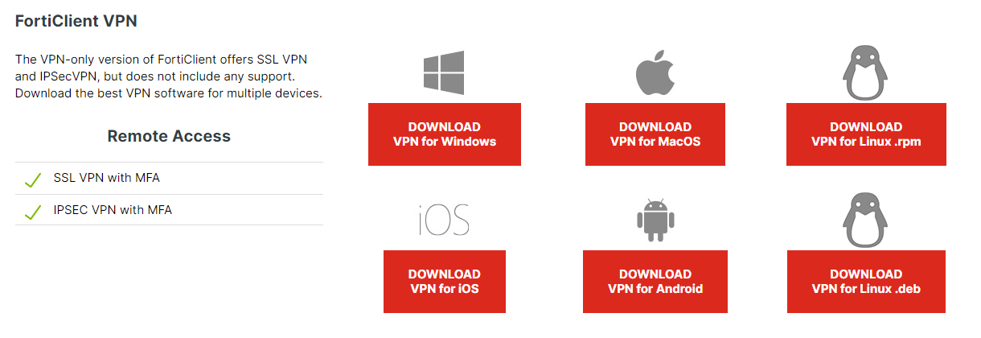
- Open the downloaded file
OR double click on the installation file (FortiClientVPNOnlineInstaller_6.4 installation file)
OR select the Installer Package, depending on your setup.

- Run the FortiClient installation file or Windows Installer Package. | 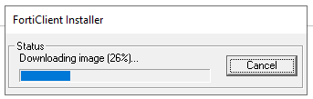
- Check the box “Yes, I have read and accept the License Agreement”.  Click Next | 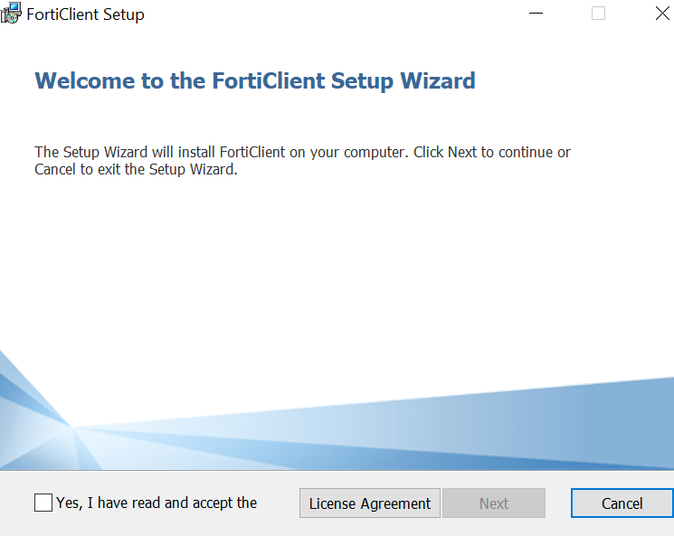
- Click Next | 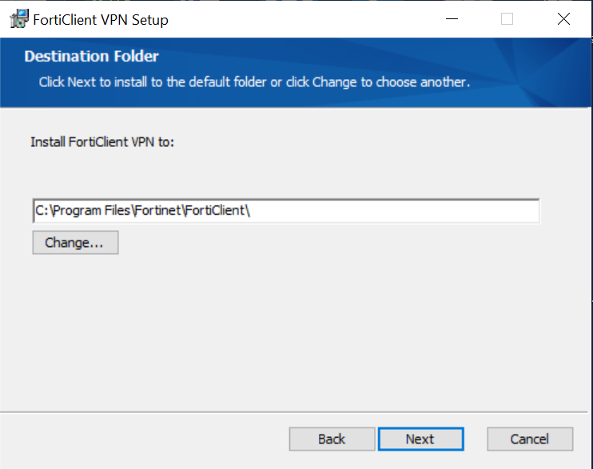
- Click on Install | 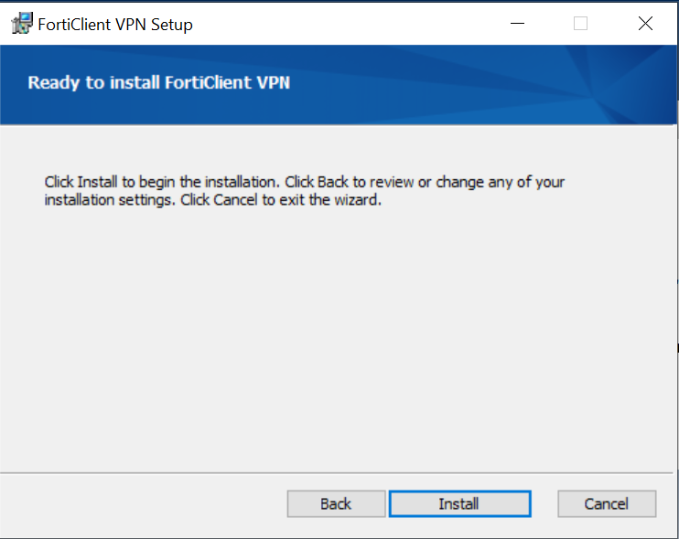
- Wait for the installation process to complete. | 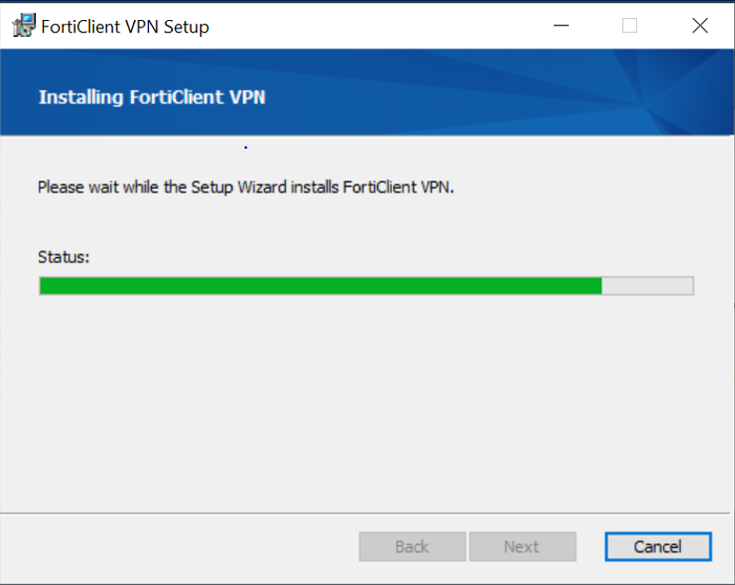
- Click on Finish | 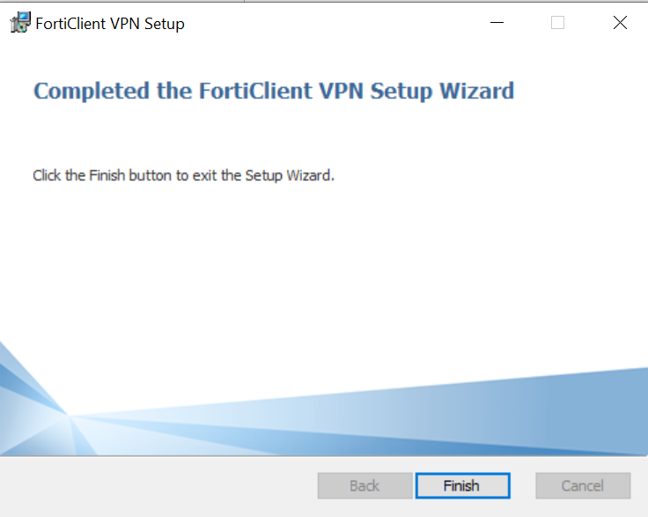
- To configure the FortiClient VPN, double click on the FortiClient VPN shortcut on your Desktop. | 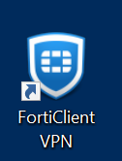
- If prompted, click to acknowledge that this is free software.  Click ‘I Accept’ | 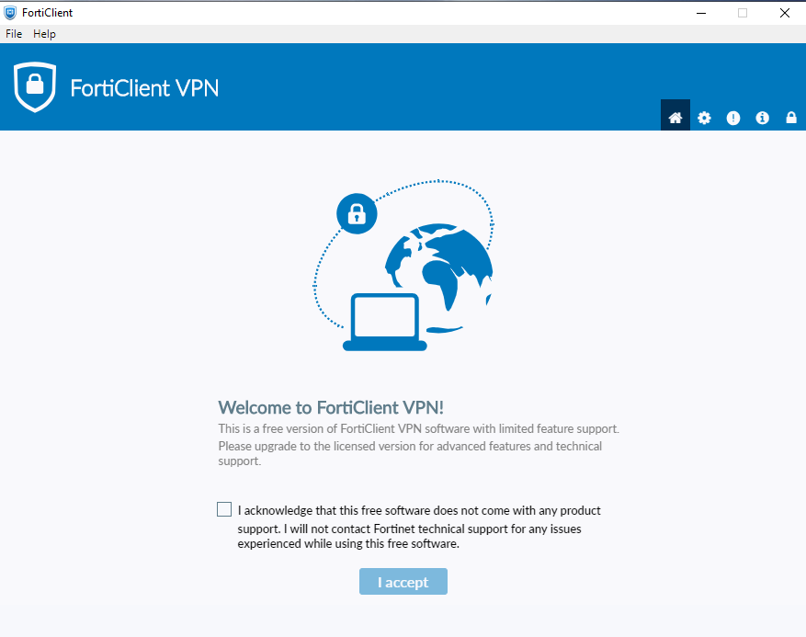
- Click on the Padlock in the top right corner.  You may get a warning notice asking if you allow FortiClient Security (Fortinet Client; Verified Publisher Fortinet Technologies) to make changes to your device. Click on Yes.  Enter your device username or Administrator username and password, if prompted, to unlock the settings. | 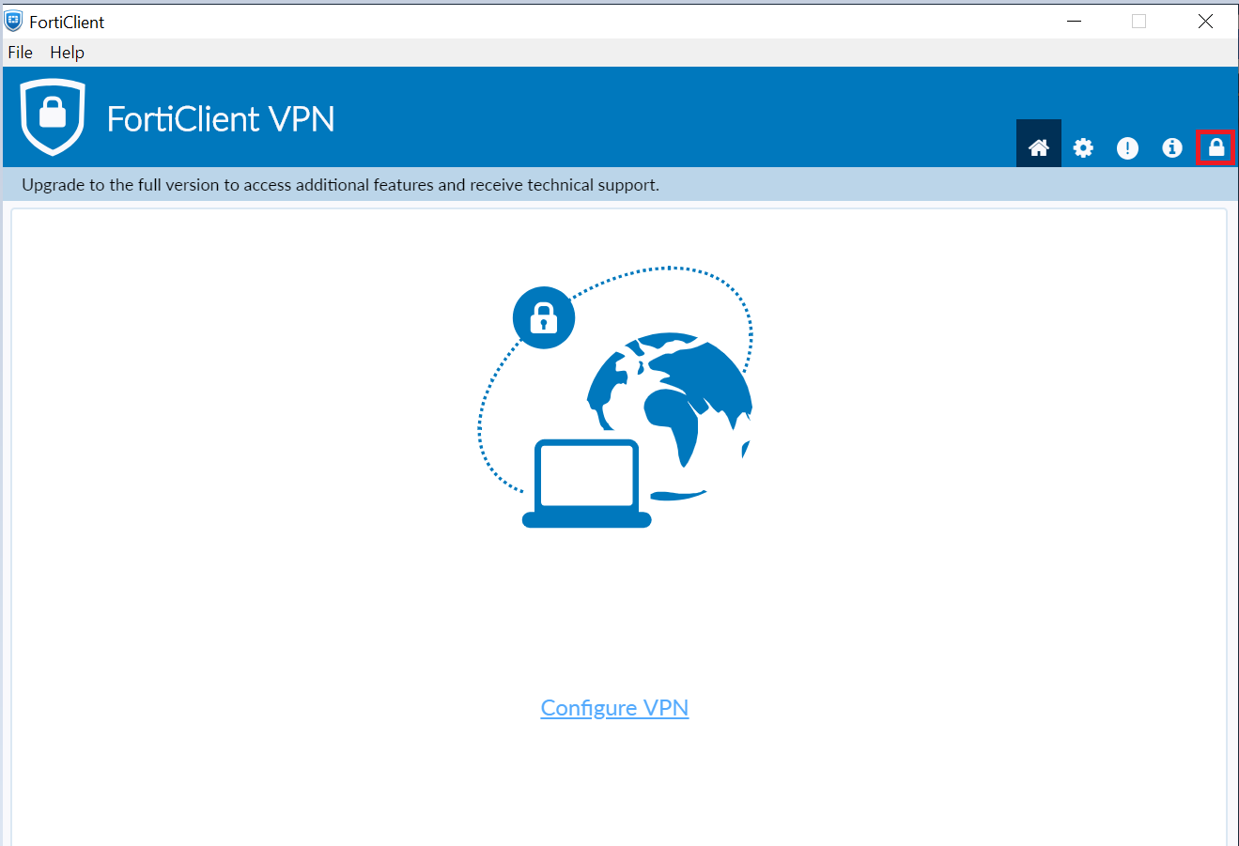
- Click Restore | 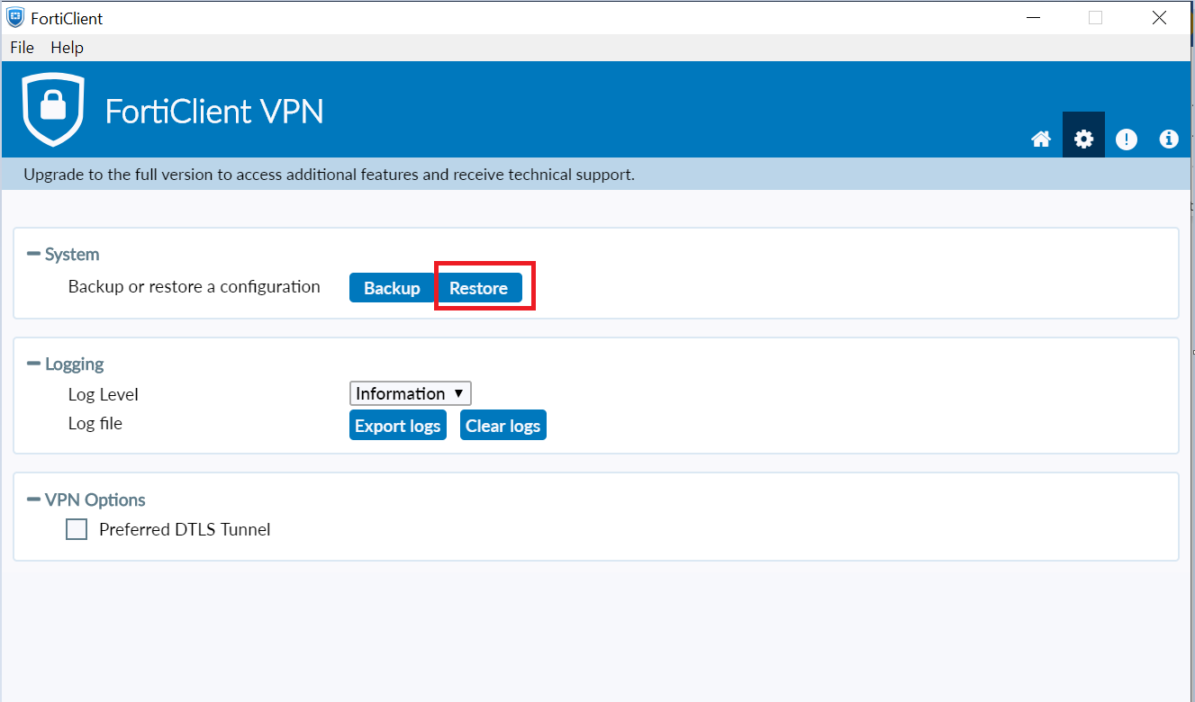
- Select FortiClientNov2020.conf file from the FortiClient VPN folder on your Downloads folder and click Open. | 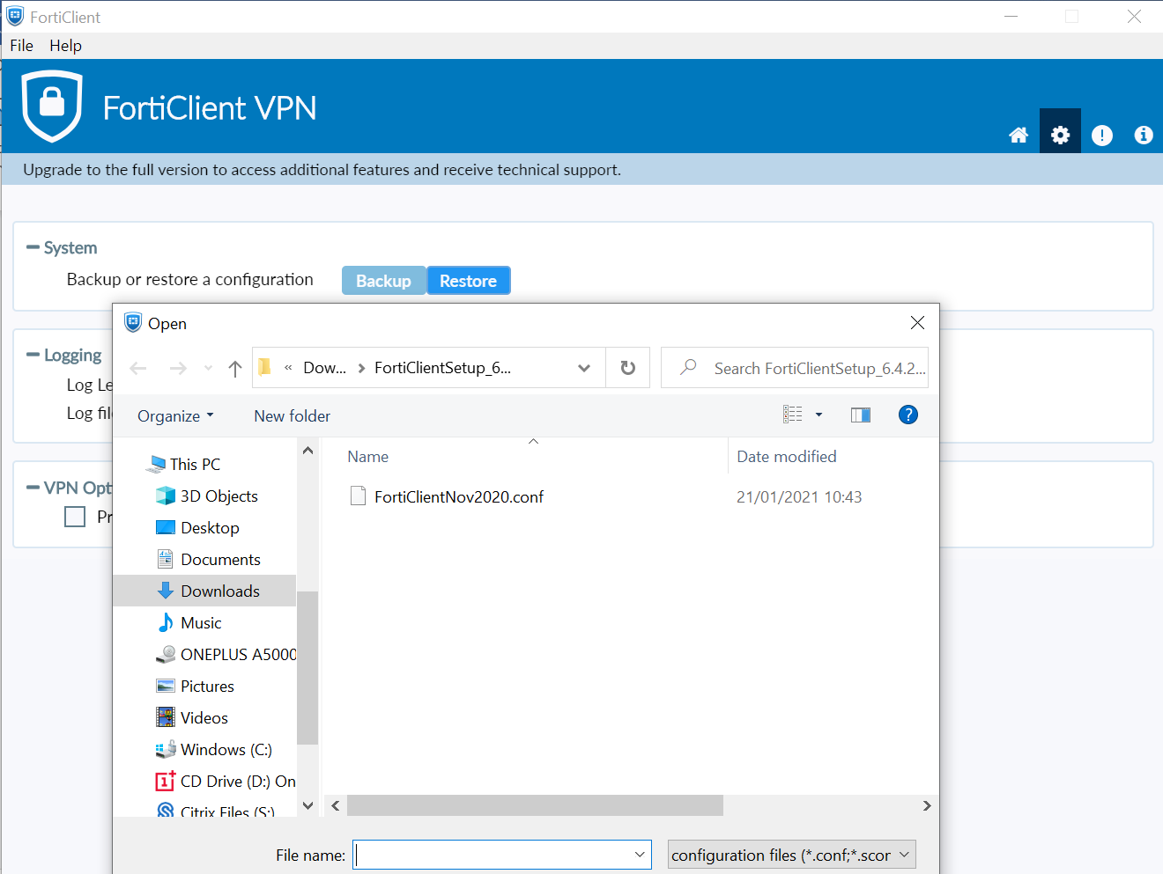
- Click OK | 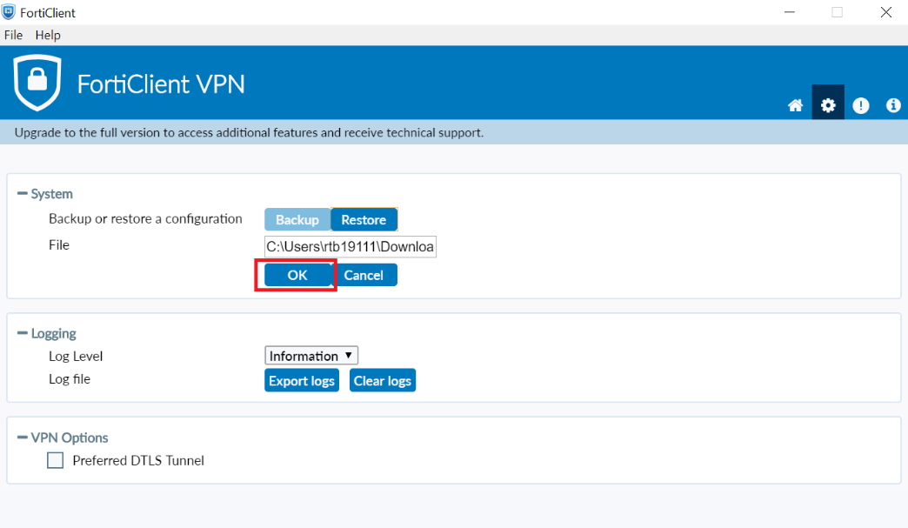
- Click OK | 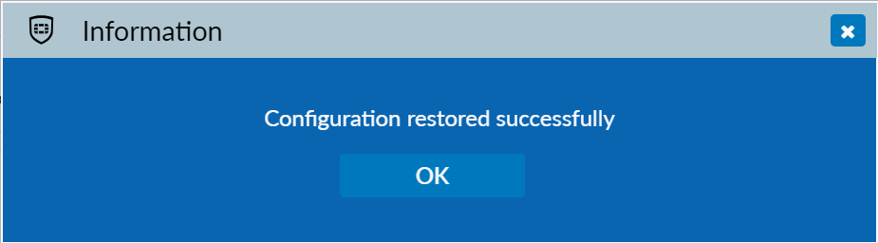
- Click on the Home icon in the top right corner, which will take you to the login screen.  On the login screen make sure the “General Strath VPN” profile is selected and enter your DS username (e.g. abc1234) and password.  Click Connect | 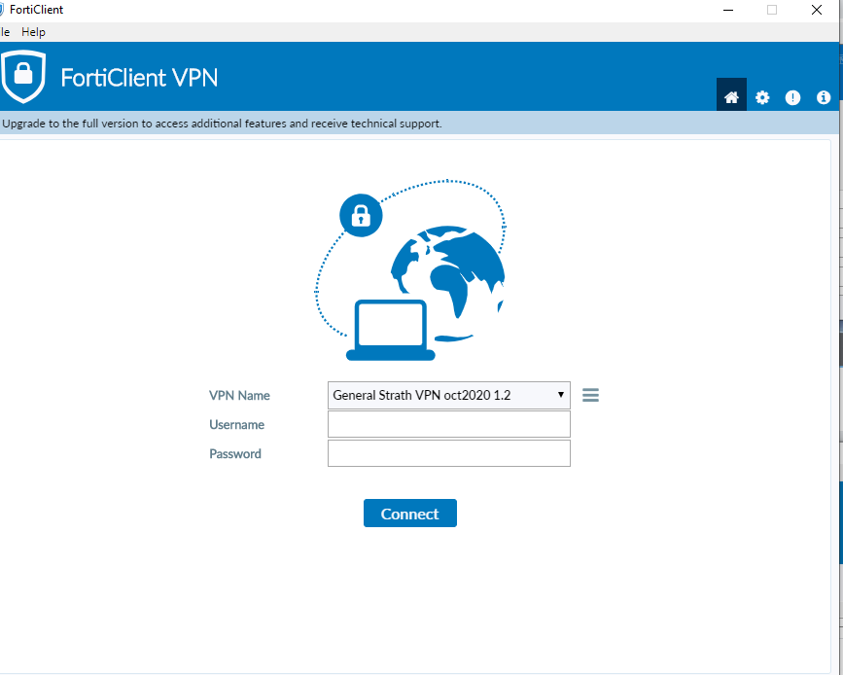
- Once you have successfully connected to FortiClient VPN, it will minimise into the System Tray.  If this does not happen automatically, you are able to minimise it manually. | 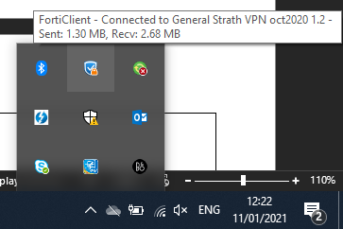
- To disconnect, right click on the FortiClient icon in the system tray and click Disconnect “General Strath VPN oct202 1.2”  You can also access the console from here by selecting Open FortiClient Console or by opening it directly from the Desktop. | 