Set up VPN on Mac (Sequoia 15.0.0 onward)

1. On the Finder menu, click on the Apple icon.
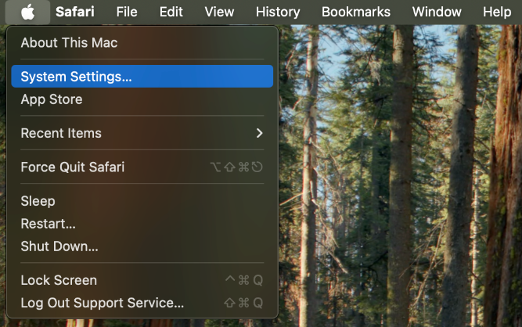
2. In the drop-down menu, click on System Settings….
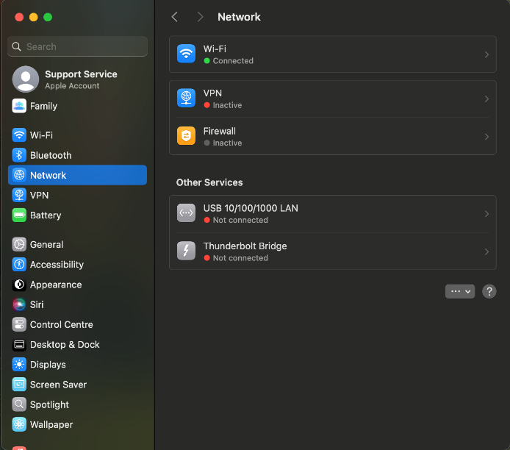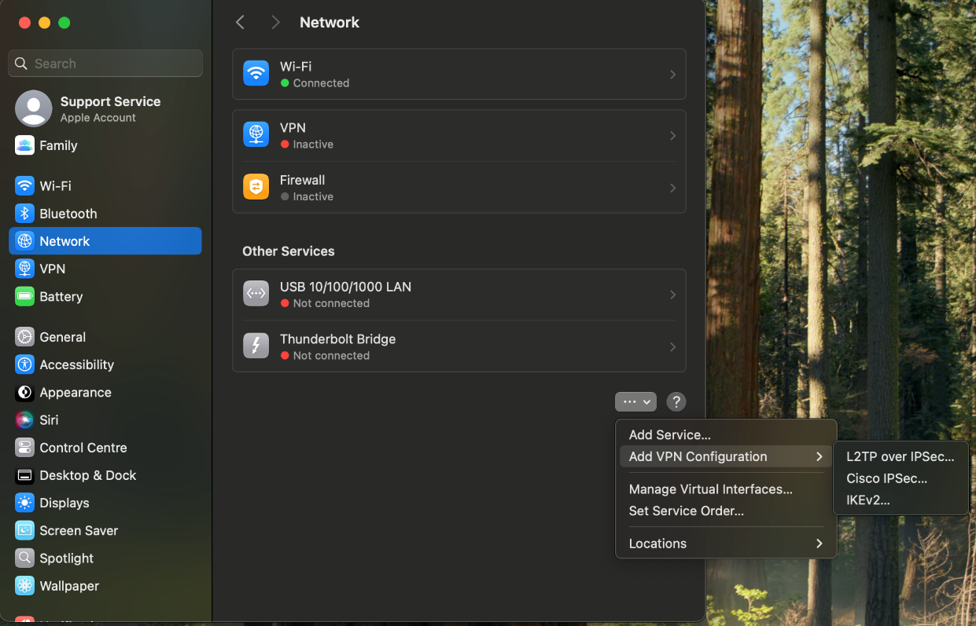
3. Click on Network.
4. Click on the ellipses > Add VPN Configuration > select “Cisco IPSec…”

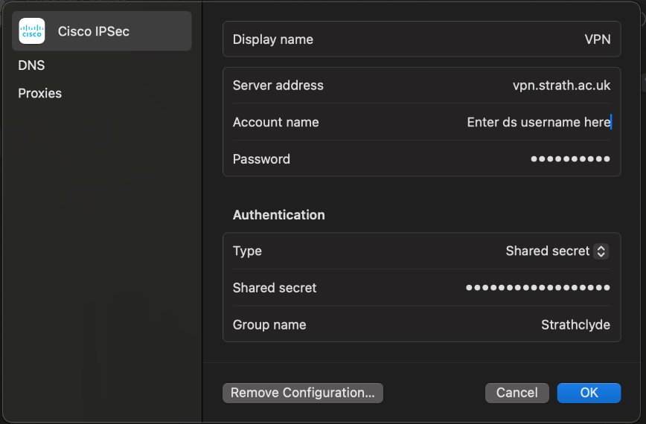
5. Enter the following details into the input fields:
Server address – vpn.strath.ac.uk
Account name – this will be your ds username
Password – this will be your password
Shared secret – johnandersoncampus
Group name - Strathclyde

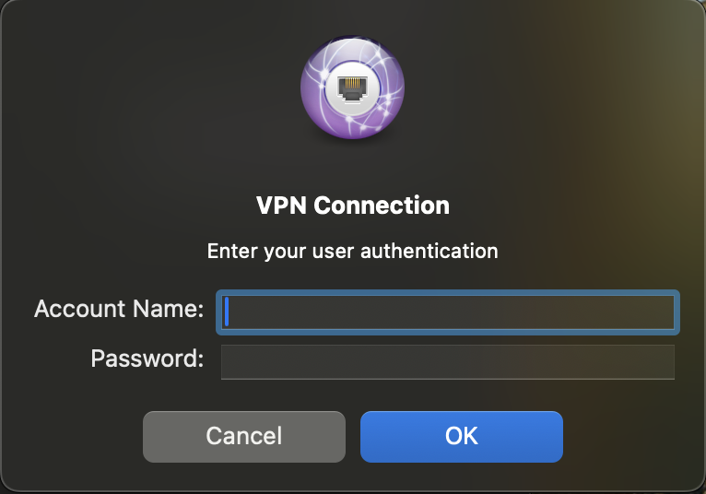
6. Enter your ds username and password and hit ok. You should now be able to toggle the VPN on in the Network page

Was this information helpful?
CONTACT US
Email: help@strath.ac.uk Call: 0141 548 4444
YOUR
LIBRARY
YOUR LEARNING…

