**­­**

Connecting your Android device to Eduroam

These instructions are for connecting your Android device to the eduroam Wi-Fi for the first time. This can be done by connecting to the StrathWifiSetup network, which is available in the Library and Student Residences. Once your device is configured to connect to eduroam, it will then connect automatically. Once your device is configured, you will also be able to connect to eduroam on any campus you travel to.

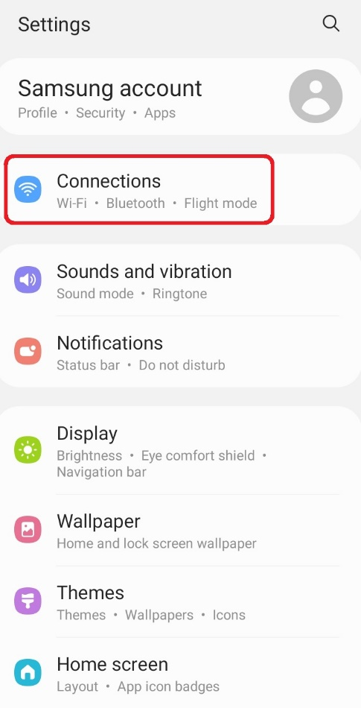

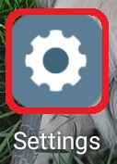

1. Select Settings.

2. Select Connections.

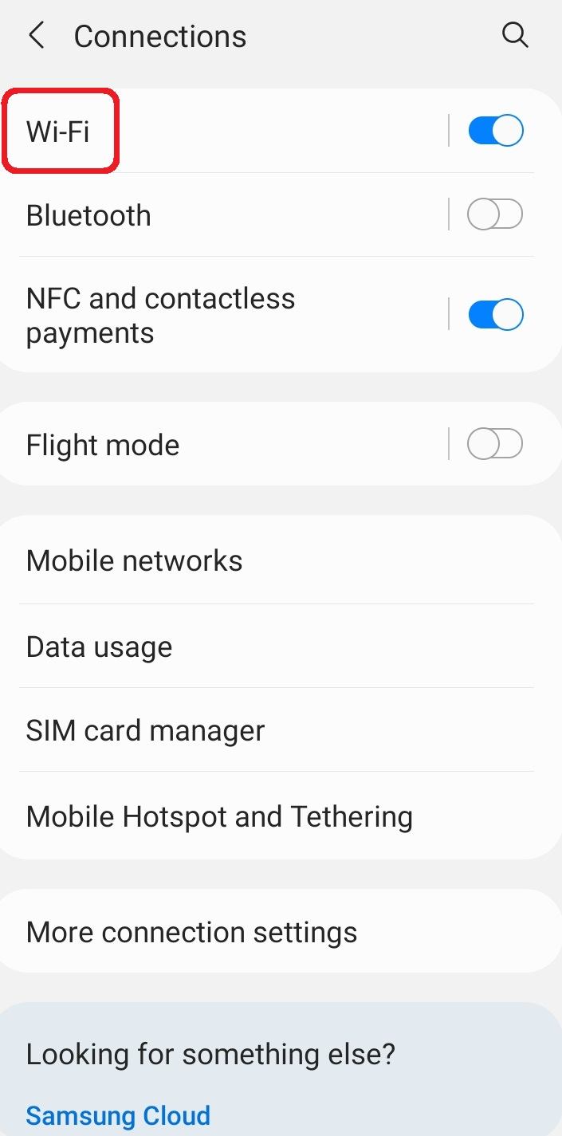 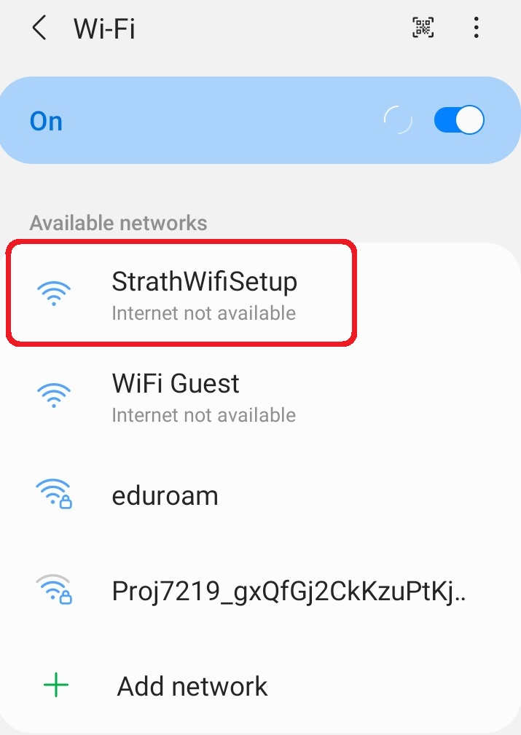

4. Select StrathWifiSetup.

3. Select Wi-Fi.

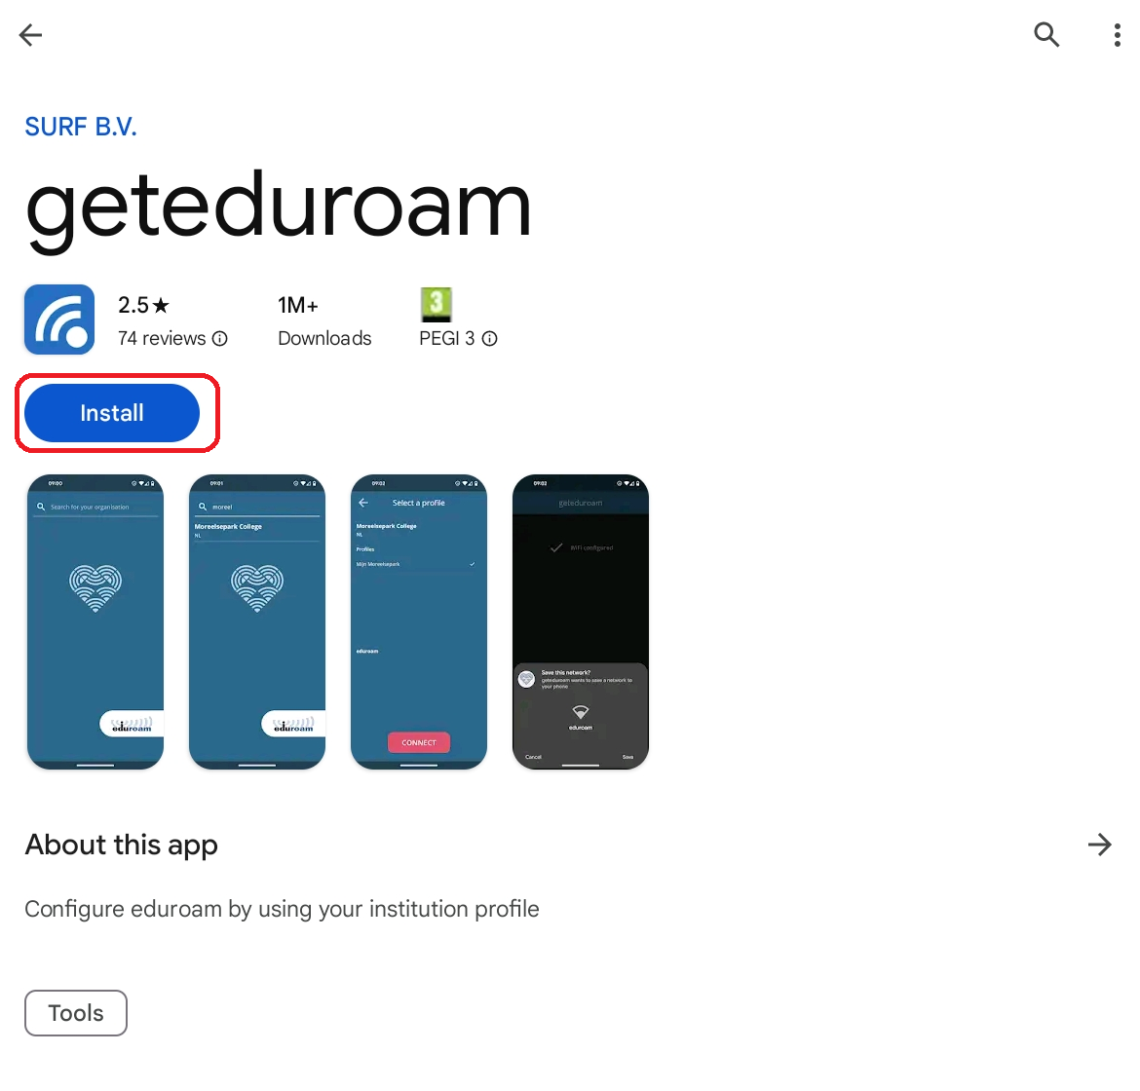

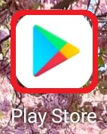

5. Open the Play Store app.

6. Search for the geteduroam app. Select Install.

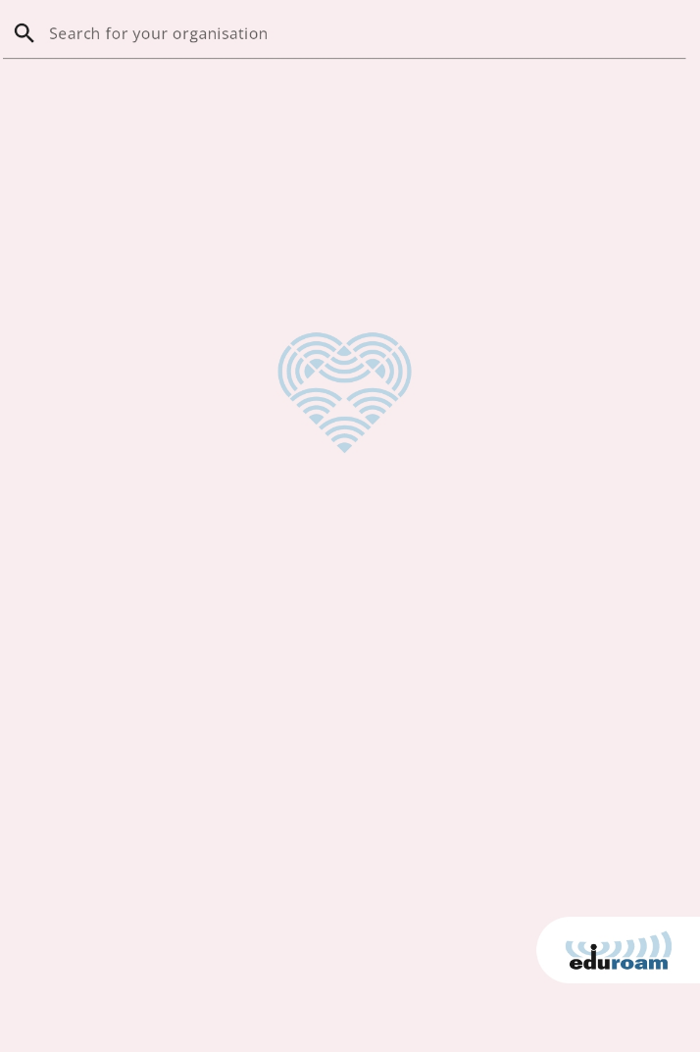

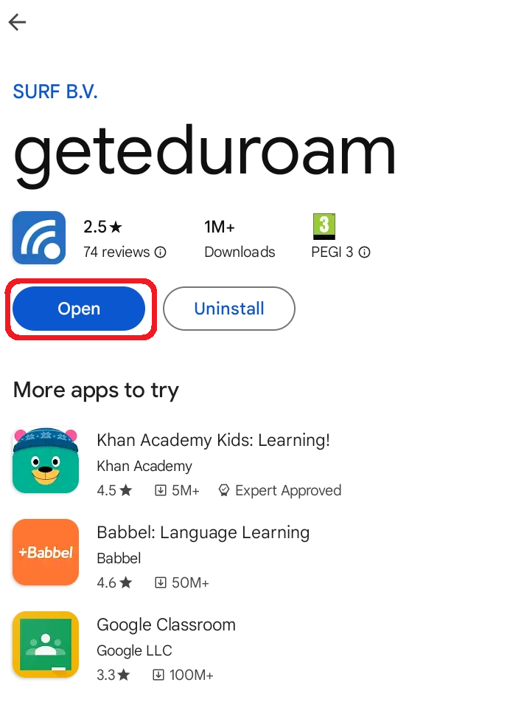

8. In the geteduroam app, enter University of Strathclyde.

7. Open the geteduroam app.

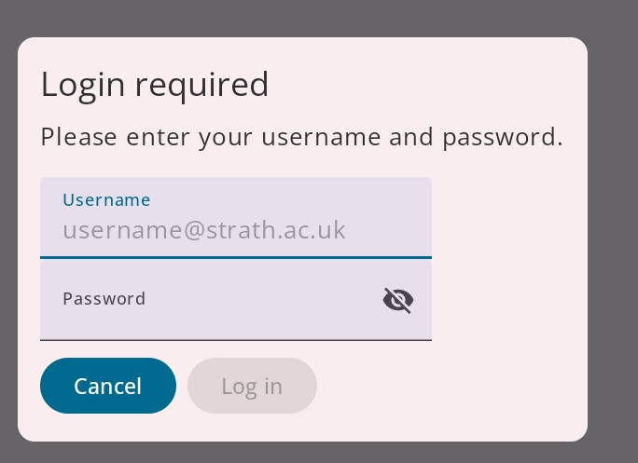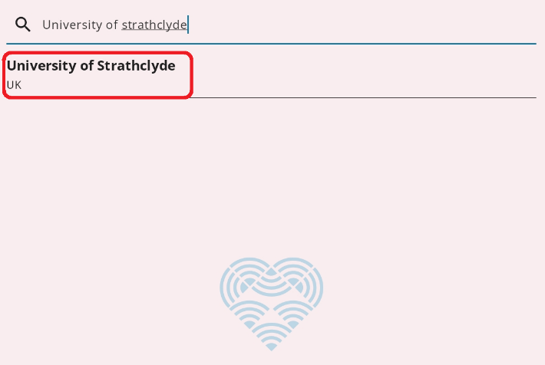

10. Enter your DS username followed by @strath.ac.uk. For example, [abc12345@strath.ac.uk](mailto:abc12345@strath.ac.uk).

Then enter your password.

9. In the drop-down menu, select University of Strathclyde.

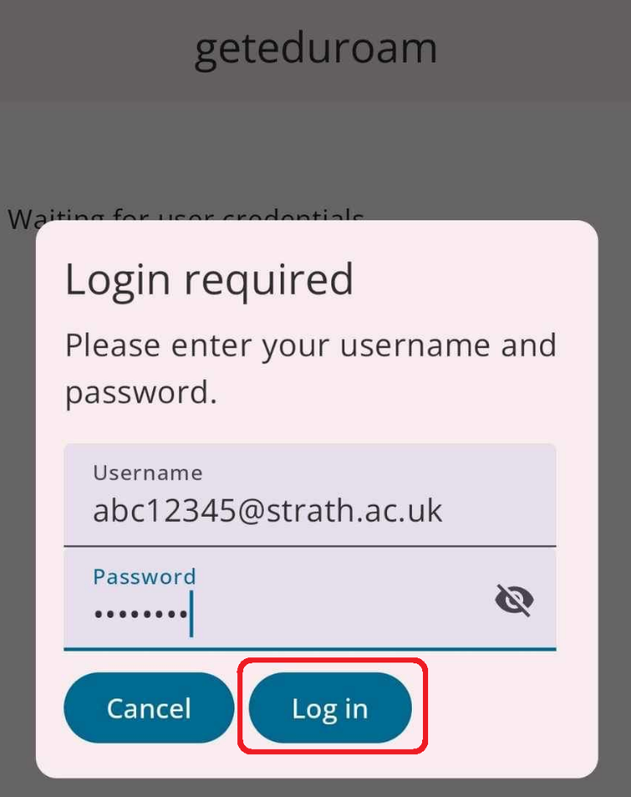

11. Select Login.

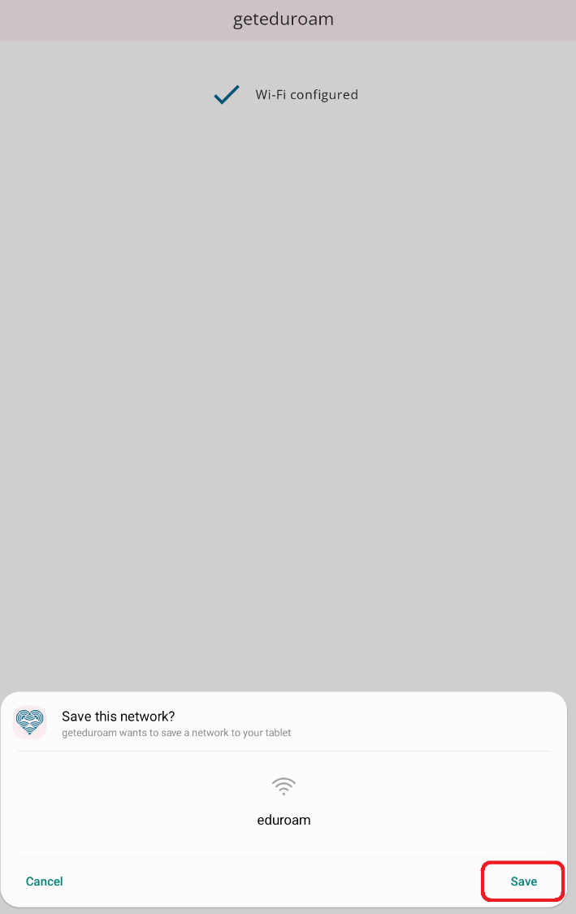

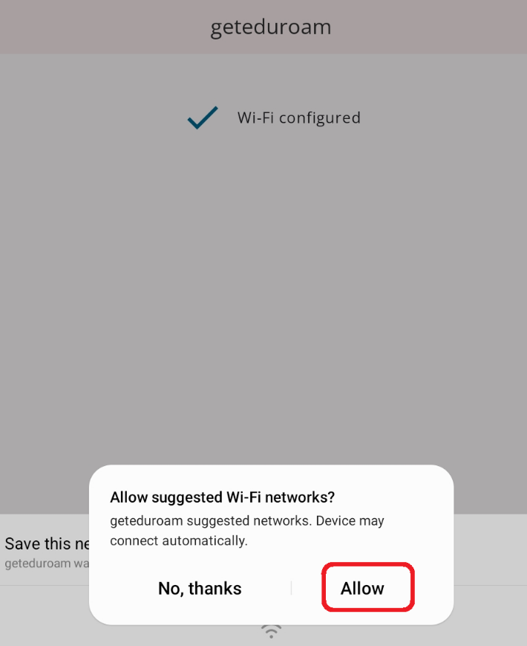

12. Select Allow.

13. Select Save.

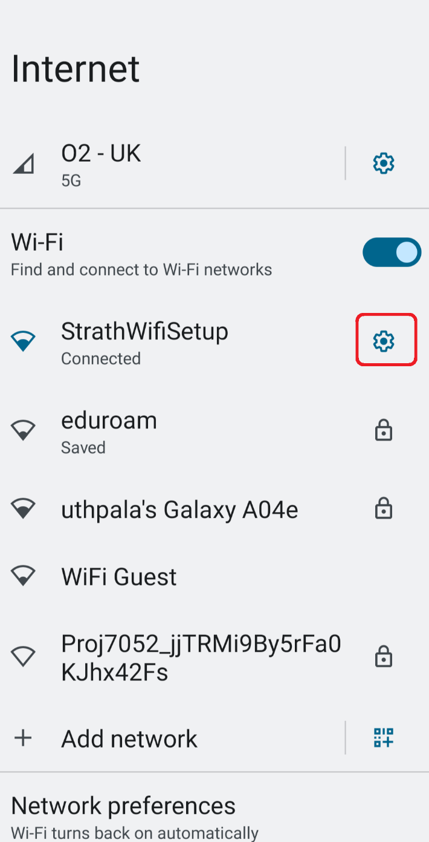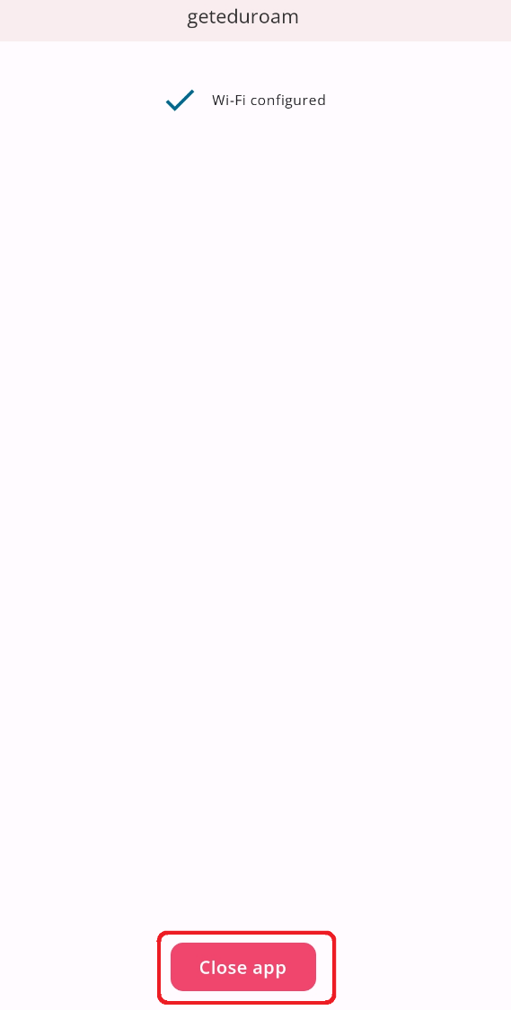

15. Return to the Wi-Fi networks section (see steps 1-3).

Select the cogwheel icon next to StrathWifiSetup.

14. Select Close app.

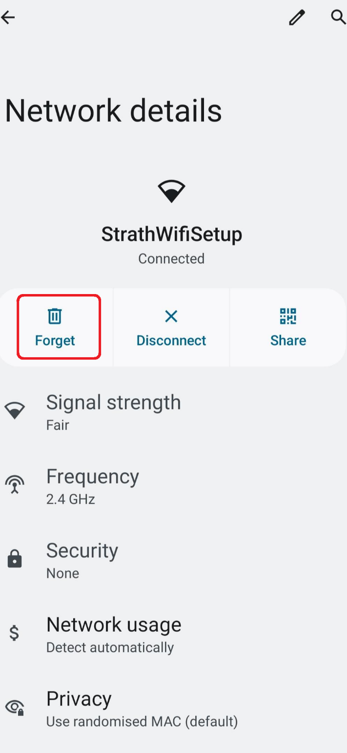

16. Select Forget.   
  
Your device is now configured and will automatically connect to Eduroam.

Was this information helpful?

**CONTACT US**

**Email**: help@strath.ac.uk **Call**: 0141 548 4444

YOUR

LIBRARY

**YOUR LEARNING…**