Guidance for Managing the Institutional Open Access Fund at Strathclyde
Pablo de Castro, Open Access Advocacy Librarian, Sep 2018 (Updated April 2021)
This policy aims to summarise the guidelines that are to rule the allocation of the Institutional Open Access Fund (IOAF) launched at Strathclyde towards the end of 2019. Any policy outlined below will be in alignment with the strategic priorities as defined by each faculty’s REF submission policy.
The main issue that this fund aims to tackle is the very strong bias in institutional APC funding towards a small number of departments in the STEM area (Phys, SIPBS, EEE). The figure below shows the APC funding distribution across Strathclyde departments and schools in the past few years (data as of January 2021). This is the result of the fact that the regular APC funding is tied to funded projects from the RCUK/UKRI or the Wellcome Trust. It’s not only that this effectively shuts off funding opportunities for (most) HaSS and SBS manuscripts, it also creates a perverse ‘detachment effect’ from the research support activity carried out by the library among authors in these underfunded areas.
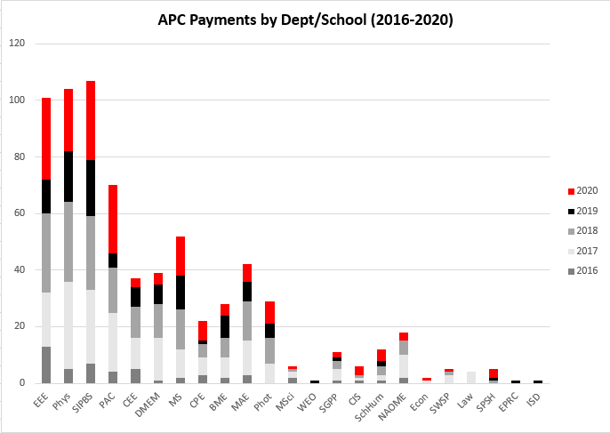
The main guideline for the application of the IOAF is then that this £50K funding will support accepted manuscripts for which no alternative sources of funding are available to cover the OA publishing fee. These do not always need to be HaSS/SBS papers, as other criteria will also be kept in mind. However, the equivalent IOAF snapshot to the one shown above for the block grants awarded by the research funders should look completely different and be far more balanced across disciplines.
The rules that will govern funding eligibility are as follows:
- No other sources of funding are available to cover the OA fee: the manuscript is not eligible for central funds provided by research funders and the APC fee cannot be funded from a project grant;
- The funding will be preferentially allocated to publications produced by HaSS and/or SBS authors, even in cases where [4] below is not met;
- The funding will be preferentially allocated where possible to PGR’s first publications;
- The amount of the APC fee will be an important factor for eligibility: while there will not be a strict funding cap, APCs above £2,000 (incl VAT) will only occasionally be considered for funding;
- In order for an accepted manuscript to be eligible for IOAF funding, the journal must be a well-established fully OA title that meets regular peer-review standards; ‘fully OA’ means that the OA publishing fee must be mandatory;
- Whenever possible the corresponding author in the paper should be a Strathclyde author. Exceptions to this rule may be considered when the publication is expected to have a high impact and does not have any other possible source of funding
- Fees for co-authored manuscripts with other institutions that also have OA funding available may be split with these. For external corresponding authors, the Strathclyde funding will cover up to 50% of the Open Access publishing cost;
- Extra charges (page, colour, overlength page charges, etc) are not eligible for funding;
- No retrospective Open Access will be funded;
- A strict £15K limit per department/school will apply;
- Funding will be granted on a first come first served basis as long as the quarterly limit per department is not exceeded;
- Authors may occasionally be contacted and offered IOAF funding in cases where the APC fee is mandatory and the publication does not have any alternative source of funding and is expected to have a high impact;
- Alignment of the topic of a paper with the UN SDGs will be taken into consideration for [12] above;
- The Open Access Team will monitor the appropriate proxy indicators for impact for IOAF-funded publications (number of views and downloads, Altmetric scores) to verify that funding is being channelled towards high-impact papers. Average values will gradually be established and cases where values are significantly lower than the average will be recorded and taken into account for future funding requests;
- The inclusion of a given paper in a press release issued by Strathclyde Corporate Comms will be taken into consideration for IOAF funding;
- When IOAF-funded manuscripts have been accepted in titles issued by publishers with whom Strathclyde has a pre-paid account, the payment will be made through these pre-paid accounts in order to benefit from the discount and the amount will be reimbursed into the UKRI block grant from the IOAF.
The following references have been considered in the process of defining this policy:
Proven, J. 2016. LOCH Pathfinder project: St Andrews Library Open Access Fund: business case and criteria. University of St Andrews Library, https://research-repository.st-andrews.ac.uk/handle/10023/8504
University of Stirling Open Access and Article processing Charge (APC) Fund Policy, https://www.stir.ac.uk/media/stirling/global-assets/documents/OpenAccess-and-APC-Fund-policy.pdf

A list of fully OA titles funded by the library in the past few years is available at the bottom of the post at https://strathoa.tumblr.com/post/185703709380/running-a-no-hybrid-open-access-funding-policy. The list includes a good number of popular titles among Strathclyde researchers such as PLoS ONE, Scientific Reports, Nature Communications, Optics Express, IEEE Access, IEEE Photonics, ACS Omega, Frontiers in Microbiology, BMC Public Health, Sensors and Sustainability to mention but a few.
In some cases there may be a need to request the publisher to extend the eligibility for the pre-paid account to an additional institutional funding scheme. Elsevier in particular were not keen to accept this in the past, as they claimed that the discount was only applicable to the agreement they had with the Jisc.

