Building: |  | Date of submission:
Submitted by: |  | Position:

Part 1: (This part is to be completed by the University Fire Safety Adviser)
Fire Firefighting Facilities
Rising (fire) mains
Fire Hydrants
Firefighting shaft(s)
Firefighting lift(s)
Smoke Control installation(s)
Fire Alarm Panel
Sprinkler Control Room
Fire suppression isolation(s)
Photovoltaic Isolation(s)
Mains Gas isolation
Mains Electricity Isolation
Mains Water isolation
Main building entry
Alternative access
Other

Emergency contact details are available from Security Services upon request

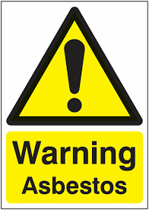 | Asbestos is/is not* present in the building. | Details:
 |  | Specialist advice – contact details:

This completed return form should be forwarded to the University Fire Safety Adviser at safety@strath.ac.uk

Part 2: (This part is to be completed by the Department)
Building: |  | Date of submission:
Submitted by: |  | Position:
Level | Room |  |  | 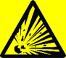 |  | 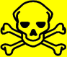 | 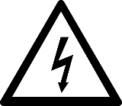 | 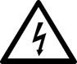 |  |  |  |  |  |  | 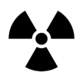 | Other
 |  | Biological | Corrosive | Explosive | Oxidiser | Toxic | Electrical < 240v | Electrical > 240 v | Solar Panels | Flammable | Comp’ Gas | Hydrogen | Acetylene | Mechanical | Radiation

Level | Room |  |  |  |  |  |  |  |  |  |  |  |  |  |  | Other
 |  | Biological | Corrosive | Explosive | Oxidiser | Toxic | Electrical < 240v | Electrical > 240 v | Solar Panels | Flammable | Comp’ Gas | Hydrogen | Acetylene | Mechanical | Radiation

Level | Room |  |  |  |  |  |  |  |  |  |  |  |  |  |  | Other
 |  | Biological | Corrosive | Explosive | Oxidiser | Toxic | Electrical < 240v | Electrical > 240 v | Solar Panels | Flammable | Comp’ Gas | Hydrogen | Acetylene | Mechanical | Radiation

