
Office of Marketing and Communications
Communications Office
University Web Site - Redevelopment Guide

Contents
1 Contents 2
2 Introduction 3
3 Summary 4
4 Changes 5
4.1 Banners 6
4.2 Right Column 7
4.3 Additional Navigation 8
4.4 Changes to navigation 9
4.5 Templates 1

Introduction
The University undertook to substantially redesign the website and it was decided to introduce the design through the Content Management System (CMS).
This is good news for sites which are currently managed through the CMS; ensuring that they benefit from central investment in the University web presence – in addition to the CMS itself and the web statistic software, you also get an up-to-date design optimised for our students.
Although the way in which you use the CMS remains largely unchanged, there are some new opportunities available to you. This document sets out how you can benefit from these additional features.

Summary
The new design (see below) brings a new focus on our student markets using updated navigation, colour coding and more imagery. The new features available to you – over and above all the tools and techniques you have been using since you started working with the CMS - are :
- More templates to allow you to differentiate your pages and tailor them to suit your content and messages
- A banner feature to allow you to get visitor’s attention when they first visit your pages.
- A right column area to allow you to highlight news, links, adverts and snippets of information to draw them to your visitor’s attention.
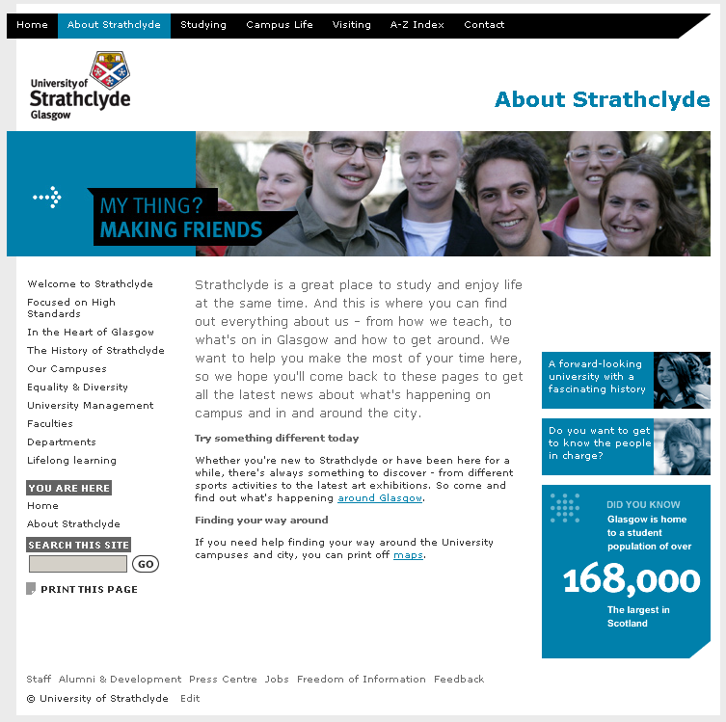

Changes
Please Note : In order to preview any of the following techniques, you must approve any content you wish to see in the ‘banner’, ‘rightcol’ or ‘uninav’ sections.

Banners
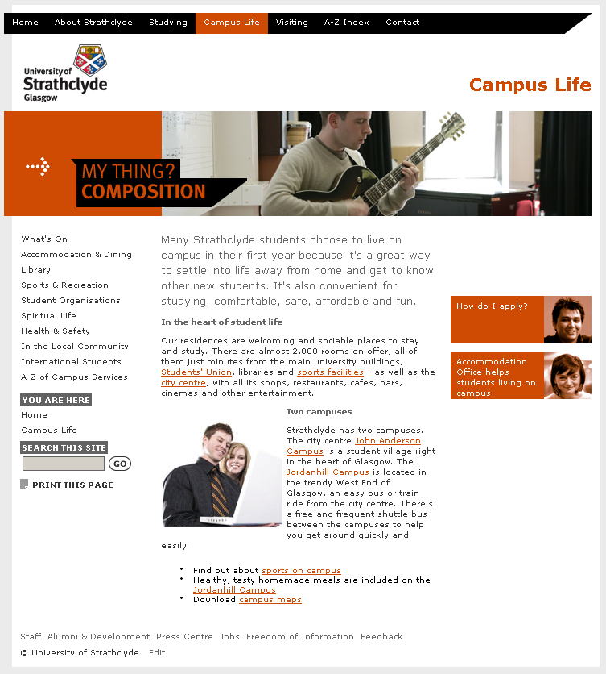
Banners are a prominent aspect of the new design allowing titles or images to be used at the top of your pages to grab your visitors’ attention. There are two types of image based banners and a text based banner. In order to make use of banners, you should follow these steps :
- Create a new Section in the Section where you would like to use a banner.
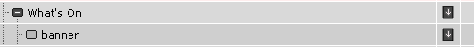
- It must be called ‘banner’ and the show in navigation box must be unchecked
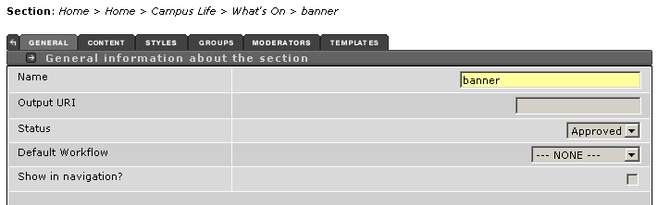
- You may then add content using “002_Banner_Dept_Img”, “002_Banner_Toplevel_Img” or “002_Banner_Toplevel_Txt”. See 4.5 for further details.
NB To preview your banner, approve the content in the ‘banner’ section.

Right Column
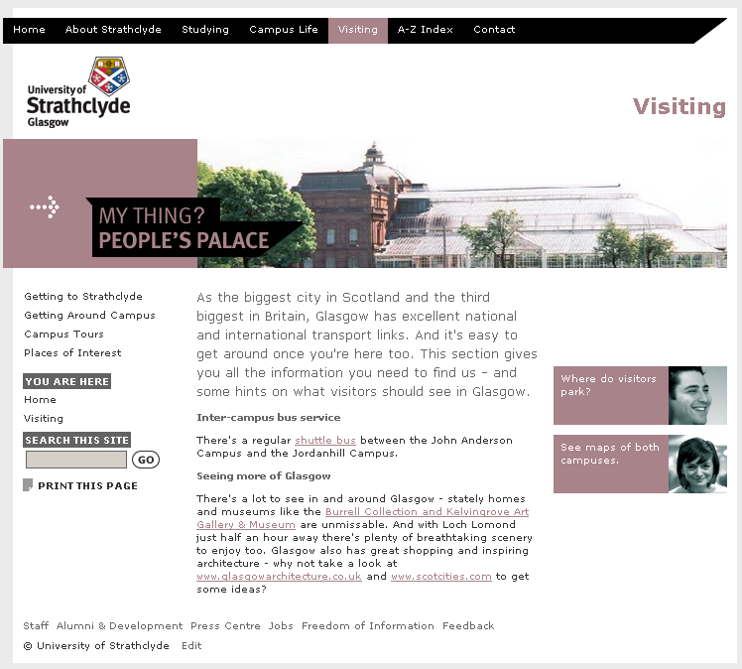
A right column has been introduced to allow you to highlight news, links, adverts and snippets of information to draw them to your visitor’s attention. Available throughout the new design. In order to make use of the column, you should follow these steps :
- Create a new Section in the Section where you would like to use the right column.
- It must be called ‘rightcol’ and the show in navigation box must be unchecked
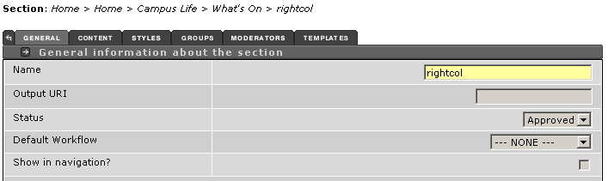
- You may then add content using “002_Right_Advert_Img”, “002_Right_ChildLinks”, “002_Right_DidYouKnow” or “002_Right_Image”, “002_Right_News”. See 4.5 for further details.
NB To preview your right column, approve the content in the ‘rightcol’ section.

Additional Navigation
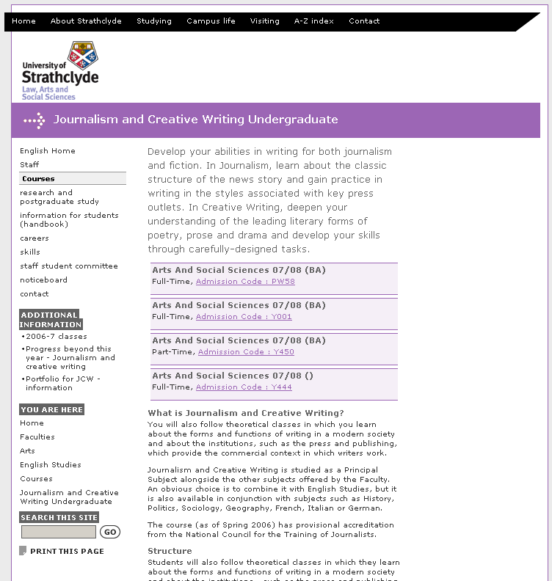
Many users have already made use of additional navigation in the current design. This continues to be available in the new design – the additional menu will appear in the left navigation area, titled ‘Additional Information’. This can be used for related information stored somewhere else on the website or as links to hidden sections in your own site. To use the additional menu, you should follow these steps :
- Create a new Section in the Section where you would like to use a banner.
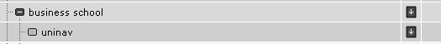
- It must be called ‘uninav’ and the show in navigation box must be unchecked
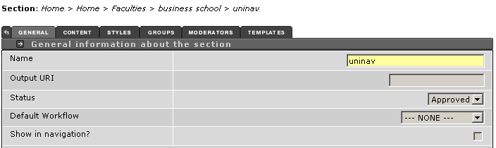
- You may then add content using “002_Main_General”. Simply add a bullet list of the links you require.
NB To preview your extra navigation, approve the content in the ‘uninav’ section.

Changes to navigation
A significant change in the new design is the left navigation.
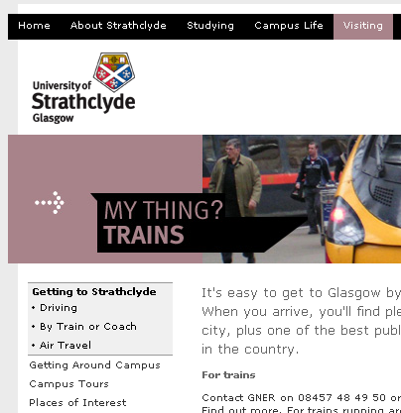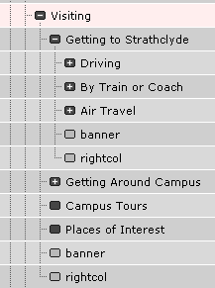
The left navigation is now ‘fixed’ and provides access to two levels of your site as illustrated above.
For most sites this will not require any further work. For some sites with deeper structures, some adjustments may be required (listed below). Please discuss this issue with Webteam before undertaking any substantial work.
- Restructuring your site yourself
- Amending content, hiding sections and using new design elements to more usefully present your information
- Webteam can make ‘global’ changes to certain sections of your site, effectively creating a sub-site within your parent site.

Templates
Template Name | Description
002_Banner_Dept_Img | Banner image for use under text banners on departmental pages.
002_Banner_Toplevel_Img | Captioned banner image for use on top level pages.
002_Banner_Toplevel_Txt | Text only banner. This is automatically added to departmental sites.
002_Main_1st_Para | Larger text for starting pages.
002_Main_3Col_Banner | 3 column image/text template for highlighting links / information at the foot of a page.
002_Main_4Col_Banner | 4 column image/text template for highlighting links / information at the top of a page.
002_Main_General | The default template for text and images.
002_Main_Grouped_Content | Allows users to add a coloured header, bold subtitle and body text.
002_Main_Highlight_Title | Title style to be used at the top of pages.
002_Main_LinkList_Siblings | Gives a list of sibling links with the heading ‘related’.
002_Right_Advert_Img | Image and text link for use in right column
002_Right_ChildLinks | Add list of automatically maintained links to child sections.
002_Right_DidYouKnow | ‘Did You Know’ image
002_Right_Image | Right column image
002_Right_News | Right column news / events
002_Right_Titlelink_Summary | Right column title / summary.

Template Name | Visual Example | Intended Use / Notes
002_Banner_Dept_Img | 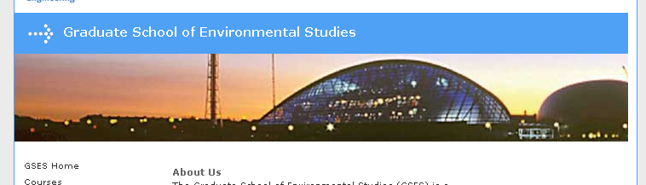  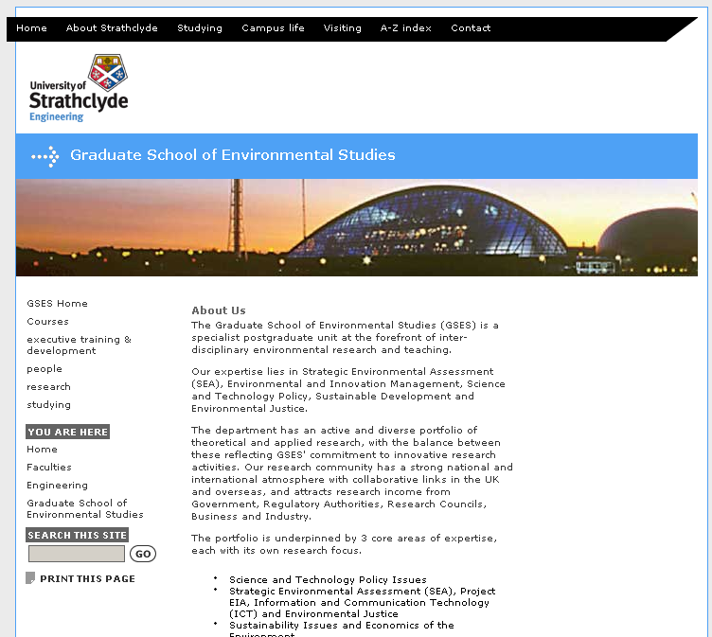 | Banner image for use under text banners on departmental pages.  - Uncaptioned image  - Stored in the media library under 002 Stock Media | Banners.  - Further images can be created for you by Webteam if required.  - If you are creating your own, they should be 720px wide by 152px high and no larger than 50k.

Template Name | Visual Example | Intended Use / Notes
002_Banner_Toplevel_Img | 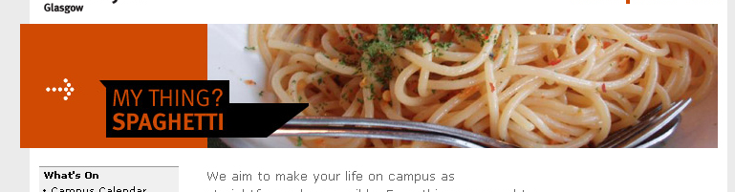  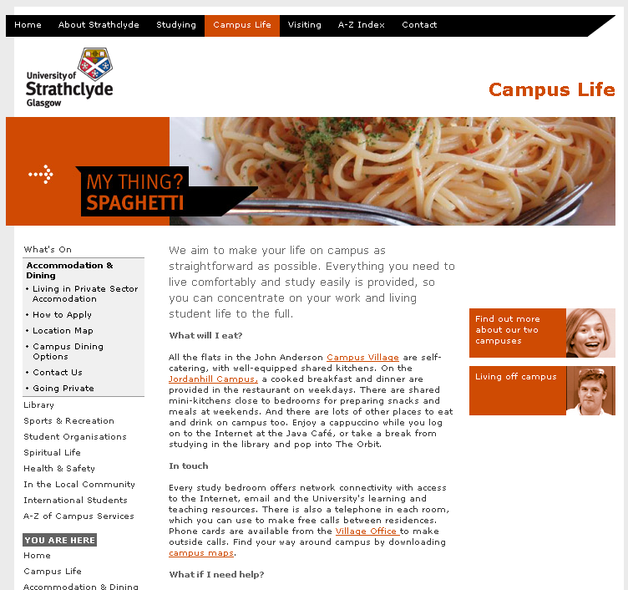 | Captioned banner image for use on top level pages.  - Not generally in use for departmental sites although it is available should an opportunity be identified.  - Stored in the media library under 002 Stock Media | Banners | Landing Pages.  - Further images can be created for you by Webteam if required.

Template Name | Visual Example | Intended Use / Notes
002_Banner_Toplevel_Txt | 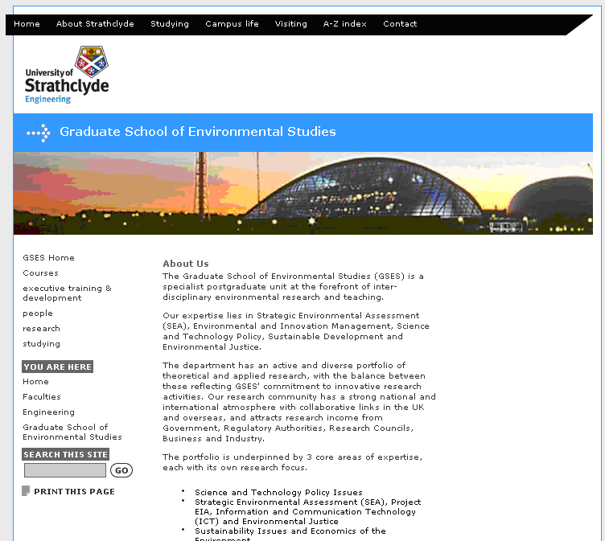 | Text only banner. This is automatically added to departmental sites.  - Can be added to other pages using this template  - Will automatically adopt the correct background colour.  - Select the appropriate arrow image from the Media Library found under 002 Stock Media | Furniture.

Template Name | Visual Example | Intended Use / Notes
002_Main_1st_Para | 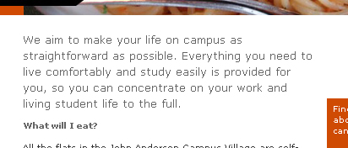  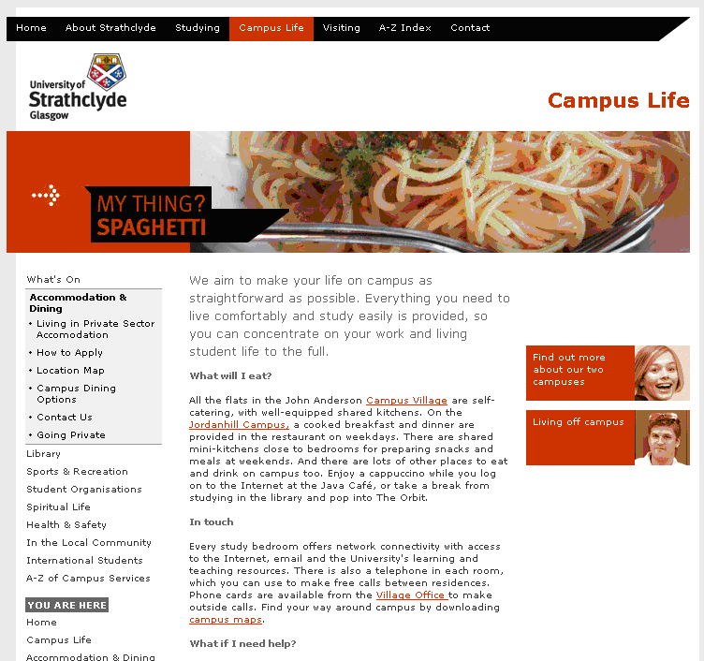 | Larger text for starting pages.  - Intended to start pages with a brief text highlight or hook to interest visitors in the page.  - Neither links nor images can be used in this template.

Template Name | Visual Example | Intended Use / Notes
002_Main_3Col_Banner | 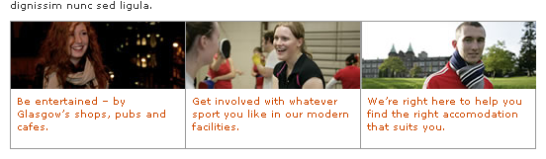  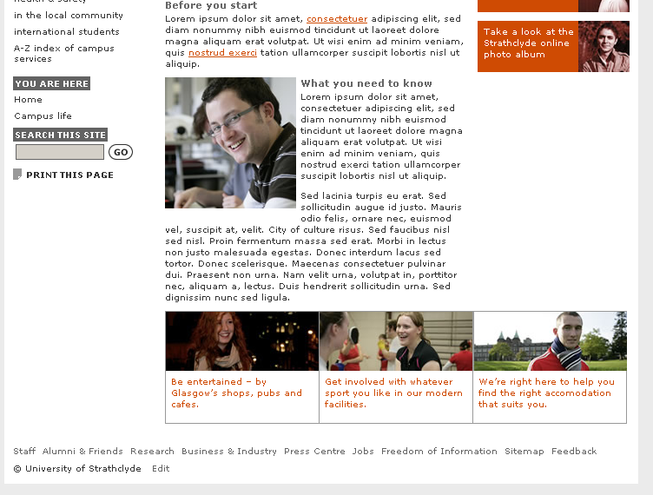 | 3 column image/text template for highlighting links / information at the foot of a page.  - All three images and associate text areas have to be populated.  - Images can be found at 002 Stock Media | 3 Column Highlight.  - If you’re adding further images, they should be 177px wide by 68px high.

Template Name | Visual Example | Intended Use / Notes
002_Main_4Col_Banner | 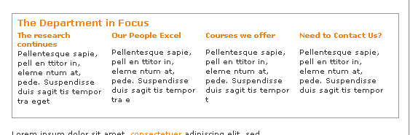  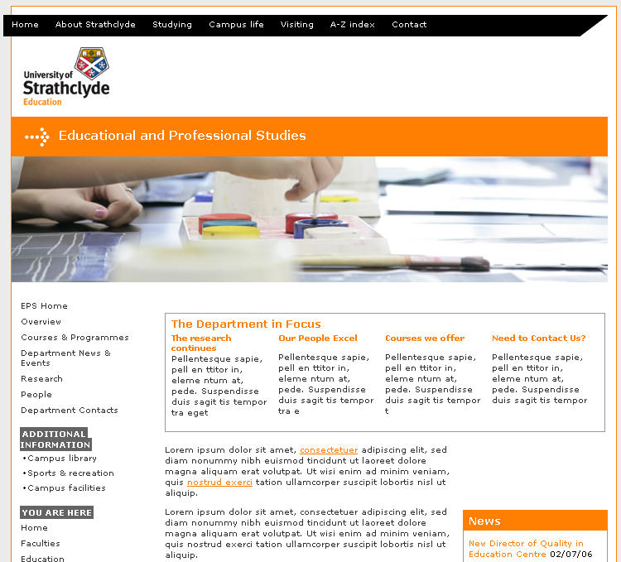 | 4 column image/text template for highlighting links / information at the top of a page.  - The heading, all four subheadings and the four text areas must be populated.  - The headings will automatically adopt the correct colour.

Template Name | Visual Example | Intended Use / Notes
002_Main_General | 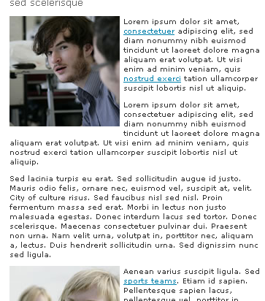 | The default template for text and images.  - Replaces the 001 Strath Site template  - No mandatory Title  - Don’t need to manually select a style.  - Titles/subtitles can be added by placing the relevant text on a new line and then making the text bold.  - Images can be added as before – they will automatically display to the left of the text.  - Old images will continue to work  - New images should either be selected from the Media Library at 002 Stock Media | Body Content (categorised as Male, Female or Male/Female) or uploaded as a 151px square image.

Template Name | Visual Example | Intended Use / Notes
002_Main_Grouped_Content | 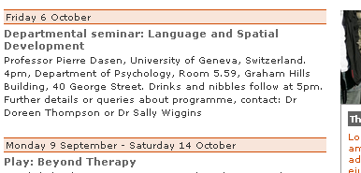  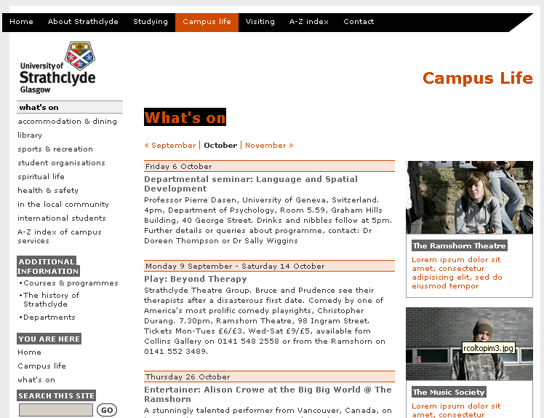 | Allows users to add a coloured header, bold subtitle and body text.  - Allows larger bodies of repetitive text to be broken up.  - Allows users to add a coloured header, bold subtitle and body text.

Template Name | Visual Example | Intended Use / Notes
002_Main_Highlight_Title | 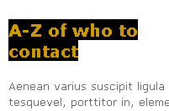  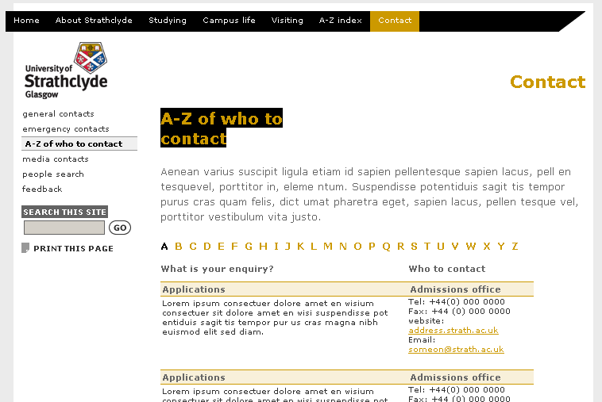 | Title style to be used at the top of pages.

Template Name | Visual Example | Intended Use / Notes
002_Main_LinkList_Siblings | 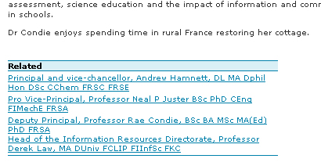  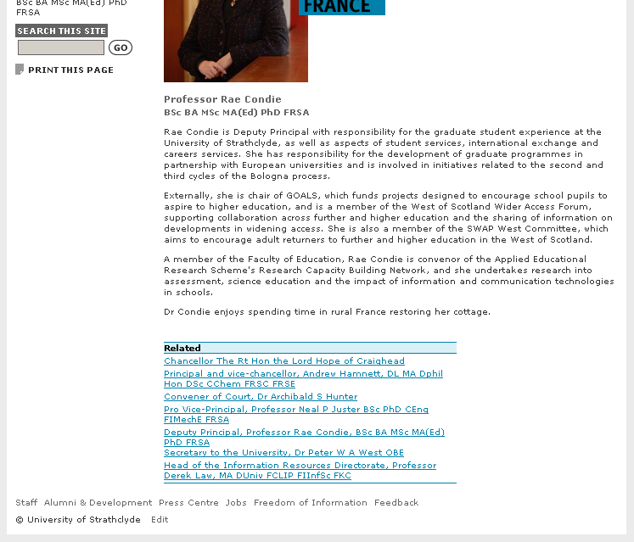 | Gives a list of sibling links with the heading ‘related’.  - Sibling links which means that the list will display links to all other pages in the same section.  - Will automatically use the correct colour for the section in which it is used.

Template Name | Visual Example | Intended Use / Notes
002_Right_Advert_Img | 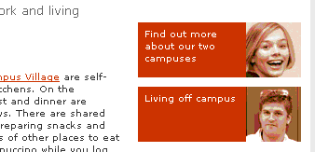  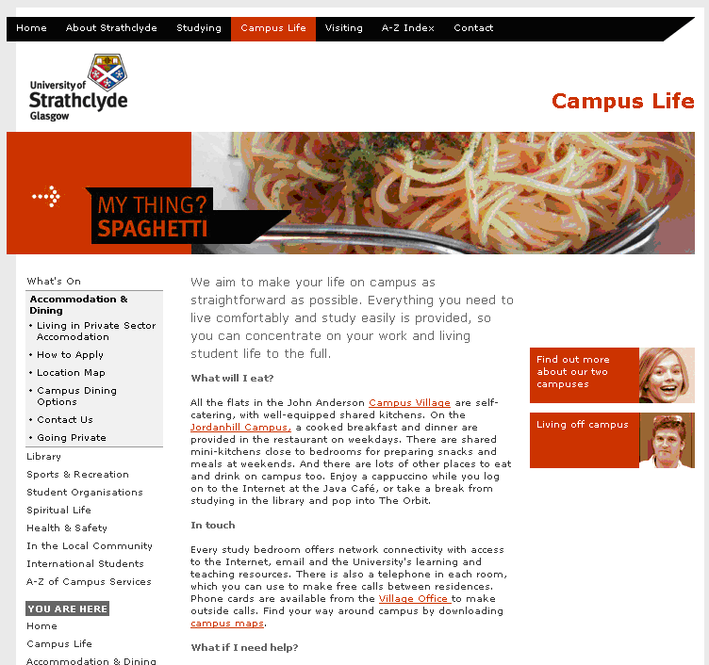 | Image and text link for use in right column  - Uses two forms of content.  - The first is a brief piece of text calling the visitors attention to important related information.  - The second is an image from the media library.  - Images can be found in 002 Stock Media | Right Column | Promotional where they are then further sub-categorised.

Template Name | Visual Example | Intended Use / Notes
002_Right_ChildLinks | 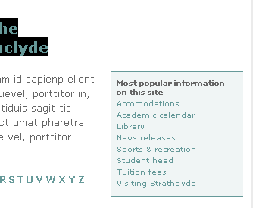  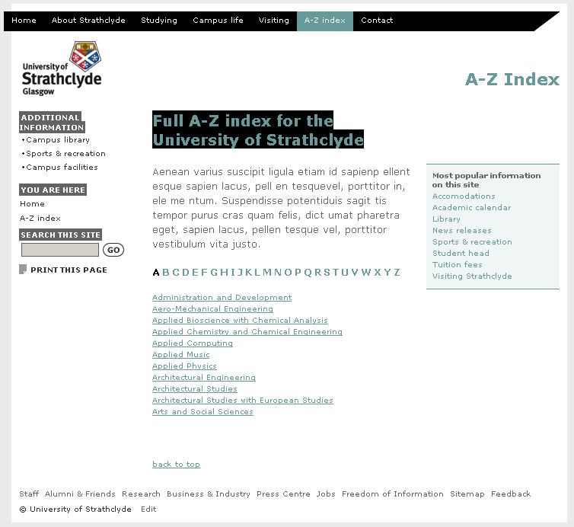 | Add list of automatically maintained links to child sections.

Template Name | Visual Example | Intended Use / Notes
002_Right_DidYouKnow | 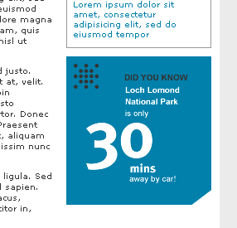 | ‘Did You Know’ image  - These can be found in 002 Stick Media | Right Column | Did You Know.  - Custom Did You Know graphics could be developed for your department – please speak to Webteam for further information.  - If you would like and existing Did You Know in a colour appropriate for your section, please ask Webteam

Template Name | Visual Example | Intended Use / Notes
002_Right_Image | 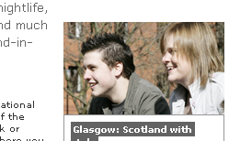  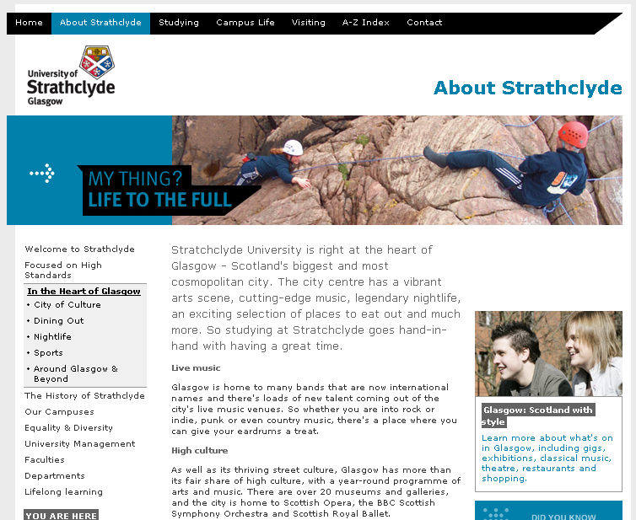 | Right column image  - Works well when paired with 002_Right_Titlelink_Summary  - Also works well as the top item in the right column.  - Located in 002 Stock Media | Right Column | Main Image  - 175px wide by 101px high

Template Name | Visual Example | Intended Use / Notes
002_Right_News | 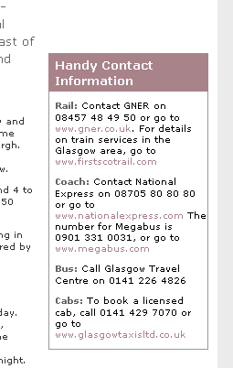  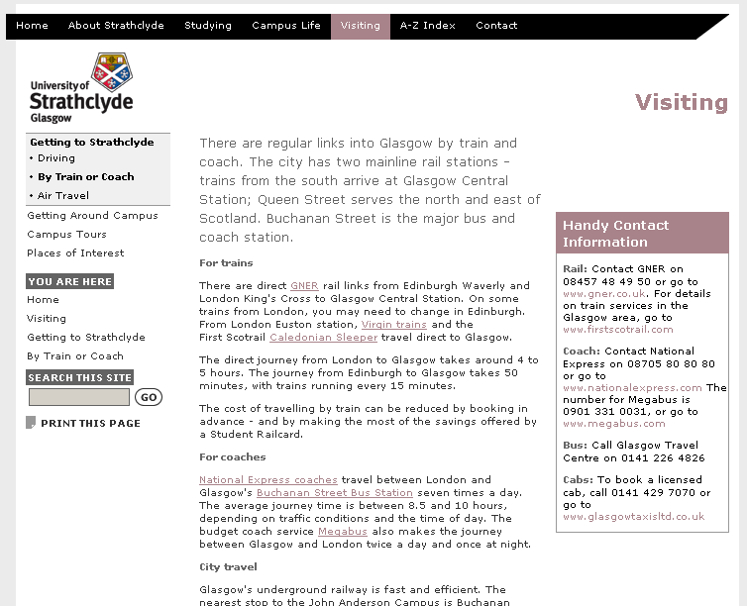 | Right column news / events  - Text based heading  - Area below for free text.  - Free text may contain links.  - Used where more information is required than 002_Right_Advert_Img

Template Name | Visual Example | Intended Use / Notes
002_Right_Titlelink_Summary | 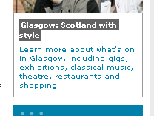  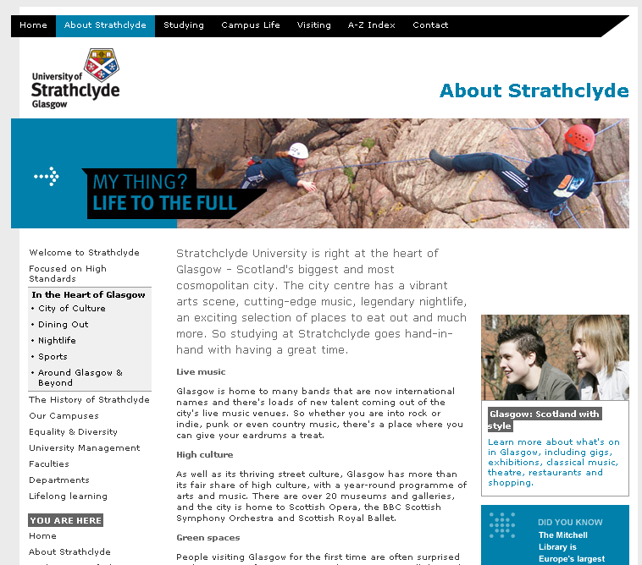 | Right column title / summary.  - Linked title  - Short summary.  - Text should expand upon the title and encourage visitors to click on the title link.

