**Course Pages**

This note sets out to clarify the automated aspects of course pages within our Content Management System (CMS) commonly known as T4.

**Process**

We import basic course information for all courses into the CMS from the Registry systems maintained by SEES. These appear as T4 Sections with one or more item of content per section. The individual course sections appear in a parent section called “Courses”.

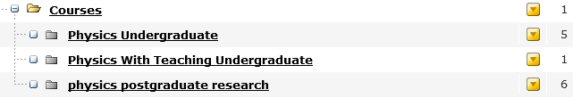

**The “Courses” section** has a single item of automated content – a drop-down list linking to each course. If you would prefer to arrange your course links differently on the page then this item of content should be “expired”. **NB** If you delete it, it will simply reappear overnight.

**Individual Course pages** can have many items of content. In this example, Physics Undergraduate has 5 items :

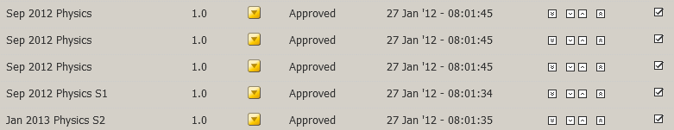

These appear on the page as :

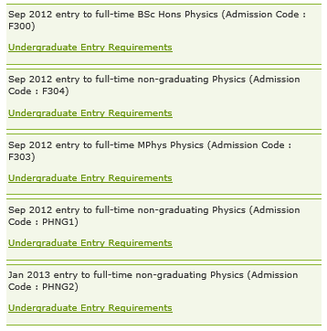You should take time to understand what each represents. In this instance :

* Sep 2012 BSc Hons is valid
* Sep 2012 MPhys is valid
* The non-graduating items are not courses we would normally  
   market, but are courses for which we record information in  
   registry systems.

Supporting marketing text should be added around the 2 valid bits of information. The other items can either be expired or may be able to be removed at source by SEES. **NB** Courses refresh annually in late-Sep / early-Oct so if you choose to expire the data you will need to revisit this task when the new information is imported.

**Taught Postgraduate Courses** are a special case as they also import an “Apply” link – the only way for students to apply for our PGT courses.

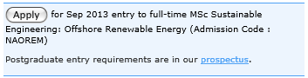

| **Common Issues** | **Result** | **Mitigation / Resolution** |
| --- | --- | --- |
| We want to rename the “Courses” section. | - | You can rename this by modifying the section in T4.  NB The search engine has a “courses” filter – this relies on the text “courses” being in the web address. If you rename the section and it does not include “courses” please contact webteam to ensure that your course still appears in the courses filter. |
| We want to rename an individual course section. |  | You can rename this by modifying the section in T4. |
| We want to rename a piece of course content. | - | You must do this through SEES who will require the appropriate approval from Senate. |
| We cannot see our course. | Course is missing from the website. | There are two main causes :  The course has not been approved by Senate and so is not in our systems yet. You must wait for Senate approval to be confirmed.  Your T4 structure has been amended manually in the past and the course is not where you expect it to be. Try searching T4 using the search from the Site Structure. If you cannot find the course, please contact webteam who will search the whole system for you. |
| Our course is not in the Course List - <http://www.strath.ac.uk/courses/> (or is mislisted) |  | This is a manually maintained page. It is your responsibility to inform webteam of any changes to this page. |
| Our PGT course has no “Apply” link | Students cannot apply. | For an Apply link to appear on a page, the following criteria must be met :   1. Course approved by Senate 2. Course entered into the registry system by SEES, has a point of entry set and has an admissions code attached. 3. Department have created and published an application form for each session for which students can apply.   **NB**  **(1)** SEES have an exclusions group which they can add programmes to – this is useful if a course closes to applications. It can also be worth checking if a link is not appearing when all other criteria are met.  **(2)** SEES also have an inclusions group. This can be used if a start date is in the past but applications are still open. |