Installing excelerator add-in for M7 on Client PCs
You will need UNIT4 Report Engine 9 for M7. Some users will already have this and therefore won’t need to make any changes.
To check whether you need to make a change please check which version of excelerator is currently installed.
Use the search option on the bottom of your screen to access the Control Panel.
Then select Programs and Programs and Features (or just Programs and Features depending on your configuration).
The screen below is the default PC configuration for Finance staff. Test systems will be configured via a full RDP desktop.
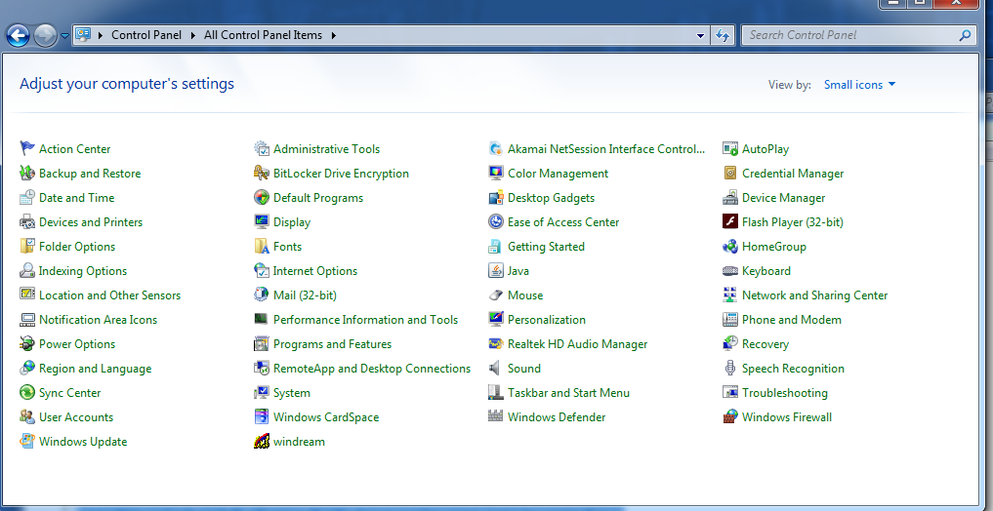
Check current versions
Example below shows UNIT4 Report Engine 9
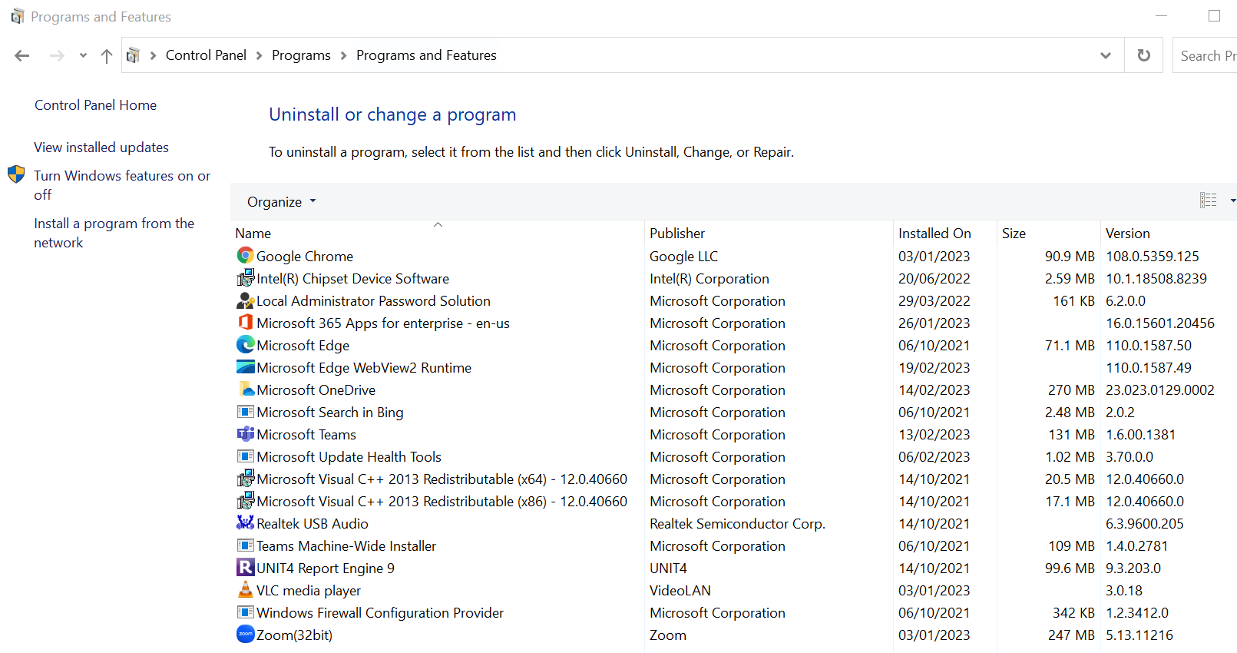
If you have UNIT4 Report Engine 9 you don’t need to do anything further

Example below shows Agresso Report Engine 8
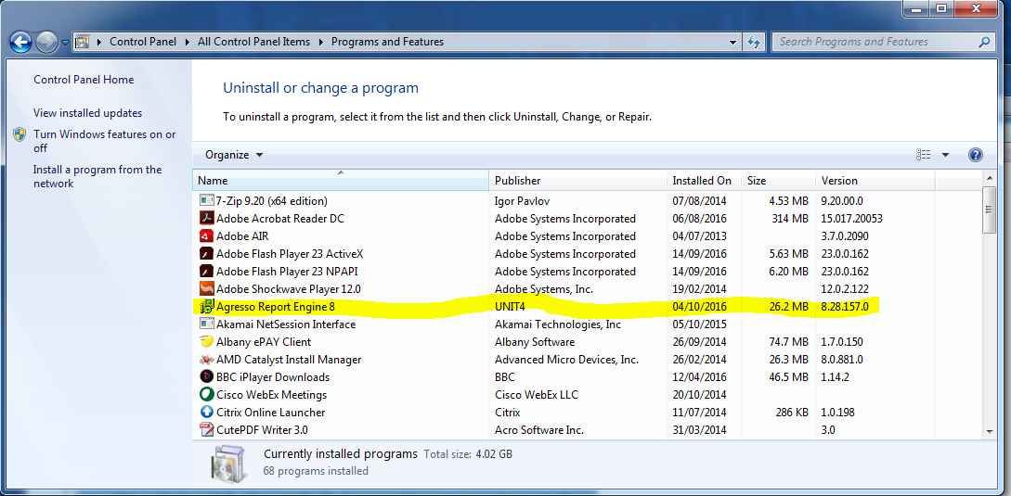

If you have Agresso Report Engine 8 or any other version you will need to follow the rest of this guidance.

Check Office version
This will work with both 64 & 32 bit Excel
Installing software
If you have Agresso Report Engine 8 or any other version de-install it.
Note you will need administrative rights to install software.
Currently the software is located in the folder
idrive\Admin\Finance\Common\IT_systems\Milestone 7\RE9.3SU2Close Excel
Launch Unit4ReportEngine9.msi.
Note that there will be the normal security Warnings e.g.
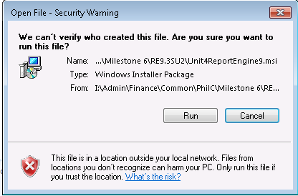

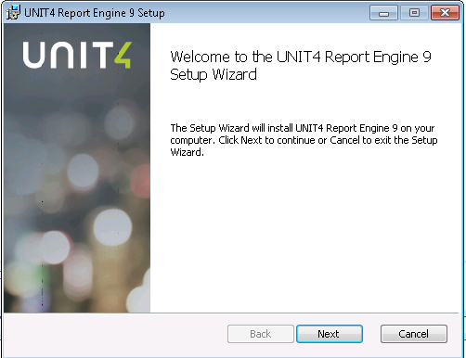
Accept the license Agreement and use don’t change any settings
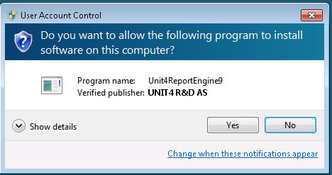
On 64-bit Windows operating systems.
The software will be installed in C:\Program Files (x86)\UNIT4 Report Engine 9\
On 32-bit Windows operating systems.
The software will be installed in C:\Program Files\UNIT4 Report Engine 9\

Installing Add-in
Open Excel with blank workbook, there may or may not be an ADD-INS tab, if other add ins have been installed.
Select File tab, Options, Add-ins
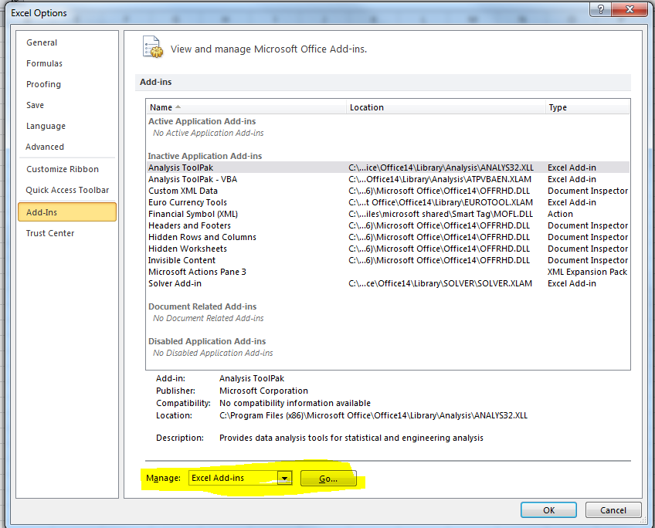
Press manage GO
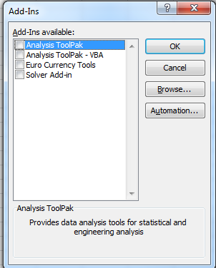
The add-in may already exist but not be selected. If the add-in does not exist, press browse and select ExceleratorVBAInterface
On 64-bit windows C:\Program Files (x86)\UNIT4 Report Engine 9
On 32-bit windows C:\Program Files\UNIT4 Report Engine 9

Select add-in if not already selected
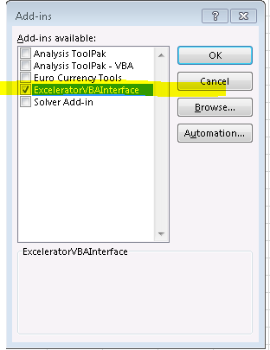
The add-in is now available for use.

Configuring the ADD-IN by completing the following:
In Excel go to the UNIT4 EXCELERATOR tab.
Select Login
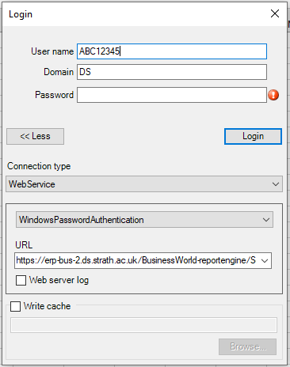
Hit the More option
And fill in the details as per below screenshot:
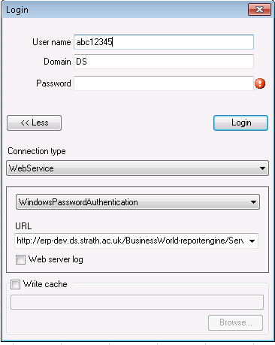

Username: your PC username
Domain: DS
Password: (get the user to enter their password)
Connection type: WebService
WindowsPasswordAuthentication
URL: https://erp7-bus1.ds.strath.ac.uk/BusinessWorld-reportengine/Service.asmx
Note that this is the Live URL.
If the authentication fails you may need to re-enter the details.
The login screen remembers the details from the last successful login.

