University Occupational Health and Safety Form
CLASS II MICROBIOLOGICAL SAFETY CABINETS
MONTHLY AIRFLOW CHECK FORM
SECTION 1 INFLOW
- On a monthly basis, measure inflow air velocities using a calibrated vane anemometer. The MSC should be running for at least 5 minutes prior to taking any measurement.
- The inflow air velocity measurements are taken at three positions along the centre line of the MSC aperture, one at each side and one in the middle. The vane must be positioned vertically at the opening of the MSC and the measurements taken along the central horizontal plane, with the centre of the vane being positioned as below. Measurements must be taken at the same positions for subsequent monthly recordings.
Position 1
Position 2
Position 3
- The measured inflows at all 3 points must be over 0.4 m/s.
- Record these reading on the Monthly Anemometer Readings Log Sheet (below).
- Retain records for 5 years.

Record a Fail if:
- Any measured inflow value is less than 0.4 m/s.
- Any individual measurement differs from the mean inflow velocity by more than 20%.
An MSC which falls outside of tolerance must not be used.

All fails must be reported to __________________
Issues Log and Record of Actions must be completed.

MSC Reference Number:
Location:
Date of last service:

Date | Recording (m/s) |  |  | Mean | Issue and action taken | Initial
 | Position 1 | Position 2 | Position 3 | m/s

SECTION 2 DOWNFLOW
- On a 6-monthly basis, measure downflow air velocities using a calibrated vane anemometer. The MSC should be running for at least 5 minutes prior to taking any measurement.
- The downflow measurements are taken using a vane anemometer placed in the horizontal plane positioned 100 mm above the top edge of the working aperture. Airflow velocity measurements are taken at a minimum of eight positions within the MSC:
  - Four positions along a line a quarter of the depth of the working space forward from the rear wall of the MSC; and
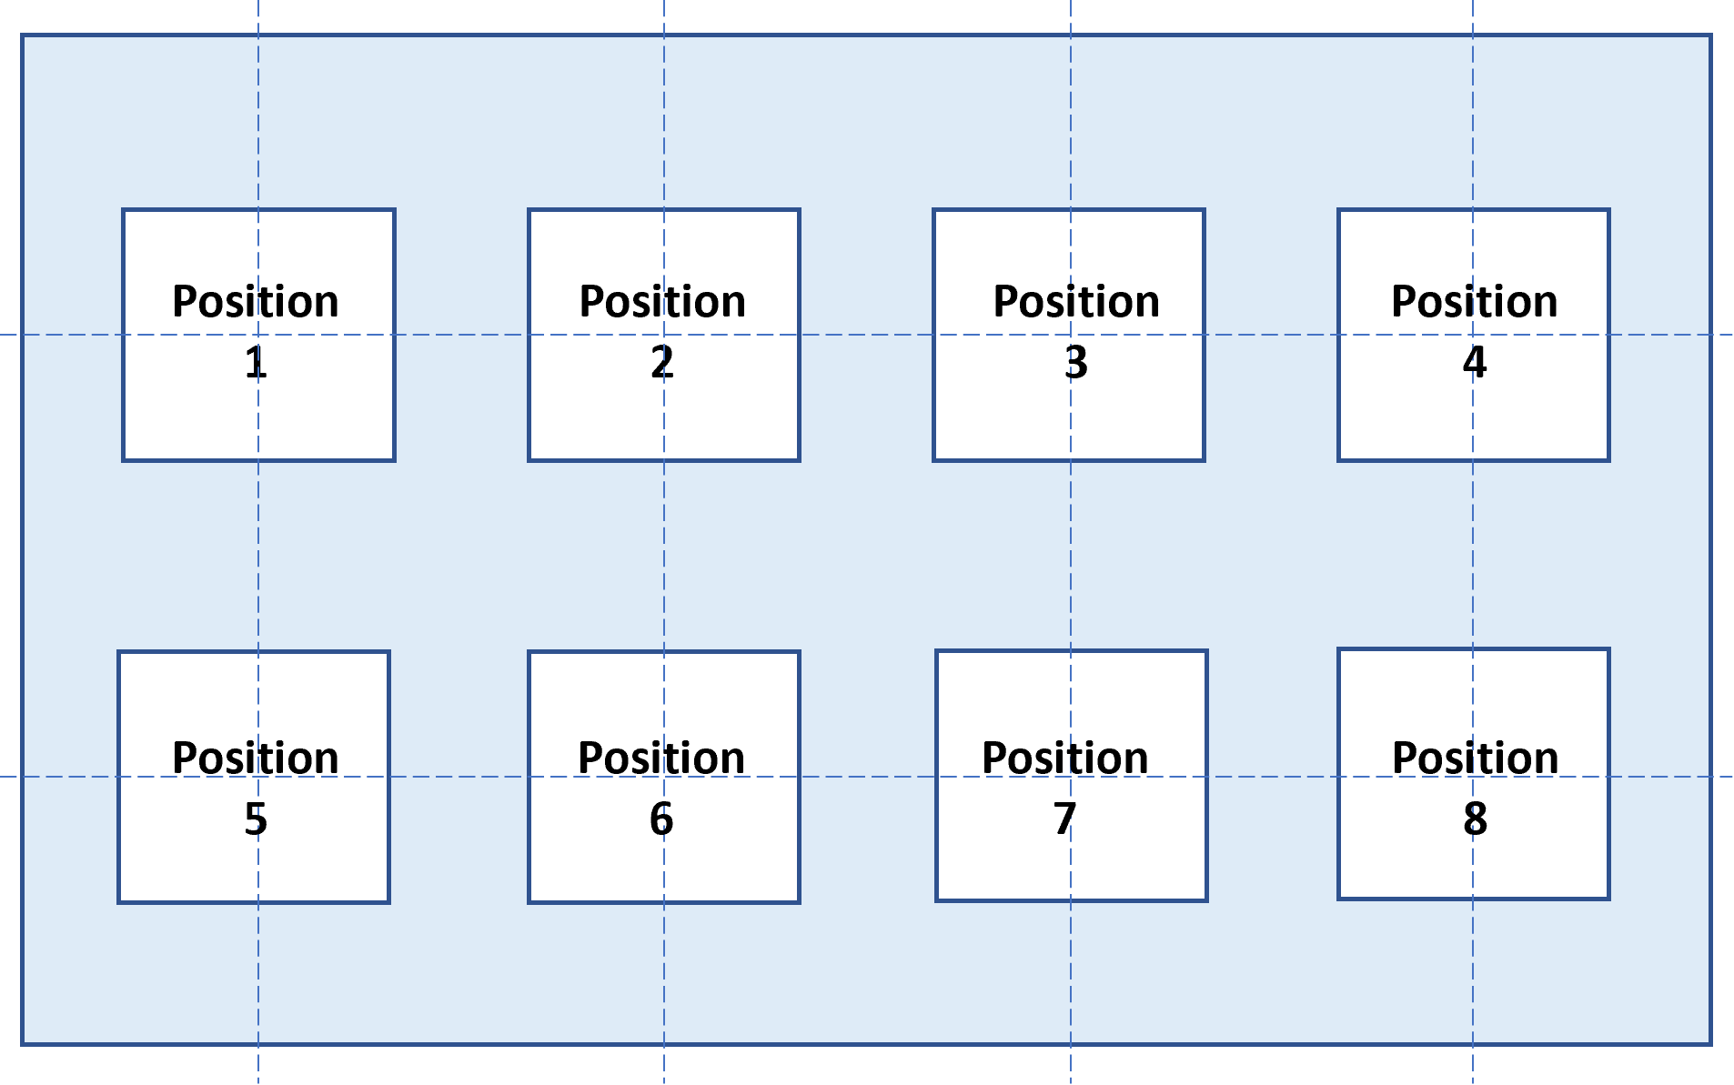
  - Four positions along a line the same distance behind the front window of the MSC.
- Measurements must be taken at the same positions for subsequent monthly recordings.
- The measured inflows at all 8 points must be between 0.25 and 0.5 m/s.
- Record these reading on the 6-Monthly Anemometer Readings Log Sheet (below).
- Retain records for 5 years.
Record a Fail if:
- Any measured downflow value is less than less than 0.25 m/s or more than 0.5 m/s.
- Any individual measurement differs from the mean downflow velocity by more than 20%.
An MSC which falls outside of tolerance must not be used.
All fails must be reported to __________________
Issues Log and Record of Actions must be completed.
MSC Reference Number:
Location:
Date of last service:

Date | Mean (m/s) |  |  | All recordings within 20%? (Y/N) | Pass / Fail ? | Issue and Action Taken | Initial
 | Mean | -20% | +20

For further information on MSCs see Management and operation of microbiological containment laboratories.

