Barra Report
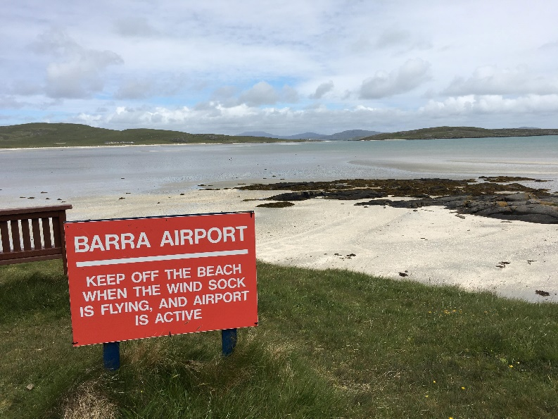

Island: Barra
Date: 19/06/2019

This report has been produced by the Strathclyde Centre for Environmental Law and Governance (SCELG) and Scottish Island Federation (SIF) in the framework of their collaboration with the Islands Team of the Scottish Government. The goal of this report is to capture the essence of the discussions that have taken place at the consultation event on Barra. The report will be sent out to participants who authorised us to do so in order to receive further comments and feedback. The report is not to be considered as an indication of what will ultimately go into the National Island Plan, but it will inform the latter. The report is also not to be considered as an indication of the position of Scottish Government on any of the points mentioned therein.

Introduction
On the 19th of May 2019, a consultation event took place on Barra between 10am and 12.30pm. The event was attended by 20 people, including children from the local primary school, and the goal was to capture both what works well on the island and the challenges faced by the community on Barra. The consultation is required by the Islands (Scotland) Act 2018, as a means to inform the National Islands Plan that Scottish Government will be presenting to Scottish Parliament on 4 October 2019.

Barra as a great place to live
The consultation highlighted the following things that make living on Barra great:
- Safety
- ‘Islandness’
- Community Spirit
- Environment
- Gaelic Culture
- Opportunities
- Freedom

It is evident that there are many things that make Barra a fantastic place to live. The list above only affords a glimpse, but it does highlight that there is a true sense of a close knit and safe community on the island, and that residents really value the uniqueness of island life and the multiple opportunities and general freedom this affords them. The participants also highlighted that they particularly enjoy the natural environment of the island, and stated that Gaelic culture and heritage is an essential element of community life on Barra.

The consultation moved on to discuss the current challenges on Barra and the main concerns of the island community. The following are the main issues that were shared by the participants at the event (see Annex for more details):
- Increasing Population Levels
- Economic Development
- Environmental Protection
- Health and Wellbeing
- Community Empowerment
- Transport
- Land Management
- Fuel Poverty
- Social Activities for 18+
- Introduction of Walking and Cycling Paths
- Gaelic Language

The National Islands Plan and the Response from the Participants
During the consultation, several key challenges were discussed in greater detail. We wish to make it very clear that a more in-depth focus was undertaken for the purposes of the face-to-face consultation, and should not be considered as any indication of prioritization in the framework of the National Islands Plan.

The areas discussed more in depth were:
- Increasing Population
- Community Empowerment
- Economic Development
- Transport

For each, participants were asked to provide more details about the challenge, their proposed solution, next steps, who should undertake these next steps and when. The following are the suggestions that we believe stemmed from the participants present at the consultation on Barra:
Challenge | Suggestion from participants
Increased Population | - Develop an island centric housing policy that fully takes into consideration the unique situation and needs of each island community.  - Support innovative development of local resources and economy that specifically focus on increasing economic opportunities for young people.  - Revise current healthcare policy to reverse centralisation and encourage the retention and expansion of on island services.
Community Empowerment | - Develop an island centric housing policy that fully takes into consideration the unique situation and needs of each island community.  - Consider the possibility of devolving current councils to allow for more autonomy of decision making at the local level.  - Revise current healthcare policy to reverse centralisation and encourage on island services.
Economic Development | - Recognise that boosting economic development on an island requires joint thinking with other policies such as, for example, housing and transport.  - Revise essential services to ensure that they are appropriately island proofed in order to retain/increase jobs in local economy, and gradually reverse decentralisation.
Transport | - Consider the possibility of developing an island focused/centric transport policy that benefits island communities.  - For Barra, this would include ensuring that both plane and ferry services are viewed as a lifeline service with priority given to island residents.

Barra Vision
Island communities know that good governance requires an integrated and holistic approach to policy. We wish to stress once again that the National Islands Plan and its implementation will not address specific issues in isolation, but rather will consider all factors together whilst taking into account their crosscutting nature. In addition, each island has its own unique character and its own unique challenges. From the consultation on Barra we have identified the following specific traits to Barra:

Firstly, it is apparent that Barra, although reliant on tourism as a key sector of its economy, also currently lacks the appropriate infrastructure to adequately deal with the number of tourists visiting the island during the summer months.

This is particularly relevant in relation to transport, with islanders unable to make use of both ferry and plane services due to the sheer number of visitors fully booking these services months in advance of their visit. There appears to be a current lack of recognition of these lifeline services at policy level, with an urgent need to rethink current transport strategies to ensure that they are driven by island communities, and that they are recognized as being a ‘lifeline’ service for islanders rather than just an economic service. For Barra, this would include ensuring that both plane and ferry services are viewed as a lifeline service with priority given to island residents.

The issue of community empowerment was also repeatedly raised by participants, and is a clear example of an issue which, if improved, would have a ‘ripple effect’ on may other areas , including economic development and increasing the island population. Currently, residents of Barra feel that the seats of decision-making in both Edinburgh and Stornoway fail to properly take into consideration the unique needs of the Barra community. It is therefore essential, that the possibility of devolving current councils to allow for more autonomy of decision making at the local level is considered as a substantive commitment going forward.

Improved community empowerment can also assist with the development of local resources and the island economy, as well as the revision of current healthcare policy to ensure that essential services are appropriately island proofed in order to retain/increase jobs in the local economy, and consequently increase the population of Barra. Finally, a current lack of affordable, fit for purpose housing on the island is acting as a barrier to increasing the local economy and population, resulting in the need to develop an island centric housing policy that fully takes into consideration the unique situation and needs of the island community.

What now?
First and foremost we wish to thank those who attended the consultation events on Barra. We encourage you to fill in the on-line consultation at https://consult.gov.scot/agriculture-and-rural-communities/national-islands-plan/. You can find the consultation document that provides background information about the Islands (Scotland) Act 2018, the National Islands Plan and the Islands Communities Impact Assessment at https://www.gov.scot/publications/national-islands-plan-islands-communities-impact-assessment-guidance-consultation/.

More importantly, please send us any comments/feedback on this report at n.crook@strath.ac.uk

The National Islands Plan will only be useful if it is truly informed by the island communities and by all those who have an interest and a stake in Scottish islands. Thanks to your participation in the consultation event and your comments and feedback, we are confident that the work being undertaken towards the National Islands Plan is capturing the voice of island communities. We are also sure that this is only the beginning and that, together, we can make sure that the National Islands Plan is not just “another” plan, but “The Plan” that works for island communities in Scotland.

Useful links:
- On-line consultation - https://consult.gov.scot/agriculture-and-rural-communities/national-islands-plan/
- Consultation document - https://www.gov.scot/publications/national-islands-plan-islands-communities-impact-assessment-guidance-consultation/
- Islands (Scotland) Act 2018
- Strathclyde Centre for Environmental Law and Governance (SCELG) - https://www.strath.ac.uk/research/strathclydecentreenvironmentallawgovernance/
- Scottish Island Federation (SIF) - http://www.scottish-islands-federation.co.uk/
- SCELG portal on the consultation - https://www.strath.ac.uk/research/strathclydecentreenvironmentallawgovernance/ourwork/research/labsincubators/eilean/islandsscotlandact/consultations/

Annex
Challenges about living and working on Barra

Depopulation  - More work opportunities  - More housing  - Barra based health and social care jobs on island  - Healthy democratic structure | Economic Development  - More proper full-time jobs  - Energy  - Reduce negative impact of tourism (eg campervans)  - Maximise economic opportunity  - Job sustainability (workforce planning)  - Opportunities for homeworking | Environmental Protection  - Improve walkways/roads paths into interior of the island  - Transport (ferries, road and infrastructure)
Health and Wellbeing  - New hospital  - Services reducing increases isolation  - Improved facilities and infrastructure  - Improve health service | Community Empowerment  - Council closer to Barra  - Council more accountable | Transport  - Improve all ferries  - RET for haulage over 6 m (freight)  - A ferry that does not break down  - Improve Transport  - Air service to meet islanders needs (mainland / interisland)
Other
- Social activities 18+
- Walking and cycle paths
- Our language spoken friendly

