Jura Report
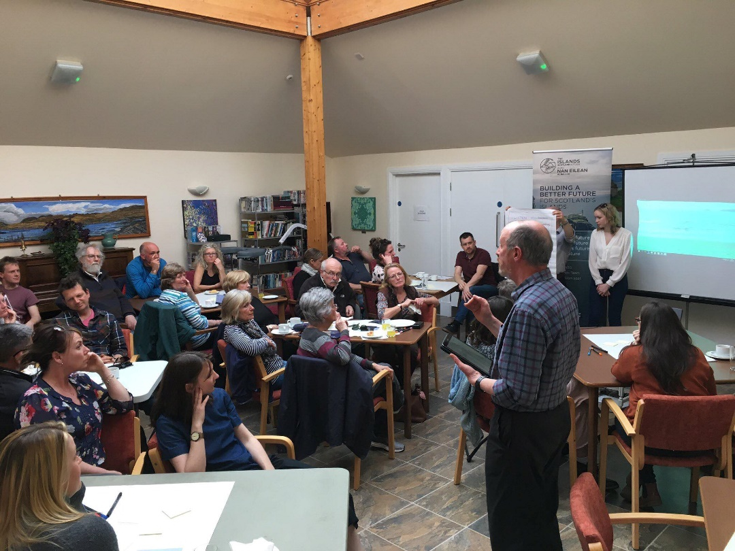

Island: Jura
Date: 18/04/2019

This report has been produced by the Strathclyde Centre for Environmental Law and Governance (SCELG) and Scottish Islands Federation (SIF) in the framework of their collaboration with the Islands Team of the Scottish Government. The goal of this report is to capture the essence of the discussions that have taken place at the consultation event on Jura. The report will be sent out to participants who authorised us to do so in order to receive further comments and feedback. The report is not to be considered as an indication of what will ultimately go into the National Island Plan, but it will inform the latter. The report is also not to be considered as an indication of the position of Scottish Government on any of the points mentioned therein.

Introduction
On 18th April 2019, a consultation event took place in Craighouse between 6pm and 8.30pm. The event was attended by 38 people and the goal was to capture both what works well on the island and the challenges faced by the community on Jura. The consultation is required by the Islands (Scotland) Act 2018, to inform the National Islands Plan that Scottish Government will be presenting to Scottish Parliament on 4 October 2019.

Jura as a great place to live
The consultation highlighted the following things that make living on Jura great:
- Safe and secure for both locals  and visitors  - Natural beauty of the island  - Community spirit  - Freedom afforded by space  - Good Primary School  - Employment  - History and Culture  - Family life  - Healthcare | 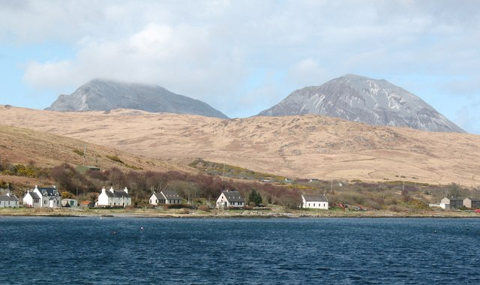
It is evident that there are many things that make Jura a fantastic place to live. The list above only affords a glimpse, but it does highlight that there is a true sense of safety on the island, that the islanders relish the natural beauty of the landscape, that culture and history are seen as being vital to continued growth and that there is real community spirit. There is a general feeling that the demands of island life force you to develop as a person, but it was also highlighted that the island community would prefer to be known as ‘resourceful’ rather than ‘resilient’ to adequately portray the skills sets which they have developed in order to live on Jura. It should be noted that whilst the areas of employment and healthcare were mentioned as positive aspects, these issues were slightly contentious and were also noted as ‘challenges’ which are discussed in more detail below.

Challenges on Jura
The consultation moved on to discuss the current challenges on Jura and the main concerns of the island community. The following are the main issues that were shared by the participants at the event (see Annex for more details):
- Stopping Population Decline  - Economic Development  - Environmental Protection  - Health and wellbeing  - Community empowerment  - Transport  - Digital Connectivity  - Fuel Poverty  - Land Management  - Biosecurity  - Housing  - Local energy generation  - Whisky tax to benefit Jura  - Education | 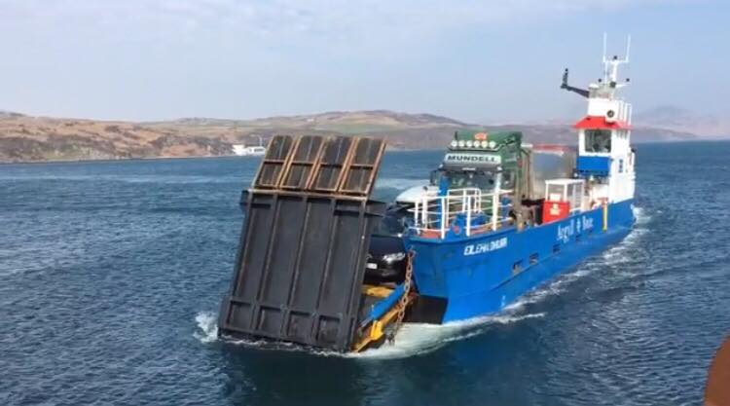

The National Islands Plan and the Response from the Participants
During the consultation, several key challenges were discussed in greater detail. We wish to make it very clear that a more in-depth focus was undertaken for the purposes of the face-to-face consultation, and should not be considered as any indication of prioritization in the framework of the National Islands Plan.

The areas discussed more in depth were:
- Increasing Population levels
- Health and Wellbeing
- Transport
- Digital Connectivity

For each, participants were asked to provide more details about the challenge, their proposed solution, next steps, who should undertake these next steps and when. The following are the suggestions that we believe stemmed from the participants present at the consultation on Jura:

Challenge | Suggestion from participants
Increase Population Levels | - Develop and implement an island focused housing policy that creates locally affordable housing stock.  - Reconsider land reform to ensure that islanders have access to more land.  - Develop an organisation to assist companies who want to proactively employ people on the islands in order to diversify current economy to include year-round, skilled workforce.
Health | - Devolving the decision making to the local level recognizing that one size does not fit all.  - Develop remote and rural health care as a specialty.  - Consider how to balance private sector operating on the island and its role in supporting lifeline services for the community.  - Increase public safety for hillwalkers.  - Improve digital connectivity.
Transport | - Review and reform of the ferry/public buses (transport policy) in line with island communities’ interests and priorities, which means an island base ferry service.  - Need for integrated transport policy and timetable, as transport for island communities is not just a service (it’s a lifeline, it’s a right).  - Introduction of public subsidies for travel costs for islanders.  - Development of legally binding minimum requirements for road infrastructure that builds upon the needs of island communities.  - Consider the possibility that each island connects with at least one ferry/air link to the mainland.
Digital connectivity | - Equity and fairness component of digital nationwide policy so that communities on islands (but also rural areas) are considered first when a new system is put in place.  - Revise digital connectivity policy to better reflect connectivity as a right/lifeline rather than just as an economic service - develop legally binding minimum standards that take such nature into account.  - Develop more resilient infrastructure including more masts and less fiber optic to suit island geography.

Jura Vision
Island communities know that good governance requires an integrated and holistic approach to policy. We wish to stress once again that the National Islands Plan and its implementation will not address specific issues in isolation, but rather will consider all factors together whilst taking into account their crosscutting nature. In addition, each island has its own unique character and its own unique challenges. From the consultation on Jura we have identified the following specific traits to Jura:

Firstly, it is essential to note that Jura is itself very distinct from the neighboring Isles of Islay and Colonsay. These islands are often grouped together with Jura for administrative and funding purposes, but differ greatly in terms of key characteristics such as size, population, economy, transport links and infrastructure. Consequently, many of the issues faced by the community on Jura are either masked or misinterpreted by overarching statistics or policies that include all three islands. It is therefore essential that moving forward a more considered approach is taken, and it was suggested by a participant that further research be undertaken as part of the National Islands Plan to define key characteristics of all Scottish Islands to allow for a more intelligent grouping structure.

Secondly, sectors like transport and digital connectivity highlight the discrepancy and ineffectiveness of policies adopted and sought by non-islanders. There is a need to revise these sectors to ensure that they are driven by island communities, and that they are recognized as being a ‘lifeline’ service for islanders rather than just an economic service: i.e. the current ferry from Jura to Islay as run by Argyll and Bute Council. This reveals a wider dissatisfaction with community empowerment and local governance. It was suggested that each island is represented within an Islands Division with the Scottish Government by someone who is actually based on that island and whose role it is to be a conduit for the flow of information in both directions, facilitating community consultation and encouraging participation.

Thirdly, it is evident that housing and diversifying the economy are crucial to increasing the population of the island and need to be adapted and reconsidered having island communities at the heart of such policies. These two areas have very strong and immediate positive ripple effects if dealt with properly. However, both cannot and should not be developed centrally considering rural communities and island communities on the periphery. Whilst there is fairly low unemployment on Jura, there remains an issue of underemployment, with many highly qualified people working in unskilled, low paid, seasonal jobs due to the lack of wider opportunities. Conversely, many mainland jobs which do not require employees to be permanently present are not available to islanders due to a lack of information in relation to remote working. The development of an ‘Innovative Island Employers’ Kitemark’ was suggested as a way to promote remote working for those living on Scottish islands.
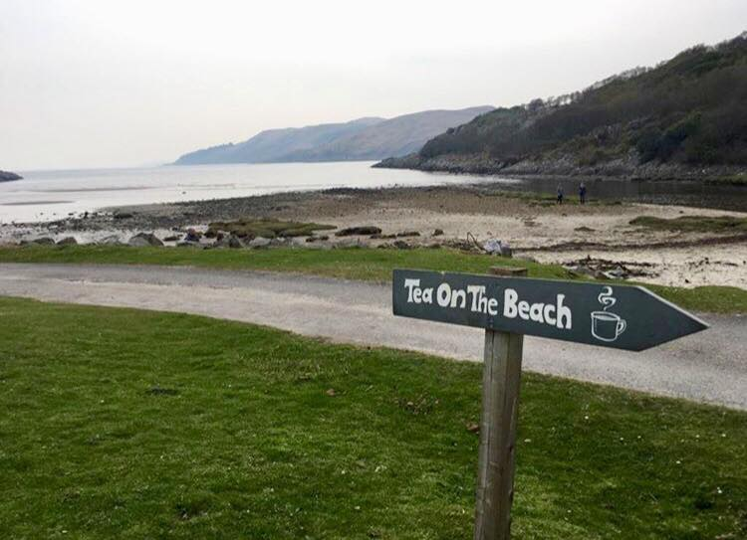

What now?
First and foremost, we wish to thank those who attended the consultation events on Jura. We encourage you to fill in the on-line consultation at https://consult.gov.scot/agriculture-and-rural-communities/national-islands-plan/. You can find the consultation document that provides background information about the Islands (Scotland) Act 2018, the National Islands Plan and the Islands Communities Impact Assessment at https://www.gov.scot/publications/national-islands-plan-islands-communities-impact-assessment-guidance-consultation/.

More importantly, please send us any comments/feedback on this report at n.crook@strath.ac.uk

The National Islands Plan will only be useful if it is truly informed by the island communities and by all those who have an interest and a stake in Scottish islands. Thanks to your participation in the consultation event and your comments and feedback, we are confident that the work being undertaken towards the National Islands Plan is capturing the voice of island communities. We are also sure that this is only the beginning and that, together, we can make sure that the National Islands Plan is not just “another” plan, but “The Plan” that works for island communities in Scotland.

Useful links:
- On-line consultation - https://consult.gov.scot/agriculture-and-rural-communities/national-islands-plan/
- Consultation document - https://www.gov.scot/publications/national-islands-plan-islands-communities-impact-assessment-guidance-consultation/
- Islands (Scotland) Act 2018
- Strathclyde Centre for Environmental Law and Governance (SCELG) - https://www.strath.ac.uk/research/strathclydecentreenvironmentallawgovernance/
- Scottish Island Federation (SIF) - http://www.scottish-islands-federation.co.uk/
- SCELG portal on the consultation - https://www.strath.ac.uk/research/strathclydecentreenvironmentallawgovernance/ourwork/research/labsincubators/eilean/islandsscotlandact/consultations/

Annex
Challenges about living and working on Jura

-Depopulation  - Build affordable housing for all  - Specified that this includes for those at entry level and for buying/renting  - Social housing is included in this.  - Flats (rather than just large houses) must also be included.  - Land must also be made available. | -Economic Development  - Increase diversity of job opportunities  - Level economic playing field with the mainland  - Subsidise transport to mainland.  - Universal basic income  - Subsidised day to day living  - Better allocation of corporate wealth  - Community co-operative initiatives to boost local economy.  - Pre 3’s free childcare.  - Training & learning opportunities beyond school.  - Maintain a well-managed tourist industry.  - No private golf courses | -Transport  - Tunnel/bridge to Islay  - Solar panel flights to Jura  - Improved provision of ferries  - Direct mainland ferry connection  - Priority system for booking ferries for essential travel for islanders  - Free ferry travel for residents  - Community determined ferry timetable  - Jura to Islay ferry too small/not fit for purpose  - Integrated transport links  - High speed mono rail to ferry.  - Improved infrastructure  - Road & bicycle track  - Zero carriage costs  - Roads  - Currently in terrible state of disrepair  - Maintenance must be improved  - Pay road tax but no benefits  - Dual carriage way.  - Possibility of road tax deduction for islands?
-Digital Connectivity  - Better broadband  - Super high speed  - Reliable and affordable  - Remote learning/working opportunities  - Improved mobile coverage | - Environmental protection  - Self-sufficiency  - Power, meat, veg., etc.  - Sustainable use of island resources  - Food infrastructure, renewable energy, 100% recycling.  - No fish farms | -Health and wellbeing  - Sports facilities  - Swimming pool (indoor & sea)  - Sports teams  - Creative studio space  - Free music tuition  - Community arts, culture & history  - Equal access to activities i.e. school swimming.  - Coastal Path in village to Corran  - Medical care  - Protection of current health services  - On island dental services  - Access to specialist medical care/consultants without a 2 night stay over.  - Remote health consultations
-Community empowerment  - Jobs to allow islanders to work remotely.  - More community lands  - Community has a say/control over their island BUT volunteers should not be expected to deliver everything  - Housing for young people to live and gain independence.  - ‘Services need to grow with the population’  - Argyll & Bute need to embrace a successfully growing island. | -Fuel poverty  - Energy sufficient  - Green energy  - No penalties for living on island  - i.e. postage costs and petrol costs.  - Cheaper cost of living (freight ferry)  - Cost of travel on/off island. | -Land management  - Take control of small isles bay from the crown commission.  - Marina
-Biosecurity  - Natural beauty protected and preserved | Council  - Rename current council Argyll & the Isles  - Restructure local council to ‘islands council’ specifically for islands  - Argyll and Bute council should have a dedicated body for dealing with islands | Food and drink industry  - Should be world leading in exporting in terms of environmental impact reduction.
-Jura nationalize whisky  - Give whisky tax back | -Planning Rules  - What is relevant on the mainland often not suited for islands. | - Do not ‘lump’ Islay, Colonsay & Jura together  - They are all unique, very different islands with numerous populations and needs that should be addressed separately.  - Jura has unique needs /one size does not fit all’

