Mull Report

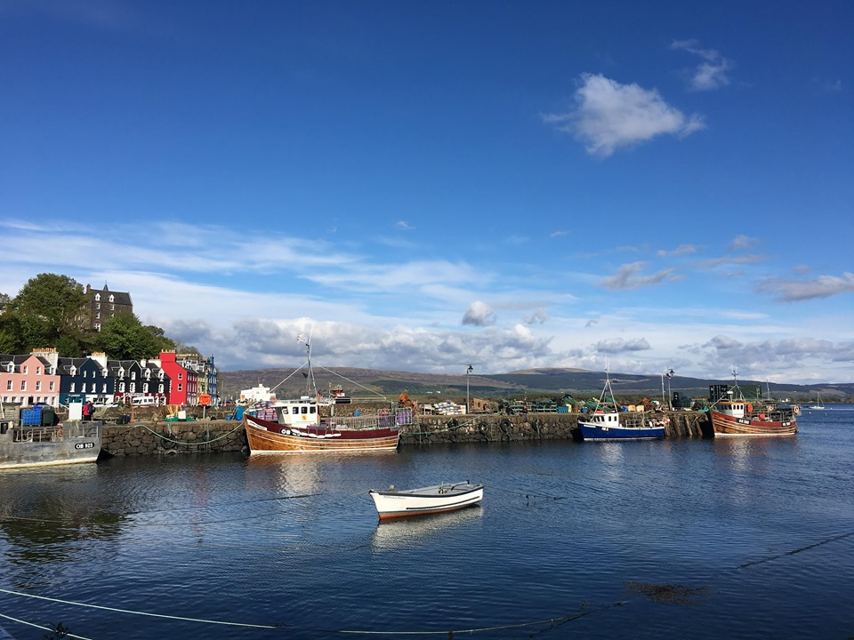

Island: Mull
Date: 31/04/2019

This report has been produced by the Strathclyde Centre for Environmental Law and Governance (SCELG) and Scottish Islands Federation (SIF) in the framework of their collaboration with the Islands Team of the Scottish Government. The goal of this report is to capture the essence of the discussions that have taken place at the consultation event on Mull. The report will be sent out to participants who authorised us to do so in order to receive further comments and feedback. The report is not to be considered as an indication of what will ultimately go into the National Island Plan, but it will inform the latter. The report is also not to be considered as an indication of the position of Scottish Government on any of the points mentioned therein.

Introduction
On the 29th of March and the 1st April 2019, consultation events took place in Craignure and Tobermory and the goal was to capture both what works well on the island and the challenges faced by the community on Mull. The consultation is required by the Islands (Scotland) Act 2018, to inform the National Islands Plan that Scottish Government will be presenting to Scottish Parliament on 4 October 2019.

Mull as a great place to live
The consultation highlighted the following things that make living on Mull great:
- Strong Sense of Community  - Volunteer Mindset  - Generational Mix  - Safe  - Good Food & Local produce  - Heritage & Culture  - Entrepreneurial Opportunities  - Environment  - Landscape & Wildlife  - Education  - Geography  - Community Hospital  - Arts, Theatre and Music  - Untapped Potential | 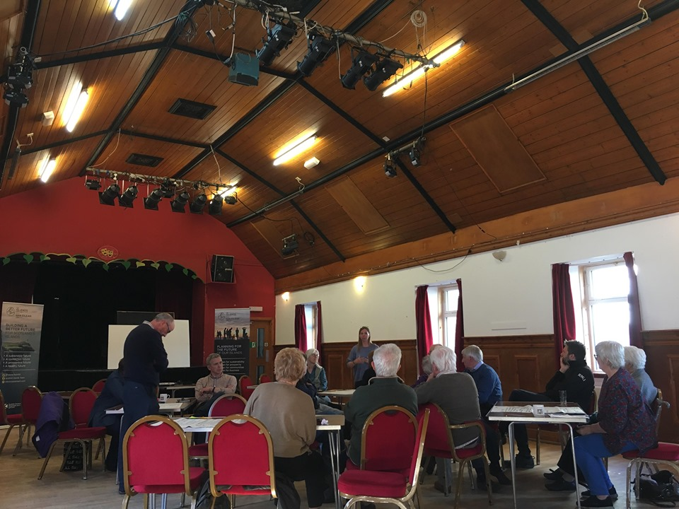
It is evident that there are many things that make Mull a fantastic place to live. The list above only affords a glimpse, but it does highlight that there is a true sense of safety on the island, that the islanders relish the natural beauty of the landscape, that culture and history are seen as being vital to continued growth and that there is real community spirit. The ‘intergenerational mix’, as well as the quality of local produce were also mentioned, and additionally, there was a real sense that there was a wealth of ‘untapped’ potential on Mull, in that the island community had a lot more to offer in economic and cultural terms if the correct support was provided.

Challenges on Mull
The consultation moved on to discuss the current challenges on Mull and the main concerns of the island community. The following are the main issues that were shared by the participants at the event (see Annex for more details):
- Stopping Population Decline  - Economic Development  - Environmental Protection  - Health and Wellbeing  - Community Empowerment  - Transport  - Digital Connectivity  - Fuel Poverty  - Land Management  - Biosecurity  - Housing  - Tourism  - Security of Fuel Supply  - Secondary Education  - Childcare  - Mobile Facilities | 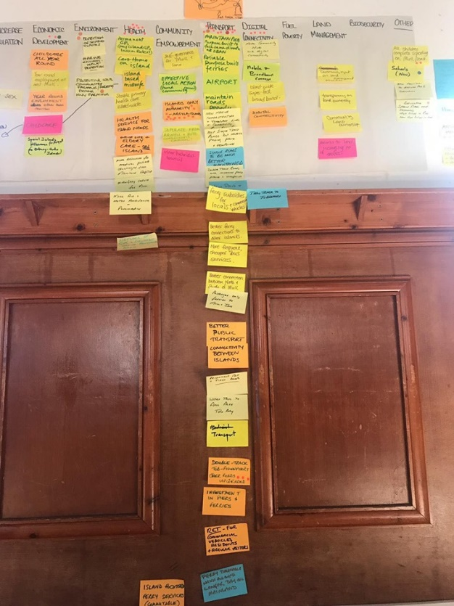

The National Islands Plan and the Response from the Participants
During the consultation, several key challenges were discussed in greater detail. We wish to make it very clear that a more in-depth focus was undertaken for the purposes of the face-to-face consultation and should not be considered as any indication of prioritization in the framework of the National Islands Plan.

The areas discussed more in depth were:
- Increasing Population Levels & Economic Development
- Health
- Transport
- Community Empowerment
- Housing

For each, participants were asked to provide more details about the challenge, their proposed solution, next steps, who should undertake these next steps and when. The following are the suggestions that we believe stemmed from the participants present at the consultation on Mull:

Challenge | Suggestion from Participants
Increasing Population Levels & Economic Development | - Need to revise current policy to promote the repopulation of the island by economically active demographic:  - Focus on affordable housing and diverse job opportunities.  - Connection with health services crucial.  - Consider the development of minimum legally binding requirements in relation to digital connectivity, starting from the periphery.  - Recognise that boosting economic development on an island requires joint thinking with other policies and opportunities beyond those directly focusing on the island.  - Develop an organisation to assist companies who want to proactively employ people on the islands in order to diversify current economy to increase year-round, skilled workforce.
Health | - Immediately revise current GP locum contract.  - Revise current health service to ensure it is ‘island proofed’ for local communities.  - Develop remote and rural health care as a specialty in its own right  - Explore the possibility of increased linkages between further education and the healthcare needs of the local community.  - Devolving the decision making to the local level recognizing that one size does not fit all.
Transport | - Review current ferry/public buses (transport policy) in line with island communities’ interests and priorities, with appropriate timetabling and boats.  - Explore the possibility of alternative fleets that respond better to island community needs.  - Support further discussion between island community and Argyll & Bute Council in relation to current and ongoing pier maintenance issues  - Need for integrated transport policy and timetable, as transport for island communities is not just a service (it’s a lifeline, it’s a right).  - Revise RET to include commercial vehicles.
Community Empowerment | - Explore the possibility of revising the current governance structure to allow decision-making to be taken for island communities, by islands (island centric).  - Increase funding routes and opportunities for local democratically elected groups (community councils) to take on a greater decision-making role.
Housing | - Develop and implement an island focused housing policy that creates locally affordable housing stock, with continued input from the island community.  - Reconsider land reform to ensure that islanders have access to more land.  - Policy acknowledgement that the housing challenge on the islands is critical and urgent and different from the mainland and needs to be developed based on the needs and knowledge of island communities.  - Revise current legislation in regard to holiday/second homes to ensure they don’t saturate the housing market at the expense of permanent residents.  - Explore the feasibility of introducing a tax on holiday homes and second homes.  - Recognise the positive ripple effect that an island focused housing strategy will have on the sustainability of the islands and their repopulation.

Mull Vision
Island communities know that good governance requires an integrated and holistic approach to policy. We wish to stress once again that the National Islands Plan and its implementation will not address specific issues in isolation, but rather will consider all factors together whilst considering their crosscutting nature. In addition, each island has its own unique character and its own unique challenges. From the consultation on Mull we have identified the following specific traits to Mull:

Firstly, it is useful to note that both of the events held on the Isle of Mull produced many similar conversations, with a lot of the participants voicing concerns over several key issues. Two such topics are transport and health, which were held as having the potential to be transformative for the island community.

There is a real sense that the current ferry policy, including both timetabling and boat size, prioritises tourism over the everyday needs of the island community. For example, current timetable and ferry capacity result in a large influx of tourists departing from Craignure en mass, which consequently puts additional strain on roads infrastructure which has not been sufficiently upgraded to support such a high number of vehicles. An integrated timetabling that better links ferries and other travel systems is needed as well as improvements in the bus services on the island. Faster and smaller ferries, which are interchangeable, were also suggested as a solution, as was widening and increasing the number of available passing places on the current road. Additionally, it was suggested that certain sections of road would hugely benefit from being made into a double track.

Secondly, the health sector highlighted the discrepancy and ineffectiveness of policies adopted and sought by non-islanders and was stated to be ‘currently inadequate and continually declining’. There is a need to revise current health policy to ensure that it is island proofed, with the current Locum GP contract a prime example of a policy that is crippling for island communities. Additionally, a lack of available on island elderly and neo-natal care, as well as subsequent childcare, were highlighted as crucial factors. Consequently, it is essential that decision-making is devolved to the local level, and recognises that a mainland-based health service does not fit the needs of island communities. It was suggested that rural healthcare be made a specialty and promoted through the development of a Rural College, with designated links to higher education for young islanders which would in turn improve the currently aging demographic of the island community.

Such issues reveal a wider dissatisfaction with community empowerment and local governance, with calls for the revision of the current governance structure to allow decision-making to be taken for island communities, by islanders. This was highlighted by the ongoing maintenance dispute regarding the pier at Craignure, and the possibility of parking charges being introduced by Argyll and Bute Council at key transport areas without undertaking an Islands Community Impact Assessment.

Thirdly, it is evident that affordable, fit for purpose housing is crucial to increasing the population of the island. Consequently, current policy needs to be adapted and reconsidered having island communities as its focus, with the development of taxation and incentives to reduce the current abundance of holiday homes which are saturating the island housing market. This area has very strong and immediate positive ripple effects if dealt with properly.

Finally, it is also useful to note that although not specified by participants as an area that they wished to discuss more in depth, digital connectivity was routinely highlighted as being crucial to the improvement of every issue previously mention.
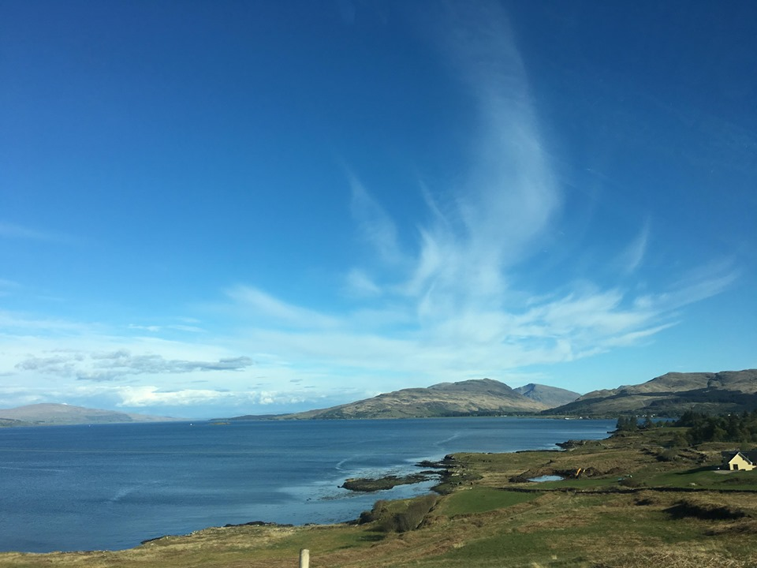
What now?
First and foremost, we wish to thank those who attended the consultation events on Mull. We encourage you to fill in the on-line consultation at https://consult.gov.scot/agriculture-and-rural-communities/national-islands-plan/. You can find the consultation document that provides background information about the Islands (Scotland) Act 2018, the National Islands Plan and the Islands Communities Impact Assessment at https://www.gov.scot/publications/national-islands-plan-islands-communities-impact-assessment-guidance-consultation/.

More importantly, please send us any comments/feedback on this report at n.crook@strath.ac.uk

The National Islands Plan will only be useful if it is truly informed by the island communities and by all those who have an interest and a stake in Scottish islands. Thanks to your participation in the consultation event and your comments and feedback, we are confident that the work being undertaken towards the National Islands Plan is capturing the voice of island communities. We are also sure that this is only the beginning and that, together, we can make sure that the National Islands Plan is not just “another” plan, but “The Plan” that works for island communities in Scotland.

Useful links:
- On-line consultation - https://consult.gov.scot/agriculture-and-rural-communities/national-islands-plan/
- Consultation document - https://www.gov.scot/publications/national-islands-plan-islands-communities-impact-assessment-guidance-consultation/
- Islands (Scotland) Act 2018
- Strathclyde Centre for Environmental Law and Governance (SCELG) - https://www.strath.ac.uk/research/strathclydecentreenvironmentallawgovernance/
- Scottish Island Federation (SIF) - http://www.scottish-islands-federation.co.uk/
- SCELG portal on the consultation - https://www.strath.ac.uk/research/strathclydecentreenvironmentallawgovernance/ourwork/research/labsincubators/eilean/islandsscotlandact/consultations/

Annex
Challenges about living and working on Mull

-Depopulation  - Build affordable housing for all  - Specified that this includes for those at entry level and for buying/renting  - Social housing is included in this.  - Flats (rather than just large houses) must also be included.  - Land must also be made available. | -Economic Development  - Increase diversity of job opportunities  - Level economic playing field with the mainland  - Subsidise transport to mainland.  - Universal basic income  - Subsidised day to day living  - Better allocation of corporate wealth  - Community co-operative initiatives to boost local economy.  - Pre 3’s free childcare.  - Training & learning opportunities beyond school.  - Maintain a well-managed tourist industry.  - No private golf courses | -Transport  - Tunnel/bridge to Islay  - Solar panel flights to Mull  - Improved provision of ferries  - Direct mainland ferry connection  - Priority system for booking ferries for essential travel for islanders  - Free ferry travel for residents  - Community determined ferry timetable  - Mull to Islay ferry too small/not fit for purpose  - Integrated transport links  - High speed monorail to ferry.  - Improved infrastructure  - Road & bicycle track  - Zero carriage costs  - Roads  - Currently in terrible state of disrepair  - Maintenance must be improved  - Pay road tax but no benefits  - Dual carriage way.  - Possibility of road tax deduction for islands?
-Digital Connectivity  - Better broadband  - Super high speed  - Reliable and affordable  - Remote learning/working opportunities  - Improved mobile coverage | - Environmental protection  - Self-sufficiency  - Power, meat, veg., etc.  - Sustainable use of island resources  - Food infrastructure, renewable energy, 100% recycling.  - No fish farms | -Health and wellbeing  - Sports facilities  - Swimming pool (indoor & sea)  - Sports teams  - Creative studio space  - Free music tuition  - Community arts, culture & history  - Equal access to activities i.e. school swimming.  - Coastal Path in village to Corran  - Medical care  - Protection of current health services  - On island dental services  - Access to specialist medical care/consultants without a 2 night stay over.  - Remote health consultations
-Community empowerment  - Jobs to allow islanders to work remotely.  - More community land  - Community has a say/control over their island BUT volunteers should not be expected to deliver everything  - Housing for young people to live and gain independence.  - ‘Services need to grow with the population’  - Argyll & Bute need to embrace a successfully growing island. | -Fuel poverty  - Energy sufficient  - Green energy  - No penalties for living on island  - i.e. postage costs and petrol costs.  - Cheaper cost of living (freight ferry)  - Cost of travel on/off island. | -Land management  - Take control of small isles bay from the crown commission.  - Marina
-Biosecurity  - Natural beauty protected and preserved | Council  - Rename current council Argyll & the Isles  - Restructure local council to ‘islands council’ specifically for islands  - Argyll and Bute council should have a dedicated body for dealing with islands | Food and drink industry  - Should be world leading in exporting in terms of environmental impact reduction.
-Mull nationalize whisky  - Give whisky tax back | -Planning Rules  - What is relevant on the mainland often not suited for islands. | - Do not ‘lump’ Islay, Colonsay & Mull together  - They are all unique, very different islands with numerous populations and needs that should be addressed separately.  - Mull has unique needs /one size does not fit all’

